ParkBot

EEL 4914 Senior Design 1
University of Central Florida
Group 12
Jason Mersch
Victor Morales
Victor Robles
Danielle Anderson

INTRODUCTION 1
- Executive Summary 1
- Project Motivation 1
- Significance 1

DEFINITION 3
- Goals/Objectives 3
- Specifications 3

REQUIREMENTS 5
- Motor 5
- Platform 5
- Motor Control 6
- Steering Servo 6
- Obstacle Avoidance Sensors 7
- Transmitter / Receiver Network 8
- Software 9
- Main CPU 10
- Power Supply 11

RESEARCH 12
- Methods 12
- Motor 12
  - DC Motor 13
  - Servo Motor 14
  - Stepper Motor 16
- Platform 18
- Motor Control 20
  - Direction 20
  - Speed 24
- Steering Servo 26
- Obstacle Avoidance Sensors 28
  - Ultrasonic Sensors 28
  - Imaging Sensors 31
  - IR Sensors 33
  - Comparison / Final Decision 34
- Remote Control Transmitter 36
  - Radio Frequency 37
  - Wi-Fi 40
  - Bluetooth 41
  - Radio Control 42
  - Infrared 43
- Remote Control Receiver 45
  - Radio Frequency 46
  - Wi-Fi 48
  - Bluetooth 49
  - Radio Control 49
  - Infrared 50
  - Comparison / Final Decision 51
- Microprocessor vs. Microcontroller 52
  - Microprocessor 52
  - Microcontroller 53
  - Comparison / Final Decision 54
- Software 57
- Algorithms 57
  - Detect Parking Spot / Move Forward 57
  - Pull Into Parking Space 58
  - Pull Out of Parking Space / Move Backwards 59
- Breadboard vs. PCB 60
- Power Supply 62
  - Solar Power 63
  - Disposable Batteries 63
    - Alkaline 64
    - Lithium 64
  - Rechargeable Batteries 65
    - Lithium-Ion 66
    - Nickel Cadmium 66
    - Nickel Metal Hydride 67
- Voltage Regulator 68
  - LM7805 69
  - LM341 70
  - LM317T 70

DESIGN 72
- Design Summary 72
- Block Diagrams 73
- Breadboard 75
- Motor 76
- Motor Control 77
  - Direction 77
  - Speed 78
- Steering Servo 79
- Obstacle Avoidance Sensors 79
- IR Remote Control / Receiver 82
- Microcontroller 84
- Software 88
- Algorithms 89
  - Detect Parking Spot / Move Forward 89
  - Pull Into Parking Space 91
  - Pull Out of Parking Space / Move Backwards 93
- Power Supply 95

PROTOTYPE 97
- Parts Acquisition 97
- Building Method 97
- Motor 98
- Chassis 98
- Steering Servo 99
- Obstacle Avoidance Sensors 99
- IR Remote Control / Receiver 100
- Microcontroller 100
- Power Supply 100
- Voltage Regulator 101

TEST 103
- Environment 103
- Initial Testing 104
  - Obstacle Avoidance Sensors 105
  - IR Remote Control / Receiver 106
  - Steering Servo 106
  - Motor 107
  - Algorithms 108
    - Detect Parking Spot / Move Forward 108
    - Pull Into Parking Space 109
    - Pull Out of Parking Space / Move Backwards 112
- Final Testing 112

ADMINISTRATIVE DETAILS 118
- Budget 118
- Project Timeline 120

APPENDICES 122
Copyright Permissions 122
INTRODUCTION

- Executive Summary

The following documentation contains all of the information with respect to research, design, testing, and implementation of the self parking ParkBot. ParkBot will be a self-parking car. ParkBot will be be programmed to execute instructions according to specific algorithms. The optimal function will be for the car to locate an open parking space on a test course autonomously and park in that space. The car will have restrictions with respect to distance travelled, speed, weight, and width of parking spaces. During operation, it will be able to avoid obstacles using sensors. ParkBot will use either an existing radio controlled car that is commercially available or will be built using a development platform. If a commercially available car is used, it will be modified in accordance with the design. If a development platform is used, it will be built using the necessary components. The project will be divided into subsystems. These subsystems will include hardware and software. The hardware will include power supplies, a motor, servo motor for the steering mechanism, speed control, transmitter, receiver, and sensors to detect obstacles and calculate distances travelled. The brain of the project will be a microcontroller or a microprocessor. The microcontroller or microprocessor is the central subsystem that will send and receive instructions/data for all of the other subsystems included. Algorithms will be written in order to make ParkBot requirements fully functional.

- Project Motivation

Parking at UCF is always a hassle on a daily basis for every student that needs to drive to campus. Plus, we are interested in cars, so we decided that it would be awesome if a car could go down a row of parking spaces and park in a spot by itself. We will be using an R/C car in place of a real car. In addition, the car will be able to pull out of the parking space when the driver wants to leave. This would eliminate the hassle of pulling in and out of a parking spot. We also thought this would be an interesting combination of hardware and software design making it a great learning experience.

- Significance

With the continuous advances in technology, many of the functions in our daily lives have become autonomous and/or more efficient. Saving time and not having to be involved in tasks that can otherwise be handled through technology, allow for our attentions to be used for additional or otherwise enjoyable activities. With the advent of the automobile, the constant concern has been to improve safety and efficiency. ParkBot could be categorized as both safe and efficient. It is more often a hassle to locate and park in a busy parking lot. Sometimes the car parked in the adjacent space is not parked properly and it requires careful maneuvering to park. Having sensors on all sides of your vehicle to detect the distance of the adjacent cars would alleviate the worry of accidentally bumping cars parked too close. In addition, it would be like having eyes in the back of your head. No more stopping short because of a pedestrian you did not see behind the car. It is realized that today some of these features are already available on some automobiles; it would also be great to have the added feature of self front end-in parking. No more worrying about the driving skills of the valet the next time you visit your favorite restaurant. In addition, having a car park itself during the busy holiday season would also be advantageous.

DEFINITION

ParkBot consists of different subsystems and additional components. The main subsystems are as follows: motor, transmitter, receiver, microcontroller, sensors, speed controller, servo steering motor and the body chassis. These subsystems will be integrated to perform the following goals and objectives with respect to the listed requirements.

- Goals / Objectives

The R/C car will be able to autonomously go down a row of straight-in parking spaces on both sides and identify when there is an open spot and park in that spot through the use of sensors. The car will also be able to automatically pull out of that spot when a signal is received from an IR remote control held by the user. The main function of this project is to develop this system to do all of the tasks that were just listed in order to get a handle of what it takes to implement this type of system in a real car.

The car will need obstacle avoidance, so that the car does not run into other cars or any solid objects. The car will also need to detect whether a spot is large enough for the car to park in it. The car will also run a straight-in parking algorithm that we will be developing when the car detects an empty parking spot. The car will run the reverse of the straight-in parking algorithm in order to get out of the spot. The project will need to be low cost due to limited funds and will need to be low power in order to maximize battery life. Also, the system controlling ParkBot must be high performance in order to handle the motor, sensor, and steering servo control efficiently. The car will also have to be very accurate when looking for a parking spot and pulling in and out of the parking spot so that no damage is done to its surroundings.

- Specifications

The following are specifications were discussed in the group’s initial meeting. ParkBot will find and actually park in the open spot which must be done in a reasonable amount of time (not over 5 minutes). The car will not bump into any type of solid objects. The car will have enough battery life to run for 20 minutes. A list outlining the main specifications for the operation of ParkBot are shown in Table 1. These guidelines will facilitate the research, design and testing of our project.

Specifications
Maximum Speed of ParkBot | 10 mph
Length of ParkBot | <= 12 inches
Width of ParkBot | < = 6 inches
Height of ParkBot | No restrictions
Total Weight | <= 5 lbs.
Terrain | Smooth, dry surface
Water resistant | No
Environment to be simulated | Covered parking lot or parking garage
Width of Parking Lot | 3 feet
Length of Parking Lot | 12 feet
# of parking spaces on each side | 19
Parked front clearance | 2 – 3 inches
Parking time interval | < 5 min.
Distance from ParkBot to parked car on left or right | <=1 ft.
Obstacle avoidance | Must be able to avoid obstacles
Safe distance away from a solid object | > 5 inches
Transmitter/Receiver range | 500 ft.
Battery life | At least 20 minutes of run time
Total cost | <= $250

Table 1 – Specifications Table

REQUIREMENTS

ParkBot will be broken down into subsystems with their respective requirements. A brief description of their purpose will also be included. Each subsystem will be listed with the respective requirements.

- Motor

The basic component necessary for movement of the car is an electric motor. The motor must produce enough power to move the car and all of its components. The weight of the car must be considered as well as the power supply. The car will need to travel the distance listed in the requirements as well. The car will be designed to travel at a speed of no more than 10 mph. The power and torque will need to be calculated in order to choose the most efficient motor. The car will be driven on a smooth indoor surface. The car might also need more than one motor depending on the chassis and number of wheels will need to propel the load. Depending on the chassis chosen, a motor may be supplied that will be sufficient to drive the system. The commercially available less expensive r/c cars have a motor supplied as well as the hobby grade car. If building the car from the platform up is the consensus, then a motor will have to be purchased separately.

- Platform

Selecting a robot platform on which to implement the circuitry and components is necessary for a successful project. The base will have to accommodate the implementation of the different subsystems. Sensor mounting should be relatively easy to install on the platform. The PCB or breadboard must fit the platform which will include the microcontroller and circuitry for sending and receiving data. In addition, the motor, receiver, power supply, and servo also will need to be implemented. There are a few options to choose from when trying to determine the best platform to build upon. The first choice would be to purchase and an inexpensive Radio Shack toy grade car and modify the existing circuitry. This grade of R/C car is perhaps the most economical alternative. These toys are designed to be controlled remotely with a low-cost radio transmitter that is included when purchased. The second choice is to design and construct our own robot platform. The final option will be to purchase a hobby grade car kit. These models are somewhat more expensive than toys and are typically sold without the radio, servos, or a speed control circuit. Instead of simple “on” and “off” control, hobbyist R/C models are designed to use radios with proportional control signals. Modification to the inexpensive car would be the cheapest route but not necessarily the most efficient. It is possible that some of the components may not be compatible with our design structure. It is also a point of concern because it has also not been determined how the sensors would be mounted to the chassis or body of this type of vehicle. The second option, purchasing a hobby grade car kit is also a consideration. The drawback is the expense that will be incurred to for this grade of R/C car. The final option will be to purchase a development platform this quite possibly will prove to be the best solution. The required platform will be determined during research and further discussion.

- Motor Control

There are two controllable parameters of a DC motor. These two parameters are speed and direction. Controlling the direction of the motor will be necessary to move the car in the forward, reverse and stop positions. The speed of the motor will ensure efficiency during operation. What will be necessary to implement motor control, is a motor controller chip or a motor controller circuit that will need to be built. The chip or circuit will need to receive input from the microcontroller rather than the transmitter. It will receive signals from the microcontroller and determine how fast the motor should be rotating. This can be realized by building a speed control circuit called an H-bridge circuit. This circuit will regulate the current supplied to the motor. Building an H-bridge circuit may prove to be an inefficient option because of the lack of experience with building this type of circuit. An alternative to building a circuit to control the speed of the motor would be to purchase a commercially available H-Bridge chip which will perform the same function. Either the H-bridge circuit or the H-bridge chip will receive signals from the microcontroller and will then determine in which direction and at what speed the motor should be moving. It is necessary to note that the signal from the microcontroller will be a digital signal.

- Steering Servo

The car will need to have proportional steering in order to successfully park. The degree of the angle of the wheels during parking will need to have more than just left, right, and straight positioning. This will require a steering control servo which will allow the steering mechanism to turn and small degrees to assist in the parking process. A servo motor itself has built in motor, gearbox, position feedback mechanism and controlling electronics. The servo motor will be signaled to adjust to specific angular positions. These signals will be fed to the steering servo from the microcontroller.

- Obstacle Avoidance Sensors

The obstacle avoidance system of ParkBot will be using either infrared waves or ultrasonic waves to project a beam of light or a pulse of sound out of the ultrasonic or infrared sensors. If the light or the pulse of sound is reflected back then the system can identify if there is an object in the path where the ultrasonic or infrared wave traveled. By transmitting the sound or light in pulses and measuring the time delay between the time the sound or was emitted and the time that the sound or light was received back, it is possible to determine how far away the nearest solid object is.

There are several different obstacle avoidance systems to choose from that are commonly used. ParkBot will use a combination of the first two obstacle avoidance systems. The first obstacle avoidance system that ParkBot will use will detect an obstacle directly in front of it in which ParkBot cannot maneuver around. An example of this would be a stopped car in the road of the parking lot. ParkBot will wait for the object to move from away from it in order to continue moving. This will be achieved by incorporating one sensor in the front of the vehicle that can view a wide angle (large enough to span the entire width of the car). This system will act as a front bumper for ParkBot essentially just preventing it from running into an object that is stopped in its drive path. This system will be used to continuously watch for objects in its path and will prevent ParkBot from hitting an object that is in its path.

The second obstacle avoidance system that ParkBot will use will detect the distance between ParkBot and an object to the left of it or to the right of it. The two side sensors on ParkBot will be utilized for this obstacle avoidance system. This obstacle avoidance system will help ParkBot look for open spaces on either side of it. This will assist ParkBot in locating an open spot and determining whether the open spot is large enough or not. The distance between ParkBot and the object that is on either side of it will be calculated. A decision will be made as to whether there is an open spot or not. If the object is at a long distance away, then the side sensors are just picking up the front barricade of the parking spot. In this case the parking spot is determined to be open. If an object is detected at a shorter distance away, then the side sensors are picking up a car that is parked in a spot. Therefore, the spot is deemed to be full, and ParkBot will continue searching for an open spot. Also, the system will be used to make sure that ParkBot does not run into any objects that may be on the left or right side of it. ParkBot will wait for the object to move from away from it in order to continue moving. This system will act as a side bumper for ParkBot essentially just preventing it from running into an object that is on either side of it. This system will be used to continuously watch for objects on its sides, will prevent ParkBot from hitting an object that is on one of its sides, will detect whether a parking spot is open or not, and will detect whether a spot is large enough or not.

The third and final type of obstacle avoidance is more complex, using a system of three or more sensors covering different angles in the forward and side directions giving ParkBot the positions of obstacles and how far away the obstacle is located. This would allow ParkBot to virtually build a two dimensional map of the obstacle layout (position and distance) in the moving path of ParkBot. This information would allow ParkBot to make an informed decision on in its drive path to avoid nearby obstacles. However, ParkBot will not need position and distance of an obstacle. ParkBot only needs know how far away an object is in front of it or on one of its sides. Due to the high complexity of this system and the fact that ParkBot does not need all of the features of this system, ParkBot will not be using this system at all.

ParkBot will most likely use Ultrasonic technology for its obstacle avoidance system. The reason for using ultrasonic sound for the obstacle avoidance system is because using ultrasonic gives us the ability to easily measure the distance from the sensor to nearest object. Using infrared would make it difficult to measure how far away an obstacle is located, but it does easily determine if an obstacle exists. Using imaging would present a big challenge to the group. Imaging sensors have a higher price tag. This higher price tag and the extra processing power required to process the data from the imaging sensor would make imaging an impractical way to detect obstacles. Ultrasonic sensors require a low amount of processing power, low amount of battery power, and an easy way to identify an obstacle’s distance away from the sensor. Ultrasonic sensors give back distance measurements for each of the obstacles that they detect. One sensor will be directly in front of ParkBot and two sensors will be on each side of ParkBot. Each sensor will feed back to the microcontroller how far away an obstacle is located. Now the microcontroller will make a decision according to what the imput is from the obstacle avoidance sensor. The sensor directly in front of ParkBot will be transmitting back to the microcontroller the distance of any obstacles in front of it. The sensors on the side of ParkBot transmit back the distance of any obstacles on either side of ParkBot. Since Ultrasonic technology is heavily used in robotics currently, the online resources for help are superfluous. Any assistance needed with wiring to the microcontroller, powering the sensors, how the sensors work, etc. will be readily available.

- Transmitter/Receiver Network
The project will require a transmitter and receiver to send commands to the receiver to then instruct the microcontroller to initiate the sequences necessary to pull out of a parking spot. Once the signal from the transmitter is picked up by the receiver, the receiver will then feed the signal to the microcontroller to begin the algorithm to pull out of a parking spot. It will not be necessary to configure the transmitter to control the basic operations of the R/C car.

- Software

Software will be written in order for ParkBot to perform the correct operations at the right times. The software for ParkBot must be entirely transparent to the user with no user interaction. All of ParkBot’s processes and tasks will be performed autonomously. The only user interaction with ParkBot will be through a handheld IR remote. Software code must be written in order to control most of the components of ParkBot. Software must control steering servo angle, motor direction, and will take input from the obstacle avoidance sensors and the IR remote control receiver sensor. All software code must be in a language or based on a language that all of the team members understand. All software will be loaded onto ParkBot’s main CPU. The CPU of ParkBot will either be a microcontroller or a microprocessor. The software must be loaded into memory that will be located on the same board as the CPU. The software package used to interface and load software onto the microcontroller or microprocessor must be free or at a very low cost in order to keep ParkBot’s overall cost low.

In order for ParkBot to make the right decisions given certain situations, algorithms must be developed and implemented using software. Three algorithms will be developed to account for all of the decisions that ParkBot needs to make. The first algorithm will make the decision of whether there is an open parking spot available on the left or right side of ParkBot. ParkBot will move forward and check the left and right sensors to see the distance of the nearest solid object. If the measurement from the sensors determine that the parking spots on the left and right side of ParkBot are unavailable, ParkBot will move on to the next parking spot and perform the same check. This cycle will be performed until an open spot is found on either side of ParkBot. Once it is determined that there is an open parking spot, ParkBot will move forward a short distance (around 1.5 inches) to get closer to the end of the parking spot and perform a check on the left or right sensor depending on whether the open spot is to the left or to the right of ParkBot. This operation is performed to check to see if the open spot that ParkBot has detected has enough room for ParkBot to fit in it. If it is determined that the spot is still open after ParkBot moves forward this short distance, then it is confirmed that ParkBot has found an open spot and the open spot is large enough for ParkBot to fit in it. Now, a second algorithm will take over the decision making. If the parking spot is deemed to be not large enough, then ParkBot must move on and check for another open parking spot. For the first algorithm, after every instruction / process in this algorithms, the front obstacle avoidance sensor will be checked to see the distance between ParkBot and the nearest car in front of it. If the threshold for safe distance away from a solid object (see Table 1) is reached or surpassed, then ParkBot will continue checking the front sensor until ParkBot’s distance from the car in front of it is greater than the threshold. This is to ensure that ParkBot does not crash into any other cars while looking for a parking spot and waits for the other car to move forward. If ParkBot does not find any parking spaces open, then ParkBot will just stop moving.

The second algorithm will implement a basic straight-in parking algorithm. The algorithm will turn the wheels of ParkBot all the way to the left or right depending on whether the left or right parking spot is available. ParkBot’s motor will be run in forward. The angle that ParkBot’s wheels are turned will gradually decrease as ParkBot pulls forward into the parking spot. Once the angle of ParkBot’s steering servo reaches neutral (wheels are straight), ParkBot will gradually move forward checking the front sensor until it reaches 6 inches from the front barricade of the parking spot. ParkBot will now go into a “sleep” or “idle” mode.

When the user is ready for ParkBot to pull out of the parking spot, the user will be required to wait for the road that ParkBot is going to pull into to be clear of any moving traffic that might be looking for a spot in the same row that ParkBot is parked in. After the user has determined that ParkBot has a clear way to pull out of the parking spot, the user will click a button on the IR remote control. After a signal is received from the user’s IR remote control, ParkBot will run its third and final algorithm. ParkBot will pull out of the parking spot by doing the opposite of the instructions in the first algorithm. ParkBot’s motors will be running in reverse. The wheels will be completely straight to start and the angle of the wheels will gradually increase as ParkBot moves in reverse out of the parking spot. Once the wheels of ParkBot are completely turned to the left or right, the process of pulling out of the parking spot has been complete and the wheels will return to being completely straight.

- Main CPU

The main CPU of ParkBot will be implemented using a microcontroller or a microprocessor. The main microprocessor or microcontroller must be mounted on a board which is small enough to fit on top of ParkBot’s chassis. The board must also be as light as possible to put the least amount of strain on ParkBot’s motors. The main microprocessor or microcontroller must also be low cost in order to keep the overall cost of ParkBot low. The main microcontroller / microprocessor must be in control of most of the components of ParkBot including steering servos, motors, and sensors. The main microcontroller / microprocessor must have enough speed to handle all of ParkBot’s decision making / algorithms efficiently. The main microcontroller / microprocessor must have enough I/O pins to handle all of the components of ParkBot. Since ParkBot will have three obstacle avoidance sensors, an IR remote control receiver, a steering servo, and an H-bridge to control the direction of ParkBot’s motor, the main microcontroller / microprocessor must have at least six I/O ports. Preferably, the microcontroller / microprocessor will have more than six I/O ports to allow for easy expansion by adding a component to ParkBot if needed. The main microcontroller / microprocessor must have enough memory space to store all of software code needed for ParkBot to operate and run the various parking alogorithms.

- Power Supply

The power supply for ParkBot is a critical component of the system. The power supply in the R/C car will be powering the steering servo. ParkBot will need an additional battery pack for the remaining components in the system such as the motor, microcontroller/microprocessor, etc. Both battery packs must supply enough power to the entire system to enable ParkBot to have at least 20 minutes of runtime. In order to assess the power needed to drive ParkBot with all of these components attached the power necessary to move the entire apparatus will be calculated. Some type of voltage regulation will have to be implemented and provide assurance that the entire system will be powered effectively. A third source of power will be needed for the handheld device that will be used as a transmitter. This will most likely be something like AA batteries or a 9 volt battery that can be bought in any retail store. Voltage requirements for each component will be assessed and an appropriate power supply will be chosen during the research process.

RESEARCH
This project features sub-systems that were defined in the previous requirements section. It is important to select the best components for implementation and integration to realize a successful project. In order to make the most economical and advantageous choices, extensive research was to be accomplished. Each sub-system with the included components must work efficiently as well as work in conjunction with the additional sub-systems. For example, it is extremely important when interfacing parts like a microcontroller with sensors and the motor control unit. This section will summarize the research findings as well as provide the reason each part was selected.

- Methods
ParkBot requires a large amount of research which covers many different topics. In order to complete the task of finding all of the correct components needed for ParkBot, we divided the material evenly between the members of the group. Most research will be done by searching the internet mainly through www.google.com. Before research can be done on the internet, the team will meet to start brainstorming ideas. After a few brainstorming sessions, each member will now have a good idea of what to look for on the internet, and research portion of the project can begin. Each group member chose the topic of ParkBot that he or she was most interested in. By each group member picking something he or she liked, it will make the research process much easier than if a group member was searching on a topic he or she was not interested in.

ParkBot will require us to accumulate information on a broad range of topics including microcontrollers, obstacle avoidance sensors, transmitter and receiver networks, motors, R/C cars, and possibly robotic platforms. The research portion will help up work out the many details needed to be figured out. After the research portion of the project is completed, we will have enough information in order to begin ParkBot’s design process. The research portion will not be complete until enough information is gathered.

- Motor
“At the most basic level, electric motors exist to convert electrical energy into mechanical energy. Most all motors work on the electrical principle of induction. When you put electric current through a wire, it generates a magnetic field around the wire. By placing a charged coil of wire in an existing magnetic field (say, between two magnets), the coil will be either be attracted to one magnet and repelled by the other, or vice versa, depending on the current flow. The higher the current is, the greater the magnetic field, and therefore the greater the attraction or repulsion. The coil is mounted on a spinning shaft in the middle of the motor. As the coil is alternately attracted to one magnet and repulsed by the other, it spins from one to the other, and we get circular motion. All inductive loads (like motors, electromagnets, and solenoids) work on this same principle: induce a magnetic field by putting current through a wire, use it to attract or repulse a magnetic body. However, the principle works in reverse as well. When you spin a wire in an existing magnetic field, the field induces a current in the wire. So if you’ve got a motor spinning, and you turn it off, the fact that the motor’s coil is spinning in a magnetic field will generate a current in the wire for a brief amount of time. This current comes back in the reverse direction of the current flow you generated to run the motor. It’s called blowback, or back voltage, and it can cause damage to your electronics. Usually it’s stopped by putting a diode in line with your motor, to stop the back voltage.”
(The information from the above paragraph was taken from: http://www.tigoe.net/pcomp/code/motors, Permission Pending)
During research, in order to find the most suitable motor for ParkBot, it is important to distinguish between motor types and the most common uses for these motors. The motor must also be cost efficient, with good reliability, and adequate speed and torque. Because the car will be running on a smooth surface indoors with a load of no more than 5 pounds, a high torque motor will not be necessary. Another point to note is that voltages for a dc motor can be as little as 6 volts for projects of this size with some as high as 24 volts for things like scooters. These features will be noted and examined for the most compatible motor for our design. The motors that will be considered are dc motors, servomotors and stepper motors.

2a. DC Motor
We will be operating our motors with a microcontroller. There are basically three kinds of motors that are most useful for this type of application: dc motors, servomotors, and stepper motors. The dc motor will be our first consideration to drive our system. When searching for a motor, the voltage rating, which is the voltage at which the motor operates at peak efficiency, the current, torque, and the speed is necessary to determine compatibility with our system. This type of motor is driven by applying a current to the positive side of the motor to move forward. In order to get the motor to spin in the opposite direction, it is necessary to reverse the polarity. The car will need to move in the forward, reverse, and stop position. The speed of the motor can be controlled by varying the current supplied to the motor. The platform that has been chosen for our project will be equipped with a standard DC motor. The specifications are not listed on the webpage where the car is going to be purchased. It is assumed that the standard motor equipped with the car will be sufficient. The speed of a DC motor is generally several thousand revolutions per minute. Controlling the speed of the motor will be done with a separate integrated circuit. If we decide to use the DC motor to power the car, and the motor that is supplied does not meet our needs, a separate motor will need to be purchased.

2b. Servo Motor
A servo motor is a control device that is typically used in radio-controlled model cars, trucks, and airplanes and can be used in a variety of applications. This type of motor is used to provide actuation for various mechanical systems such as the steering of a car, the flaps on a plane, and can be modified to operate the driveshaft for movement in a remote controlled car. They are composed of an electric motor mechanically linked to a potentiometer. They are controlled using Pulse-Width modulation (PWM) signals which are sent to the servo and are translated into a position command by the electronics inside the servo. When the servo is commanded to rotate, the motor is powered until the potentiometer reaches the value corresponding to that commanded position. The servo is controlled by three wires: ground (usually black/orange), power (red) and control (brown/other color). The servo will move based on the pulses sent over the control wire, which set the angle of the actuator arm. Depending on the type of servo, it will expect a pulse in the ms time frame. The width will contain the information that will adjust the potentiometer to a specific value that corresponds to an angle at which the gear head should adjust. Rc servos usually take a pulse of between 1-2 ms every 18-20 ms. They rotate 0 to 180 degrees depending on the pulse width. A pulse of 1 ms will turn the motor to 0 degrees; 2 ms will turn it to 180 degrees. A servo needs to see a pulse every 18-20 ms even when it is not turning, to keep it in its current position, so once you’ve moved the motor to a new position, it’s essential to keep sending a pulse command with the same pulse width to keep it there.
Some of the advantages of servo motors over stepper motors are as follows:
- High intermittent torque
- High torque to inertia ratio
- High speeds
- Work well for velocity control
- Available in all sizes
- Quiet
Some of the disadvantages of servo motors compared with stepper motors are as follows:
- More expensive than stepper motors
- Cannot work open loop - feedback is required
- Require tuning of control loop parameters
- More maintenance due to brushes on brushed DC motors
Choosing this type of motor would be advantageous because of their affordability, reliability, and they are easy to control with microprocessors. The small size also makes them ideal for use in small-scale robotics applications.
The disadvantages in this choice unfortunately outweigh the advantages. The physical limits and timings of the servo hardware varies between brands and models, but a general servo's angular motion will travel somewhere in the range of 180° - 210° and the neutral position is almost always at 1.5 ms. This would require that the servo be modified to rotate 360 degrees for operation as a motor to move our system. The trick to modifying the servo is to make it think that the output shaft is always at the 90 degree mark. This can be done by removing the feedback sensor, and replacing it with an equivalent circuit that creates the same readings as the sensor being at 90 degrees. In doing so gives it the signal for 0 degrees and will cause the motor to turn on full speed in one direction. The signal for 180 degrees will cause the motor to go the other direction. Since the feedback from the output shaft is disconnected, the servo will continue in the desired direction as long as the signal remains. Choosing this motor will require modification and adjustments that might prove to be unnecessary. Figure 1 shows an unmodified and modified servo motor and has been inserted below.

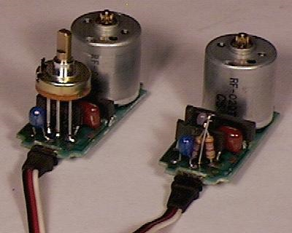
Figure 1 - Unmodified (left) and modified servo motor.
(Re-Printed with permission from seattlerobotics.org)

2c. Stepper Motor
For applications where precise measuring of a motors' rotor position is critical, a stepper motor is usually the best choice. Stepper motors operate differently than other motors; instead of the voltage being applied and the rotor spinning smoothly, stepper motors turn on a series of electrical pulses to the motor's windings. Each pulse rotates the rotor by an exact degree. These pulses are called "steps", this is why the motor is aptly named stepper motor. The rotor inside the motor is stepped from electromagnet to electromagnet by activating each magnet in a specific order. These motors and be seen as regular dc motors without commutators. Stepper motors are constructed with a permanent magnet rotating shaft, called the rotor, and electromagnets on the stationary portion that surrounds the motor, called the stator. All of the commutation must be handled externally by a motor controller, and typically, the motors and controllers are designed so that the motor may be held in any fixed position as well as being rotated one way or the other. The order in which the electromagnets are activated is what determines the direction of rotation. To operate the stepper motor it is necessary to set what is called the resolution of a step. This resolution generally ranges from 1.8 degrees to 3.6 degrees. To get a complete revolution, at 1.8 degrees it will take 360/1.8 or 200 steps. The degree at which each step is set is called its resolution. Basically what this means is that each step will move so many degrees and needs a preset set of positions to move through. This will require some type of control in order to make the motor rotate. To control a stepper motor requires a stepper drive and a controller. You control a stepper motor by providing the drive with a step and direction signal. The drive then interprets these signals and causes the motor to rotate. This type of motor can cause movement at low speeds to be irregular or jerky. This can be adjusted if high resolution is used. This means that each step would have to be made a small as possible to smooth out the movement. At higher resolutions, the stepper motor is not as choppy, but it does not have as much torque. When the motor is idle, a stepper motor has a higher holding torque than a servo motor of similar size, since current is continuously flowing in the stepper motor windings.
Some of the advantages of stepper motors over servo motors are as follows:
- Low cost
- Can work in an open loop (no feedback required)
- Excellent holding torque (eliminated brakes/clutches)
- Excellent torque at low speeds
- Low maintenance (brushless)
- Very rugged - any environment
- Excellent for precise positioning control
- No tuning required
Some of the disadvantages of stepper motors in comparison with servo motors are as follows:
- Rough performance at low speeds unless you use microstepping
- Consume current regardless of load
- Limited sizes available
- Noisy
- Torque decreases with speed (an oversized motor for higher torque is necessary at higher speeds)
- Stepper motors can stall or lose position running without a control loop

Some of the advantages of stepper motors over servo motors that they are lower in cost. These motors do not need feedback so work in and open loop environment. They have excellent holding torque for stopping. The torque is also good at low speeds. Because these motors are brushless, they require less maintenance. This is not a concern with our project because we do not see long term use of the system. They are considered to be very sturdy or rugged motors. Finally, no tuning is required.

The most important disadvantage of stepper motors in comparison to servo motors is that it consumes current regardless of the load. The performance of movement is rough unless a high resolution or what is called microstepping is employed. These motors tend to be very noisy. As the speed of the motor increases the torque decreases. If is sometimes experienced that the motor will stall because of the lack of feedback. An finally, it is necessary to implement a controller.

It is important to consider all of the advantages and disadvantages of using a particular type of motor for our application. The servo motor will need alterations in order to make it suitable to our needs. Removing the senor for the feedback and adding additional circuitry is not a desirable solution. When taking the stepper motor into consideration, it has even more drawbacks to consider. The need for high resolution, or what is called microstepping, has potential to be a time consumer because of the adjustments that need to be made with the tuning of the speed. The servo motor also needs and external control. Because a regular dc motor comes with the car that will be purchased definitely will save money as well as time. This motor can also be controlled by purchasing a cheap controller or with the use of a small circuit called an H-bridge. This will allow us to control the forward, reverse, and stop positioning of the car. For these reasons, we will be utilizing the brushed dc motor.

- Platform
Every design needs a foundation. The foundation for ParkBot will need to be a robot platform, or an already assembled commercially available R/C car. All of the components listed in the requirements will need to be easily mounted on to the platform. The entire system will weight no more than 5 lbs.; will be no more than 15 inches long; and will be no more than 8 inches wide.
As a first option, a robot development platform will be considered. The Pololu Round Robot Chassis Kit is a circular laser-cut plastic robot chassis. The description states that the acrylic chassis is ideal for building sturdy robots capable of navigating tight spaces. The chassis kit includes a Tamiya twin-motor gearbox, ball caster, and only two truck tires. The diameter is five inches (slightly bigger than a CD), differential drive, 1.42 inch wheel size, and recommends the purchase of a 6V motor. The cost for the kit was listed as $25.00. The kit requires full assembly. This kit was the most economical platform available that could possibly meet our needs. Several factors will be noted when taking into account this option. The drawbacks noted are that the kit has to be fully assembled; it does not come with a motor; it only has two wheels, which would require modifications to the design for steering of the apparatus; and finally it required a lot of build time.
A second option to consider is purchasing a lower grade ready to run remote controlled toy car and modify the existing circuitry with the possibility of replacing the existing motor. Finding a car in this category is not difficult. It is desirable for the car to come equipped with proportional steering to allow for easy implementation of steering control. Cost is the number one advantage of toy R/C vehicles. The average medium-scale toy R/C car is around $50–$100 cheaper than an electric hobby class vehicle. Toy class vehicles are easy to operate, have a relatively low danger level with top speeds that are typically around 20 mph with most only in the 10-15 mph range. Toy class vehicles are usually modeled after real cars (most hobby class vehicles aren't), and often feature details that hobby class vehicles lack, like working lights, sounds, windows, opening doors and hoods, and realistic interiors. There is also an almost endless array of toy R/C vehicles, ranging from common cars and trucks, to tanks, bulldozers, and motor cycles. The disadvantages of selecting this type of car is they are primarily crude design and construction, poor performance, cheap hardware, and the lack of spare parts. Many of the cheaper R/C cars do not come equipped with proportional steering. In addition, the specifications for these cars are not very detailed. These are definitely drawbacks. If this car is to be considered, the cost and efficiency of implementing our own steering system will be of concern. The advantage of this type of car is the low cost. Radio Shack carries models that range in the $30 - $50 and range in size between 1:12 and 1:16 which are suitable as a platform. This could prove to be very economical depending on the cost of the steering mechanism and ease of incorporation into this platform.
The final consideration is to purchase a hobby grade R/C car. This could prove to be an expensive choice. The majority of hobby grade cars come fully equipped with a motor, proportional steering, transmitter, receiver, power pack, electronic speed control, and is ready to run. The cheapest car found of this grade was $99.00. The manufacturer of this car is Losi and is called the Mini-T. With all of the supplied components, it would have made our project more of a software design based project. In addition, it could be possible that the prospective car does not have the components that would be compatible with the microcontroller that will be chosen which will require additional expense. An attempt to contact the manufacturer to get more detailed specs on the cars components was unsuccessful. For this reason, this option was immediately disregarded.
It was decided that the best solution would be to search for a car that could fall in the category between mid-grade and hobby grade. After careful consideration and the size of all of the components necessary to mount on the car, we agreed on the purchase of a care manufactured by Silverlit. This was a desirable choice for many reasons. The cost of the car is $39.95 on sale from $129.99. The size of the car is 3 inches in height, 10.5 inches in length and 4.8 inches wide. It comes with proportional steering; full function digital proportional radio control; a 6V NiCd Rechargeable Battery; independent front and rear suspension; professional level transmitter; 6v 750 mAh NiCd Rechargeable Battery; a AC Wall Charger; and 4 AA Alkaline Batteries. It is possible that the transmitter and receiver will not be used, but the option is there if we choose. The car is shown in Figure 2.
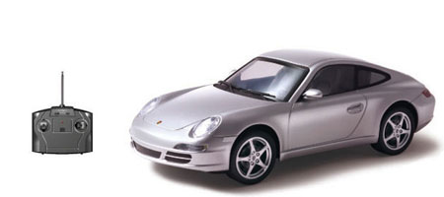
Figure 2 - Silverlit Electric 1:16 Official Licensed Porsche Carrera RC Car
(Permission Pending)

- Motor Control
There are two controllable parameters of a DC motor. These two parameters are speed and direction. Controlling the direction of the motor will be necessary to move the car in the forward, reverse and stop positions. To control the direction, the polarity of the motor is reversed. To control the speed, the input voltage is varied using pulse width modulation (PWM). The speed of the motor will ensure efficiency during operation. It will be necessary to implement some type of speed control for the motor in order to move the car in the forward, reverse and stop position. This can be achieved by building a control circuit called and h-bridge or an already integrated circuit can be purchased that will achieve the same function as the hand built h-bridge. These two options will be explored and the most efficient and cost effective option will be chosen. The two major factors that control this design are current capacity and cost. We would like to have a design that will be inexpensive to build but can control a wide variety of easily accessible motors. This is desirable because the specifications for the motor included in the remote controlled car we will purchase are not included in the listing where the car is being purchased from.
4a. Direction
In order to control the direction of the rotation of our motor to achieve forward, reverse, and braking action, it will be necessary to implement some type of motor driver. An H-Bridge can be implemented to achieve this. There is a plethora of H-Bridge designs that can be built, tested and applied to our motor. In addition, integrated circuits are also available for purchase. These two options will be explored to find the cheapest and most efficient means of implementing motor control to our system.
The theory behind the H-Bridge is quite straight forward. First, connect the positive side of the battery to one side of your DC motor. Then connect the negative side of the battery to the other motor lead. The motor will spin forward. Now, if you swap the battery leady, the motor will spin in the opposite direction which will give you reverse. Figure 2 depicts the switching mechanism behind the H-Bridge.
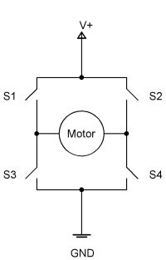
Figure 2 - Simplified H-Bridge
(Re-printed with permission from http://roko.ca/robotics)
We have the choice of constructing this circuit with BJT’s or MOSFETS. Four are configured in an H formation hence the name H-Bridge. These solid state circuits provide power and ground connections to the motor. The high side drivers need to be the current "sources" which are implemented with PNP transistors and P-channel FETs. The low side drivers need to be current "sinks" which utilize NPN transistors and N-channel FETs. If the two upper circuits are turned on, the motor resists turning, so what effectively happens is that a breaking mechanism is created. The same is true if both of the lower circuits are turned on. This is because the motor is a generator and when it turns it generates a voltage. If the terminals of the motor are connected (shorted), then the voltage generated counteracts the motors freedom to turn. It is as if you are applying a similar but opposite voltage to the one generated by the motor being turned. This configuration will allow for one state that will move the motor in the forward direction; a second state that will move the motor in the reverse direction; two states that will cause a braking action; and finally two states that should be avoided because it will cause a short circuit between the battery terminals.
To build this circuit, we will need to select components for the H-Bridge that will be compatible with the motor that we will be using. We will take into account the operating voltage, current, and of course cost. An H-Bridge design was found that allows the control of motors that take a dc voltage of between 3 and 24 volts and when stalled do not consume more than 5 to 6 amps of current. Our motor uses a 6V battery so this should be sufficient. Figure 3 shows a diagram of the proposed H-Bridge.
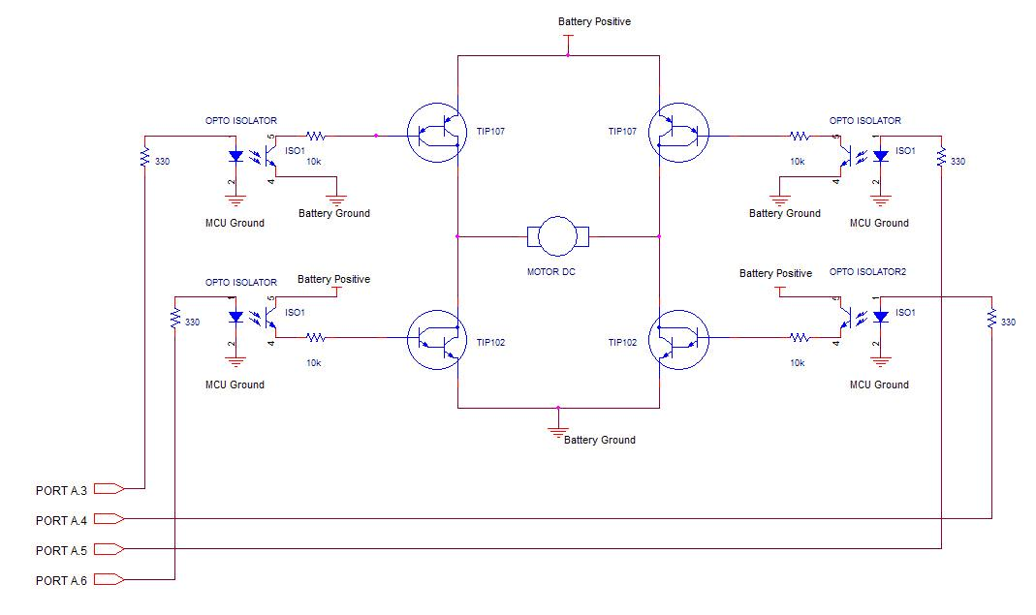
Figure 3 - H-Bridge Using Discrete Components
(Permission Pending)
This H-Bridge design is essentially four switches, where the switch is a BJT. When the top left and bottom right switches are turned on high from the microcontroller, the current will flow from the battery source through the switches and will spin the motor in one direction. When the top right and bottom left switches are turned on, the current will flow the opposite direction through the motor. This opposite direction of current flow causes the motor to spin the opposite direction. When the two top switches are turned on and the bottom two switches are turned off, it creates a short circuit across the motor. This short causes the motor to spin in both directions and will cause braking or deceleration. It is important to note that switches on the same side (left or right) should never be turned on because, as mentioned before, will cause a short between the two terminals and damage the circuitry as well as the power source. The included diodes are important across the collectors and emitters for protection from what is called inductive kickback that is caused by the switching of the direction of the motor. Choosing the TIP102 and TIP107 erases the need because they already have protection diodes built-in so there is no need for external protection diodes. The total cost to build this circuit would be no more than $5.00. This could be considered cheap, but before we make that determination, it will be necessary to look and the IC H-Bridge chip.
As an alternative, H-Bridges are available already integrated in chip form. There are a few types available that could possibly meet our needs. The most attractive being the L293NE. The L293NE is a dual H-bridge driver for DC brushed motors and stepper motors. The L293NE contains 2 H-Bridges and can handle 1amp and peak current draws to about 3amps. In this IC there are two different power supplies (Vcc1 and Vcc2). Vcc1 is for logic input circuit while Vcc2 is supply for the output circuit. This means that you should apply about 4.5V to Vcc1 and whatever voltage required by the motor (up to 36V max for this IC) to Vcc2. Each Half H-Bridge has an individual ground. So you must ground the terminal corresponding to the Half H-Bridge you want to use or else you can also just ground all the 4 terminals. To use the IC a Full H-Bridge, you connect the motor (or the load) between the outputs of two Half H-Bridges and the inputs will be the two inputs of the Half H-Bridges. In order to utilize the chip as a Full H-Bridge, it is necessary to connect Half H-Bridges 1 and 2 to form a Full H-Bridge. Table 2 shows the truth table for the H-bridge with the pin layout of the H-bridge chip shown in Figure 4 below it.

INPUT  1A | INPUT  2A | OUTPUT  1Y | OUTPUT  2Y | Description
L | L | L | L | Braking (both terminals of motor are Gnd)
L | H | L | H | Forward Running
H | L | H | L | Backward Running
H | H | H | H | Braking (both terminals of motor at Vcc2)

Table 2 - Truth Table for Full H-bridge

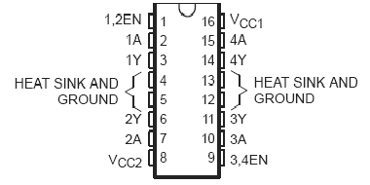

Figure 4 - L293 Quad H-Bridge IC
(Permission Pending)
The L293NE can be purchased commercially for $2.93 from Jameco.com. It is equipped with internal electrostatic discharge protection. It has thermal shutdown as well as high noise immunity. When comparing the H-Bridge constructed of discrete components with the IC chip, the selling point first and foremost is that the IC chip is cheaper. In addition, it also will be a time saver having all of the circuitry already integrated versus attempting to build our own. For these reasons, the Texas Instruments L293NE is the logical choice to use for operation of our motor drive sub-system.

4b. Speed

The H-Bridge is the component that will handle the direction of the motor and the speed at which it rotates will be controlled with Pulse Width Modulation (PWM).
“Pulse width modulation (PWM) is a technique in which a series of digital pulses are used to control an analog circuit. The length and frequency of these pulses determines the total power delivered to the circuit. PWM signals are most commonly used to control DC motors, but have many other applications ranging from controlling valves or pumps to adjusting the brightness of an LED. Controlling our dc motor will utilize this technique. The digital pulse train that makes up a PWM signal has a fixed frequency and varies the pulse width to alter the average power of the signal. The ratio of the pulse width to the period is referred to as the duty cycle of the signal. For example, if a PWM signal has a 10 ms period and its pulses are 2 ms long, that signal is said to have a 20 percent duty cycle.”
(Taken from http://zone.ni.com/devzone/cda/tut/p/id/2991)

Figure 6 shows three PWM signals with different duty cycles.

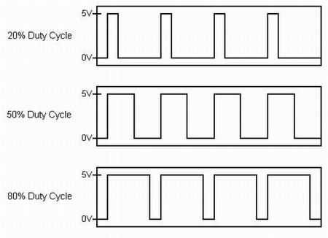
Figure 6 - Sample Pulse Width Voltage Outputs
(Permission Pending)
The H-Bridge is the component that will handle the direction of the motor and the speed at which it rotates will be controlled with Pulse Width Modulation (PWM). This is implemented using digital pulses to create some analog value other than just ‘high’ and ‘low’ for the power supply. If you filter a signal that has a 50% duty cycle, given a 5V source you get an average voltage of 2.5 Volts. Other duty cycles can produce any voltage in the range of 0 to 100% of the ‘high’ voltage, depending upon the PWM resolution. The duty cycle is defined as the percentage of digital ‘high’ to digital ‘low’ signals present during a PWM period. The PWM resolution is defined as the maximum number of pulses that you can pack into a PWM period. The PWM period is an arbitrarily time period in which PWM takes place.

The brain of our system is going to be a microcontroller. The microcontroller sends signals that are digital. In order to drive our motor, it is necessary to convert this signal to analog. There are a few different way to accomplish this. PWM can be used to generate and analog voltage level. The resolution of the Pulse Width should be equal or greater than the resolutions requirements of the power supply. The PWM output can then be filtered to obtain acceptable ripple. A simple low-pass filter can then be used. Figure 7 shows a PIC microcontroller generating a 50% duty cycle PWM signal at 5,000 Hz. After passing through the low pass filter a direct current input of +2.5 Volts is generated.

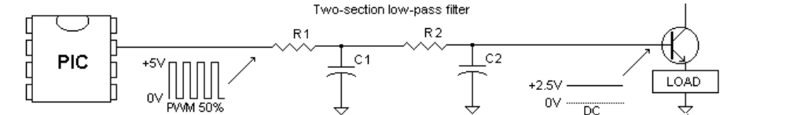

Figure 7 - Sample pulse generating analog voltage level
(Permission Pending)

It was determined very early in the research process that the microcontroller that is to be utilized as the brain of our system is going to be the Arduino. It has the capability of using PWM as an output signal. It includes 14 digital input/output pins of which 6 can be used as six pins for PWM output. These pins are 3, 5, 6, 9, 10, and 11. They provide 8-bit PWM output with the analogWrite() function. This is essential for outputting signals to our dc motor. This alleviates the need to implement PWM using 555 timers, RC or LC filtering, etc. PWM is basically a digital-to-analog converter (DAC). It is the least expensive way to get an analog voltage output from a microcontroller. Because of its relative simplicity and it will be the least expensive way to control the speed of our motor, PWM will be implemented using the Arduino microcontroller.

- Steering Servo
DC servo motors are used in closed loop type applications were the position of the output motor shaft is fed back to the motor control circuit. Typical position control devices include Resolvers, Encoders and Potentiometers as used in radio control models such as cars, airplanes, and boats. The radio is wired up to either electronic speed controls or servo-mechanisms which perform actions such as throttle control, braking, steering, and on some cars, engaging either forward or reverse gears. Electronic speed controls and servos are commanded by the receiver through pulse width modulation; the pulse duration is used to set either the amount of current that an electronic speed control allows to flow into the electric motor or sets the angle of the servo. In models where the servo is attached to a steering mechanism, the rotation of the servo is mechanically changed into a force which steers the wheels on the model. Figure 8 illustrates a cut-away of a servo and shows you what it looks like on the inside.

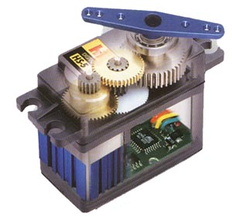
Figure 8 - Servo Motor
(Permission Pending)
One of the features that was important as an inclusion in the R/C cars platform, was that the platform chosen had proportional steering. It is vital in our application since front end parking requires the freedom to turn the wheels at angles between 0 and near 90 degrees, which is usually a standard maximum for servos, to the left and right. It would not suffice to just have the capability to turn full right or full left. Proportional steering is achieved by using a type of motor called a servo which is short for servo-mechanic motor. A servo motor generally includes a built-in gearbox for speed reduction and is capable of delivering high torques directly. The output shaft of a servo motor does not rotate freely compared to the shafts of DC motors because of the gearbox and feedback devices attached. If servo motors are utilized a dc motor, some modifications are necessary. For our application, this is not necessary because we will be using it as a steering mechanism. Servos have three wires to them, unlike most DC and gear-head motors, which have two. The first two in a servo are power and ground, and the third is a digital control line. This third line is used to set the position of a servo. Unlike other DC motors, you do not have to reverse the polarity of a servo’s power connections to reverse its direction. The servo included in the rc car that will be purchased did not specify manufacturer or any specs. Most servos that are already included in remote controlled cars are easily controlled my means of PWM, again, the microcontroller we have chosen has that capability. Figure 9 shows an example of how pulse width controls the turning angle follows. The timing of the width determines the position.

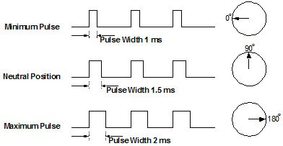
Figure 9 - Sample Pulse Width for Servo Control
(Permission Pending)

- Obstacle Avoidance Sensors

In ParkBot, we will consider different kinds of sensors. These sensors must meet requirements like detection of objects and measuring distances. Through research, we have narrowed it down to three different kinds of sensors: ultrasonic, imaging and infrared. The Parallax Company makes two of these sensors that could meet the specifications of ParkBot. The first sensor from Parllax is the Ping Ultrasonic Range Finder. The other sensor from Parallax is the TSL 1401 Linescan Imaging Sensor Daughterboard. For the infrared sensor, the Sharp IR GP2D12 Sensor will be chosen for comparison.

6a. Ultrasonic Sensors
Ultrasonic sensors are also known as transceivers because they both send and receive a signal. They work based on a principle similar to radar or sonar. Distance is calculated by the time it takes for the sound wave emitted by the sensor to bounce off an object and back to the sensor. Ultrasonic sensors generate high frequency sound waves and calculate the time it took for an echo to be received back at the sensor. Sensors calculate the time interval between sending the signal and receiving the echo to determine the distance to an object. This technology can be used for measuring: wind speed and direction, fullness of a tank and speed through air or water. For measuring speed or direction, a device can use multiple ultrasonic sensors which calculate the speed from the relative distances to particles in the air or water. The way an ultrasonic sensor measures liquid in a tank is that the sensor measures the distance to the surface of the fluid. Some systems use a transducer (ultrasonic sensors are also traducers) which generates sound waves in the ultrasonic range, above 20,000 hertz, by turning electrical energy into sound. Then, upon receiving the echo turn, the sound waves are turned into electrical energy which can be measured and displayed. The location at which a transducer focuses the sound can be determined by the active transducer area and shape, the ultrasound frequency, and the sound velocity of the propagation medium. Ultrasonic sensors measure the distance that an object is away is by multiplying one-half times the speed the signal was send (speed of sound) times the time it took from the point the sound wave was sent out to the point when the sound wave was received back at the sensor. The formula is:
d=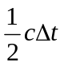

The Ultrasonic sensor that we will be considering is the Ping Ultrasonic Range Finder. The ultrasonic distance sensor provides high precision in detecting objects by avoiding contact with objects with distance up to 3.3 yards. It is very easy to connect to a microcontroller, requiring only one I/O pin. This sensor works by transmitting an ultrasonic frequency to object and receiving the wave once it bounces back from the object. Once the wave is released and captured, it will measure how long it took and will provide the right measurement to the microcontroller. This ultrasonic sensor has a male 3-pin header that has ground, power, and signal pins. This ultrasonic sensor will only require 30mA to 35mA which is ideal because of its low current. The header may be plugged into a directly into solder less breadboard, or into a standard 3-wire extension cable. This sensor will emit a short 40 kHz signal that will be used to detect objects.

Some of the flaws that this sensor has are that if the sensor is too low to the ground it has the possibility of giving the microcontroller improper readings. Also, if the object that we are trying to detect is over the distance of 3.3 yards the sensor will not work. If the object is of a type of material such as a sponge or fabric that could absorb the signal, this would not create an echo, and the sensor could calculate the distance for detection of the object. Figure 10 shows the dimensions of the Ping Ultrasonic Sensor.

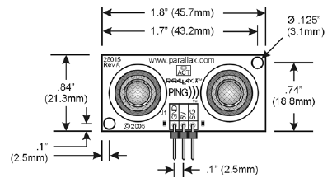

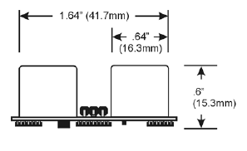

Figure 10 – Ultrasonic Sensor Dimensions

(Re-printed with permission from Parallax Inc.)

The following list details the features and specifications of the Ping Ultrasonic Sensor:

- Range: 0.8 in to 3.3 yd
- Burst indicator LED shows sensor
Activity
- Bidirectional TTL pulse interface on a
single I/O pin can communicate with 5 V
- TTL or 3.3 V CMOS microcontrollers
- Input trigger: positive TTL pulse, 2 μs
min, 5 μs typ.
- Echo pulse: positive TTL pulse, 115 μs
minimum to 18.5 ms maximum.
- RoHS Compliant
- Supply voltage: +5 VDC
- Supply current: 30 mA typ; 35 mA max
- Communication: Positive TTL pulse
- Package: 3-pin SIP, 0.1” spacing
(ground, power, signal)
- Operating temperature: 0 – 70° C.
- Size: 22 mm H x 46 mm W x 16 mm (0.84 in x 1.8 in x 0.6 in)
Weight: 9 g (0.32 oz)

6b. Imaging Sensors
An imaging sensor is a device that converts an optical image to an electric signal. This sensor has a range of how many optical pixels it can detect. The technology used for imaging sensors is frequently used in digital cameras and other imaging devices. An imaging sensor is typically a charge-coupled device or a complementary metal–oxide–semiconductor active-pixel sensor. Today, most digital cameras use either a CCD image sensor or a CMOS sensor. Both types of imaging sensors accomplish the same task of capturing light and converting it into electrical signals. A CCD is an analog device that works when light strikes the chip, and then a small electrical charge is held in each photo sensor. The charges are converted to a voltage one pixel at a time as they are read from the chip. Additional circuitry in the camera converts the voltage into digital information. A CMOS chip is a type of active pixel sensor made using the CMOS semiconductor process. Extra circuitry next to each photo sensor converts the light energy to a voltage. Additional circuitry on the chip may be included to convert the voltage to digital data. Neither technology has a clear advantage in image quality. CMOS can potentially be implemented with fewer components, use less power, and/or provide faster readout than CCDs. CCD is a more mature technology and is in most respects equal to the technology of CMOS. There are many parameters that can be used to evaluate the performance of an imaging sensor, including its dynamic range, its signal-to-noise ratio, its low-light sensitivity, etc.
The imaging sensor that we will take into consideration is the TSL 1401 Linescan Imaging Sensor Daughterboard. The TSL 1401 Linescan Imaging Sensor Daughterboard has the TAOS TSL1401R 128-pixel sensor chip, a 7.9mm focal length imaging lens, which could aid for objects that need to be detected or just to acknowledge any object that needs to be avoided for a collision. This sensor will produce a clocked analog data output, whose voltage levels correspond to the light intensity at each pixel. This means of an analog-to-digital converter image data. Then it will make it easier to transfer the intensity of the light to a microcontroller to detect any objects, edges, gaps, holes, textures, emissive sources, simple barcodes, and other visible features. Once the image is capture is seen in real time and with the information capture by the imaging sensor will align with precision. It also includes user-selectable measurement tools for locating edges, counting pixels, computing extreme and averages, and the like. Also it focuses the imaging for better viewing. The lens optical dimension 7.9mm, optical manual focus, and image resolution of 128 pixels. The amount of voltage required to power is between 3.3 to 5 volts. This is a very good thing because we are considering using three to four sensors mounted to ParkBot in order for it could perform its tasks. With the TSL 1401 could detect gaps, edge, holes as obstacles in the autonomous parking scenario. It also could detect bright and dark colors such as shadow and flame. Figure 11 shows the TSL 1401 Linescan Imaging Sensor Daughterboard.
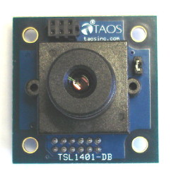
Figure 11 –TSL 1401 Linescan Imaging Sensor
(Permission Pending)
The following two lists detail the features, specifications, and applications of the TSL 1401 Linescan Imaging Sensor Daughterboard.

Features:
- 128-pixel linear image sensor (TAOS TSL1401R)
- Focusable imaging lens
- Simple three-pin interface with analog pixel output
- Connector: 12-pin Hirose DF11 (M) main connector, 6-pin Hirose DF11 (F) accessory connector
- Lens: 7.9mm focal length, f2.4 fixed aperture, manual focus, 12mm x 0.5mm thread
- Exposure Time: 267µS to 68mS (MoBoStamp-pe, Propeller, SX, PIC, AVR, etc.); 2.03ms to 68ms (BS2)
- Resolution: 128 pixels (grayscale); 255 pixels (interpolated binary)
- Direct plug-in for Parallax motherboards (e.g. MoBoStamp-pe) and adapters
- Accessory socket for future add-ons, such as LED strobes

Applications:
- Detection of objects, edges, gaps, holes, liquid levels, etc.
- Non-contact measurement of height, width, diameter, position
- Line following for robots
- Light and flame detection and location for robots
- Simple barcode reading

Key Specifications:
- Power Requirements: 3.3V to 5.0V at less than 5mA
- Dimensions (with lens): 1.35 x 1.35 x 1.22 in (34.3 x 34.3 x 31mm)

6c. IR Sensors
Infrared radiation is similar to a common camera that forms an image using visible light. Instead of the 450–750 nanometer range of visible light cameras, infrared cameras operate in wavelengths as long as 14,000 nm (14 µm). Infrared energy is just one part of the electromagnetic spectrum that includes gamma rays, x-rays, ultra-violet rays, visible light, infrared waves, microwaves, and radio waves. These are all related and differentiated in the length of their wave (wavelength). All objects emit a certain amount of black body radiation as a function of their temperatures. Generally speaking, the higher an object's temperature is the more infrared radiation it emits. A special infrared camera can detect this radiation in a way similar to the way an ordinary camera does visible light. Infrared cameras work even in total darkness because ambient light level does not matter. This makes it useful for rescue operations in smoke-filled buildings and underground.
The infrared sensor that we will take into consideration is the Sharp IR GP2D12 Sensor. This sensor works by emitting an infrared light to an object and once the signal bounces back it calculates the distance of the object that is detected. This sensor could cover of a range of 10 to 80cm with a judgment distance of 24cm. This sensor is very low in cost (less than $10). The Sharp IR GP2D12 could be powered with very low voltage (from 0.3 to 7 volts). The max current that the sensor will draw is 10mA. It can detect an object in about one second. This particular sensor work best with objects that easily reflect light. If the object is dark or does not reflect any light, the IR sensor will have a hard time detecting it. Figure 12 shows the Sharp IR GP2D12 Sensor.
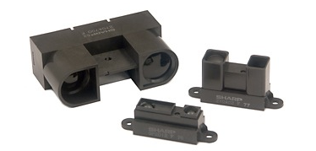
Figure 12 – Sharp IR GP2D12 Sensor
(Permission Pending)

6d. Comparison / Final Decision
When it comes to compare all the sensors, the Ping Ultrasonic Range Finder, TSL 1401 Linescan Imaging Sensor Daughterboard, and the Sharp IR GP2D12 Sensor, each of them has their advantages and disadvantages. The Ultrasonic sensor will detect objects much faster, 115 us up to 18.5 ms time for detecting an object, while the Imaging sensor takes 2.03 ms to 68ms. If speed will be the decision factor, the Sharp IR GP2D12 will work in 1 second. When it comes to cost the Sharp IR GP2D12 is less than $10, the Ultrasonic sensor cost less than $ 30, and the Imaging sensor is less than $ 50. Another factor that we have to take in consideration is the size of each sensor because there will be a need for up to four sensors (currently we will be using three). In this case the Ultrasonic sensor has the best measurements and is the most compact of all of the sensors at .84 inches in height, 1.8inches in width, and 0.6 inches length. Now, when it comes to performance in power required for the sensors, the Sharp IF GP2D12 sensor is better due to the face that it only requires only 0.3 to 0.5 Volts and will be able to maintain the voltage down to a very minimum to make the battery last longer so that ParkBot will be able to work for a longer amount of time. If we take in consideration the current that the sensor will draw, the Ultrasonic sensor and the Sharp IF GP2D12 only requires 30mA to 35mA, while the Imaging sensor requires 5mA. The imaging sensor detects more hazards like spaces, holes, and gaps better than the Ultrasonic sensor. Another advantage of the Imaging sensor will be that it will not matter where it is located ParkBot. Whereas, with the Ultrasonic sensor, we will have to take into consideration the location to properly mount the sensor. One major critical disadvantage of the Ultrasonic sensor is the location of where it will be mounted on ParkBot. If the Ultrasonic sensor is too close to the ground, the Ultrasonic sensor could get an invalid reading, and it could cause ParkBot to miss an empty space. The position of the Ultrasonic sensor has to be specific, so that it could get a proper reading and ParkBot can detect empty and full parking spaces properly.
After researching the three sensors, we have a lot to take into consideration. The Sharp IF GP2D12 works in very low voltage and current. Also, its speed of detecting objects is faster than any sensor. The Imaging sensor is not required to be mounted in a position at a specific angle. The Imaging sensor will analyze the object in its own range of pixels. Fo this reason, the Imaging sensor is great at detecting gaps, edges, holes, texture than the Sharp IR GP2D12 sensor or the Ping Ultrasonic Range Finder. When it comes to power the Sharp IR GP2D12 sensor operates at lowest voltage than the other two sensors. Another good thing about the Sharp IR GP2D12 sensor is that the size very small and will be easy to mount on ParkBot. The Sharp IR GP2D12 sensor can detect an object at any height from the ground. This means that it would not matter at which height the sensor needs to be mounted in order to operate properly. When it comes to comparing the weights of the sensors, the Sharp IR GP2D12 sensor is the lightest of all three.
All of these sensors have their disadvantages. The Sharp IR GP2D12 sensor has a limited detection range of 80cm. Sharp IR GP2D12 sensor only works at peak performance up to a distance of 25cm. Because of the limited range that the Sharp IR GP2D12 sensor has, it will not work for ParkBot. For the Imaging sensor, the price is one of the reasons why we are not going to choose it to use in ParkBot. The cost of each Imaging sensor is $40, and since we will need three sensors, it will be too expensive. The current that the Imaging sensor draws is the greatest of all three sensors. This is another reason that the Imaging sensor will not be chosen for ParkBot. The final disadvantage of the Imaging sensor is that the speed of detection of the Imaging sensor is the slowest of the three sensors
The sensor that we are choosing that is most fit for ParkBot is the Ping Ultrasonic Range Finder. The Ultrasonic sensor is easy to program and work with. Also its cost and low power dissipation helped make the decision easier. We have to take in consideration that we will need three sensors and ParkBot must have enough voltage to power all three sensors in order to process information from the sensors precisely. The Ultrasonic sensor can detect objects of all different sizes, and its range is superb.

- Remote Control Transmitter
The remote control transmitter in ParkBot will be in charge of activating the autonomous RC car to pull out of the parking lot. The transmitter use in this project will send a signal to the receiver that later is going to be interpret by the microcontroller to operate the autonomous RC car. The remote utilized for this project should be small and portable for the user. There are so many fascinating ways to control or send a signal to ParkBot to do its job of pulling out of a spot. Figure 13 below describes the function the transmitter is going to play in ParkBot.
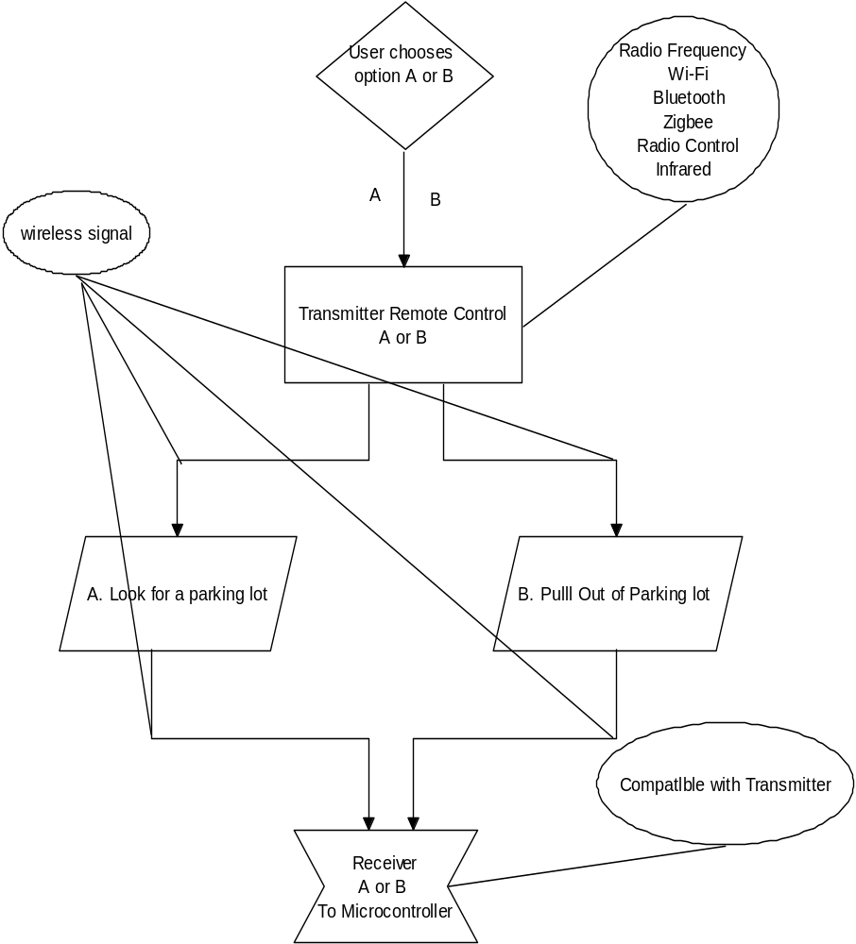
Figure 13 – Remote Control Function Diagram

As shown in the diagram describing the functions that ParkBot will implement by the microcontroller when the user chooses option A, look for a parking lot or B, pull out of the parking lot. The options available are using a RF remote control, a Bluetooth remote control, a laptop through Wi-Fi connection, the original RC remote control that comes with the RC car selected, or an IR remote control. However, there are costs and implementation difficulties choosing some of the remote control alternatives describe above. Also the costs and difficulties of the receiver modules that communicate between the remote controller and microcontroller add to the disadvantages of some of the remote control choices. Table 3 below illustrates the specifications of the type of remote controller listed above and brief description of each type. The table is follow by a summary of the disadvantages and advantages of each remote control type and component taken in consideration. In the receiver part in the next session the equivalent receiver type for these transmitters are discussed in detail.

Type | Radio Frequency | Wi-Fi | Bluetooth | Radio Control | Infrared
Operating Voltage | 9-12VDC | 9-12VDC | 9-12VDC | 9-12VDC | 6-9VDC
Communication  Range | MHz | GHz | GHz | MHz -GHz | KHz
Approximate  Cost | Low | High | High | none | Low
Difficulties  Of use | Moderate | Moderate | Moderate | Low | Low

Table 3 – Remote Control Comparison Table

7a. Radio Frequency
Radio frequency remote controllers use radio waves to transmit signals to the RF receiver at a specific frequency based on the Federal Communications Commission (FCC) of the United States. Precise transmitter use decoders to makes sure the frequency signal sent by the transmitter does not get affected or interrupted by any other frequency circulating in the region produced by the hundreds of electronics around the device. The RF remote controller will send a frequency signal to the RF receiver installed on ParkBot and later take by the microcontroller that will start executing the desire tasks. Radio frequency devices bring advantages and disadvantages for the use of ParkBot. The advantages of using a RF transmitter are that direct line of sight between transmitter and receiver on ParkBot are not required like any other remote, blockage by common objects like people, concrete or vehicles does not interfere with the transmission signal send to ParkBot, it also has longer range capabilities that ParkBot will need in case the RC car is far from the user, and light or weather conditions do not interfere with transmission and is a good thing since the project might be test outdoors. Like any other electronic device there also disadvantages of using an RF transmitter for ParkBot. The drawbacks are that other devices using similar frequencies in the same range may interfere with the signal send to ParkBot, lack of security when sending a signal wirelessly because other RF readers can interpret the signal, it also has higher cost in electronics parts affecting the low budget of ParkBot, like mention above some RF products require FCC licenses to be used, and finally lower speed of transmission between transmitter and receiver than other types of transmission technologies have. Even though RF has disadvantages and the cost is higher than other types of communication, RF transmitters are still an option for controlling ParkBot commands and are taking into considerations for the project.
For the radio frequency remote controller there are many different options out there, for instance getting a RF transmitter module and assemble it on a board with its own power supply, microchip and keys for the specific purpose of the project or buying an already assembled remote case and PCB receiver board kit. If buying a RF transmitter module for assemble like the Seeedstudio 315MHz Transmitter/Receiver Pair with Encoder/Decoder from www.roboshop.com product code RB-See-13 which has the price of $9.98. Although this transmitter seems promising for ParkBot because it is a RF module that already comes with a receiver module and decoder module that are affordable, assemble of the remote might bring more costs, difficulties and testing for the project. Therefore it was decided that if a RF remote is going to be implemented in this project, it was better to get an already assemble RF remote with its receiver board or compatible receiver. Since ParkBot will only need to perform two tasks, one way to implement this is by getting a two-channel transmitter with its respective two-channel receiver board that would be well-suited for the microcontroller selected. If more channels for ParkBot are needed, a new transmitter/receiver with more channels could replace the old one instead of building a new one. There were also many different kinds of already assemble RF remote transmitters with PCB receiver boards. One choice was the HD2COMBO from www.electronickits.com that includes a two-channel assembled RF remote control and RF relay board that costs $29.99.
The two-channel RF remote control will communicate with the microcontroller by the RF relay board installed on ParkBot. The RF transmitter will send a signal at 433.9 MHz to the two-channel receiver relay board connected to the microcontroller for execution of tasks. Each channel will be access by one of the two buttons of the RF transmitter either as momentary or latching. The transmitter could be use as latching which will turn on when push and turn off when pushed one more time. This transmitter is very portable and the user can attach it to the keychain. . Figure 14, below the specifications, shows the approximate size of this transmitter and how portable it can be. The transmitter uses code hoping when sending the signal to ParkBot making the device very secure and impossible to be electronically cracked. The transmission range is over 250 feet to the receiver board. The price of the transmitter/receiver board kit is good compare to other similar devices out there. The specifications of the device are shown below.
- Range is over 250 feet.
- Transmits on 433.9 MHz
- Transmitter includes battery.
- Transmitter Dimensions 2-1/4" L x 1-1/2" W x 1/2" D

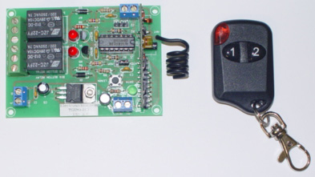
Figure 14 – Transmitter and Receiver
(Permission Pending)
7b. Wi-Fi (802.11)
Wi-Fi is another way of communication as radio frequency but using higher frequencies. Wi-Fi also known as 802.11 networking connects different computers and devices wirelessly to the same network. Wi-Fi uses radio waves like RF transmitter but at frequencies of 2.4GHz, 3.6GHz or 5GHz. Wi-Fi adapters convert digital code to radio waves to communicate and the opposite method to interpret the information sent. Wi-Fi devices also have standards regulated by the IEEE. There are three different types of Wi-Fi connections classified as for the IEEE as 802.11a, 802.11b and 802.11g, and 802.11n is the new connection that is going to be available by the end of 2009. However, using Wi-Fi as a remote controller for ParkBot not only has advantages, it also brings disadvantages of using for the projects. The advantages of using Wi-Fi for the project are that Wi-Fi does not require wire connection like any the other remote controller researched for the project, Wi-Fi can connect more than one device to the same network giving access to the four members full control of ParkBot to send information, receive, record data and location of the RC vehicle every time the project is being executed for common debugs of errors and future improvements, it also has the advantage of a firewall security to keep the connection secure from intruders. Like any other wireless remote control, Wi-Fi contains disadvantages for the use of ParkBot. The disadvantages of using a Wi-Fi connection for the use of ParkBot are that the band mostly use which is 2.4GHz are used by many electronics devices affecting the connection of a laptop to ParkBot and maybe more when using more computers when connected to ParkBot. There is a range limit of about 100-300 ft and when the RC car is far from the transceiver the connection speed and accuracy is greatly affected. The price of Wi-Fi device is greater than other connection technologies specified. It also has the downfall of security risk when security encryption is not well configure and it may cause more problems when trying to successfully secure the network connection being send to ParkBot. Finally Wi-Fi devices required more power for operation draining more battery life of ParkBot. With the advantages and disadvantages illustrated, the Wi-Fi may have more downfalls with the project but it is good way to track and record everything ParkBot does, therefore it is still an option for the transmitter communication mode of the project.
As seen by other groups in previous senior design semesters and many other projects on the internet, the way of use Wi-Fi to wirelessly control robotic projects is by using a laptop and serial-to-Wireless LAN device mounted to the RC vehicle or robotic project. A computer is good way to wirelessly control and active ParkBot commands since it is an excellent way to keep track of the position and data when ParkBot is executing the tasks of either looking for a parking lot space or returning to the user from one. Any laptop computer could be use in the project and since every member of the group has one, the need of buying one was not required making the budget for ParkBot less costly. In the receiver session part, it will be explained more in detailed about the proper Wi-Fi module mounted on ParkBot for the connection any laptop and the project. If Wi-Fi is chosen as an option for the control operation of ParkBot, there is also an option to control it from any web-enable Smartphone or iPhone.
7c. Bluetooth (802.15)
Bluetooth remote control devices use radio waves similar as radio frequency and Wi-Fi technologies to communicate between transmitter and receiver. The radio wave technology use by Bluetooth is known as frequency-hopping spread spectrum. This technology chops chunks of data being sent and randomly changes the frequency being used to send the data 1600 times every second to avoid interfering by other electronics using the same range of frequency band. Bluetooth technology can use up to 79 different frequencies when randomly changes. This technology is implemented on Bluetooth since Bluetooth uses a frequency band range of between 2.402 GHz and 2.480GHz, which is very common to the frequencies other wireless devices use to communicate. Since Bluetooth usage is very common nowadays, it will be a good thing to implement it on ParkBot. As previously seen, every kind of technology being discussed has benefits and drawbacks when being used to send data or control robotic projects like ParkBot. The advantages of using Bluetooth for ParkBot are that this kind of technology is widely used and many devices such as computer, PDA, cell phones and so forth have this mechanism built-in getting the option of control ParkBot through these devices. The simplicity of using Bluetooth is a plus and the connection of the remote with the Bluetooth receiver on ParkBot, it is possibly similar to the connection already use for other electronics. Many Bluetooth devices have low power consumption making perfect for the battery life on ParkBot. Due to the way the technology operates as changing frequencies 1600 times per second, it gives the freedom of interference when controlling ParkBot through Bluetooth. When instant personal area network (PAN) it is already configured, the connection will be automatically everything the control and module are in proximity. This technology seems very promising and cool when controlling ParkBot, but it also its weaknesses. The disadvantages of using Bluetooth technology for the control method of ParkBot are that it has a range that it can only operate. The range of operation of Bluetooth depends on the power being utilize which is also allowed by the IEEE, for example when transmitting at 100mW the range proximity is of about 100 meters, 2,5mW of 22 meters and 1mW of 6 meters; the more commonly used of 1mW. It also has a less capacity of data transmission than other wireless options out there. Sometimes the security of Bluetooth is easy to crack since it automatically tries to connect to other Bluetooth devices. Price could be increase affecting the low budget for ParkBot. With all of its difficulties and everything, Bluetooth is a still a nice way of wirelessly connecting devices and it is taken in consideration as an option for controlling the commands of ParkBot.
For the Bluetooth remote control that could be use in the project, there are two options available that can be choose to transmit the commands of ParkBot. One way of controlling ParkBot through Bluetooth is by getting any regular universal remote control with built-in Bluetooth. These remote controllers come already assemble and there is no need of build a new Bluetooth transmitter since it may be complex due to the lack of knowledge of creating one. These kind of remote controllers run from between $20 to more than $300. Since ParkBot is only going to have two functions of locating a parking lot and pulling out of one, there is no need of expending too much money for the transmitter. The transmitter will only activate ParkBot to do its two functions and it is not going to control it since ParkBot will be controlled autonomously, leaving the expensive Bluetooth remote controllers as not an alternative for the transmitter. One remote control that could be use is the SMK-Link Blu_Link universal remote control with Bluetooth and infrared enabled and runs for about $50 online. This remote control can communicate with ParkBot by the Bluetooth adapter that needs to be installed on ParkBot. This remote controller could cause problems when sending the signal to ParkBot due to the lack of experience using a regular PS3 Bluetooth remote control to connect it to a Bluetooth module on ParkBot. A better way of using a Bluetooth to activate ParkBot for execution is by using a laptop, Smartphone or cell phone with built-in Bluetooth. This is a good alternative since every member has any of the three devices listed above and the need of buying a new remote is excluded from the budget. The Bluetooth receiver will be explained later in the receiver section.

7d. Radio Control (RC)
Radio remote controllers operate the same as radio frequency technology explained above, and the advantages and disadvantages of using this kind of remote for the control of ParkBot are extensively explained on the section of radio frequency. Most RC cars operate at either 27MHz or 49MHz. the remote controller that comes with the RC operates at 27MHz and have two different control units to controls the front and rear wheels respectively. Even though the RC already has a compatible RC remote that comes with the vehicle, the need of incorporating a different one is very important due to the fact that the receiver already installed on the RC car is not going to meet the requirements for the project and the RC remote control is already programmed to the one the car has. There was also the option of getting a new RC remote controlled commonly used for RC like the FUTUBA 3-channel 2.4GHZ system. This remote has the ability of traction control, stick position angle adjustment, throttle start acceleration and other good features for any kind regular RC vehicle. However, for this project which is going to be autonomously controlled, this kind of remote controller is not an option; therefore the RC control that comes with the selected vehicle is not going to help when activating ParkBot. Figure 15 attached below, illustrates the FUTUBA 3VCS and why a regular RC remote or the RC remote that comes with the RC selected car is not an option for this project for controlling ParkBot, an autonomous vehicle.
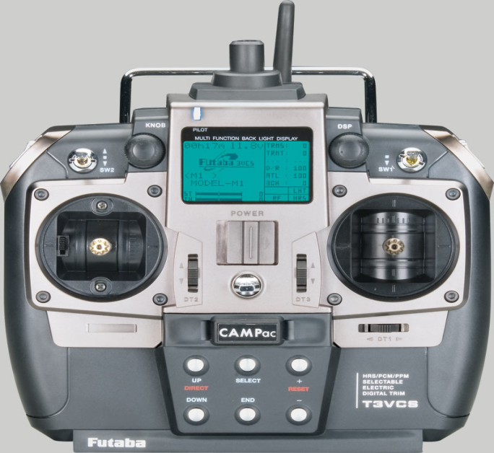
Figure 15 – RC Controller
(Permission Pending)
7e. Infrared
Infrared remote controllers use light to transmit the signal through a light-emitting diode (LED) device to the infrared receiver. Generally infrared remote control transmitters operate between 32 to 40 KHz. The transmitter sends out pulses of binary code through infrared light to the receiver that communicates the commands that ParkBot will interpret by the microcontroller to operate the desire task of looking for a parking lot or pull out of the parking lot and go back to the user. Infrared transmitters have advantages and disadvantages for the use of ParkBot. The advantages of using an infrared transmitter for ParkBot are the low power consumption therefore ideal for the user who might use the remote control several times throughout a day, cheap electronics parts making them affordable for the budget, easily to manipulate with other devices in this case to communicate with the microcontroller, direction of the LED makes sure the signal goes straight to the infrared receiver making secure when it transmits the signal, IR remotes are usually small and portable ideal in the use of ParkBot, and high resistance to noise of nearby signals caused by other electronic devices. The infrared remote controllers come with disadvantages too. The disadvantages of using an infrared remote controller for ParkBot are that the line of sight the remote controller transmitter has to have with the IR receiver must be directly aligned from each to be able to communicate the commands send, blockage by nearby objects like people, concrete, and/or cars can bock the complete transmission between the IR remote and IR receiver installed on ParkBot, IR remotes transmits over shorter than other kind of remotes and performance falls with longer ranges, light sensitivity due to sunlight, rain, dust, fog and so forth, it can affect the transmission between remote and receiver, speed in sending signal may be reduced due to all the disadvantages described above. Even though IR transmitters have disadvantages to be used with ParkBot, IR devices are more suitable for the project due to price and implementation with the microcontroller and the overall project.
For infrared remote controllers there were different choices available out there. One way was to build our own IR remote control or buying an IR remote control transmitter with its respective IR LED reader. If buying the electronics parts to create the IR remote, the time in finishing the project will be increase and we only have one semester to finish the prototype, therefore it was decided to buy a universal IR remote transmitter and find a IR reader to be installed on ParkBot. The infrared remote control taking into consideration for ParkBot to be used to send commands to ParkBot was the IR remote parts kit item code 29122 from www.parallax.com. The IR remote kit comes with the universal remote with manufacturer manual item code 020-00001, IR detector item code 350-00014, 220Ω item code 150-02210 and a bag of 10 jumper wires item code 800-00016. With this IR remote kit ParkBot can receive the commands to start execution by the microcontroller.
The remote control will communicate with ParkBot when the IR LED sends the infrared light at 38.5 KHz for short periods of time sending binary codes that would be taken by the IR detector and later interpret by the microcontroller that would execute ParkBot tasks. The codes are created by the periods of time the IR LED flashes on and off, it usually takes milliseconds to produce each binary code by the IR LED. In Figure 16 shown below is a demonstration on how ParkBot will get the message. Note that the robot used in the figure is different that how ParkBot will look when built.
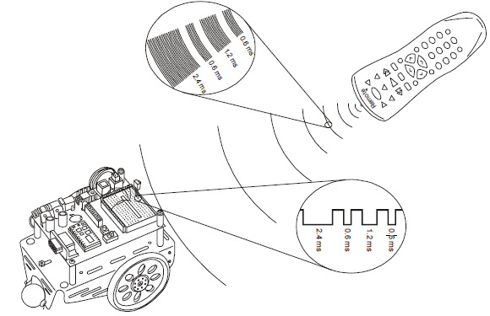
Figure 16 – Interfacing with Remote Control and Platform
(Re-printed with permission from Parallax Inc.)
In the case of activating ParkBot to execute its task of pulling out of a parking spot, a binary code of 01 could be used to be send to the IR receiver and later interpret by the microcontroller to start the task of finding a parking lot and a binary code of 11 could be used to be send to the IR detector and later taken by the microcontroller to pull out of the parking lot and go back to the remote control held by the user. Some of the specifications of the remote control are shown below. Like a typical TV remote control the IR remote control comes already assembled and only two AA alkaline batteries are needed for use. The remote control transmitter is shown in Figure 17.
- Power Requirements: 9 VDC
- Communication: IR Modulated at 38.5 kHz
- Dimensions: 6.75 x 2 x 1.37 in (171.45 x 50.8 x 34.7 mm)
- Operating Temperature: -32 to +158 °F (0 to +70 °C)

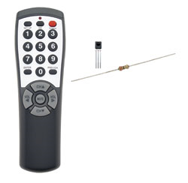
Figure 17 – Remote Control Transmitter
(Re-printed with permission from Parallax Inc.)

- Remote Control Receiver
The receiver on ParkBot will be in charge of successfully receive the signal from the transmitter and it will later send this signal to the microcontroller that it will understand it and start execution by controlling the servos that drive the RC car and complete the tasks desired by ParkBot. The kind receiver module technology use in the project is based on the type of transmitter selected as the better alternative for control of ParkBot since both transmitter and receiver have to be compatible to successfully communicate from the remote control to the RC car. A brief description of each kind of receiver compatible with each kind of transmitter describe previously is presented in this section. As previously describe the type of technologies taken in consideration are radio frequency, Wi-Fi, Bluetooth, the regular receiver that comes with the car, or infrared. Some types have more difficulties and than others. The receiver will also help decide which kind could be use for the project. Figure 18 below illustrates the function of the receiver on ParkBot.
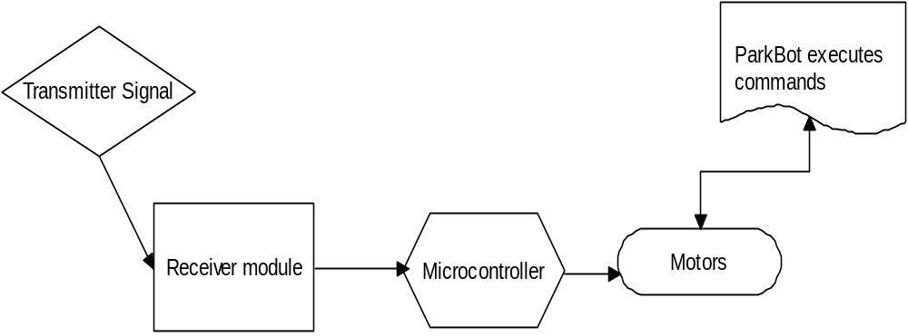

Figure 18 – Receiver Function Diagram

8a. Radio Frequency
If the radio frequency is selected as the choice of transmission between user and ParkBot, a radio frequency receiver will need to be used to be compatible with the transmitter. Since it was decided that it was not necessary to build our own RF remote control and receiver relay board, The HD2COMBO from www.electronickits.com that includes a two-channel assembled RF remote control and RF relay board that costs $29.99 was the proper option for this kind of technology. This relay board has two channels and either can be chosen as momentary or latching when receiving the signal. Figure 19 shown below, shows the layout of the of the receiver board and how this can be connect it to the microcontroller. the receiver power needed for this board is 12VDC and the max current allowed by the board is 2amps, this operating voltage is a little high compare to the microcontroller that it will need 9VDC. however the relay contacts can handle more amps,and the traces on the PCB can only operate at 2 amps max. The receiver will be operate as latching mode by connecting cable to A and B. below are the especifications of this realy board.
- Receiver Power 12 VDC
Circuit draws 9mA in idle state, 1 relay energized 40mA and 2 relays energized draws 70mA.
- Relays have a Common, Normally Closed (NC), and Normally Open (NO).
- Each Individual Relay is jumper selectable latching or momentary.
- PCB Board Amperage Rating: 2 Amps Max (Even though the relay contacts rated below can handle more amperage, the traces on the PCB can't. You will have to beef up the traces on the board with jumper wire if you want to switch devices that draw more than 2 amps.)
- Relay Contact Ratings: 24VDC@15A, 250VAC@12A, 120VAC@15A.
- Transmitter Dimensions 2-1/4" L x 1-1/2" W x 1/2" D
- Receiver Board Dimensions 3-3/8" L x 2-3/8" W x 7/8" H

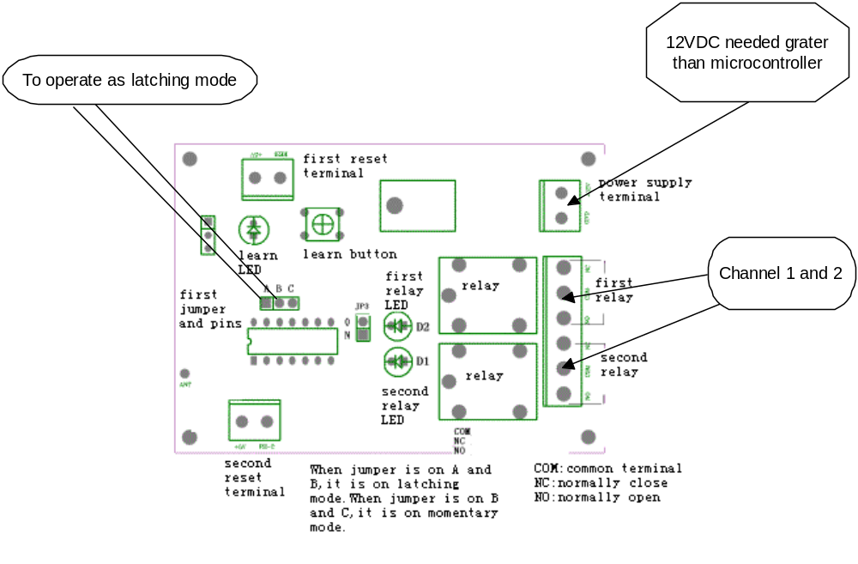
Figure 19 – Receiver Circuit
(Permission Pending)

8b. Wi-Fi (802.11)
If the project was to be controlled through Wi-Fi connection to send and receive data from ParkBot location and for future improvements of debugging errors, a laptop was the choice of connection between the Wi-Fi module that is going to be on ParkBot and the user. When using a Wi-Fi module, it usually operates a transceiver giving the advantage of recoding data for future enhancement of ParkBot. With all the nice Wi-Fi modules out on the market, it was hard to pick one that it will give the convenience of use. The once selected was one another autonomous robotic use in a different project, this Wi-Fi module works well with their project, so it was decided to include in the list of receiver modules. The one selected was the Mini Socket iWiFi by Connect One that cost around $59.00. This module is a serial-to-wireless LAN device server module which can connect ParkBot with a laptop using 802.11b/g connection. The module securely connects the application to the network. The server module offers two on chip websites, an application and a configuration website. It includes the iChip CO2128 IP communication controller chip and Marvell 88W8686 WiFi chipset. It supports both TCP/UDP, and it also supports protocol for security as WEP, WPA, WPA2 Wi-Fi encryption. The hardware and software specifications are shown below for a better understanding. This device can be connected to a GPS unit to record location of ParkBot when execution, but this is just an improvement that could be add later on to the project depending on time.

- Size: 41.0x31.5x5.0mm
- Core CPU: 32-bit RISC ARM7TDMI, low-leakage, 0.13 micron, at 48MHz
- Operating Voltage: +3.3V+/-10%
- Operating Humidity: 90% maximum (non-condensing)
- Operating Temperature Range: -20° to 75°C (-4° to 167°F)
- Power Consumption:
  - Transmit –250mA@16dbm, 235mA@12dbm (typical)
  - Receive – 190mA (typical)
  - Power Save mode – 8mA
  - Power Down mode – 40uA (typical)
- RF Connector: SMA reverse polarity
- Header: 6x2 male
- Host Interface: TTL serial interface
- RoHS-compliant; lead-free
- Host Data Rate: up to 3Mbps in serial mode • Serial Data Format (AT+i mode): Asynchronous character; binary; 8 data bits; no parity; 1 stop bit
- Serial Data Format (SerialNET mode): Asynchronous character; binary; 7 or 8 data bits; odd, even, or no parity; 1 stop bit
- Flow Control: Hardware (-RTS, -CTS) and software flow control.

8c. Bluetooth (802.15)
Bluetooth connection from ParkBot to user by either a laptop or Smart phone it is another option that could be use in the project based on budget and time needed to implement such kind of technology to ParkBot. Bluetooth will connect similar to Wi-Fi connection but with the exception that Bluetooth can be a low power consumption operation. The Bluetooth module taking in consideration is the Bluetooth modem BlueSMiRF Gold from sparkfun electronics with sku-00582 and cost around $64.95. this device has the convenience of being small in size having dimensions of only 51.5x15.8x5.6 mm and it has been successfully operated in open air at distance of 350ft. the serial stream from computer can be send from 9600 to 115200bps. The module can be powered from 3.3v up to 6v for easy attachment. This module can be installed on ParkBot for the full control of any Bluetooth-enable device. Below there are the specifications of this module.
- FCC Approved Class 1 Bluetooth® Radio Modem
- Extremely small radio - 0.15x0.6x1.9"
- Low power consumption : 25mA
- Hardy frequency hopping scheme
- Encrypted connection
- Frequency: 2.4~2.524 GHz
- Operating Voltage: 3.3V-6V
- Serial communications: 2400-115200bps
- Operating Temperature: -40 ~ +70C
- Built-in antenna

8d. Radio Control (RC)
If selection of the default radio controller that comes with the RC car and only making a few modifications to meet ParkBot requirements, the existing RC receiver needs to be use. However since it was already decided that the regular RC remote control will not meet the requirements needed for the execution of ParkBot, the existing radio receiver for ParkBot is not an option for the receiver component of the project.

8e. Infrared
The infrared technology is still a strong option for the control of ParkBot. Any kind of IR receiver could be use for the IR transmitter. There are many different options universal IR receiver boards like the IR Receiver Breakout board from sparkfun electronics sku-08554 that cost $9.95. It has the filtering and 38 KHz demodulation built in to the unit. This board can emit 1s and 0s out of the data pin. This could be a good way to convert the IR signal from infrared to digital so it can be understand by the microcontroller to start execution. Some of the features of this device is that it has very low supply current, photo detector and preamplifier in one package, internal frequency for PCM frequency, supply voltage of 2.5v to 5.5v, which is required by many other components. Immunity against ambient light has been improved, two lenses for high sensitivity and wide receiving angle. This IR board has to be considered for the use of ParkBot if a LED IR detector cannot be implemented on the microcontroller board.
The universal remote control comes with its IR detector and resistor needed for implementation. The IR remote kit from parallax inc. This detector operates similar to how the detectors on TV set work. This detector detects IR flashing on/off at 38.5 KHz and a high signal the rest of the time. When the detector send low signal to the microcontroller, it measures to figure out which key was pressed. The microcontroller can be programmed to detect, measure, store, and interpret the sequence of low pulses. The IR works as pulse width modulation (PWM) where low pulses are send from the IR detector. Figure 20 shows how this procedure works.

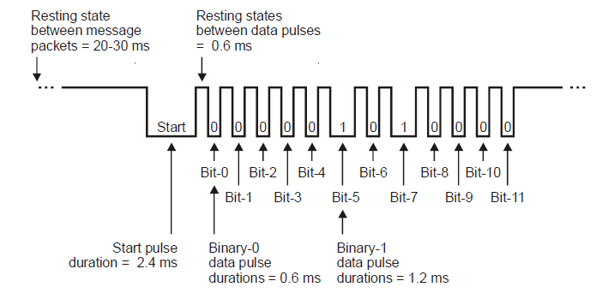
Figure 20 – Infrared Detection Diagram
(Re-printed with permission from Parallax Inc.)
8f. Comparison / Final Decision
After carefully reviewing the advantages and disadvantages of each type of remote control transmitter and receiver pair suitable for ParkBot, the remote control and receiver detector that will be the most effective way of activating ParkBot to function as desire is the IR remote control technology. Due to the easiness of employ, test and price friendly the universal IR remote control from parallax inc. is the choice of IR transmitter and receiver pair selected. The kit already comes with a manual of programming the remote with the IR transmitter and compatibility with the microcontroller. The user manual and datasheets shows example code of programs of the remote control with a similar robotic project. Table 3 shown below, shows a comparison of the five different technologies taken in consideration for the transmitter ParkBot will need and why the IR was the number one choice of use. Even though the IR communication technology is chosen as the type of transmitter/receiver pair that needs to be use for the this project, it is a good way to have in mind the other kinds of transmitter that can be use for later alterations and enhancements of the project.

 | Radio Frequency | Wi-Fi | Bluetooth | Radio Control | Infrared
Type | HD2TX/  HD2RX | Laptop/ Smartphone | Laptop/ Smartphone | RC included with car | Parallax IR Remote Kit
Operating Voltage | 12VDC | 9-cell lithium ion/3.7v Li-ion | 9-cell lithium ion/3.7v Li-ion | 9VCD | 9 VDC
Power Supply | GP alkaline  (included) | 9-cell lithium ion/3.7v Li-ion | 9-cell lithium ion/3.7v Li-ion | 9v alkaline  (included) | 2 AA alkaline
Communication | RF at 433.9 MHz | Wi-Fi (802.11b/g) | Bluetooth (802.15.1) | RF at 27MHz | IR at 38.5KHz
Dimensions | 2-1/4" x 1-1/2" x 1/2" | 15.4/4.0x2.0 in | 15.4/4.0x2.0 in | -------------- | 6.75x2x1.37 in
Cost | $29.99 | $0.00  owned | $0.00  owned | $0.00  Included with car | $12.99
Table 3 – Transmitter Comparison Table

- Microprocessor vs. Microcontroller
The tasks of ParkBot will be executed through the use of a computer system. The computer system will execute different tasks at certain times. The computer system will have a vast array of inputs to control such as distance sensors, motor controllers, servos, and IR/RF sensors. Taking everything into account, it is essential that the correct computer system is chosen for ParkBot. Two types of computer systems will be taken into account: the microcontroller-based system and the microprocessor-based system.

9a. Microprocessor
A microprocessor essentially consists of the following components:
- ALU (Arithmetic Logic Unit)
- Control Unit
- ROM
- Registers
A microprocessor can perform both arithmetic and logic operations. The Arithmetic Logic Unit (ALU) performs these operations. The Control Unit on the microprocessor is in charge of controlling the external memory components and external I/O chipsets. The microprocessor also has a set of general purpose registers. The set of registers form the internal memory of the microprocessor.
All microprocessors come with ROM on directly on the microprocessor chip which executes a certain set of instructions every time the microprocessor starts such as performing tests on hardware to see if those components are working properly, but microprocessors do not contain RAM or EEPROM on board. Since ParkBot will be performing basic sensor, steering servo, and motor control operations and will be frequently programmed and reprogrammed, RAM and EEPROM is essential for ParkBot to operate properly. The RAM and EEPROM would have to be implemented externally if a microprocessor is used. Also, external chipsets or circuits to communicate with the sensors, steering servos, and motor controllers in ParkBot must be used with the microprocessor-based system. A microprocessor needs some external components in order to be a functional “brain” for ParkBot. These external components are detailed in a general diagram of microprocessor architecture shown in Figure 21.
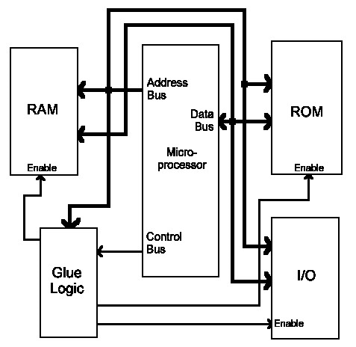
Figure 21 – Microprocessor System Architecture
(Permission Pending)

9b. Microcontroller
Microcontrollers incorporate the following components:
- Microprocessor (CPU)
- Memory
- Parallel Digital I/O
- Timer
In addition to the microprocessor, a microcontroller integrates other components onto a single microchip. The memory in the microcontroller comes in the form of RAM, ROM, EEPROM, and Flash memory. ROM performs the same operation as in the microprocessor-based system. RAM is used for temporary data storage during the execution of instructions. EEPROM is used for long-term data storage. Flash memory is a special form of EEPROM and is used to store the program that is loaded onto the microcontroller. Microcontrollers run whatever program is stored in the flash, uses the RAM for temporary storage and the EEPROM for longer term storage. Flash memory and EEPROM allow for the microcontroller to be easily programmed, erased, and then reprogrammed many times if needed.
The parallel I/O ports on the microcontroller are used for importing and exporting data. The timer on the microcontroller can be used to determine how long a certain process has been running or can be used to run a process for a set amount of time.

9c. Comparison / Final Decision
For a microprocessor, the need for external RAM and EEPROM and external chips or circuits to communicate with I/O devices would increase the overall complexity, cost, and size of the system needed to control ParkBot. One advantage that the microcontroller-based system has over the micro-processor based system is that the microcontroller implements all of the external components needed for the microprocessor into one microchip. This makes the overall system to control ParkBot smaller, cheaper, and simpler to work with. Also, powering the microprocessor-based system with the external memory and chipsets over the microcontroller-based system with just a microcontroller would consume more power than desired and would not meet the requirement of the system to be low power in order to extend battery life.
The system that controls ParkBot must be able to handle and run simultaneous instructions efficiently. Microprocessors range from 4-bits to 64-bits and processing speeds ranging up to 3.4 GHz. Microcontrollers also have CPU’s ranging from 4-bit to 64-bit, but the most popular AVR microcontroller has processing speeds ranging up to 20 MHz. For ParkBot, the performance and speed of a microprocessor-based system is not neeeded. Even though microcontrollers are not as fast as microprocessors, the microcontroller-based system has enough performance and speed to handle all of the tasks that ParkBot will perform and will meet the requirement of the system to have enough speed and performance handle the motor, sensor, and servo control efficiently
Since ParkBot will only be using “low level” hardware such as sensors, servos, and DC motor controllers, a microcontroller is the more logical choice to use for ParkBot because microprocessors are better suited for handling more complex hardware such as keyboards, monitors, and Ethernet cards and microcontrollers are designed to just handle a small specific set of instructions. Therefore, for all of these reasons, the use of microcontroller for ParkBot is the logical choice.
In an effort to simplify the circuitry of the microcontroller system, a microcontroller on a USB circuit board will be used. The USB microcontroller circuit boards make it easy to interface with a computer through USB connectivity and have digital and analog I/O pins for servo control and sensor input along with PWM I/O pins for variable motor control. The microcontroller USB module must have 3 digital input pins for the sensors, 1 PWM output pin for the motor controller, and 1 digital output pin to control the steering servo. The system for ParkBot will require at least 1 KB of RAM for efficient operation and good performance. The microcontroller USB module must feature a low level of programming complexity with good programming support. There are a variety of microcontrollers that are able to provide these characteristics.

The USB Microcontroller Boards that will be taken into consideration are the Arduino, BasicATOM, and PICAXE. The BasicATOM USB microcontroller module was eliminated right off the bat due to being double the price of the other USB microcontroller modules being considered. The Arduino Duemilanove USB microcontroller board and the PICAXE USB microcontroller module will be considered for the comparison in Table 4.

 | Arduino Duemilanove | PICAXE USB Starter Pack
Microcontroller | Atmel ATMega328 | PICAXE-28X1 (based on PIC 16F886 IC)
Operating Voltage | 5 V | 4.5 V
Processor Speed | 16 MHz | 20 MHz
EEPROM | 1 KB | 2 KB
Flash Memory | 32 KB | 14 KB
RAM | 2 KB | 368 x 8 Bytes
Digital I/O | 8 (in or out) | 8 (in), 8 (out)
Analog Input | 6 | 4
PWM Output | 6 | supported
Programming Language | Arduino | BASIC
Cost of Programming Software | Free | Free
Cost of Microcontroller | $29.99 | $48.99

Table 4 – MCU Comparison Table

In the comparison, the two USB microcontroller modules do not differ greatly. The major difference between the two USB microcontroller modules is that the PICAXE USB microcontroller module uses the BASIC programming language which we are all unfamiliar with. The Arduino USB microcontroller module uses the Arduino programming language which we are all also unfamiliar with, but the advantage with the Arduino language over the BASIC language is that the Arduino language is similar to the C and C++ programming languages which we are fully familiar with. The Arduino programming language is much easier to work with based on the tasks that ParkBot will perform as compared to the BASIC language. Also, the programming support for the Arduino language is much better than programming support for the BASIC language.
Another very important major difference that will be considered is price. The two USB microcontroller modules are about even in categories of number of I/O ports, processor speed, and amount of memory, but the PICAXE is priced $19.00 higher than the Arduino USB microcontroller module. With these two major advantages of the Arduino USB microcontroller module considered, we decided that the microcontroller that ParkBot will be using is the Arduino Duemilanove USB microcontroller board shown in Figure 1.

- Software
The control system for ParkBot will be implemented using the Arduino programming language. As already stated before, the Arduino language is based on the C and C++ programming languages. As a matter of fact, the Arduino language is just a set of C/C++ functions. These functions are specialized for use with microcontrollers. Any type of forward or backward movement of the R/C car will involve writing code that controls the motor’s speed and direction (forward or backwards). Any type left or right movement of the R/C car will involve writing code that controls the steering servo. Even with our unfamiliarity with the Arduino programming language, we feel that the resources, examples, and programming support found during our research is sufficient information to program ParkBot to do all of the tasks that it needs to accomplish.

- Algorithms
ParkBot will execute the following algorithms in order to successfully complete its tasks:
- Detect Parking Spot / Move Forward Algorithm
- Pull Into Parking Space Algorithm
- Pull Out of Parking Spot / Move Backwards Algorithm

11a. Detect Parking Spot / Move Forward
This algorithm will be performed first in order to get ParkBot moving. The parking spot detection / move car forward algorithm in state machine form is depicted in Figure 22.

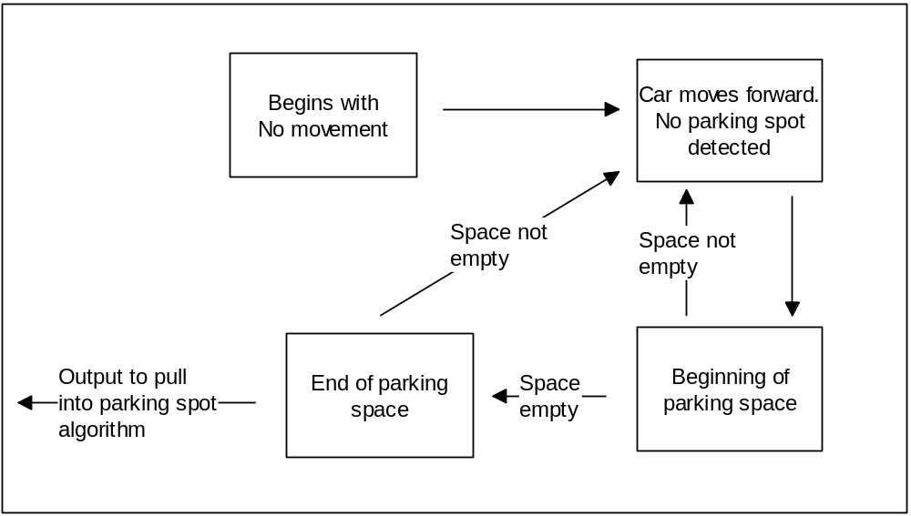

Figure 22 – Detecting Parking Spot Algorithm

After every instruction / process in this algorithm, the front obstacle avoidance sensor will be checked to see the distance between ParkBot and the nearest car in front of it. If the threshold for safe distance away from a solid object is reached or surpassed, then ParkBot will continue checking the front sensor until ParkBot’s distance from the car in front of it is greater than the threshold. This is to ensure that ParkBot does not crash into any other cars while looking for a parking spot and waits for the other car to move forward.

11b. Pull Into Parking Space
This will be performed after an open parking spot is detected by ParkBot. The pull into parking space algorithm in state machine form is depicted in Figure 23.
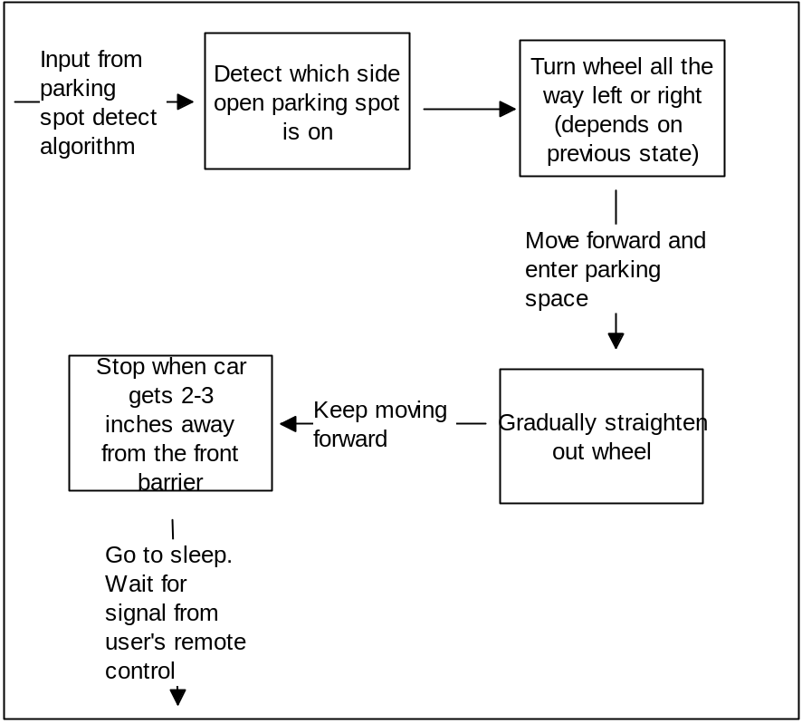
Figure 23 – Pull-In Parking Algorithm

11c. Pull Out of Parking Spot / Move Backwards
ParkBot will be in a “sleep” mode after it pulls into a parking spot. ParkBot will only be awoken by a signal from the user’s IR remote control. The pull out of parking spot / move backwards algorithm will be performed after a signal is received from the user’s IR remote control. The pull out of parking spot / move car backwards algorithm in state machine form is depicted in Figure 24.
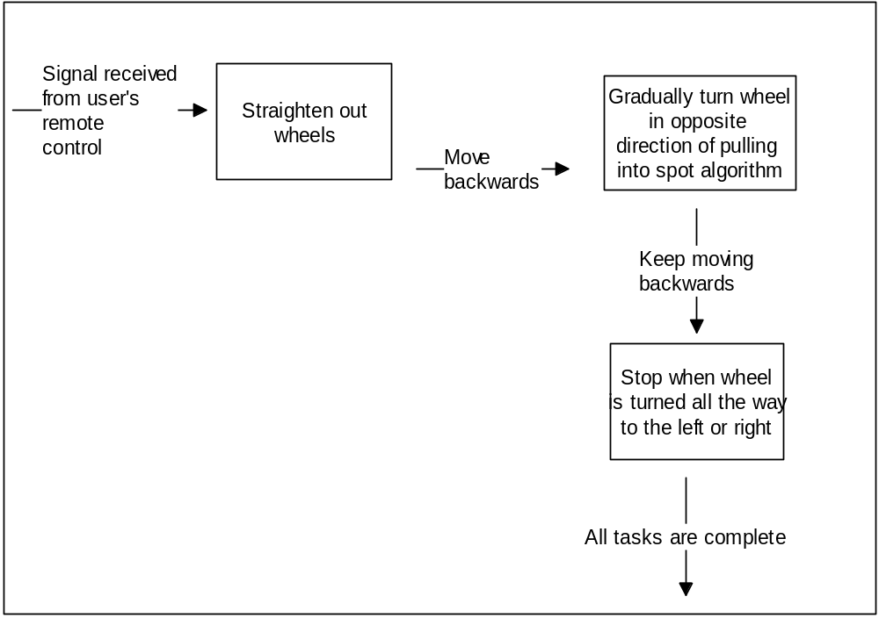

Figure 24 – Pull Out of Spot Algorithm

- Breadboard vs. PCB
A point of contention surrounding this project was deciding whether or not a protoboard or a PCB board should be used to integrate our system of electronics. A protoboard or commonly known as a breadboard is a rectangular plastic box filled with holes, which have contacts in which you can insert electronic components and wires. These breadboards come in different sizes and can be linked together as needed if the circuitry needs additions. A breadboard is what is used to string together a temporary version of a circuit. There is no need for solder wires or anything else; instead, components and wires are stuck into the little contact holes arranged in rows and connected by lines of metal; then you can connect your components together with wires to form a circuit. The components are connected using hook-up with which can be purchased in spools at a reasonable price. It is also a good idea to purchase an assortment of jumper wires that come pre-bent. The nice thing about a breadboard is that, if a component is connected wrong, or we change our mind and would like to replace or rearrange components, it can be done with no trouble. Typically, an electronic project or small circuit is laid out on a breadboard to make sure that everything works. Once this has been tested and verified, it can be made permanent by means of a PCB. A breadboard that measures 6 1/2" x 2 1/8" was found on goldmine-elec-products.com for $6.95. If you have a project you wish to save, you can create a more permanent version.
Circuitry can be made permanent by implementing components on a Printed Circuit Board (PCB). This can turn out to be time consuming and expensive. The first drawback of a PCB that can be, for lack of a better word, detrimental, is the key word “permanence”. This will be our first major hands on project and it will be a learning experience. It is necessary to be flexible and allow for mistakes and revisions when necessary. A printed circuit board requires soldering of all of the components in your system. To do this, it is necessary to procure a universal printed circuit board. This is much like a breadboard except that you can solder all the connections you've made to keep them around. A universal printed circuit board has rows of individual holes throughout the board with copper pads around each hole and metal lines connecting the holes in each row similar to a breadboard. The parts are mounted on the face of the board and then leads are passed through holes to the components. The leads are then soldered to the copper pads on the bottom of the board. Universal printed circuit boards are available in a variety of patterns of contact holes and metal lines.
It can be taken one step further, and a get a custom printed circuit board. This is done by submitting a drawing of your circuit to a printed circuit board company. It is crucial at this stage to be sure that the layout of the circuit is error free. Once it is sent to be fabricated, it is too late to make changes. These boards are not cheap. After perusing the pcbpool.com website, and getting a quote for a 4in x 5in board, with a turnaround time of 8 working days, cost $68.00.
In order to make a decision on what type of board should be used to implement our circuitry, all factors are considered. The advantages of going with the breadboard seem to outweigh those of the printed PCB. To begin, the breadboard does not require permanence and allows for changes to be made at any time during the project build. It would be less time consuming to layout the circuitry once and it would be complete. This would deter us from taking the time to check and re-check the circuit before having it fabricated on a board. The cost is lower to use a breadboard. Maybe if we had some sponsors, it would not be a big deal to spend the extra money. It was decided that going with the breadboard would be advantageous in our case because of these multiple elements of concern.

- Power Supply
The power supply is one the most important components of ParkBot because without a good power supply delivering the current and voltage needed for every element added to ParkBot, the RC will not function properly and executes the desire tasks. Also if the power supply is not properly designed and built, it can burn out some of the components and it will increase price and time need it to complete overall project of ParkBot. Therefore, the power supply requires an extensive research and understanding before choosing the right power supply whether is one central power supply delivering the power for all the components, or are several power supplies distributing the power to the components of ParkBot. There are also different kinds of power options available to deliver current to the components of ParkBot. The options available for the power supply of ParkBot are solar power, disposable batteries, and rechargeable batteries. Figure 25 illustrates the operation of the power supply on ParkBot.

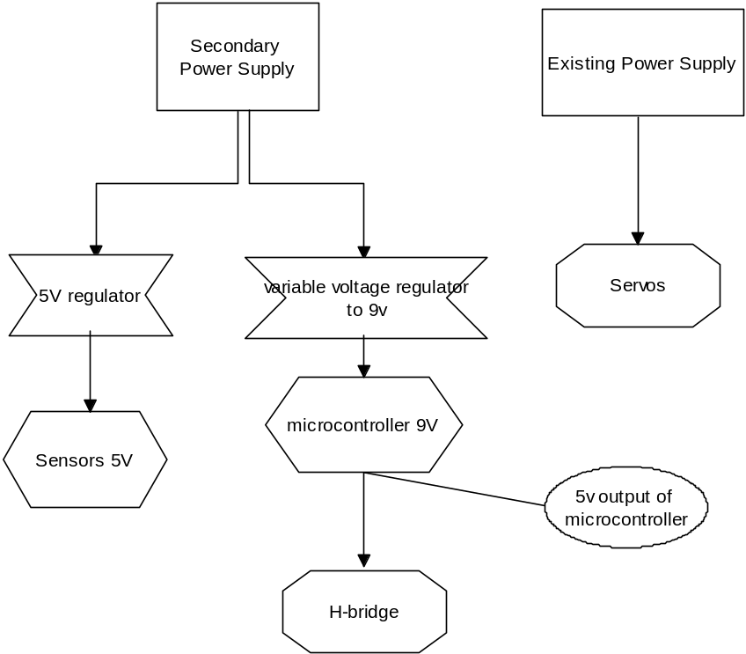

Figure 25 – Power Supply Operation

13a. Solar Power
Solar power would be a good and nice technology to include in this project, especially since nowadays is very common and helps the environment. This option was discussed since one of the sponsors that were going to appear in class needed groups using renewable energy to be incorporated in the senior design projects. Even though the group does not have any sponsor looking for this kind of technology, it would be pleasant to incorporate solar panels for the project. But first, it is important to know how difficult, time and price this option will require. The only way to use solar panels for the power supply is to have the photovoltaic (PVs) charge the rechargeable batteries since the PVs are arrays of cells that converts solar radiation into electricity. The use of solar power not only increases the price of the project but also adds more weight to ParkBot and therefore more torque is needed increasing the power consumption. This option would be taking in consideration for future improvements of ParkBot if time and money is not a matter.

13b. Disposable Batteries
Disposable batteries are batteries that their electrochemical reaction is not reversible, therefore once their chemical reactance store in the battery is drained every time is used; there is no way to restore them to their initial position and capacity. There are many kinds of disposable batteries use for different applications, but the more common ones use for electronic devices are alkaline and lithium batteries. Both batteries have advantages and limitations especially when used in this project. In Figure 26 there is a pie chart showing the kinds of disposable batteries available.
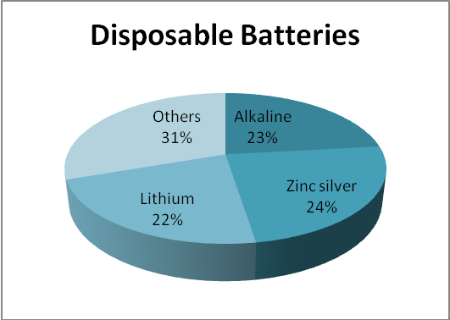
Figure 26 – Disposable Battery Availability

13b.i. Alkaline
Alkaline batteries are the most common type of disposable battery use in electronic devices. They produce power from the reaction between zinc and manganese (Zn/MnO2). The capacity of alkaline batteries is dependent on the load applied, this load can be from 3000mAh to as low of 700mAh, having in mind that their amount of current it can be deliver depends on the size of the battery, and their nominal voltage of new battery is of approximately 1.5v. The benefits of using this kind of technology for the project is that they have a very slow self-discharge rate, they last long time if they are not being use, they can perform well at high and low temperatures when used. However, alkaline batteries also have limitations and those are that these batteries are not useful in high current drain applications which ParkBot will need, in order to get the current needed it will increase its size adding weight to the RC car and they can leak potassium hydroxide if they are unattended for long period of time. In Table 5 below there is a brief description of alkaline batteries.

Alkaline
Open Voltage | 1.5v
Nominal Voltage | 1.2v
Discharge | slopping
Max available Temp. | 93°C
Table 5 – Alkaline Battery Specifications

13b.ii. Lithium
Lithium batteries are another very common type of disposable battery use in electronics devices. These batteries can generate voltages form 1.5v to 3.7v depending on the design and chemical compound used. Lithium is very reactive giving the potential to achieve high energy and power densities. Lithium has different chemistries such as lithium-thionyl chloride (Li-SOCl2) which has very high density energy and operates between 3.5v and 3.65v, lithium-sulfuryl chloride (Li-SO₂Cl₂), even higher energy density due to higher voltage and increased current capability, and many other lithium chemical combinations. The advantages of using lithium for ParkBot are that high voltage is generated, the weight of the battery is light, it can sustain high temperature, and it can give power for long period of times. The limitations of lithium disposable batteries are that their price is higher and they are not rechargeable. In the Table 6 below there is a brief description of these two chemistries described for lithium.

 | Lithium Thionyl Chloride | Lithium Thionyl Chloride
Open Voltage | 3.67v | 3.9v
Nominal Voltage | 3.4v | 3.5v
Discharge | Flat | Flat
Max available Temp. | 85°C,150°C, 180°C  200°C | 150°C, 165°C

Table 6 – Types of Lithium Batteries

13c. Rechargeable Batteries
Rechargeable batteries perform the same as disposable batteries when they are being discharged. Rechargeable batteries work the same as car batteries, which are lead acid batteries, when they are being charged. The battery charge when electrical energy is applied to the battery using the battery charger, when the battery is applied to the charger the process of electrons flowing from negative to positive that was used when discharging is reversed. Depends on the kind of chemistry the battery is what determines the time rate it will take to charge the battery. This is beneficial for the application of the power supply ParkBot will need. The three main options for rechargeable batteries ParkBot could use on the power supply are lithium ion (Li-ion), nickel cadmium (NiCd), and nickel metal hydride (NiMH). Both have benefits and limitations for the use of ParkBot. In Figure 27 there is a pie chart showing the kinds of disposable batteries available.
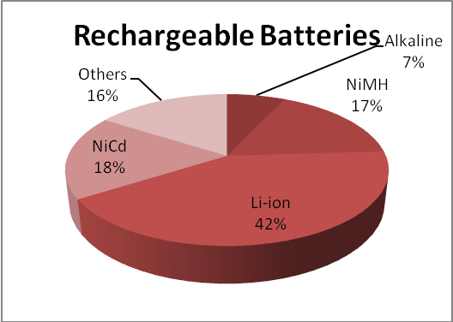
Figure 27 – Types of Disposable Batteries

13c.i Lithium Ion
Lithium ion rechargeable batteries are the most commonly and widely use in modern portable electronic devices. The cathode contains lithium and the anode carbon. When being use, the current flows from the negative to positive terminal like any other regular disposable battery. To charge up the battery to its previous state of usage, the current is passed in the reverse direction. A voltage of about 4.2v is applied to charge a battery of 3.7v due to internal resistance. This kind of batteries are use due to the high energy to weigh ratio, lack of memory effect and slow self-discharge when not being use. The benefits of using this battery for ParkBot are that they come in different sizes and shapes for any kind of application, they are light weight, they do not to be discharge when attempting to charge them, and slow self-discharge about 5-10% per month. The limitations of using this battery for power supply are that expensive because of manufacturing, requires sophisticated chargers for every size, they start disintegration after they are produced and only last for about two to three years, sensitive to high temperatures and it the battery fails it , it will get on fire.

13c.ii. Nickel Cadmium
Nickel cadmium rechargeable batteries use nickel oxide hydroxide and metallic cadmium as electrodes. Nickel cadmium batteries have a nominal potential of 1.2v and it has the ability of delivering a steady voltage until is completely discharge. Nickel cadium batteries charge faster and prefer pulse than DC charge, it is not like to be use occasionally since it creates crystals on the material degrading the performance over time, and the discharge rate is of around 2% when not being used which much smaller than other rechargeable batteries. This kind of battery could handle rigorous tasks and is ideal for ParkBot since more than one device such as the sensors and microcontroller will be drained power for high performance. The advantages of using NiCd as the power supply for ParkBot that they are fast and simple to charge, high number of charge/discharge cycles of 1000, long shelf life around five years, low temperature performance, inexpensively and available in different sizes. However, the NiCd batteries also bring limitations for the project and these are relatively low energy density, memory effect requires the battery to be occasionally utilized to avoid memory, and it has high discharged when used.

13c.iii. Nickel Metal Hydride
Nickel metal hydride batteries are similar than NiCd batteries but instead of having cadmium in the negative terminal, it uses a hydrogen-absorbing alloy. The nickel metal hydride has two to three times the capacity that NiCd has with the same size of battery, NiMH only needs exercise to prevent crystallization once every three months compared to once every month for NiCd . The initial voltage of NiMH could be 1.2v or 7.2v, the internal resistance of NiMH is also small as those in NiCd giving high currents making ideal for applications as ParkBot. Nickel metal hydride is less durable than nickel cadmium and undergoes high self-discharge. The advantages of using NiMH for the power supply of ParkBot are that they are 30-40% higher than NiCd, and less prone to memory effects, which does not require as much utilize when not being used for long period of times. Even though the capacity is higher and it has advantages than NiCd, it has limitations affecting the use of them for the project. The drawbacks of using NiCd for the use of power supply are that it has limited service life and performance deteriorates after being cycled, restricted discharge current to conserve the battery’s life since big loads reduce its life. It also requires longer time charging the battery when completely discharged, high self discharge, and it degrades if stored at high temperatures. Table 7 below shows the comparison of three rechargeable batteries discussed and some other ones that are considered for the use of this project.

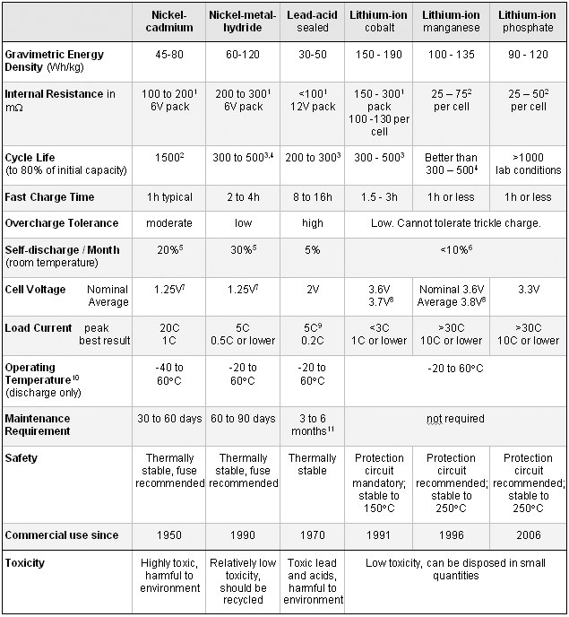
Table 7 – Rechargeable Battery Comparison
(Permission Pending)

- Voltage Regulator

Voltage regulators are implemented to maintain a constant voltage level. These components are able to control AC or DC voltage. Voltage regulators can be categorized into three different types. These types are capable of having a low ground current. They are designed to continuously maintain a constant output voltage at the design level regardless of changes in input voltage or load current. This is achieved using feedback design. To provide stability, some type of compensation is required. This is provided through the inclusion of internal capacitance for some types. A characteristic of a voltage regulator that applies to all types is the transient response of the component. A requirement is that the time that a change has been detected and corrected be finite. This can be measured by the time it takes the voltage level to return to steady state. Linear voltage regulators come in three different variations. These types are classified as standard, low dropout (LDO), and quasi low dropout regulator. Standard voltage regulators require that the battery used be at least 2V higher than the output voltage. The LDO does not have this requirement. We will be considering standard types to implement into our project. Different regulators will be explored and the one that is most compatible to our needs will be utilized if necessary in our circuit design.

14a. LM7805

The LM7805 voltage regulator has several fixed output voltages, which makes it useful in a wide range of applications. This is the most common type of linear regulator. It uses internal current limiting and thermal shut down to ensure safe operating area protection. As a disadvantage, linear regulators have been tested to have low efficiency. In addition, another disadvantage is that they waste battery power and create a lot of heat. Despite this fact, if adequate heat sinking is provided, the linear regulator can deliver in excess of 1A of output current. The linear regulator can also be used to adjust voltage and current levels as needed. Figure 29 depicts a LM7805 voltage regulator.

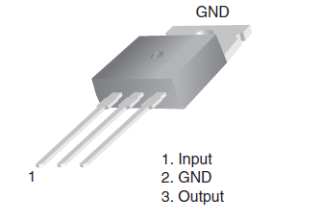

Figure 29 - LM7805 Voltage Regulator
(Permission Pending)
The features of the LM7805 are detailed in the following list.

- Output Current up to 1A
- Output Voltages of 5, 6, 8, 9, 10, 12, 15, 18, 24
- Thermal Overload Protection
- Short Circuit Protection
- Output Transistor Safe Operating Area Protection

14b. LM341

The LM341 is a three-terminal positive voltage regulator. With adequate heat-sinking, the LM341 can supply more than 0.5A of output current. This is lower than the LM7805. The LM341 is used in many practical applications such as acting as a local regulator that can eliminate the noise and increase the performance associated with single-point regulation. The features of the LM341 are detailed in the following list.
The features of the LM341 are detailed in the following list.
• | Output current in excess of 0.5A
• | No external components
• | Internal thermal overload protection
• | Internal short circuit current-limiting
• | Output transistor safe-area compensation
• | Available in TO-220, TO-39, and TO-252 D-PAK packages
• | Output voltages of 5V, 12V, and 15V
14c. LM317T

LM317T is monolithic integrated circuit for use as a positive adjustable voltage regulator. It is designed to supply more than 1.5 A of load current which tops both the LM341 and the LM7805. It can also deliver an output voltage from 1.2 to 37 V. The nominal output voltage is selected by means of only a resistive divider, making the device exceptionally easy to use and eliminating the stocking of many fixed regulators.

The features of the LM317T are detailed in the following list.
- Output voltage range: 1.2 to 37 V
- Output current in excess of 1.5 A
- 0.1% Line and load regulation
- Floating operation for high voltages
- Complete series of protections: current limiting,
- Thermal shutdown and SOA control

The previous voltage regulator chips can be compared according to the need. The drawback to the LM7805 is the need for the additional 2V above the output voltage desired. In addition, the heat dissipation as a result of linearity, could possibly call for a heat-sink to be included. The LM7805 has also been known for their inefficiency. The LM317T is desirable because of it voltage range and the fact that it does not require additional voltage from the battery in order to operate properly. Comparing and contrasting the different voltage regulators would have been gone into greater detail if we needed to implement this component into our system. At the moment, we are unsure whether or not we are going to utilize a voltage regulator in our design. The necessity will be determined when we are in the process of building. In the event we find it necessary, the advantages and drawbacks will be considered.

DESIGN
Now that the research is complete, all of the main components of ParkBot are now chosen. In order for these components to be properly implemented, a good design plan must be set in order for successful prototyping. The design plan will show how all of the components in ParkBot will be tied together.

  - Design Summary
ParkBot will have one Arduino USB Microcontroller Module that will be used to control ParkBot’s motor and steering servo and will receive input from the obstacle avoiding/parking spot detecting ultrasonic sensors and user’s IR remote control’s receiver. ParkBot will locate, pull into, and pull out of a parking spot by using three different algorithms. ParkBot will be using the motor, the chasis, the steering servo, and the battery from the Silverlit Electric R/C Car. The reason for using these components from the R/C car is because it already includes a battery, a chassis, a motor that controls the forward and backward movement of the wheels, and a steering servo that will give us proportional steering. A steering servo that allows for proportional steering is required due to the fact that ParkBot will need to be turned at precise steering angles when parking in a spot and pulling out of a spot. Using the R/C car’s existing chassis also eliminates the tedious, expensive, and time consuming task of building your own chassis which would involve placement and mounting of your own components such as wheels, motors, and steering servos. The only thing on the R/C car that we will not be using is the actually body of the car that houses the chasis. This component will be removed in order to make room for the microcontroller module, breadboard, battery pack, etc. The already existing speed/motor control on the R/C car will not be used. The terminals of the motor on the R/C car will be connected to an H-bridge chip that will be used to control the motor which will turn the rear wheels backwards or forward. The H-bridge chip will be connected to and controlled by the Arduino USB microcontroller module. Also, the existing network on the R/C car that controls the steering servo will not be used. Instead, the signal wire from the steering servo will be connected directly to the Arduino USB microcontroller module. This will enable the microcontroller to directly control the proportional steering by setting the angle of the steering servo.
The steering servo will still be powered by the battery on the R/C car. ParkBot’s Arduino USB microcontroller module, obstacle avoidance sensors, IR receiver, and motor will be directly powered by an external NiMH battery pack. The battery pack will provide enough voltage and current to sustain and power all of these components for a long enough amount of time for ParkBot to perform all of its tasks. Ultrasonic sensors will be used to detect obstacles (mainly other cars). The Ultrasonic sensors will be used in order to detect open parking spots, detect the where the front barricade of a parking spot is, and detect whether there is a car blocking its path to find an open parking spot. Figure 30 names off all of the components of ParkBot and gives their approximate location.

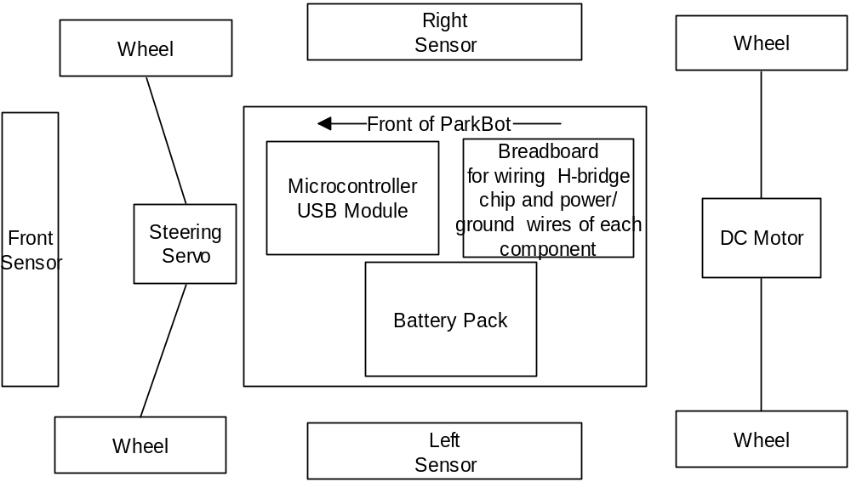
Figure 30 – Location of each component on ParkBot

  - Block Diagrams
ParkBot takes in a series of inputs from different devices and processes the information from these devices to generate a desired output. The general subject of the each of the inputs and outputs of ParkBot will be described in greater detail in this section (Design section). The general I/O block diagram, shown in Figure 31, visually depicts all of the inputs and outputs to the system as a whole.
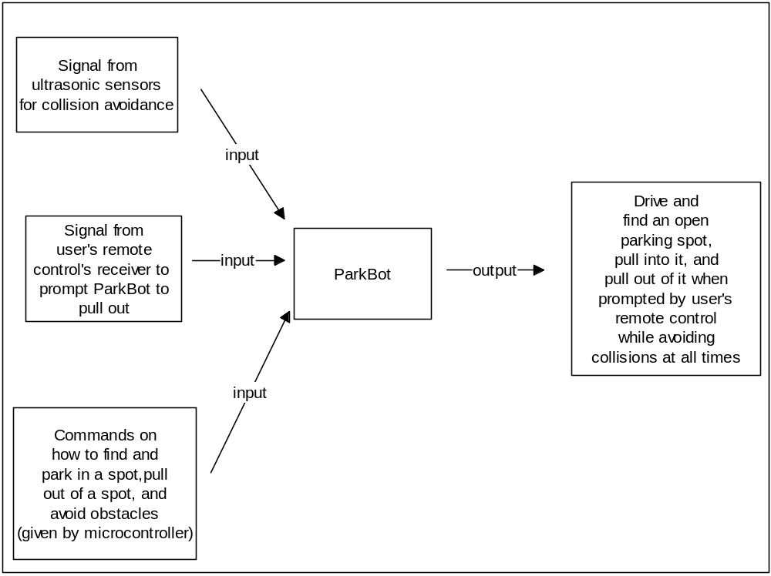
Figure 31 – General I/O Block Diagram

The microcontroller block diagram, shown in Figure 32, depicts an overview of what the microcontroller is in control of and what the microcontroller receives input from. The microcontroller block diagram also shows which component each group member is responsible for. Even though each component is assigned to a certain group member, all group members will contribute to each component that is connected to the microcontroller in an overall strong team effort.

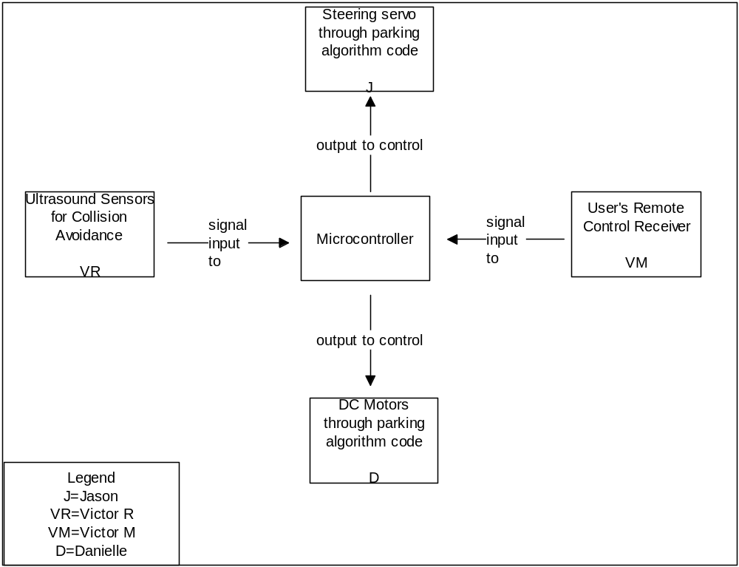
Figure 32 – Microcontroller Block Diagram

  - Breadboard
The breadboard design is vital for organization and implementation of the sub-systems. Since we decided against a PCB and opted for the breadboard, it will allow for the effortless consolidation of all of the components in this system. In addition, this platform is sizeable enough to realize an organized layout. All of the components depicted in Figure 32 above will need to be incorporated on the breadboard. The microcontroller only has one 5V output pin that essentially needs to supply power to more than one component. The 5V signal will be wired to the breadboard so that the additional components that need to tap that voltage can get their power from it. The components include the H-bridge, the receiver, and all three obstacle avoidance sensors. All of these components will be organized and wired on the breadboard.

  - Motor
The platform on which ParkBot will be built will be an Electric 1:16 Official Licensed Porsche Carrera RC Car manufactured by Silverlit. We felt this vehicle is best suited to realize the requirements necessary to complete ParkBots objectives. As outlined previously, the vehicle has specific requirements pertaining to the frame and body, steering mechanism, and the power supply. The frame and body of the Porche is large enough to accommodate the sub-systems that will be implemented. The Porshe Carrera comes with a four wheel independent suspension. The only shortcoming of the toy grade radio controlled vehicle is the lack of specifications for the included components and possibly the quality of those components. The motor will be included with the purchase of the remote controlled car. The internal circuitry will be analyzed. The leads to the motor will be snipped and connected to the Texas Instruments L293NE H-bridge IC chip. The mounting of the motor will remain as it was during manufacturing. Detailed pin layouts and connections will be depicted in a subsequent section.

  - Motor Control
There are two controllable parameters of a DC motor. These two parameters are speed and direction. Controlling the direction of the motor will be necessary to move the car in the forward, reverse and stop positions.

5a. Direction
The speed of the motor will be controlled by integrating a speed controller module known as an H-bridge which will receive signals from the microcontroller. The H-bridge chosen is manufactured by Texas Instruments and the model is L293NE. Figure 34 was taken from the data sheet and will be connected accordingly.

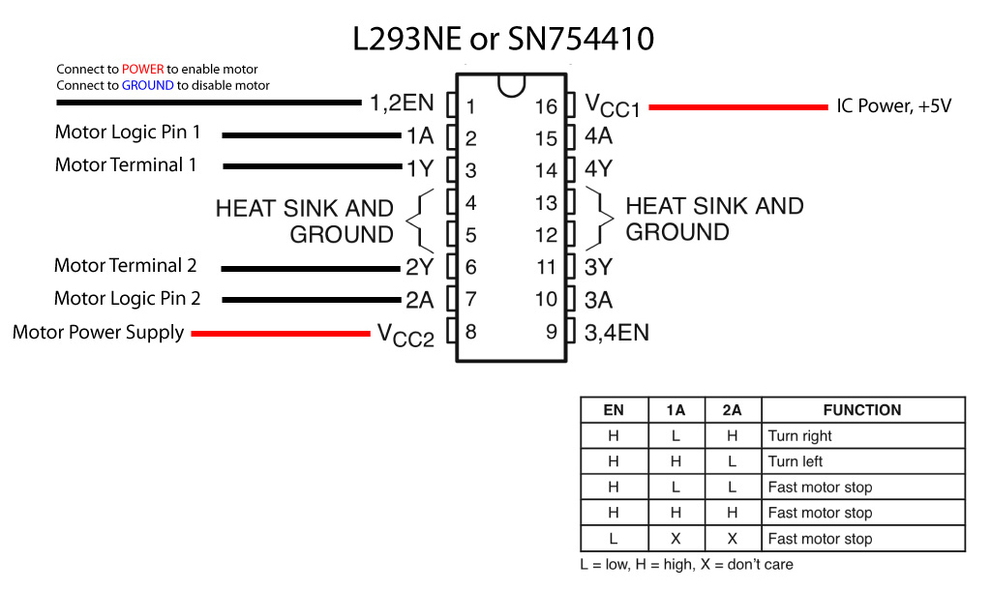
Figure 34 – H-bridge connections to a DC motor
(Permission Pending)

Pin Assignments
- Pin 1 (1,2EN) enables and disables our motor whether it is given HIGH or LOW
- Pin 2 (1A) to Pin 9 of microcontroller
- Pin 3 (1Y) positive terminal of motor
- Pin 4-5 are for ground
- Pin 6 (2Y) negative terminal of motor
- Pin 7 (2A) is to Pin 1 of microcontroller
- Pin 8 (VCC2) is the power supply for our motor, this should be given the rated voltage of your motor
- Pin 9-11 are unconnected as we are only using one motor
- Pin 12-13 are for ground
- Pin 14-15 are unconnected
- Pin 16 (VCC1) is connected to 5V supplied from microcontroller
Enable will be set high always by connecting the enable pin to the positive terminal of the power supply. The functions listed in the table will be realized with this pin set-up and will be tested for proper functionality. The motor will be rotate in the direction according to the signals being fed from the microcontroller. Ideally PWM will be implemented to drive the H-bridge to ultimately propel the car in the desired direction.

5b. Speed
The H-Bridge is the component that will handle the direction of the motor and the speed at which it rotates will be controlled with Pulse Width Modulation (PWM). This is implemented using digital pulses to create some analog value other than just ‘high’ and ‘low’ for the power supply. In order to implement PWM to control the speed of the motor, a module will be written in C programming language for the microcontroller. This should be relatively easy to implement. The pins marked PWM (pins 9 – 11 on Arduino, PWM 0 – 5 on Wiring) can be pulsed using the analogOut() command. We will be using Pin 1 and Pin 9. Using a pulseout command will make it possible to vary the speed of the DC motor. We use the same transistor circuit as we did to turn on and off the motor, the proposed L293NE H-bridge IC chip, but instead of putting the output pin of the microcontroller high or low, we use pulseout command on it. The range of the pulseout will vary somewhere between 0.0002 to 0.02. The varying pseudo-analog voltage on the base of the transistor creates a corresponding variance on the current flowing through the motor, and the motor will spin at a variable rate. Pulse width is a value from 0 – 255. 0 corresponds to 0 volts. 255 corresponds to 5 volts. Every change of one point changes the pseudo-analog output voltage by 5/255, or 0.0196 volts. The software design section that follows goes more in depth as to how exactly this mode of control will be employed.

  - Steering Servo
The steering servo that will be implemented in our design will be included in the remote controlled car that we are going to purchase commercially. The mechanism will be inspected and adjustments to the functionality will be made accordingly. Because the car is what is termed as “ready-to-run”, some type of driver must be included that controls the steering servo. It will be necessary to dismantle the control and provide the signal inputs to be fed to the servo from the microcontroller. The control will use PWM communicating specific voltage levels that correspond to turn angles for the servo. Additionally, this entails software design to employ and will go into more depth in subsequent design sub-headings in the software sections.

  - Obstacle Avoidance Sensors
Before ParkBot has that sensors mounted, we must take in consideration a few factors for the Ultrasonic sensor to work properly. One of factors is the distance that the sensor is mounted from the ground. This must be taken into careful consideration. The environment is another factor that must be taken into consideration. If the room carries echo very well, this would affect the sensor’s ability to give the microcontroller a proper distance reading. An improper reading from the sensor will cause ParkBot to make improper decisions because it will not be able to tell whether a spot is open or not. Since this Ultrasonic sensor emits it signal at 40 kHz, the floor would be another factor that we must take into consideration. For example, if the floor is tile, the signal could bounce back very quickly and give ParkBot an improper reading. If the floor of the room happens to be carpet, the signal could be absorbed by the carpet and could absorb the Ultrasonic signal to a level where the signal would not be able to return to the sensor for detection. Tests that the Parallax Lab ran for the Ping Ultrasonic Range Finder confirmed that the sensor would be able to perform in watery conditions or noisy environments. Also, they tested different temperature environments. They found out that if the temperature is too low, it will affect the speed that the signal is sent and received. The objects that will be detected must be objects made of that concrete, cardboard, etc. and not made of any cloth or fluffy material because the signal must be able to bounce back to the sensor so that the sensor could work properly.
The position is another factor to consider. If the sensor is too close to the floor, the floor would create distortion of the Ultrasonic signal emitted by the sensor. If the sensor is too high, the signal could spread out so far that it would be out of the range of the sensor. Finally, the size of the obstacle that needs to be detected will need to be taken into consideration. If the object is too small, then signal will not come back to the sensor. Since each sensor will be working independently, each Ultrasonic obstacle avoidance sensor will be wired to its own digital I/O pin. The sensor on the left side of ParkBot will detect objects on the left side of the car. It will also detect if there is an open or full parking space on the left side of ParkBot. The sensor on the front of ParkBot will detect objects that are in front of ParkBot. This sensor will provide information as to if there is any object in front of the car while it is driving through the simulated parking lot. The sensor on the right of ParkBot will be detecting objects that are to the right of ParkBot. It will also detect if there is an open or full parking space on the right side of ParkBot. The way that these Ultrasonic sensors will work when mounted at certain angles is illustrated in Figure 35.
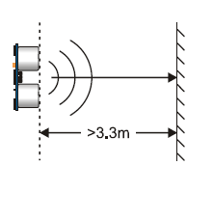
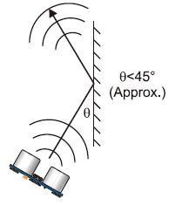
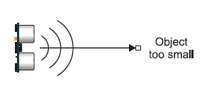
Figrure 35 - From PING)))™ Ultrasonic Distance Sensor Sheet (#28015)
(Re-Printed with permission from Parallax Inc)

The first figure shows the scenario where an object is being detected correctly. The second figure shows what happens when the sensor is mounted at an angle and how it cannot detect an object that is at a 90 degree angle. The third figure depicts what happens when the object that the sensor is trying to detect is too small. The sensors on ParkBot will be mounted in a similar fashion as depicted in the first figure. The front sensor will be parallel with the front bumper, and the two side sensors will be parallel with the side of ParkBot’s chassis.

The Ultrasonic sensors will be connected to the Arduino USB microcontroller module by connecting the signal pin of the sensor to one of the digital I/O pins on the microcontroller. Figure 36 depicts how an individual sensor can be tested on the microcontroller board. The individual sensors will be wired like this on an individual basis in the initial testing phase of the project.
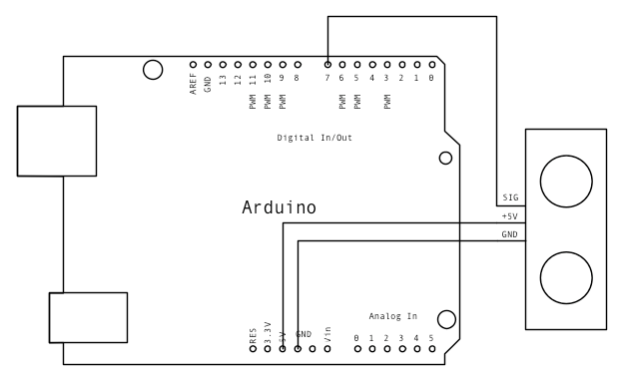
Figure 36 – Ultrasonic Sensor Interface with Arduino Board
(Permission Pending)

  - IR Remote Control / Receiver
For the transmitter of ParkBot, it was selected a universal IR remote control as the needed for the operation of the project. This universal remote control comes already assemble and there is no need to design the hardware of it. The only thing that needs to be design is the software part of the remote control. Since the remote control has not been obtained yet, the configuration of the remote is not known yet until the remote arrived with its respective manual.
The design of the receiver is also simple as the one of the transmitter; it will only need configuration from the manual that comes with the remote and receiver kit. The IR detector will only need software implementation with the remote control, and most of the code comes with the manual included in the kit. From the application sheet from the parallax Inc website, there is an example on how to check the message of timing diagram for the remote, for instance if the remote control is hold for 10 seconds, it can be determined how many messages per second the remote control is sending. Figure 37 illustrates how to determine the messages send by the milliseconds calculated.
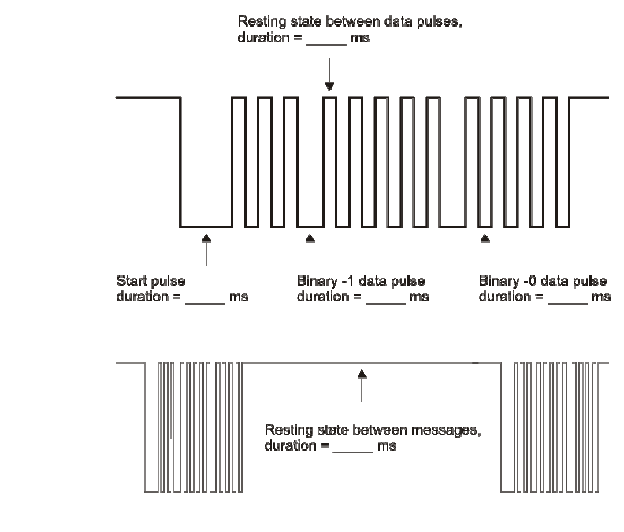
Figure 37 – Data Transmission Sample
(Re-printed with permission from Parallax Inc.)

The IR receiver for the remote control contains 3 pin-outs. Pin 1 is the power pin. Pin 2 is the ground pin. Pin 3 is the signal pin. The signal wire will be connected to a digital I/O pin on the Arduino USB module. P9 will instead be a digital I/O pin on the Arduino board. The power pin will be wired to the row where the power supply is, and the ground pin will be wired to where the ground terminal is.

  - Microcontroller
To start off, Table 8 displays a summary of the features / specifications of the Arduino Duemilanove USB microcontroller board. Following the table, in Figure 39a and 39b, will be a schematic of how the entire Arduino Duemilanove USB microcontroller board is wired including how the microcontroller is wired to the I/O pins of the Arduino USB Microcontroller Module.

Microcontroller | ATMega328
Operating Voltage | 5V
Input Voltage (recommended) | 7-12V
Input Voltage (limits) | 6-20V
Digital I/O Pins | 14 (of which 6 provide PWM output)
Analog Input Pins | 6
DC Current per I/O Pin | 40 mA
DC Current for 3.3V Pin | 50 mA
Flash Memory | 32 KB of which 2 KB used by bootloader
SRAM | 2 KB
EEPROM | 1 KB
Clock Speed | 16 MHz

Table 8 – Arduino Summary of Features

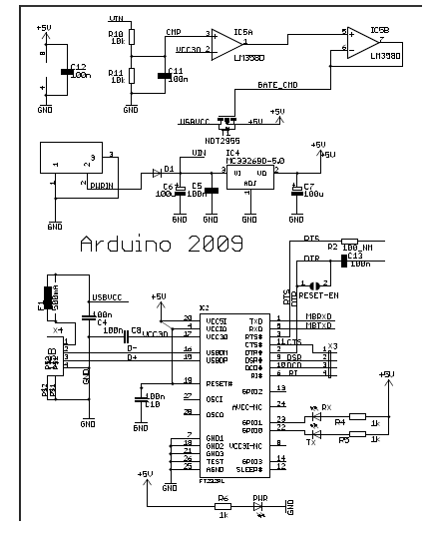

Figure 39a – Arduino USB Board Schematic
(Permission Pending)

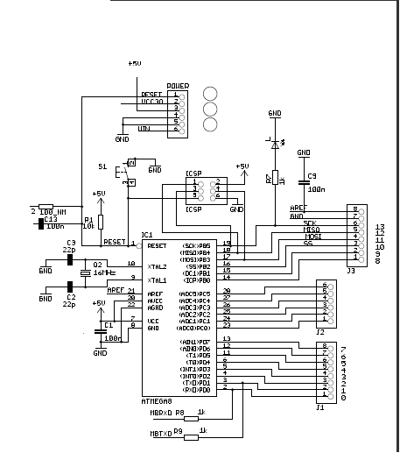
Figure 39b – Arduino USB Board Schematic
(Permission Pending)

As shown in the microcontroller block diagram, the microcontroller will be responsible for receiving and processing input from the ultrasonic collision-avoidance sensors and the user’s IR remote’s receiver. The data from the receiver and sensors will be used to determine what ParkBot will do in certain situations where input is needed from the sensors or receiver. The microcontroller will be responsible for sending commands to the steering servo which control the left and right movement of ParkBot and the DC motor which control the forward and backwards movement of ParkBot. These commands will be written up programmatically and programmed onto the microcontroller. Shown in Figure 40 is the Arduino Duemilanove USB microcontroller board. This figure will be used as a reference when describing how each component of ParkBot will be connected to the USB microcontroller board.
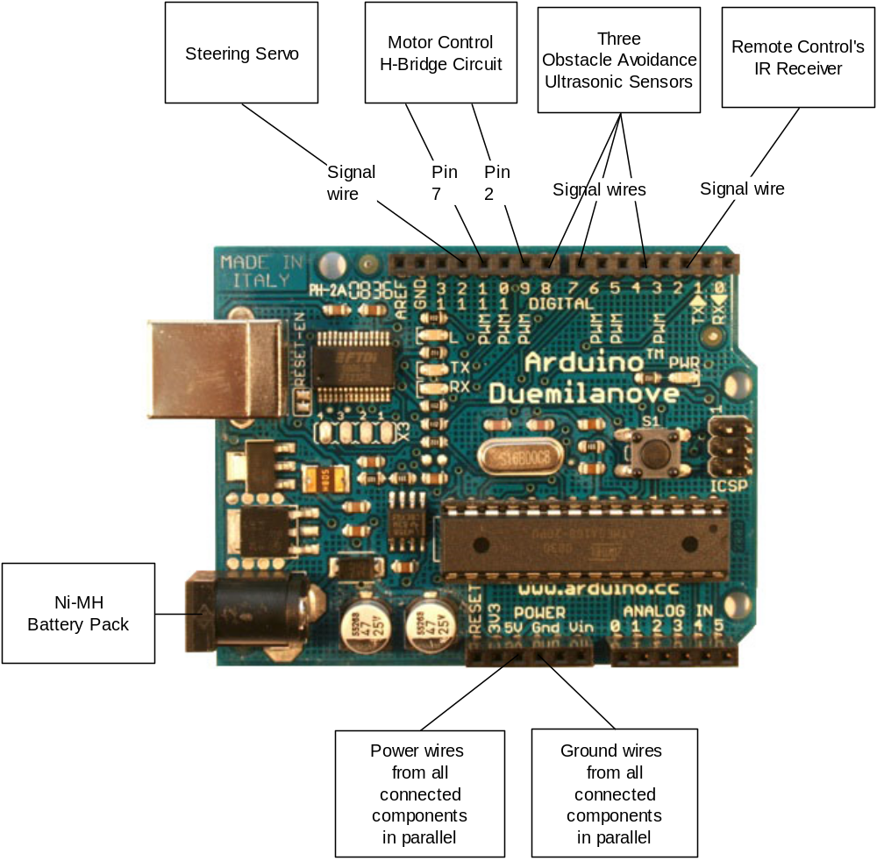
Figure 40 – Arduino Duemilanove Board
(Permission Pending)
Forward and backward motor control will be controlled by an H-bridge chip. Pin numbers for the H-bridge chip are shown in Figure 34. One terminal of the DC motor will be connected to Pin 3 on the H-bridge chip. The other terminal of the DC motor will be connected to Pin 6 on the H-bridge chip. Pin 2 on the H-bridge chip will control the logic of the DC motor terminal that was connected to Pin 3 on the H-bridge chip. This pin will be connected to the digital I/O pin 9. Pin 7 on the H-bridge chip will control the logic of the DC motor terminal that was connected to Pin 6 on the H-bridge chip. This pin will be connected to the digital I/O pin 11. The power and ground pins of the H-bridge chip will be connected to the 5V and Gnd pins of the Arduino USB module, respectively. The steering servo has three wires: power, ground, and signal. The power wire will be connected to the 5V pin on the Arduino USB module. The ground wire is typically will be connected to the Gnd pin on the Arduino USB module. The signal wire will be connected to digital I/O pin 12.
The PING))) Ultrasonic Sensor has three pins: power, ground, and signal. The signal pins of the three ultrasonic collision-avoidance sensors will be connected to digital I/O pins 4, 7, and 8. The power and ground pins of the ultrasonic sensors will be connected to the 5V and Gnd pins of the Arduino USB module, respectively. The IR receiver for the user’s IR remote control has three wires just like the ultrasonic sensors (power, ground, and signal). The signal pin will be connected to digital I/O pin 2 on the Arduino USB module. The power and ground pins of the IR receiver will be connected to the 5V and Gnd pins of the Arduino USB module, respectively.

  - Software
In order to start coding, the Arduino software needs to be downloaded from www.arduino.cc. After the software is downloaded, the Arduino application can be launched, and coding for ParkBot can begin. Every Arduino program must contain two basic functions, the setup() function and the loop() function. The setup() function is the function that is called as soon as an Arduino USB module is powered up or reset and is only called once. The setup() function is used to declare and initialize variables and declare the pins that the different components of ParkBot are connected to as INPUT or OUTPUT. After the setup() function has completed, the loop() function is called. This is where the code for ParkBot’s control algorithms will be placed.
To start, the different components of ParkBot that are connected to the Arduino USB Board’s I/O pins must be declared as constants with their respective pin numbers. For example, the ultrasonic senosor connected to digital I/O pin 7 will be declared as: “const int sensorPin = 7;”. This declaration will be used in the code snippet in the next paragraph. The other components connected to the microcontroller board will be declared in a similar fashion.

  - Algorithms
ParkBot is run entirely based on algorithms. A series of three algorithms will be run in sequential order in order for ParkBot to successfully complete its tasks. These three algorithms will be implemented through software code. These three algorithms will be coded sequentially in one big Arduino program. We will not be making separate programs for each algorithm for the sake of simplicity and cohesiveness. These algorithms, which were developed in the research portion of this project will now be translated into Arduino code so that the microcontroller understands what must be done in order to successfully complete these three algorithms.

11a. Detect Parking Spot / Move Forward
The first algorithm that will be run is the algorithm to move the car forward and check for an open parking spot. Since ParkBot will need to stop execution if a parking spot is not found after looking through all of the 19 spots on either side of it, we will need to keep track of the number of spaces that ParkBot has checked. We will keep track of this by declaring an “int” that will be incremented by one each time ParkBot checks the spot to its left and to its right. We will enclose the entire detect parking spot / move forward code in a “while” loop, and the “while” loop will check to see if the “int” that is being incremented after each left and right parking spot check has reached 19 or not. When the parking spot count reaches 19, ParkBot will cease execution completely.
The first step is for ParkBot to move forward. The logic of both terminals of the DC motor will by controlled by the microcontroller. If one of the terminals (exactly which terminal is yet to be determined) is given a LOW signal and the other is given a HIGH signal, the motor will cause ParkBot to move forward. In order stop the motor, LOW signals will be sent to both of the motor terminals. In order to run the motor for one second, a delay must be placed after the proper signals are sent to both of the motor terminals. A delay in an Arduino program is implemented using the following line of code: “delay(time in milliseconds);”. If one of the motor terminals is declared as “motorTerm1” and the other is declared as “motorTerm2”, the following code snippet will run the motor in forward mode for one second and then stop the motor:
pinMode(motorTerm1, OUTPUT);
pinMode(motorTerm2, OUTPUT);
digitalWrite(motorTerm1, LOW);
digitalWrite(motorTerm2, HIGH);
delay(1000);
digitalWrite(motorTerm1, LOW);
digitalWrite(motorTerm2, LOW);

If the motor terminal that received the LOW signal now receives a HIGH signal and the motor terminal that received a HIGH signal now receives a LOW signal, the motor will cause ParkBot to move backwards. This is done in a similar fashion as shown in the code snippet for running the motor in forward mode.
To start, the motor will be pulsed to turn on for 1 second. After approximately 3 seconds, ParkBot will get input from the left sensor (which will be given as a distance in inches) to see if a car is present in the parking space to ParkBot’s left side. In order to get input from the ultrasonic sensor the following two lines of code will be used:
pinMode(sensorPin, INPUT); // 1st line
duration = pulseIn(sensorPin, HIGH); // 2nd line

(Code snippet taken from http://arduino.cc/en/Tutorial/Ping, Permission Pending)

The first line sets the digital I/O pin to receive input from the sensor that is hooked up to that digital I/O pin. The second line takes in the input from the sensor. The next paragraph describes what must be done with the value of the variable “duration.”

“Duration is the time (in microseconds) from the sending out of the ultrasonic wave to the receiving of its echo off of an object. This time, however, must be converted to a distance in order to be a useful quantity to ParkBot. According to Parallax's datasheet for the PING))) Ultrasonic sensor, there are 73.746 microseconds per inch (i.e. sound travels at 1130 feet per second). This gives the distance travelled by the ultrasonic wave, out and back, so we divide by 2 to get the distance of that ParkBot is away from the nearest object to its left or right depending on which sensor we are reading from.”

(Above paragraph taken from http://arduino.cc/en/Tutorial/Ping, Permission Pending)

The conversion from time to distance will be done programmatically. First, we will check the input from the left sensor. It may be another R/C car that is to the left of ParkBot, or it could be an open parking spot. If the distance is less than 8 inches, there is a car present in the parking spot to the left of ParkBot. If the previous statement is true, the system will now check the second sensor on the right of ParkBot. If the distance is greater than 8 inches, there is an open parking spot to the left of ParkBot. If ParkBot needs to check the right sensor, it will repeat the same process that the left sensor went through. If it is determined that the parking spaces to the left and right of ParkBot are filled, ParkBot will now get input from the front sensor. If the distance between ParkBot and the car ahead of it is less than or equal to 5 inches, then ParkBot will continue checking the front sensor until ParkBot’s distance from the car in front of it is greater than 5 inches. This is to ensure that ParkBot does not crash into any other cars while looking for a parking spot and waits for the other car to move forward and out of the way. This will be accomplished by using an infinite “while” loop where ParkBot will constatantly get input from the front sensor and will “break” out of the infinte loop when the distance that ParkBot is away from another car is greater than 5 inches. If it is determined that ParkBot has nothing in front of it blocking its way, the motor will be pulsed to turn on for 1 second again, and after approximately 3 seconds, the cycle of checking left, right, and front sensors will repeat. This whole cycle will repeat until an open parking spot is found. Once an open spot is found, motor will be pulsed on for a very short amount of time (will be set to 0.5 seconds for initial testing). This operation is performed to check to see if the open spot that ParkBot has detected has enough room for ParkBot to fit in it. After another front sensor check, if the distance is greater than 8 inches, then the spot is deemed to be still open. Now, the spot will be deemed large enough for ParkBot to fit in it. If the distance is less than 8 inches, the parking spot is not large enough for ParkBot to fit in it, and ParkBot will have to continue searching for an open parking space. The system will then move on to its second algorithm once there is confirmation that there is an open parking spot to the left or right and confirmation that the spot is large enough.

11b. Pull Into Parking Space

The second algorithm will pull ParkBot into an empty parking space. The motor will be pulsed to turn on in reverse for 2 seconds. After approximately 3 seconds, the wheels on ParkBot will be turned to the steering servo’s upper or lower limit depending on whether the car is going into the left parking spot or the right parking spot. (0 degrees if the car is turning left or 180 degrees if the the car is turning right). The Arduino language contains a separate servo library that is used to control servos. A servo is treated as an object in the program. The servo must be declared in the beginning of the program in the following manner: “Servo steerServo;”. This declaration will be used in the code snippet in this paragraph. The servo is then set up to receive digital output from the digital I/O pin that it is connected to. The following code snippet sets up steerServo to receive output from digital I/O pin 9:

void setup()
{
steerServo.attach(9); // attaches the servo on pin 9 to the servo object
}

(Code snippet taken from http://arduino.cc/en/Tutorial/Sweep, Permission Pending)

After the servo object is declared and set up, the servo must be set 0 degrees if the car is turning left or 180 degrees if the the car is turning right using the following line of code (this line of code will set the servo to 180 degrees): “steerServo.write(180);”. After this, the motor will be pulsed on for 1 second. After approximately 3 seconds, the angle of the servo will be subtracted by 15 degrees if ParkBot is pulling into a spot on its right, or the angle of the servo will have 15 degrees added to it if ParkBot is pulling into a spot on its left. This addition/subtraction will be implemented using a basic “for” loop and will occur until the servo’s angle reaches 90 degrees which will have the front wheels completely straight. Also, after every addition/subtraction of steering servo angles, ParkBot will now get input from the front sensor. If the distance between ParkBot and the parked car in front of it is less than or equal to 5 inches, ParkBot will the decrease the steeering servo’s angle by 15 degrees and the motor will be pulsed on for 1 second. After this adjustment is made, ParkBot will pick up right where it left off in the parking process. The motor will be pulsed on for one second after every servo angle adjustment and front sensor check.

Now that the steering/alignment is taken care of, now ParkBot must pull itself into the parking spot completely. Initial specifications state that ParkBot must be 3 inches from the front barrier of the parking spot. The motor will be pulsed on for 1 second. After approximately 3 seconds, ParkBot will get input from the front sensor which will give the distance in inches that ParkBot is away from the front barrier of the parking spot. If ParkBot is 3 inches or less away from the front barrier of the parking spot, ParkBot will go into a “sleep” mode. If the distance from the front barrier is greater than 3 inches, the motor will be pulsed on for 1 second, and the check will be performed again. This will be repeated until ParkBot is at the specified distance away from the front barrier of the parking spot. The number of times the motor is pulsed on for one second in order to get close enough to the front barrier of the parking spot will be saved as a variable in the program to be used in the pulling out of parking spot algorithm.

After ParkBot is completely parked, ParkBot will go into a “sleep” mode where it will be waiting for a signal from an IR remote control. Since the IR receiver will be connected to digital I/O pin 2 on the Arduino USB module, it must be declared with the following line of code: “const int irReceiver = 2”. This declaration will be used in the upcoming code snippet in this paragraph. Programmatically, to achieve a “sleep” mode, ParkBot will be in an infinite “while” loop. In the infinite loop, ParkBot will be constantly performing a check to see if a signal is being sent by the user’s IR remote control. The output pin on the IR receiver will send a LOW signal to the Arduino USB module when a signal is received from the user’s IR remote control. Once a signal is received from the user’s IR remote control, ParkBot will essentially “wake up” by “breaking” out of the infinite “while” loop and start the pull out of parking spot algorithm. The following code snippet puts ParkBot into “sleep” mode, constantly checks for a signal from the user’s IR remote control, and “wakes up” ParkBot when a signal from the user’s IR remote control is received:

pinMode(irReceiver, INPUT);
while(true)
{
if(pulseIn(irReceiver, LOW))
{
break;
}
}

11c. Pull Out of Parking Space / Move Backwards

Pulling out of the parking spot is achieved by doing exactly the opposite of pulling into the parking spot. With the servo angle at 90 degrees, the motor will be pulsed on in reverse for 1 second. This will be done the exact number of times that it was done when pulling into the parking spot after the servo was set at 90 degrees. This will be achieved using the variable that was set and stored after the pull into parking spot algorithm was completed. The angle of the servo will be subtracted by 15 degrees if ParkBot is pulling out of a spot that it pulled into on its right, or the angle of the servo will have 15 degrees added to it if ParkBot is pulling out of a spot that it pulled into on its left. This addition/subtraction will be implemented using a basic “for” loop and will occur until the servo’s angle reaches 0 degrees if the car is pulling out of a spot that it pulled into on its right or 180 degrees if the car is pulling out of a spot that it pulled into on its left. The motor will be pulsed on in reverse for one second after every servo angle adjustment. Now, the servo angle will be set to 90 degrees for the wheels to be straight and ready for the user to get in the car and go happily on his or her way.

Now that the coding is completed, the software for ParkBot can be compiled by going to the “Sketch” menu and selecting “Verify/Compile”.

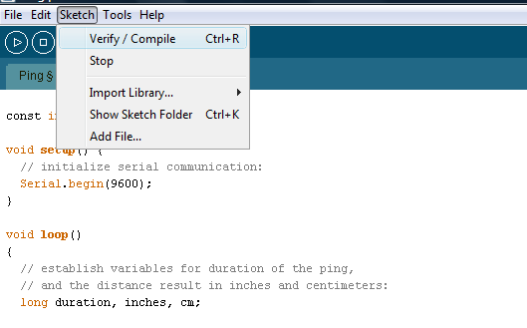

After the program is compiled, the Arduino USB board can be connected to the computer with a USB cable. Next, make sure the green light one the board is on and the correct COM port is chosen. Now, the microcontroller is ready to be uploaded to. The program is loaded onto the microcontroller by going to the “File” menu and selecting “Upload to I/O Board”.

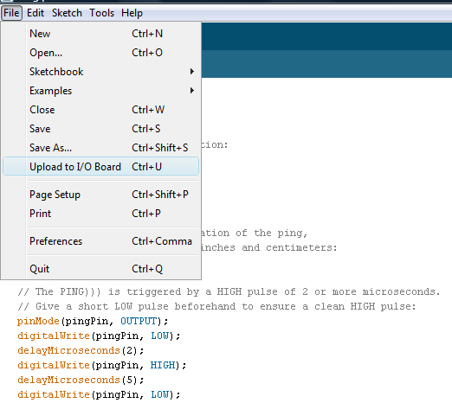

  - Power Supply
The power supply of ParkBot would need to be properly configured to successfully deliver the amount of current or voltage handle by the electronic components added to the RC car to make ParkBot. As previously discussed, the three different kind of ways to operate the power supply of the project are solar power, disposable batteries, or rechargeable batteries; and of the three possible ways researched, the most suitable and efficient way for the project is by using rechargeable batteries since the project would be run many times to ensure proper execution and during testing. By choosing rechargeable batteries for the power supply the overall price is not increase and the batteries can be reuse as many times if properly used. The three rechargeable batteries discussed were lithium ion (Li-ion), nickel cadmium (NiCd), and nickel metal hydride (NiMH). After comparing the benefits and limitations of each of the rechargeable batteries discussed, NiMH will be use as the power supply for ParkBot since this kind of technology delivers 30-40% more current to the components added to ParkBot. NiMH is use in high-drain applications and with more capacity, these batteries give longer battery life and freedom of memory effect NiCd has. The components that need to be power are the servos, h-bridge, sensors, and microcontroller. Table 9 shows the power consumption of the components used on the project.

 | Current | Voltage
Arduino Duemilanove - ATMEGA 328 | 40mA | 7-12v (9V)
Ping ultrasonic sensors | 30mA | 5V
H-bridge | 2000mA | 5V
Servos | ----------- | ------------
Receiver | 2.4mA | 5V
Table 9 – Power Consumption for Components
Table 9 above summarizes the power requirements of the components added to the RC car. That is a total of 2072.4mA current needed for the components added to ParkBot to work properly and allow ParkBot to successfully execute. Since NiMH was selected for the technology of the power supply, the current is not going to be an issue and an external power supply for the elements added to the RC car is not necessary. Therefore, the power supply of ParkBot will be divided in only two; one of the power supplies is for the components added and the other one which is the existing power supply that comes with the car is for the servos and steering. There is still unsure if the existing power for that comes with the RC car will meet the requirements to operate the steering and servos as desired. If there is the possibility that the existing power needs to be remove, another power supply could be incremented to the project in the case that the current needed will be greater than the one deliver by the batteries. As previously describe current would not be an issue, but the power would need to be regulated to linearly generate a steady amount of voltage need it by the components added. Since there are three components that need 5v to operate, a 5V voltage regulator could be implemented to give a steady voltage to the three components. The only component that needs a different voltage than 5v is the microcontroller that would need a voltage of 9v to operate. Therefore, a 9v regulator would need to be implemented on the board to properly operate the microcontroller. The NiMH selected must be greater than 9v and 2072.4mA to properly deliver all the require power. It also important to have in mind how to connect the batteries if more than a pack is use for ParkBot. For instance if the batteries are connected in series the voltage is double maintaining the same capacity or amp hours and if the batteries are connecting in parallel the voltage is kept the same but the capacity is double.
PROTOTYPE

Since the mounting and location of the different components of ParkBot is vital to the proper operation of ParkBot, a proper building method must be planned out before any type of real building can begin. This section details the building of each of the main components of ParkBot.

  - Parts Acquisition

All of the components of ParkBot will be acquired with an even contribution of money from each group member. Any company sponsorship or other outside funding will most likely not be acquired. All of the components of ParkBot will be acquired through a retail store or through an online retailer. The Ultrasonic sensors, IR remote control and receiver, Arduino USB microcontroller module, solderless breadboard, H-bridge chip, and Silverlit Electric R/C car will be acquired from online retailers. The reason for acquiring these parts from online retailers is because of lower prices than retail stores and the fact that some of the needed components for ParkBot are not available in retail stores. The Ni-MH battery pack will be most likely acquired from Radio Shack. Any small parts that are needed such as resistors, capacitors, transistors, wires, and connectors will be acquired through a retail store such as Radio Shack. All of the components of ParkBot will be bought and received by the beginning of February. Having all of the parts by that time will give us enough time to build and test ParkBot.

  - Building Method
Once the R/C car is acquired, it will be tested for general functionality with the given RC remote. This is to ensure that the motors are running properly, and the steering servo is working properly. The steering servo will be tested with the given RC remote for its proportional steering to ensure that the wheels are turning at specific angles and not just to the left at one angle and to the right at one angle. As we acquire each of the other components for ParkBot, they will be tested for functionality in general and with the microcontroller. Once functionality is confirmed with each component of ParkBot, they will be ready to be mounted if they are not mounted already. After they are mounted, they will be ready to be wired to the microcontroller and power supply. Before building is started a few building considerations need to be thought about first. We must ensure that the obstacle avoidance sensors are mounted at the correct height. The height that the sensors need to be at will be detailed in the test section. We also must ensure that the IR receiver is mounted in a place where the user’s remote control can have a direct line of sight with it. Also, all components that need to be mounted on the chassis of ParkBot, such as the breadboard, Arduino USB microcontroller module, battery pack, obstacle avoidance sensors, etc., must be mounted in such a way that it cannot fall off during operation. Everything needs to be secured in some way. The way each component will be mounted and wired will be described in this section.

  - Motor
The motor of ParkBot will already be mounted, connected to the rear wheels, housed properly and ready to go. All that needs to be located with the motor is the positive and negative terminal wires. The positive terminal wire will be red and the negative terminal wire will be black. As with the steering servo, before any wire cutting can occur, we need to ensure that the battery pack on the R/C car is not connected. It is vital that this step is observed. Now, the motor’s housing must be opened in order to determine where the positive and negative terminal wires are. The positive and negative terminal wires will be the only two wires coming out of the motor. Once the housing is opened, the motor will be carefully observed to see where the positive and negative terminal wires are. Once the two wires are found, they will be cut to the longest length possible. When it is time to wire the motor to the H-bridge chip on the breadboard, if the wire is not long enough, a black wire of proper length will be added to the wire of the negative terminal of the motor, and a red wire of proper length will be added to the wire of the positive terminal in order for the both of the wires to reach the H-bridge chip on the breadboard.
Something that will be taken into consideration before any wires are cut is the existing speed / direction control system in the R/C car. How the R/C car controls the direction and speed of the motor is unknown at this time and will not be known until the R/C car is acquired. Once the R/C car is acquired, the existing speed and direction control system will be looked at to see if could be used with the microcontroller. Part numbers will be acquired from the speed / direction control circuit. The part numbers will be used in research of how this speed / direction control circuit works. If a way is found to connect this circuit to the Arduino USB microcontroller module, then this circuit will be used in place of the H-bridge chip.

  - Chassis
Once we have the R/C car, we will take the cover of the car off. This will reveal the chassis that we will be using for ParkBot. All of the components of ParkBot will be attached to this chassis. The parts that must be mounted are the breadboard, IR receiver, Ultrasonic obstacle avoidance sensors, Arduino USB microcontroller module, and Ni-MH battery pack. The steering servo and motor will already be attached to the chassis. On the front bumper of ParkBot, we will mount one L-shaped bracket that will hold the front obstacle avoidance sensor. On the each side of ParkBot’s chassis, an L-shaped bracket will be mounted which will hold each of ParkBot’s side sensors. A small wooden platform will be made to mount the Microcontroller and breadboard. This wooden platform will be mounted in the center of ParkBot’s chassis. The microcontroller will be mounted on the wooden platform first, and then the breadboard will be placed in the middle of the microcontroller board. Careful consideration must be taken to ensure that the breadboard is high enough for the IR receiver to have a clear line of sight with the user’s remote control transmitter. The breadboard will be attached by a piece of Velcro that will be stuck on the bottom of the breadboard and on the top of the microcontroller chip. The battery pack will be mounted by means of Velcro also. A piece a Velcro on the bottom of the battery pack will be attached to a piece of Velcro on the wooden platform.

  - Steering Servo
The steering servo on ParkBot will already be, mounted, connected to the front wheels, housed properly, and ready to go. All that needs to be located with the steering servo is the signal wire. Before any wire cutting can occur, we need to ensure that the battery pack on the R/C car is not connected. It is vital that this step is observed. Now, the steering servo’s housing must be opened in order to determine where the signal wire is. Once the housing is opened, the steering servo will be carefully observed to see where the power, ground, and signal wires are. The signal wire will be the wire that is not red or black. The red and black wires will be the power and ground wires, respectively. Once the signal wire is found, it will be cut to the longest length possible. When it is time to wire the steering servo to the microcontroller, if the wire is not long enough, a wire of the same color will be added to in order for the wire to reach the one of the microcontroller’s digital I/O pins.

  - Obstacle Avoidance Sensors
The best way to mount each Ping Ultrasonic Range Finder to ParkBot would be to buy a bracket that would stand about six inches from the floor mounted to on the front of ParkBot and on the sides of ParkBot taking in consideration the height of ParkBot is away from the ground. Two of the Ultrasonic sensor will be mounted onto a bracket that will be attached on both sides of the chassis of ParkBot, and the third will be mounted in front of ParkBot mounted on a bracket attached to the front bumper. Each bracket will be secured so that the vibration that ParkBot generates with the movement from the steering and acceleration from the motor so that it will not interfere with operation of each sensor. Each sensor’s power pin and ground pin will be wired to the breadboard by soldering a wire to each of the power and ground pins and then connecting the wire to the proper positive and negative terminals on the breadboard. The sensors will be wired in parallel. Parallax Labs tested one Ultrasonic sensor at 40in from the ground. It was able to detect a box that was 12in by 12in and a cylinder that was four feet tall and less than 10in in diameter. We will use this case when taking into consideration how high we need to mount each sensor on ParkBot.

  - IR Remote Control / Receiver
The IR receiver’s pins will be connected directly to the breadboard. Since careful consideration was taken when mounting the breadboard to ensure that the IR receiver would be high enough to be in the line of sight of the user’s remote control transmitter, we do not have to worry about fabricating a bracket for the IR receiver. The signal pin will be wired to the microcontroller, while the power and ground pins will be wired on the breadboard just as described in the breadboard design section. The remote control transmitter will be carried by the user and will be independently powered.

  - Microcontroller

Most of the components and how they will be connected to the microcontroller module was already described in great detail. Also, the mounting of the microcontroller has already been described. The microcontroller will be mounted just as described in the chassis section in prototyping. Also, the wiring diagram can be found in the microcontroller design section.

  - Power Supply

The external power supply outside of the existing power supply that comes with the R/C car will be a 9.6V Ni-MH battery pack. The mounting of this power supply was described in the chassis prototyping section. Since this power supply does not have to proper connector to be directly connected to the Arduino USB microcontroller board, we must attach the proper connector to the positive and negative wires of the battery pack. A 2.5mm power plug will need to be connected to the negative and positive wires of the battery pack. The negative and positive wires of the battery pack will be soldered to the negative and positive terminals, respectively. The connector is shown with soldered wires in Figure 41.

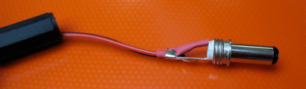
Figure 41 – Power Connector for Arduino
(Permission Pending)

Since the connector of the battery pack needs to be preserved in order for it to still be able to be connected to the charger, the positive and negative terminal wires of the battery pack cannot just be cut and soldered to the 2.5mm power plug. A compatible male connector with the existing female connector on the battery pack will be found. Two wires, one black and one red, will be attached to the acquired male connector. The black wire will be connected to the negative terminal on the male connector, and the red wire will be connected to the positive terminal on the male connector. These wires will then be connected to the 2.5mm power plug in the manner described before.

  - Voltage Regulator

Initially, we have determined that a voltage regulator is not exactly necessary. If a situation arises where most of the components of ParkBot have trouble keeping constant voltages, have voltages that drop too low at times, or have extreme voltage spikes, then a voltage regulator will be used between the Ni-MH battery pack and the microcontroller power plug. The voltage regulator will help alleviate the problems already stated. The voltage regulator will just simply be placed on the breadboard and has three pin-outs, input voltage, output voltage, and ground pins. The positive terminal wire from the male connector to the battery pack will be connected to the input pin on the voltage regulator. The negative terminal wire of the male connector will be connected to the ground pin of the voltage regulator. The positive terminal wire of the 2.5mm power plug of the Arduino USB microcontroller module will be connected to the output pin of the voltage regulator. The negative terminal wire of the 2.5mm power plug of the Arduino USB microcontroller module will be connected to the ground pin of the voltage regulator.
TEST

Testing of the operations of ParkBot is very vital to the success of this project. Before the final testing of every one of ParkBot’s operation performed in succession, a series of initial tests must be performed in order to test the individual components of ParkBot. After testing the individual components, portions of ParkBot’s three algorithms will be fine tuned to test certain values. Once these values are adjusted to the correct values, ParkBot’s final testing of all three algorithms performed in succession can be performed. This section gives details on the different tests that will be performed on the individual components of ParkBot and on the final testing scenarios.

  - Environment

ParkBot will be tested in a small scale mock parking lot that will be 12 feet in length by 6 feet in width. The total space in between the left and right parking spots will be 3 feet. Since ParkBot is 4.8 inches in length, which is 0.4 feet, and will be centered in the space between the left and right parking spots, ParkBot will have 1.3 feet on each side of it. This will be sufficient room for ParkBot to properly park in a left or right parking spot. Each parking spot will be 18 inches in length which is approximately 1.7 times larger than the length of ParkBot and 7.5 inches in width which is approximately 1.5 times larger than the width of ParkBot. This will result in 19 spots on each side of ParkBot. Mock parking lot is show in Figure 42.

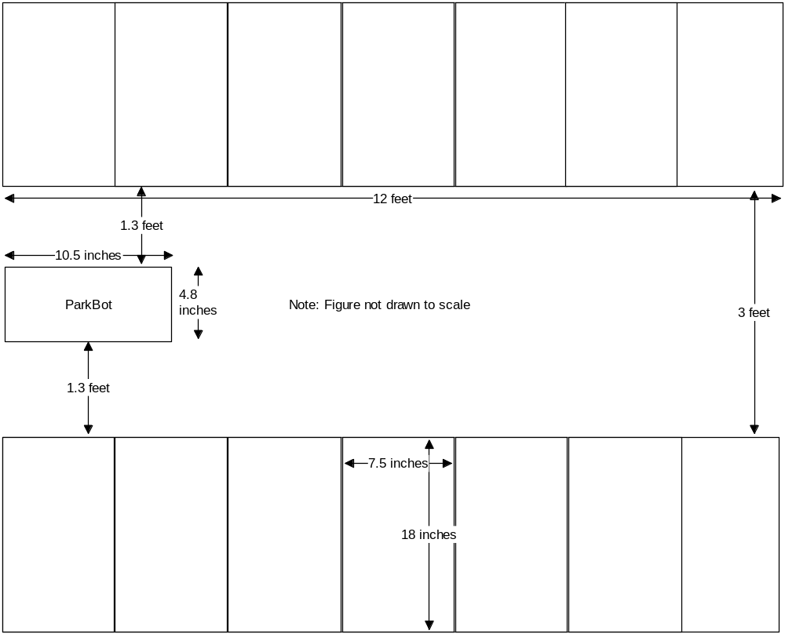
Figure 42 – Mock Parking Lot

This mock parking lot will be set up with large pieces of cardboard as the occupied spots. The opening between cardboard pieces will signify that there is an open spot.

  - Initial Testing

It is essential that these tests be performed initially before any final tests are performed. First, tests of obstacle avoidance sensors, the remote control’s IR receiver, the steering servo, and the motor will be performed. Basic tests will ensure that these components are working properly. Secondly, initial tests of algorithms will be performed which will involve fine tuning distances, durations, and steering wheel angles.

2a. Obstacle Avoidance Sensors

In addition, we will test the Ultrasonic obstacle avoidance sensor at different heights to see which height the sensor will detect at its best. We will connect the sensor to an oscilloscope to see the results of holding the sensor at different heights result. Also by connecting the sensor to the oscilloscope we could determine the voltage needed to power the sensors in order to receive proper readings from the sensor. We are hoping that the sensors will work just inches from the floor. In this way, the sensors will be more secure and close to the car. Another important thing that we have to consider is the angle that each sensor is mounted on ParkBot. The left, right, and front sensors will each be tested at different angles to determine which the best angle to have them at. This will ensure that we always get proper readings from the sensors. This is very critical because if the sensor misses the obstacle detection, a collision will occur. Now, by observation, we could say that if the Ping Ultrasonic Range Finder is inches from the floor, it should be able to detect the object just fine as if it were mounted two feet from the floor. Another test that will be run will check the voltage of the sensor with a volt meter to see if each sensor is getting the correct amount of voltage that it needs. Each sensor needs 3 to 5 volts to be able to work properly. We will be shooting to give each sensor 4 to 4.5 volts.
Once an ultrasonic obstacle avoidance sensor is obtained, the sensor can be tested for its detection of objects that are certain distances away. The objects will be set at 1, 2, 3, 4, 5, and 12 inches away from the obstacle avoidance sensors. These distance values cover most of the distance values that are used in ParkBot’s algorithms. The object that will be used is a square cut-out from a cardboard box. In order to test these values, an LED will be used. The obstacle avoidance sensor will be connected to the Arduino USB module just as described in the microcontroller design section. The positive pin of the LED will be connected to the Arduino USB module’s digital I/O pin 13, and the negative pin of the LED will be connected to the GND pin that is located on the same row as the digital I/O pins on the Arduino USB module. The sensors will be given a plus or minus 0.2 inch error range. For example, if we are checking the 3 inch distance, we will check to see if the sensor senses an object between 2.8 and 3.2 inches away. A simple “if” statement will be used to check if the sensor is reading distances correctly. For the previous example, if “distance” is the variable storing the distance between ParkBot and the object, the “if” statement would be written as “if(distance >= 2.8 && distance <= 3.2)”. If the “if” statement is evaluated to true, then the LED will be turned on using the following line of code (assuming the LED is declared as ledPin in the program): “digitalWrite(ledPin, HIGH);”. If the statement is evaluated to false, then nothing will happen, and the LED will not turn on. If this is the case, then a larger error range will be given to the sensor. The error range will be increased to 0.3, and if 0.3 is still not a large enough error range, then 0.4 will be used. No error range value beyond 0.4 will be used. If the LED still does not turn on even with the 0.4 error range, then the connections of the ultrasonic sensor to the Arduino USB module and the software code must be reevaluated. This will be repeated for all of the distances stated before that need to be tested and for all of the obstacle avoidance sensors that will be used in the project.

2b. IR Remote Control / Receiver

Once the IR remote control with its IR receiver is obtained, this network can be tested on the Arduino USB module. The IR receiver will be connected just as described in the microcontroller design section. A simple test to check whether the Arduino USB module is reading the input from the IR receiver correctly will be performed. To perform this test, a simple “if” statement will be used along with the LED used in the test of the obstacle avoidance sensor. The LED will be set up just like it was set up in the test of the obstacle avoidance sensor. If the IR receiver is declared as irPin in the program, the “if” statement in the code of the Arduino program will read: “if(pulseIn(irPin, LOW))”. If the “if’ statements evaluates to true, then the LED will turn on. If the statement evaluates to false, then the connections of the IR receiver to the Arduino USB module and the software code must be reevaluated. Also, since it is an IR network, it must be certain that the IR receiever is in the line of sight of the signal from the IR remote control.

2c. Steering Servo

Various initial tests must be performed on the steering servo that controls the angle that the front wheels of ParkBot are turned. These tests will ensure that the microcontroller is sending the correct instructions to the steering servo and will ensure that the steering servo is performing the instructions from the microcontroller properly. Testing whether the steering servo has the wheels turned at exactly a certain angle cannot be measured exactly, so a simple judgment by the human eye must be made. The steering servo will be connected to the Arduino USB module just as described in the microcontroller design section. The steering servo will be set at 90 degrees to start which is the wheels’ straight position. The steering servo will be decreased by 30 degrees every ten seconds for this test. The code for setting the steering servo angle and setting a ten second delay was described in great detail in the software design section. Decreasing the steering servo by 30 degrees every ten seconds will turn ParkBot’s wheels to the left, with respect to looking at ParkBot from the back, at angles of 60, 30, and 0 degrees to the left. Judgment must be made as to whether the wheels are close to being turned at 30 and 60 degrees to the left. 0 degrees will have the wheels turned completely to the left. If this test goes well, ParkBot’s wheels will be returned to the straight position. If the test does not go well, then the connections of the steering servo to the Arduino USB module and the software code must be reevaluated. Next, the steering servo will be increased by 30 degrees every ten seconds. Increasing the steering servo by 30 degrees every ten seconds will turn ParkBot’s wheels to the right, with respect to looking at ParkBot from the back, at angles of 60, 30, and 0 degrees to the right. Judgment must be made as to whether the wheels are close to being turned at 30 and 60 degrees to the right. 0 degrees will have the wheels turned completely to the right. If this test goes well, the testing of the steering servo is now complete. If the test does not go well, then the connections of the steering servo to the Arduino USB module and the software code must be reevaluated.

2d. Motor
The remote controlled car that we will be purchasing will be equipped with a motor already installed. Motors need a lot of energy, especially cheap motors since they're less efficient. The first important thing to figure out is that the motor is getting enough voltage. The website he car listed on did not have specifications for the motor. The car will be equipped with a 6V power supply, and this is common. The datasheet for the motor drive states 1-A output current capability per driver pulsed current 2-A driver wide supply voltage range is 4.5 V to 36 V. Voltage measurements will be taken in order to figure out how many volts the motor is getting.
The L293NE H-bridge will need to be tested to assure it is functioning as desired with respect to the requirements. To begin, the motor can be connected to the left side of the chip with the terminals connected to Pins 3 and 6. Then motor can be connected to the left side of the IC chip at Pins 11 and 14. If there is movement of the car, in the desired direction, then the test can be deemed successful. If the direction is not the desired one, either the code needs to be altered for pin assignment or the terminals from the motor need to be swapped.
Various initial tests must be performed on the motor that controls the forward and backward movement of ParkBot. Since the motor is controlled by an H-bridge chip, the signals from the microcontroller will be processed by the H-bridge which will send the corresponding signals to the motor to move backwards and forward. These tests will ensure that the microcontroller is sending the correct instructions to the H-bridge chip and will ensure that the H-bridge is decoding the instructions from the microcontroller properly. The motor will be connected to the H-bridge circuit just as described in Figure 34. The H-bridge chip will be connected to the Arduino USB module just as described in the microcontroller design section. The motor will be turned on in forward mode for ten seconds, stopped for ten seconds, in reverse mode for ten seconds, and then the test will be repeated again from the beginning. The software code needed to perform this test was described in great detail in the software design section. A stop watch will be used in order to determine if ParkBot performed the individual tasks for the predetermined amount of time. This test will be given a plus or minus 0.5 second error range to account for the inaccuracies of the reflexes of a human. If the test goes well and ParkBot does not go out of the 0.5 second error range and does perform all of its tasks correctly, then the testing of the motor is completed. Otherwise, the connections of the H-bridge chip to the Arduino USB module, the connections between the H-bridge and the motor, and the software code must be reevaluated.

2e. Algorithms

ParkBot is run entirely based on algorithms. Rigorous testing of these algorithms is vital to the proper operation of ParkBot. All three algorithms will feature multiple tests that will fine tune various instructions of the algorithms in order for everything to run smoothly.

2e.i. Detect Parking Spot / Move Forward
The first series of tests will fine tune the algorithm that moves ParkBot forward and detects whether a parking spot is occupied or not. Since ParkBot does not feature any type of braking system, the only way that ParkBot stops is when ParkBot comes to a rest after the motor has been turned on for a designated amount of time. The first initial test to perform is to see how long the motor must be turned on for ParkBot to move from one parking spot to another. Also, this initial test must be performed on a flat, smooth tile surface. This will be the surface that the final presentation will be performed on, so it is important that the test is performed on this surface. Initially as a starting point, the motor will be turned on for one second. After the motor is turned on for one second, the distance will be measured. This will be repeated ten times due to the fact that ParkBot will not travel the same exact distance every time the motor is pulsed on for one second. This inconsistency is due to slippage in the wheels with the surface which varies with each run. Major differences between the measured distances are not expected. An average of the distances will be taken in order to determine the average distance that ParkBot travels when the motor is pulsed on for one second. If the average distance is within plus or minus 0.1 inches the width of a parking spot which is 7.5 inches, this initial test is now complete. If not, the duration that the motor is turned on must be adjusted accordingly. Duration needs to be increased if the average distance is less than 7.5 inches and needs to be decreased if the average distance is greater than 7.5 inches. The amount that the duration needs to be increased or decrease will be a judgment call according to how far off the average distance is from 7.5 inches. Duration is easily modified in the software code by modifying the value passed to the delay instruction that is located after the instruction for the motors to turn on. Once a new duration is determined, the same testing process that was performed before will be repeated. This entire process will be repeated until the average distance that ParkBot travels is within the range of 7.4 to 7.6 inches.

Another consequence of ParkBot not featuring a braking system is the fact that ParkBot will come to a complete stop only after a certain time period. Accurate obstacle avoidance sensor readings can only be done when ParkBot comes to a complete stop. This will be tested in concurrence with the previous test. In addition to measuring the distance that ParkBot travels when the motor is pulsed on for one second, the time starting from the moment ParkBot starts to move forward to the moment that ParkBot comes to a complete stop will be measured. This will be performed ten times and then average time duration will be calculated. Major differences between time values are not expected. The differences would be due to human error in measuring time between when ParkBot starts and then stops moving. This time value will be tied to the fact that the motor was pulsed on for one second. If the one second motor turn-on duration is used, then testing is completed. If additional motor turn-on duration must be tested, the time that ParkBot takes to come to a complete stop must be calculated again and will be calculated for every value of motor turn-on duration that is tested. Once a proper motor turn-on duration is found, the time for ParkBot to come to a complete stop is now known. The value will be changed in the delay instruction after the instructions are given to the motors to turn off.

Lastly, for the pull detect parking spot / move forward algorithm, a test must be run in order to see how long the motor must be turned on for ParkBot to move 1.5 inches. To determine the duration that ParkBot’s motor must be turned on in order to travel 1.5 inches, the first test of this algorithm will be repeated until the desired results are achieved.

2e.ii. Pull Into Parking Space
The second series of initial tests will be fine tuning that algorithm that pulls ParkBot into an open parking spot. When ParkBot pulls into a parking spot, the wheels of ParkBot are turned to ParkBot’s steering servo’s upper limit initially. The wheels will be turned to the left if ParkBot is pulling into a spot on its left or turned to the right if ParkBot is pulling into a spot on its right. After this, ParkBot’s motor will be pulsed on for one second. Then, the angle of the steering servo will be decreased by 15 degrees, and the motor will be pulsed on for one second again. This will be repeated until the wheels of ParkBot are back to their neutral position (steering servo will be at 90 degrees). The steering servo angle can be modified in the software code by modifying the value that is passed to “steerServo.write();”. The first test that will be run for this algorithm will fine tune the angle that the steering servo will be decreased by every time the motor is pulsed on for one second. The steering servo angle must be decreased every time the motor is pulsed on such that ParkBot will be completely straight when the wheels get to the neutral (straight) position. During this test an open spot will be set up for ParkBot to park in. ParkBot will run this algorithm with the steering angle set to decrease by 15 degrees after each time the motor pulses on for one second. This will be run ten times, and after each run, an assessment will be taken to judge how straight ParkBot is in the parking spot. A rating from 1 to 5 will be given as to how straight ParkBot is in the parking spot with 5 being the most straight and 1 being the most crooked. After the ten runs, an average of the ratings will be taken. If the average rating ends up being 4.5 or better, then this test is completed, and the initial assumption to decrease ParkBot’s steering angle by 15 degrees is correct. If the average rating ends up being less than 4.5, then the degrees to decrease the steering angle by must be adjusted according to the average rating and in what direction ParkBot is crooked. If ParkBot is crooked by being angled toward the car to its left if ParkBot is pulling into a spot on its left or by being angled toward the car to its right if ParkBot is pulling into a spot on its right, the angle that the steering servo is decreased by must be decreased. If ParkBot is crooked by being angled toward the car to its right if ParkBot is pulling into a spot on its left or by being angled toward the car to its right if ParkBot is pulling into a spot on its right, the angle that the steering servo is decreased by must be increased. These two scenarios are better described and depicted in Figure 43. This test will be performed until ParkBot gets an average rating of 4.5 or better.
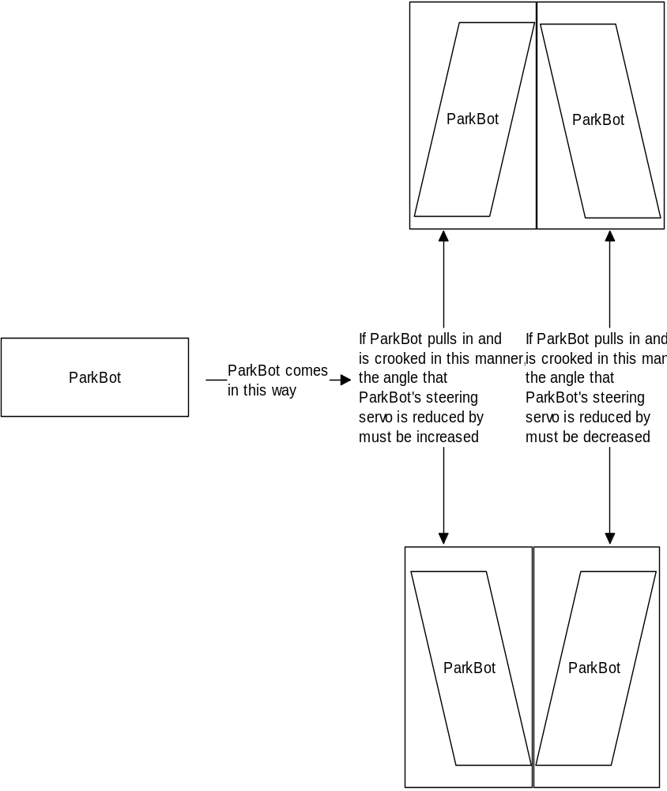
Figure 43 – Parking Scenarios

Once ParkBot is completely straight, ParkBot now must pull to within 3 inches of the front barricade of the parking spot. Initially, the motor will be pulsed on for one second and then the front sensor will be checked to see the distance between ParkBot and the front barricade. As tested before, the distance that ParkBot travels when the motor is pulsed on for one second must be less than three inches. If ParkBot is 3.1 to 4.9 inches away from the front barrier and the motor is pulsed on for one second and ParkBot ends up traveling 3.0 inches, then we are below 2.0 inches away from the front barricade which violates our specifications. For this test, the motor turn-on duration must be determined for ParkBot to travel one inch. If ParkBot ends up being 3.1 inches from the barricade and we pulse on the motor so that ParkBot travels one inch, then we will be at 2.1 inches away from the front barricade which does not violate ParkBot’s specifications. To determine the duration that ParkBot’s motor must be turned on in order to travel one inch, the first test of the first algorithm will be repeated.

2e.iii. Pull Out of Parking Spot / Move Backwards
Since ParkBot will perform the same operation as pulling into the parking spot except in reverse, all of the proper values acquired from testing the pulling into the parking spot algorithm will be valid for the pull out of parking spot algorithm. The same testing process will be performed for this algorithm as done previously for the pull into parking spot algorithm. The only difference is that the wheels will be turned to the right if ParkBot pulled into a spot that was on its left or turned to the left if ParkBot pulled into a spot on its right, and the motor will be run in reverse mode. Another difference will be that instead of the wheels going from completely turned to completely straight, the wheels will be going from completely straight to completely turned. First, the motor will be turned on in reverse for the amount of time determined from the testing of the pull into parking spot algorithm and will be turned on the same number of times that it was turned on to pull into the parking spot fully after ParkBot was properly aligned. After this, the steering servo angle will be gradually increased by the final value determined by the testing of the pull into parking spot algorithm (value not known at this time) with the motor being turned on for one second after every angle adjustment. If the test goes well and ParkBot pulls out of the parking spot properly without hitting adjacent cars, then the testing of this algorithm is completed. Otherwise, the value that the steering servo angle is increased by must be adjusted and retested. The angle will be adjusted and retested until the desired results are achieved.

  - Final Testing

Now that all initial testing has been completed and each individual component has been tested for functionality, it is now time to put everything together and perform some final testing. The final testing phase of the project will involve testing all of the scenarios that will be shown in the final presentation. All algorithms will be run in order in all of the final testing scenarios. In the first scenario ParkBot will encounter a stopped car in its path in the middle of looking for an open spot. ParkBot will wait until the car starts moving forward and is sufficiently far away for ParkBot to move forward and continue to look for an open parking spot. This scenario is depicted in Figure 44.

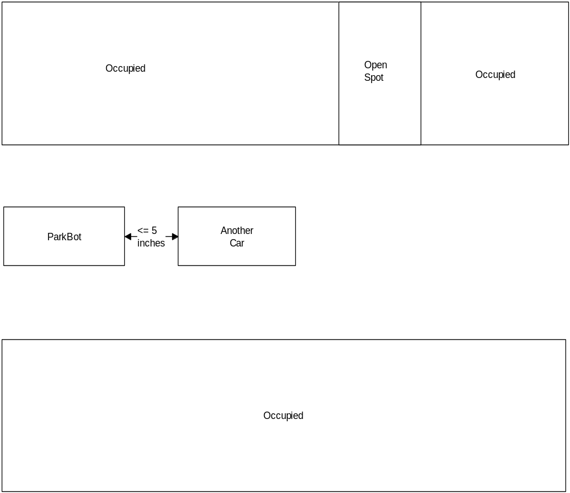
Figure 44 – Testing Scenario 1

A few different tests will be run for this first scenario. ParkBot will begin by starting to look for an open parking spot. Then, ParkBot will encounter a stopped car and will get to within 5 inches of the stopped car before stopping to wait for the car that is blocking its path to move. The car blocking ParkBot will be kept there for one minute to ensure that ParkBot is constantly checking the front sensor properly. The car blocking ParkBot will then pull away from ParkBot completely so that ParkBot has a clear path to the open parking spot. ParkBot will then pull into the available parking spot on its left. This will simulate that the car in front of ParkBot is waiting for another car to pull into a spot that it was waiting for. After all of the rigorous initial testing, ParkBot should have no problem completing this test successfully. If any problems are encountered, the particular issue, whether it be a sensor problem, steering servo problem, or a problem with any other component, will have to be addressed using the initial tests already performed. This will be done until ParkBot has successfully completed this test. Another test that will be performed on this scenario will involve moving the car blocking ParkBot twice. Also, the open parking spot will be moved to the right of ParkBot instead of the left. ParkBot will begin by starting to look for an open parking spot. Then, ParkBot will encounter a stopped car and will get to within 5 inches of the stopped car before stopping to wait for the car that is blocking its path to move. The car blocking ParkBot will stay for 30 seconds, and then it will be moved forward 3 inches, and will start pulling into a parking spot. ParkBot will move forward to get within 5 inches of the car blocking it. The blocking car will stay in this spot for 30 seconds. After 30 seconds, the car will pull completely into the spot and will be out of ParkBot’s way. ParkBot will now continue to look for an open parking spot. When ParkBot finds the open spot that is located to its right, ParkBot will then pull into that available parking spot. This test simulates a car that is waiting for a parking spot, and then when the parking spot clears, they will start to slowly pull into the parking space. The car will pull into the spot slow enough for ParkBot to have to pull forward and wait again for the car to completely get out of its way. This will test to see if ParkBot’s front sensor is checking to see if there is a car in its way, and then rechecking after a readjustment to see if the car that was blocking it has stopped again. After all of the rigorous initial testing, ParkBot should have no problem completing this test successfully. If any problems are encountered, the particular issue, whether it be a sensor problem, steering servo problem, or a problem with any other component, will have to be addressed using the initial tests already performed. This will be done until ParkBot has successfully completed this test. This completes the testing for the first scenario.

ParkBot has now successfully avoided hitting a car that was in its way while looking for a parking spot and has successfully found and parked in the first available parking spot on its right and left. In the second scenario, ParkBot will find an available parking spot that is too small for ParkBot to fit in it. This will simulate that a car has parked poorly and did not leave enough room for ParkBot to fit in the parking space. After ParkBot determines that the parking spot is not large enough, then ParkBot will move on and try to find an open parking spot that is large enough. To simulate this, the parking spot will be made 6 inches in width instead of 7.5 inches. After all of the rigorous initial testing, ParkBot should have no problem completing this test successfully. If any problems are encountered, the particular issue, whether it be a sensor problem or a problem with any other component, will have to be addressed using the initial tests already performed. This will be done until ParkBot has successfully completed this test. This testing scenario is shown in Figure 45.

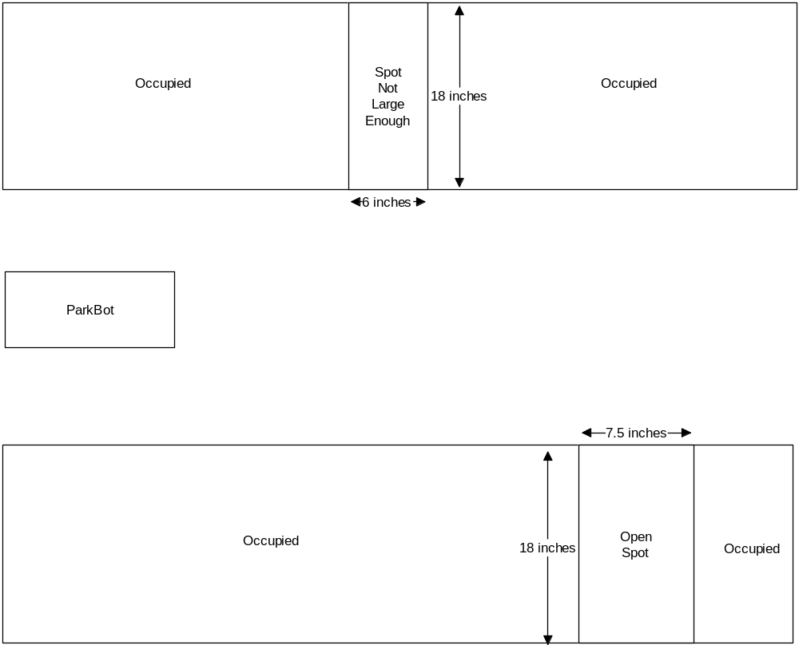
Figure 45 – Testing Scenario 2

The next scenario will test to see if ParkBot ceases execution after not finding any open parking spaces. To test this, all of the parking spaces will be occupied, and ParkBot will check each and every spot to see if it is open or not. Once ParkBot has checked every spot and has deemed every spot as occupied, then ParkBot will stop and completely cease execution. This scenario is depicted in Figure 46.

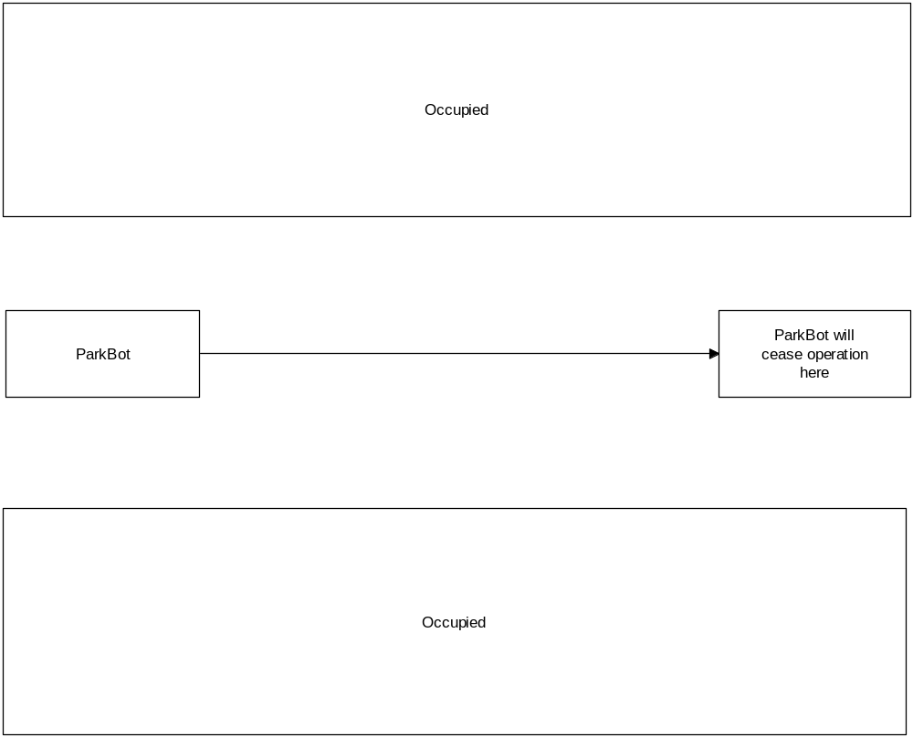
Figure 46 – Testing Scenario 3

After all of the rigorous initial testing, ParkBot should have no problem completing this test successfully. If any problems are encountered, the particular issue, whether it be a sensor problem or a problem with any other component, will have to be addressed using the initial tests already performed. This will be done until ParkBot has successfully completed this test.

The final test scenario will not involve cars blocking the way of ParkBot’s quest to find an open spot nor will it involve P\arkBot finding a parking spot that is too small for it to park in. The final test scenario will just have an open spot on the right first, then an open spot on the left 1 foot later. Both of the parking spaces will be large enough for ParkBot. ParkBot will determine that the spot on its right is open and will park in it. Figure 47 describes this scenario.
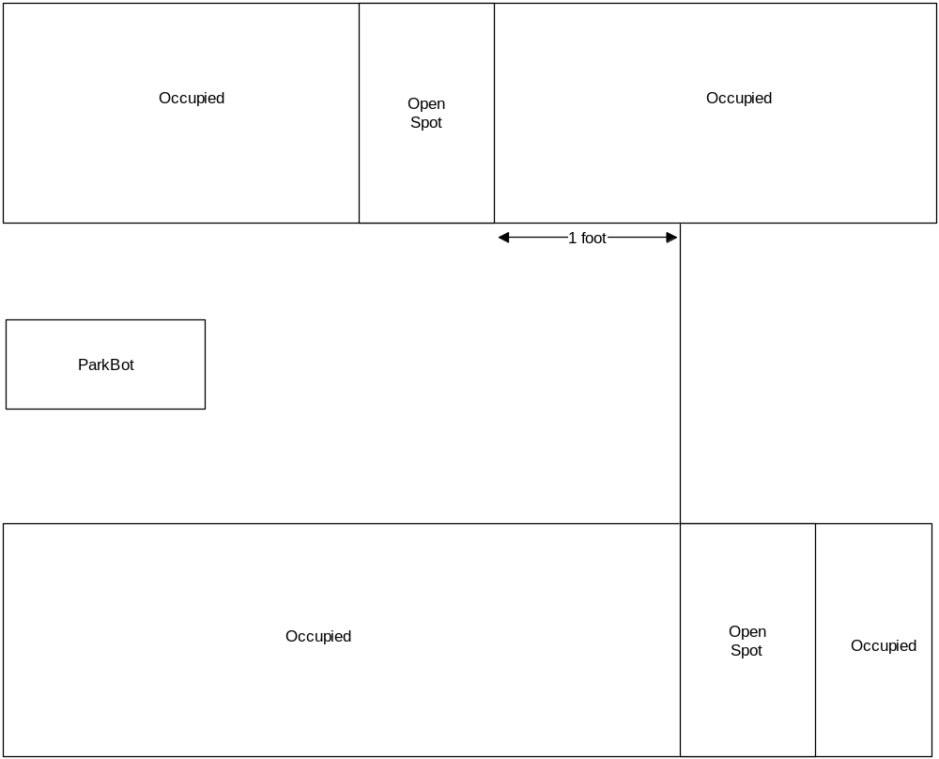
Figure 47 – Testing Scenario 4

After all of the rigorous initial testing, ParkBot should have no problem completing this test successfully. If any problems are encountered, the particular issue, whether it be a sensor problem, steering servo problem, or a problem with any other component, will have to be addressed using the initial tests already performed. This test will simulate the most typical scenario that ParkBot should encounter if it was going to be implemented in a full scale motor vehicle. After all of the rigorous initial testing, ParkBot should have no problem completing this test successfully. If any problems are encountered, the particular issue, whether it be a sensor problem, steering servo problem, or a problem with any other component, will have to be addressed using the initial tests already performed. This will be done until ParkBot has successfully completed this test. This completes the testing for the final scenario.
ADMINISTRATIVE DETAILS

  - Budget

ParkBot will be entirely funded by the members of the group with no financial assistance from any companies or outside sources. The cost of the project will be split evenly among group members. Since the project will be entirely funded by contributions from each group member, we must ensure that the parts being acquired are necessary and of high quality to last for the duration of the project. We feel that enough research was done in order to acquire the best parts. If problems are encountered with parts such as failures, we expect the budget to rise due to the need of getting another one of the parts that failed. Each group member will be purchasing individual parts on their own. At the end of the project, receipts from all of the purchases will be gathered, and the money spent by each group member will be tallied. Compensations between group members will be made in order to ensure that each group member spent the same amount of money. Table 9 shows the cost of the entire project as a whole. Table 10 will show the breakdown of who is going to acquire which part, and Table 11 will show compensations that we expect to make to ensure that everyone spends an even amount of money.

Part | Quantity | Price per Quantity | Total
Silverlit Electric 1:16 Official Licensed Porsche Carrera RC Car | 1 | $39.99 | $39.99
 | 3 | $29.99 | $89.97
  Parallax PING))) Ultrasonic Sensor
9.6V, 1600mAh Ni-MH Battery Pack and Charger | 1 | $19.99 | $19.99
Parallax IR Remote Kit (Transmitter/Receiver) | 1 | $12.99 | $12.99
Arduino Duemilanove USB Microcontroller Module | 1 | $29.99 | $29.99
Solderless Breadboard | 1 | $3.99 | $3.99
H-bridge chip | 1 | $2.39 | $2.39
Mounting hardware | 1 | $10.00 | $10.00
Miscellaneous (wires, resistors, etc.) | 1 | $5.00 | $5.00
SUB TOTAL |  |  | $214.31
TAX (6.5%) |  |  | $13.94
GRAND TOTAL |  |  | $228.25
GRAND TOTAL divided between 4 group members |  |  | $57.07

Table 9 – Expected Budget

Part | Purchasing Group Member | Price
Silverlit Electric 1:16 Official Licensed Porsche Carrera RC Car | Danielle | $39.99
 | Victor M. | $89.97
  Parallax PING))) Ultrasonic Sensor
9.6V, 1600mAh Ni-MH Battery Pack and Charger | Victor R. | $19.99
Parallax IR Remote Kit (Transmitter/Receiver) | Victor R. | $12.99
Arduino Duemilanove USB Microcontroller Module | Jason | $29.99
Solderless Breadboard | Jason | $3.99
H-bridge chip | Jason | $2.39
Mounting hardware | Victor R. | $10.00
Miscellaneous (wires, resistors, etc.) and tax | Shared expense | $18.94

Table 10 – Break down of group member purchases

Group Member | Total Spent | Total group member must spend | Difference
Jason | $41.11 | $57.07 | Will owe $15.96
Danielle | $39.99 | $57.07 | Will owe $17.08
Victor M. | $89.97 | $57.07 | Will be compensated for $32.90
Victor R. | $42.98 | $57.07 | Will owe $14.09

Table 11 – Compensations

  - Project Timeline

Depicted on the next page is the project timeline complete with approximate completion dates of the different phases of building and testing that will be accomplished in Senior Design 2. The timeline spans the entire spring semester and will keep us on track in order to have a successful final presentation.
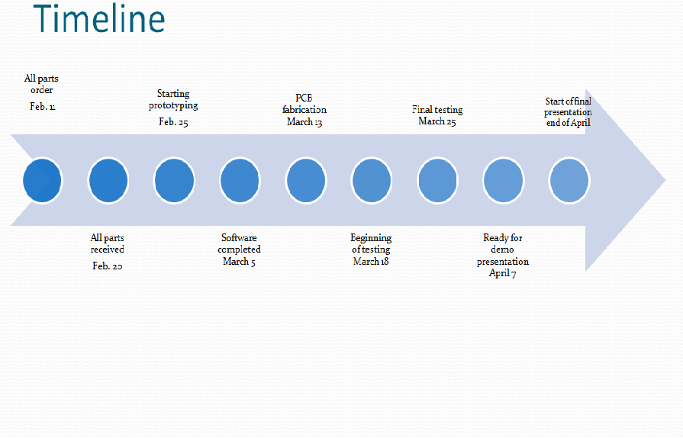
APPENDICIES

- Copyright Permissions

From: Victor Morales [mailto:osmosis25@hotmail.com]
Sent: Monday, November 30, 2009 6:06 AM
To: Sales; JavelinTech; Support; Webmaster
Subject: Hello my name is Victor and I have a quick question
To whom may concern:
Hello my name is Victor Morales. I'm a student at the University of Central Florida. As right now I'm taking a Senior Design class and me and my group we are writing our Senior Design project which is a autonomous remote control car that will self park. My question to you is if I could use some of the pictures and research on the products Ping Ultrasonic Range Finder, TSL 1401 Linescan Imaging Sensor Daughterboard and the IR Remote Parts Kit on my paper. I will appreciate your approval at soon as possible.
Sincerely
Victor Morales
Subject: FW: Hello my name is Victor and I have a quick question
Date: Mon, 30 Nov 2009 10:22:07 -0800
From: slindsay@parallax.com
To: osmosis25@hotmail.com
Hello Victor,

You are more than welcome to use pictures and excerpts from our online product documentation for your Senior Design paper and presentation materials. Please just cite your sources as you would do in any academic work. You may use "Copyright Parallax Inc.; used with permission" or whatever attribution is required by your professor. We wish you well with your project!

Best regards,

-Stephanie

Stephanie Lindsay
Technical Editor
Parallax Inc.
www.parallax.com
On Fri, Dec 11, 2009 at 10:48 AM, Danielle Anderson <danid333@att.net> wrote:
Hello,
I am a senior at the Univ. of Central Florida. I am emailing to ask permission to reprint the first figure on your website of the basic h-bridge in my senior design research paper.
Thank you for your time,
Danielle Anderson

From:
  Roger Korus <rkorus@gmail.com> |  |  | Save Address |  |  | Reminder
To: | Danielle Anderson <danid333@att.net>
Subject: | Re: Roko.ca - Permission to re-print photo
Date: | Friday, December 11, 2009 9:42:52 PM [View Source]

Sure thing.
Roger

-----Original Message-----
> From: danid333@att.net [mailto:danid333@att.net]
> Sent: Thursday, December 10, 2009 6:10 PM
> To: webcomments@seattlerobotics.org
> Subject: Permission to reprint photo.
>
> Dear Ms. Saxton,
> I am a senior at the Univ. of Central Florida. I am emailing to ask
> permission to reprint the fourth figure on your webpage
> (www.seattlerobotics.org/guide/servohack.html) showing the unmodified and
> modified servo motor in my senior design research paper.
> Thank you for your time,
> Danielle Anderson
>
>

--------------------------------------------------
From: "Cathy Saxton" <cathy@seattlerobotics.org>
Sent: Thursday, December 10, 2009 6:36 PM
To: "'Kevin Ross'" <kevinro@live.com>
Subject: FW: Permission to reprint photo.

> Kevin, I believe that this is your page / photo. Is that correct, and may
> Danielle have permission to reprint your photos?
>
> Cathy
>
>

From: Jason Mersch <jason.m.300@gmail.com>
Date: Sun, Dec 13, 2009 at 1:49 PM
Subject: Senior design student needs permission to reprint photo
To: info@proto-advantage.com
To whom it may concern,
Hello, I am Jason Mersch, and I am a student at the University of Central Florida. Currently, I am in senior design. Could I have permission to reprint the photo of the Arduino Duemilanove 328 and 400 pts. solderless breadboard? I want to include these photos in my senior design paper.
Thank you,
Jason Mersch

