|  |
| --- |
| Low Concentration Thin Films with Solar Tracking |
| Group 11 |
| Amanda Klein  Jesse Trawick  Sean Murphy  Motiur Bhuiyan  SPONSORED BY: Progress Energy |

Table of Contents

**1. Executive Summary........................................................................................1**

**2. Project Definition………………………………………………………..…………2**

2.1 Motivation........................................................................................................2

2.2 Objective Overview.........................................................................................3

2.3 Design Specifications and Requirements.......................................................3

*2.3.1 Solar Panels……………………………………………………………3*

*2.3.2 Batteries……………………………………………………………..…4*

*2.3.3 DC/DC Converter…………………………………………………......4*

*2.3.4 Inverter……………………………………………………………....…4*

*2.3.5 Optical Reflecting Dish…………………………………………....….5*

*2.3.6 Solar Tracking…………………………………………………..….....5*

*2.3.7 Sensors………………………………………………………..……….6*

*2.3.8 Data Storage………………………………………………..………....6*

*2.3.9 Data Transmission………………………………………..………......6*

*2.3.10 User Interface…………………………………………..…………....7*

*2.3.11 Structrual Requirements…………………………………………....7*

2.4 Roles and Responsibilities.............................................................................7

2.5 Budget Overview............................................................................................8

2.6 Milestone Chart..............................................................................................9

**3. Project Research………………………………………………………….…..….10**

3.1 Research Overview......................................................................................10

3.2 Photovoltiac Research..................................................................................10

*3.2.1 Solar Panels……………………………………………………….….11*

*3.2.2 Module Efficiency………………………………………………….…11*

*3.2.3 Photovoltaic Cells…………………………………………………....12*

*3.2.4 Thin Films…………………………………………………………..…14*

*3.2.5 Silicon Thin Film…………………………………………………..….14*

*3.2.6 Cadium Telluride(CdTe)………………………………………….…15*

*3.2.7 Copper Indium/Gallium Diselenide(CIGS)……………………..….16*

*3.2.8 Gallium Arsenide(GaAs)…………………………………………....16*

*3.2.9 Dye-Sensitized Solar Cell(DSSC)………………………………....17*

*3.2.10 Organic/Polymer Solar Cells………………………………….…..17*

*3.2.11 Concentrated Photovoltaics………………………………….…...21*

3.3 Battery Bank Research................................................................................21

3.4 DC/DC Converter Research........................................................................25

3.5 Inverter Research........................................................................................27

3.6 Sensor Research.........................................................................................29

3.7 Solar Collector Research.............................................................................32

3.8 Solar Tracking Research.............................................................................39

3.9 Data Storage Research...............................................................................44

3.10 Router Research........................................................................................53

3.11 LCD Research............................................................................................55

3.12 Wireless Data Transmission Research.....................................................59

3.13 User Interface Research...........................................................................61

3.14 Research Summary..................................................................................62

**4. Project Design………………………………………………………………………...64**

4.1 Design Overview.........................................................................................64

4.2 Solar Film Design........................................................................................65

4.3 Battery Bank Design....................................................................................66

4.4 DC/DC Converter Design............................................................................67

4.5 Inverter Design............................................................................................74

4.6 Solar Collector Design.................................................................................75

4.7 Sensor Design.............................................................................................76

4.8 Solar Tracking Design.................................................................................79

4.9 Data Storage Design...................................................................................82

*4.9.1 Data Storage Hardware…………………………………………....83*

*4.9.2 Data Storage Software……………………………………………..88*

4.10 LCD Research............................................................................................90

4.11 Wireless Data Transmission Research.....................................................94

4.12 User Interface Research...........................................................................96

**5. Design Summary………………………………………………………………..98**

**6. Build Plan………………………………………………………………………..101**

**7. Testing………………………………………………………………………………….101**

7.1 Testing Overview.......................................................................................101

7.2 Equipment..................................................................................................101

7.3 Environment…………………………………………………………………...102

*7.3.1 Estimation PV System Output……………………………………102*

*7.3.2 Standard Test Conditions………………………………………....102*

*7.3.3 Temperature…………………………………………………..…....103*

*7.3.4 Dirt and Dust…………………………………………………..……103*

*7.3.5 Module Mismatch and Wiring Losses……………………..……..103*

*7.3.6 Installation Effort……………………………………………..……..103*

*7.3.7 Estimating Energy Savings………………………………………..104*

7.4 Test Plan.....................................................................................................104

*7.4.1 Control Values for the Solar Panels………………..………….…104*

*7.4.2 Control Values for the Battery Bank………………..………….…104*

*7.4.3 Testing the DC/DC Converter…………………………….…..…..105*

*7.4.4 Determining How Long the Panels Need*

*to Charge the Batteries………………………………..…….....….106*

*7.4.5 Determining Focal Point of Mirror*

*and Mounting Distance………………………………………...….106*

*7.4.6 Determing Resistance of Photo-resistors…………………..…...107*

*7.4.7 Determing Maximum and Minimum Voltages*

*For Photo-Resistor Circuit Output…………………………..……107*

*7.4.8 Testing the Movement of the Motor………………………..…….107*

*7.4.9 Testing the Data Storage Capabilities…………………………...108*

*7.4.10 Testing the Wireless Capabilities…………………………….…108*

*7.4.11 Testing the User Interface……………………………………....108*

*7.4.12 Final Efficiency Testing………………………………………….109*

*7.4.13 Determine the Running Time for the System…………………109*

7.5 Evaluation Plan.........................................................................................110

*7.5.1 DC/DC Converter………………………………………………….110*

*7.5.2 Solar Tracking…………………………………………………...…110*

*7.5.3 Data Logging and Storage………………………………………..110*

*7.5.4 Wireless Transmission……………………………………………111*

*7.5.5 User Interface……………………………………………………...111*

*7.5.6 Final Design………………………………………………………..111*

**8. Project Operation…………………………………………………………...….112**

8.1 Mounting the Solar Panels…………………………………………………..112

8.2 Setting Up the Batteries……………………………………………………...112

8.3 Plugging in the Hardware……………………………………………………113

8.4 Setting Up the Data Storage………………………………………………...113

8.5 Finalize Preparation………………………………………………………….114

8.6 Accessing the User Interface……………………………………………….114

8.7 Accessing the Back-up Storage…………………………………………….115

**9. Project Conclusions..................................................................................116**

**10. Personnel……………………………………………………………………………117**

**10. Appendices……………………………………………………………………118**

A. Bibliography…………………………………………………………………….118

B. Copyrights……………………………………………………………………...123

**Executive Summary**

With the demand for solar power on the rise, more companies are feeling the heat to provide a product to meet consumer’s needs. For individual consumers, the main product is crystalline silicon solar panels. However, for commercial needs, thin film solar panels are used.

Crystalline solar panels have decent efficiency, up to twenty percent. They are not too expensive. But they are large and usually have to be installed on the roof in a fixed position. The efficiency degrades at higher temperatures, which will not due in Florida’s high temperature climate. Now thin film solar films would do well in higher temperatures. They are thinner than crystalline solar panels and can be flexible. With the price equivocating to be less than crystalline panels, these appear to be the clear winner for consumers. But with an efficiency of around half of crystalline panels, consumers are staying with the crystalline panels for now.

Our proposal is simple: to increase the efficiency of thin films by using the ideas of solar tracking and optics reflection. A cost analysis was completed to make sure that the cost justified the increase in efficiency. The design is light and portable, so it is easy to move by the consumer.

We wanted to have the cost of our design compare to that of a standard crystalline solar panel install of the same wattage. We believe that thin film technology is the key for renewable energy in hotter climates. If we can create a design that is cost comparative to other solar technologies, we hypothesized that thin film solar panels can be made for individual applications, and not just for large scale commercial applications.

Extra features in this design allow the consumer to be more involved in this solar power device. The solar panel has a user-friendly display that will display the instantaneous power, voltage, current, and temperature output of the solar panel. It also is connected to a wireless transmitter so the owner can access information inside on their PC. The user is able to see a plot of the power generated over a set period of time. This way the user can assess how much power they are using over how much is being generated by the thin film panel.

Experimentation with increasing the efficiency of thin films is not common. Our goal for efficiency and what we create are not guaranteed to be equal. We hoped to overshoot our goal and help push the solar thin film technology into the spotlight as a contender for a viable power generation source.

By keeping the project cost low, we hoped that price-wise our thin film solar design was comparable to the typical crystalline products on the market today. Solar energy does not need to be cornered with crystalline panels.

**Project Definition**

**2.1 Motivation**

A majority of today’s solar solutions are targeted towards large scale commercial applications, in which a large amount of space is available for large solar arrays. In this project, the goal was to adapt a high efficiency small scale array such that it occupied a relatively small space and outputted power greater than would be expected for the space used if that area were filled with static panels. In doing so, the range of applications for high power solar solutions could be extended to residential and limited space applications, while still remaining cost-effective for the consumer. The long-term effects of implementing this design philosophy on a large scale included a reduction of the strain on the current power-grid, a reduction in emissions resulting from power generation for residential areas, and lower cost energy for the consumer.

This is achieved by implementing thin film solar cells into a design to increase the efficiency output with the use of solar tracking and optics. This was done as accurately as possible while keeping costs to a minimum. The cost of the improvements to the design must be low for the consumer. The design is light-weight and easy to setup. The project explores single and dual axis solar tracking, and reflection using solar collectors of multiple shapes and materials. With keeping costs versus output in mind, a design was made to have the highest efficiency for the price. With the successful testing of the design, the hope is that more consumers will look into the different types of solar, and with a little bit of engineering, come up with a design like the one in this project to suit their power needs.

Solar energy is a constant source to fulfill a consumer’s needs. By introducing another viable product to choose from for a consumer’s solar energy needs, product competition will take over, and the price for these power producers will fall. Solar energy is abundant, and with the increases in technology, harnessing that energy is should be at a low cost. Power plants are not in the position to decrease their cost of power with the cost of materials they burn to produce power not decreasing in price. With more interest in renewable energy, the idea of paying less for energy is possible. With multiple options, the group forsaw the cost of energy per kilowatt hour will be a great deal less than what the power companies can provide by using solar energy.

With more customers opting for supplementing their power usage with a renewable energy source, such as solar, the carbon emissions from the power plants will decrease.

**2.2 Objective Overview**

This project was designed with the following objectives in mind:

* High Power - Must generate enough power to run large appliances or several small appliances continuously.
* Low Area - The space this device occupies must be minimized. Anytime the device is made larger, there must be the promise of a net gain larger than filling that area with additional modules.
* Self-Sustaining - Should draw no additional power from external sources, including but not limited to the power grid.
* Low Maintenance - Should be weather proofed such that there is little degradation of the components that would result in frequent replacement.
* Low Cost - Must be affordable for residential applications.
* Return On Investment - Must pay for itself in energy savings based on local residential power rates in a reasonable time (<5 years).

To ensure that our design goals were met, a series of sensors were installed and experiments run, with the results catalogued and displayed in a user friendly interface. There is a memory storage capability in order to see the power output for vast periods of time. This data can be accessed through a wireless transmitter in an easy to read format for the consumer. It’s important that the consumer be able see the power that is generated from the solar design and use appliances accordingly.

**2.3 Design Specifications and Requirements**

This section will describe the specifications and requirements of the overall design. The final working design must meet these specifications and requirements in order to reach the objectives stated in the previous section.

**2.3.1 Solar Panels**

The solar panels are the crux of this project, and as such they were chosen extra carefully. When deciding on a solar panel, you need to know how much power you want, the area you have available to mount them, and the type of technology you want to use. In this project, we were exclusively exploring thin film technologies as they are a low cost alternative to the larger silicon based photo-voltaics. The ultimate goal of this project hinged on the ability to make this technology available to the public on a large scale. When deciding on a thin film panel, this project made decisions based on the following criteria:

* 60 Watt total
* Less than 3’x3’ for each panel to limit size
* Competitive cost for panels of the same size/wattage
* Anti-reflective coating to contain most of the photons
* Ability to handle higher temperatures

**2.3.2 Batteries**

The battery bank was the next most important part of any solar system that is not grid-tie and is recommended for those that were. In this project, we worked off the grid, so choosing the right battery bank was essential. Other than cost, the most important criteria to choose a battery based on include voltage, charging algorithm complexity (which adss or reduces cost in the dc/dc converter), and reliability. This project operates under experimental conditions, thus, to limit variables due to battery inconsistencies, a battery that is simple to charge, is not affected by the memory effect, robust to rapidly changing conditions and reliable for extended periods of time will be chosen. To summarize, our batteries:

* Consist of 12V batteries
* Be deep cycle batteries, to be able to handle all types of discharge rates
* Have the simplest charging solution possible
* Be the lowest cost possible without sacrificing power needed for equipment
* Be robust to overcharging/undercharging and non-idea conditions
* Be able to provide 300W of power for 2 hours continuously
* must be able to charge from empty to full in less than 10 hours by panels

**2.3.3 DC/DC Converter**

A dc/dc converter can greatly affect the overall efficiency of the array as a whole. Using it wisely can extract a greater portion of the panels overall power in the form of added charging current that would otherwise be lost. However, improper use of the dc/dc converter can and will damage either your array or your batteries. Therefore, a proper design should strive to prevent this while still transferring as much power as possible. The dc/dc converters in this project were designed under the following criteria:

* Should prevent damage to battery bank due to overcharging/undercharging
* Should transmit 90%+ of the panel’s effective power to bank to ensure there is enough energy to run test equipment in all battery modes

**2.3.4 Inverter**

Converting the power extracted from the solar array to AC power is essential for both grid-tie and non-grid tie systems. A majority of household appliances either use AC power or have built in ac/dc converters to extract what they need from the power grid. Thus, choosing an inverter is important if the extra power, and the design itself, are to be useful to a consumer. There are several things to consider when deciding on an inverter that is proper for any given design. The first of which, is the region it is being designed for, as that will have an effect on the frequency and expected input voltage of devices sold in that area. Failure to adhere to this restriction will render your array useless to the consumer or possibly even dangerous if a device they plug in becomes volatile under those conditions. The next thing to consider is the types of devices that will be plugged into your array. Devices that use timing based on the shape of the AC power being input may require a true sine wave in order to function. The last thing to consider is the power output expected from the device. The inverter must be rated for the power being drawn from the device from all equipment plugged into it at any given time. Given that the array in this project is intended for use in the United States and that it includes controllers and processors that may require a strict waveform, the inverter has the following:

* An output of 60Hz and 100-127VAC
* At least a 300W continuous Power output
* A high enough max rating to meet the start-up power for all devices

**2.3.5 Optical Reflecting Dish**

In this project, it is expected that the overall size of the device can be reduced by placing panels back to back and focusing stray light rays onto the back panel. To achieve this, a highly reflective mirror was used in conjunction with the array. This part of the project is the most open to interpretation and a final shape and design was decided upon after much research. However, any mirror design must have met the following criteria:

* High reflectivity to cost ratio
* Focal point must be clear. Blemishes in mirror must be reduced
* Size may not exceed 6’ in diameter, in order to keep array size small
* Reflective material should have a high reflective rate and low cost

**2.3.6 Solar Tracking**

Solar tracking is greatly underused in large industrial applications, despite it being reported to increase efficiency of the array by up to 35%. This is due greatly to the amount of space available for additional panels, and the cost of controlling and maintaining thousands of solar tracking motors. This project, however, was designed under the assumption that space is relatively limited and thus must take advantage of any increases in efficiency possible. It is theorized that enough power can be gained from solar tracking to justify the use of a motor and controller in the small scale environment. Our solar tracking system operates under the following conditions:

* Motor must be able to support and move weight of panels and optical mirror
* Range of motion will be +/- 80 from vertical degrees in the east-west axis
* Must be autonomous and move based on optical sensor readings
* Must be relatively low maintenance

**2.3.7 Sensors**

In order to decide if the project was successful in meeting the design objectives, a way to measure the output of the system was implemented. In addition, the solar tracking controllers required sensors to determine which direction to rotate and the user required a way to track the temperature of the system to ensure it is being properly cooled, as the efficiency of the array degrades as the temperature goes up. The exact method in which this is accomplished will be determined in the research section but the following criteria must be met to ensure that the sensors do not skew the data significantly:

* All sensors must not draw considerable power from the array before it reaches the inverter and is ready for use, to avoid skewing the data to lower efficiency than is real
* Temperature, voltage and current sensors must take readings every minute and transfer them to the data storage unit via the data transmission subsystem

**2.3.8 Data Storage**

In this project, the data from the sensors had to be stored in some location to allow a user to access it for future log updates. Without a log of information, there would be no way to distinguish the efficiency of the project itself. A data storage unit was used for this function; the data gathered from the sensors is transmitted to a data storage unit in order to be stored for a period of time. The data storage also follows these criteria:

* Must have enough data storage space for 3 months worth of current, voltage and temperature data
* Must be able to have connections available so the sensors can connect to them properly
* Must be able to correctly read and identify the data from the sensors so as to properly organize the information
* Must be able to have wireless capabilities
* Accuracy must be +/- 5%

**2.3.9 Data Transmission**

The data gathered from the sensors is transmitted from the data storage unit to a user interface to allow a location from which to view the data. For this, a wireless transmission was used. Research was conducted in order to determine what kind of wireless transmission would be used to accomplish the following specifications:

* Data will be sent via wireless transmission using a router or a wireless transmitter that sends to a wireless receiver to a user interface for website analysis
* Wireless network range must have range of 50 ft and be secured

**2.3.10 User Interface**

A user interface was implemented in the project in order to allow access to the data that is stored in the data storage unit. A wireless transmitter is connected directly to the sensors, and a wireless receiver is connected to the user interface, allowing the interface to act as a navigational unit for the data acquired from the sensors. The user interface also conducts extra features that are represented as the following specifications:

* Real time tracking of voltage, current, power and array temperature must be accessible by user
* Reports of a specified time frame, in the form of graphs, must be accessible by the user for all variables tracked
* Accuracy must be +/- 5%

**2.3.11 Structural Requirements**

Many regions have structural codes for devices of this type that must be met to mount them legally. Research was done to look into the specifics of these codes for the region in which the testing would take place, and those requirements were adhered to strictly. In addition, the maintenance cost of the array hinges greatly on how structurally sound the array is. Thus, to keep maintenance costs low, the design:

* Must be weatherproofed such that array components do not degrade or require frequent maintenance or replacement
* Must be able to survive Category 2 hurricanes
* Must conform to all Florida building standards for structures of this type
* To be light-weight

**2.4 Roles and Responsibilities**

This project was undertaken using a divide-and-conquer design philosophy in which each member was responsible for supervising a section of the total design. As such, the person responsible ensured that research was being done and the final design met the specifications given in section 2.3 of this paper. Since there were two members who were students studying Electrical Engineering and two members who were students studying Computer Engineering, the breakdown simply came down to electrical components research and design and computer software research and design. These categories were further broken down to subcategories that each member would be responsible for reseraching and designing. After the completion of each member’s subcategory, all members worked together in integrating all of the design sections in order to finalize the final working project. The assignments for each group member are shown in the block diagram given in Table 2.4.1. The first two members worked on the electrical portion of the design while the second two members worked on the computer software portion of the design.

*Table 2.4.1 - Responsibility Breakdown for Design Sections*

|  |  |
| --- | --- |
| **Team Member** | **Responsibilities** |
| Jesse Trawick | * DC/DC Converter, Inverter, and Battery Bank research * DC/DC Converter and Battery Bank design |
| Amanda Klein | * Solar film, Sensor, & Solar Tracking Unit research * Sensor and Solar Tracking Unit design |
| Sean Murphy | * Data Storage, Router, and LCD research * Data Storage, Router, and LCD design |
| Motiur Bhuiyan | * Photovoltaic, Data Transmission, User Interface research * Data Transmission, User Interface design |

**2.5 Budget Overview**

The projected budget for the thin film efficiency project is shown in Table 2.5.1 and Table 2.5.2. The goal of this project was to keep the costs to a minimum, so the final budget should be less than what was predicted.

*Table 2.5.1 - Budget for Thin Film Efficiency Project*

|  |  |  |  |
| --- | --- | --- | --- |
| **Item** | **Price** | **# of Units** | **Total** |
| Thin film solar panels, 2ftx2ft , 30 W | $200 | 2 | $400 |
| DC/AC inverter, 100W, 12V | $50 | 1 | $50 |
| Aluminum reflective dish (~115 sq ft) | $250 | 1 | $250 |
| 12V lead batteries | $25 | 2 | $50 |
| Aluminum framing | $ 70 | 1 | $ 70 |
| MMPT charge controller | $75 | 1 | $75 |
| Sensors (current, voltage, solar tracking, temperature) | $20 | 1 | $20 |
| Stepper motors | $50 | 2 | $100 |

*Table 2.5.2 - Budget for Thin Film Efficiency Project cont’d*

|  |  |  |  |
| --- | --- | --- | --- |
| **Item** | **Price** | **# of Units** | **Total** |
| Stepper motor controller | $50 | 1 | $50 |
| Wireless router | $50 | 1 | $50 |
| Data storage/logger | $120 | 1 | $120 |
| Miscellaneous expenses: | $100 | 1 | $100 |
| Grand Total: |  |  | $1335 |

Once the design portion took place, the budget was redone to show areas that have saved money. This final chart will be shown in the design summary section.

**2.6 Milestone Chart**

In order to best accomplish the goal of building, troubleshooting and testing all aspects of the design in the goal of completing the full design, the group had set a series of goals and the deadlines for those goals.  The objective was to prepare for both the Progress Energy Expo that was held in April 2011 and the Senior Design II presentation at the end of April 2011 a month before hand, so there was plenty of time to go over the results of the testing and prepare graphs that showed the overall efficiency gain of the design.  In addition to the schedule below, the group had a sit-down meeting every Monday following the initial meeting.  The schedule is as follows:

January

10th:  First meeting to discuss the results of the Senior Design I report and prepare to buy components

11th-17th:  Order all components and fix any errors found in the Senior Design I report.

18th-21st:  Begin initial testing for unknown design parameters, such as max and min battery and panel voltage.

24th:  Begin construction and troubleshooting of the DC/DC Converter, Solar Tracking System, Data Storage Unit and begin coding the User Interface.

February

25th:  Finish troubleshooting the DC/DC Converter, Solar Tracking, Data Logging and Storage Unit and User Interface

28th:  Begin evaluation testing for all subsystems

March

4th:  Finish all subsystem evaluations and analyze their performance.

7th-25th:  Assemble all subsystems together into the final design and perform the final efficiency testing.

28th:  Start analysis of final efficiency testing and organizing data.

April

4th:  Finish final efficiency analysis and begin preparing for the Progress Energy and Senior Design II Speeches.

15th:  Finish preparing for the Progress Energy and Senior Design II Speeches.

**Research**

**3.1 Research Overview**

This section of the paper contains the discussion of the available technologies for each part of the project so that an informed decision on which parts to purchase could made be made in the design section. While covering each of the technologies, it is important to keep in mind the guidelines stated in Section 2.3 and the specifications listed in Section 2.4.

During the course of the research, professors at the University of Central Florida were consulted on their areas of expertise to assist the group in the design of this project. The professors in question include Dr. Arthur Weeks, who was consulted on the solar tracking circuit and dc/dc converter and Dr. James Harvey from The College of Optics and Photonics, who assisted the group on the solar concentrator design possibilities. In addition, multiple resources were referenced during the course of the fall 2010 semester, including online resources, textbooks, and company catalogues.

**3.2 Photovoltaic Research**

As electricity costs continue to rise, photovoltaic (PV) solar technology continues to advance and become a more attractive investment. In the near future, PV power will not only be a more economically viable option in alternative, renewable energy, but a reality.

**Advantages:**

* Electricity produced from solar cells is clean. During production and use, end-wastes and emissions are manageable using existing pollution controls.
* Small-scale solar plants can be installed on unused space on rooftops of existing buildings.
* A PV system is scalable, meaning it can be constructed in any size based on energy requirements.
* After initial cost of installation, it can operate for many years with little maintenance. In other words, the operating costs are extremely low compared to existing power technologies.

**Disadvantages:**

* Photovoltaic systems are costly to install.
* Solar power is a variable energy source, with energy production dependent on the sunlight. It cannot be produced at night and can be much reduced in cloudy conditions. Therefore, storage is required.

**3.2.1 Solar Panels**

There are currently two types of solar panels or photovoltaic modules commonly used on the market today: crystalline silicon modules and thin film modules.

Crystalline Silicon Modules

* Produced from silicon PV cells
* Typically sub-categorized into monocrystalline and polycrystalline modules

Thin Film Modules

* Produced from thin film PV cells (commonly using amorphous silicon)
* Typically sub-categorized into rigid thin-film and flexible thin-film modules

From the typcial solar panel voltage versus current and voltage versus power, it can be seen that solar modules operate at constant current and variable voltage ranges less than their maximum voltage. As voltage increases, the total power increases linearly until the maximum power rating of the device is reached at which point the power generated drops a bit. In addition, other ways to increase the power output is to provide more sun exposure to the device, which shifts the I-V and power curves upwards.

**3.2.2 Module Efficiency**

Commercially available crystalline photovoltaic modules have an efficiency range of typically 17 to 22%. The module efficiency is usually 1 to 3% lower than the solar cell efficiency due to various reasons such as glass reflection, frame shadowing, higher temperatures, etc. Amorphous modules have the lowest price and efficiencies up to 10%; but its lifetime is short compared to rigid models. Table 3.2.2.1 shows typical PV module efficiencies for standard testing conditions, which is 1000 watts per meter squared.

*Table 3.2.2.1: PV Module Efficiencies*



**3.2.3 Photovoltaic Cells**

The first generation solar cells are made from silicon. They are usually flat-plated, and generally are the most efficient. The second generation solar cells are called thin-film solar cells. Typically, they are made from amorphous silicon or non-silicon materials such as cadmium telluride. The third generation solar cells are made from various types of materials besides silicon, such as solar inks, solar dyes, and conductive plastics. Some solar cells use plastic mirrors or lenses to concentrate sunlight onto a very small area of high efficiency solar photovoltaic material.

Crystalline Silicon

Solar cells are created with a mass produced material (i.e. crystalline silicon). There are three types of crystalline silicon: ingot, ribbon, and wafer. Crystalline silicon solar cells are designed reasonably thick. Crystalline silicon solar cells have around 10-16% efficiency.

Monocrystalline Silicon

Monocrystalline silicon (c-Si), or single-crystalline silicon, is more efficient at electricity generation from solar panels, especially under low light conditions. It tends to be more expensive than other silicon technologies. Monocrystalline silicon cells are very pure silicon wafers. They are constructed from slices of a large single crystal ingot.

Polycrystalline Silicon

Polycrystalline silicon (poly-Si), or multi-crystalline silicon (mc-Si), is composed of many crystals or grains. It is made from cast square ingots. It is less efficient in converting sunlight into electricity. Polycrystalline silicon cells are less expensive to manufacture than monocrystalline silicon cells.

Ribbon Silicon

Ribbon silicon is a form of multi-crystalline silicon. It is formed by drawing flat thin films from molten silicon and is fabricated by a variety of crystallization methods. Ribbon silicon cells have lower efficiencies than polycrystalline silicon. The production costs are less due to a great reduction in silicon waste.

Thin Film PV vs. Crystalline Silicon PV

A typical thin film module delivers between 80 and 90 watts under standard testing conditions, with efficiency between 8% and 10%, and measure about 3 by 3 feet in size. Although thin film photovoltaics don’t have conversion efficiencies as high as crystalline silicon photovoltaics, it shows superior performance in hot and overcast climates. Multiple p-n junctions help absorb different wavelengths of sunlight. It requires less manufacturing materials to produce a typical thin film and has lower cost per watt. It has more shade tolerance compared to crystalline modules.

A typical crystalline module generates between 190 and 240 watts under standard testing conditions, with efficiency between 17% and 22%, and measure approximately 3 by 5 feet in size. Crystalline modules require less space than thin film modules to produce the equivalent amount of power. Crystalline modules generate the highest power per area. It requires less racking and support material and has a large number of module choices. It has greatest inverter flexibility. Table 3.2.3.1 compares the strengths, efficiencies, and weakness of Thin Film and Crystalline Silicon PV technologies.

*Table 3.2.3.1- PV Module Efficiencies*

|  |  |  |
| --- | --- | --- |
|  | **Thin Film** | **Crystalline Silicon** |
| Strengths | Low cost per watt  Thin modules  Multiple surface options | Proven Technology  Modular  Durable cells with good efficiencies |
| Weakness | Lower efficiencies  Uniformity issues  Utilize rare Earth elements | Very costly manufacturing  Relatively poor absorber of light  Wafers are thick and bulky |
| Efficiency (PCE) | 6-11%  Maximum of 21% | 15-20%  Maximum of 30% |

Thin Film PV Advantages over Crystalline Silicon PV:

* Lower production cost
* Lower production facility cost per watt
* Superior performance in hot and cloudy climates
* Integrates seamlessly in homes and buildings
* Produces the lowest cost power

PV production capacities are expected to grow with an annual growth rate of 20-30% between 2009 and 2013. The global thin film module production capacities have increased significantly since 2007. While new technologies such as thin film continue to develop, crystalline silicon is used in the production of more than 90% of photovoltaic cells and modules. .

For today’s solar energy needs, the majority of power comes from crystalline solar panels. They are made from silicon, which is a semiconducting material that is becoming easier to manufacture. With the thickness of the material in the range of 180 to 240 micrometers, the cost of the panel is in relation to the amount of material that is used. With efficiencies edging close to thirty percent, these crystalline panels are starting to come to the physical limitations of the material. And with no new ways to increase efficiency of crystalline silicon at this time, newer ways to convert sunlight into power is being explored with the design of thin film solar panels.

**3.2.4 Thin Films**

The projected thin film solar production in next three years compared to the last five years is encouraging for the thin film market. The last five years have had a very slow rise in thin film solar production. However, due to the openess of thin film technology, thin film solar production is starting to kick-off at a much faster rate than in previous years. Over the next three years, it is projected that due to rising technologies with thin film, thin film solar production will increase at an exponential rate. Thin film solar production is expected to reach almost 10 gigawatts in 2012, ten times the amount from five years ago.

Thin film solar cell (TFSC) or thin film photovoltaic (TFPV) cell is produced by depositing thin layers of photovoltaic material on a substrate. Thin films reduce the number of materials that are required to produce a solar cell. They can also coat multiple surfaces, allowing them to be flexible and weigh less. Since less material is used, the efficiency tends to decrease compared to a wafer crystalline solar panel. With the efficiency being the most notable disadvantage, thin films are becoming more desirable to use for converting solar energy. Different photovoltaic materials are deposited with different deposition methods on different substrates. Thin film solar cells are usually categorized based on the photovoltaic material used to produce them.

**3.2.5 Silicon Thin Film**

Silicon thin films have been around the longest, mostly because silicon is currently one of the most studied materials on Earth. Thin film silicon solar cells are low-cost, flexible, light weight, and easy to integrate, compared to wafer silicon cells. These films have high absorption coefficients and require cell thicknesses of only a few micrometers or less. They are made by forming very thin silicon films on glass substrates. Thin film silicon solar cells have lower power generation efficiency (less than 10%). Thin film silicon cells are mainly deposited by chemical vapor deposition (typically plasma-enhanced) from silane gas and hydrogen gas. They can be divided into amorphous silicon (a-Si or a-Si:H), protocrystalline silicon or nanocrystalline silicon (nc-Si or nc-Si:H), also called microcrystalline silicon based on their deposition parameters.

Amorphous silicon can be deposited in thin films at low temperatures onto a variety of substrates. It offers some unique capabilities for a variety of electronics. Amorphous silicon solar cells are made of amorphous or microcrystalline silicon. Their basic electronic structure is the p-i-n junction. It has a higher absorption rate of light than crystalline cells. A film that is only 1 micron thick can absorb 90% of the usable solar energy. Amorphous silicon has the advantage over crystalline silicon in that for a given layer thickness, a-Si:H absorbs much more energy than c-Si; in the range of about 2.5 times. This thickness can be only 1 micron and still absorb this great of an amount of solar energy over the crystalline silicon wafers. This is due to its band gap of 1.7eV over crystalline silicon’s band gap of only 1.1eV. [1] With efficiencies of around 10%, amorphous silicon performs well at lower temperatures. [2] Up to 20 degrees Celsius, amorphous silicon increases in efficiency, but then drastically decreases over that temperature. This material is not good for hotter climates like Florida, where a typical summer can reach a peak temperature close to 40 degrees Celsius. Currently, research is being done with doping the silicon and creating multiple layers with other materials to decrease the performance degradation during high temperatures. [3]

Protocrystalline silicon is an ideal material for top cell absorber of multi-junctions like tandem cells for various reasons. Short-wavelength light is almost completely absorbed in the protocrystalline top cell absorber without being transmitted. Long-wavelength light is low-loss transmitted into the bottom cell absorber, absorbs most of the red part of the solar spectrum, and therefore allows a proper current matching in the complete solar cell.

Nanocrystalline silicon (nc-Si) has about the same bandgap as c-Si. Nc-Si combined with a-Si in thin layers creates a layered cell called a tandem cell. The visible light is absorbed by the top cell in a-Si and the infrared part of the spectrum is left for the bottom cell in nc-Si. Nanocrystalline silicon and polycrystalline silicon may be able to replace amorphous silicon as the bottom cell in multi-junction devices.

**3.2.6 Cadmium Telluride (CdTe)**

Cadmium telluride (CdTe) is a newer material that shows great potenial in photovoltaic applications and becoming a prominent polycrystalline thin film material. It is a metallic element that can be found in the water and soil. A square meter of CdTe contains approximately the same amount of cadmium that exists in a single C cell Nickel-cadmium battery, but in a more stable form. Cadmium is frequently used because of its highly desirable chemical and physical properties: a resistance to corrosion and chemicals, a tolerance to high temperatures, a low melting point, and excellent electrical conduction. Tellurium (a semi-metallic element) has a greater electrical conductivity and the conductivity increases slightly when exposed to light. When tellurium is in molten state, it is corrosive to copper, iron and stainless steel.

With efficiencies of sixteen percent in laboratories, and a bandgap of 1.47eV, just one micron of this material absorbs 90% of the solar spectrum. [4] Since cadmium telluride has a very high band gap for single-junction devices, it is expected that small-area CdTe thin film solar cells may exceed 20% efficiency in near future.

One of the advantages of cadmium telluride thin film solar cells is the low cost fabrication option. There are a number of simple and low-cost methods have been used to produce the solar cells with 10-16% efficiencies.

Although cadmium telluride has huge potential to use in commercial PV applications, there are concerns over the health risks associated with its improper use in residential applications. Cadmium is toxic to humans. However, with the small amounts of cadmium that make up CdTe and how it is applied to create the thin film, there is a very minuscule risk of exposure. There are also concerns over its safe disposal at the end of the PV module's life cycle which still causes some negative publicity about the thin film material.

**3.2.7 Copper Indium/Gallium Diselenide (CIGS)**

This composite is applied to materials just like cadmium telluride, using thin amounts of roughly 2-3 micrometers. This keeps the cost low of the overall product. It is also not toxic and complies with the European Restriction of Hazardous Substances (RoHS) rules. [5] Copper indium selenide (CIS) has an extremely high optical absorption coefficient, which means 99% of the sunlight shining on CIS will be absorbed (in the first micrometer of the material). It is easy to recycle Indium from decommissioned PV modules. Selenium allows for better uniformity across the layer which helps the conversion efficiency. CIS thin film solar cells (without Ga) reached higher than 14% efficiency. The most common material for the top layer in CIS devices is cadmium sulfide. Sometimes zinc is added to improve transparency. Adding small amounts of gallium to the CIS layer boosts its bandgap. With a band gap of 1.04eV to 1.67eV, it can vary greatly depending on the amount of gallium that is added to the composite. [6]

**3.2.8 Gallium Arsenide (GaAs)**

Gallium Arsenide (GaAs) is another contender for solar thin films. Modern GaAs solar cells are multi-junction cells and consist of multiple thin films and are very suitable to use in high-efficiency and multi-junction solar cells. GaAs offers a wide range of cell design options which can include having several layers of slightly different compositions on the substrate. This gives a cell designer more control in the generation and efficiencies of the cell. GaAs based multi-junction devices are one of the most efficient solar cells to date. With a band gap of 1.43eV, its ability to absorb large amounts of solar energy is better than most silicon. Its high absorption rate requires cells of just a few microns thick to absorb sunlight. They can reach the efficiency of over 40% under the laboratory conditions.

Gallium arsenide solar cells have high conversion efficiency. GaAs cells are mostly known for their use in outer space and on solar powered race cars. It is very resistant to radiation damage. GaAs cells are relatively insensitive to heat compared to silicon cells. This material is used mostly for satellite applications since it’s very resilient against radiation from the sun and will not deteriorate quickly. [7]

However, the biggest drawback to the success of GaAs cells has been the high production cost of a single-crystal GaAs substrate. Therefore, GaAs solar cells are used primarily in concentrator systems. Typical concentrator cells with very small area can produce significant amounts of power in high concentrations. Researchers are looking into fabricating GaAs cells on cheaper substrates to lower the cost of GaAs devices. With a current estimated price tag of $10,000 per square meter for a single-crystal GaAs substrate, it’s not used often for commercial applications.

**3.2.9 Dye-Sensitized Solar Cell (DSSC)**

Dye-sensitized solar cells (DSSC) belong to the group of thin film solar cells. It is based on a semiconductor formed between a photo-sensitized anode and an electrolyte. Sunlight is absorbed in dye molecules in the DSSC, different from typical thin-film cells, where light is absorbed in semiconductor layer. The dye molecules are very small (nanometer in size). The layer of dye molecules needs to be made fairly thick in order to capture a reasonable amount of the incoming light. Nano particles (Titanium Dioxide) are coated with a dye that absorbs a wide range of light waves from the sun.

The biggest advantage of the dye-sensitized solar cells is the low-cost materials and simple manufacturing process. It should be significantly cheaper than older solid-state cell designs in bulk production. Overall peak power production efficiency for DSSC is about 11%. Although its conversion efficiency is less than other thin film cells, its price per performance ratio should allow it to compete with other solar cells.

**3.2.10 Organic/Polymer Solar Cells**

Organic solar cells are a relatively newer technology when comparing to inorganic technology. Organic solar cells hold promise in the race for renewable energy in today’s market. They can be manufactured easily and cheaply. They also have a low impact on the environment. Since they can easily be deposited onto either rigid or flexible substrates, they could be used in numerous applications such as packaging, clothing, flexible screens, or for recharging cell phones and laptops.

The active material in organic thin film solar cells is a blend of two components forming an interpenetrating network at the nano scale. These two components consist of a conjugated polymer. The conjugated polymer absorbs light from the sun and a fullerene molecule, necessary to promote photo-induced charge transfer which is a fundamental step to generate current from the sun light. The most successful device designed as of today has an active layer containing a composite blend using derivatized fullerenes (e.g. PCBM) and conducting polymers from the polyphenylenevinylene or polythiophene class of structures. These cells are the most efficient yet discovered. However, the use of polymers poses a certain number of problems: synthesis, purification, control of the molecular structure and mass, and the distribution of different lengths of chain.

Although their energy conversion rates are still considerably lower than crystalline silicon cells, over last few years their efficiency have reached 6.77%. However, they could make a significant contribution to the photovoltaic conversion of solar energy in the longer term, considering major investment in research into more efficient and stable materials.

Each year more progress is being made in increasing the efficiency of solar power. More compounds are being explored and even layered with other compounds as well. Figure 3.2.10.1 shows the trends in thin films and crystalline materials in particular.

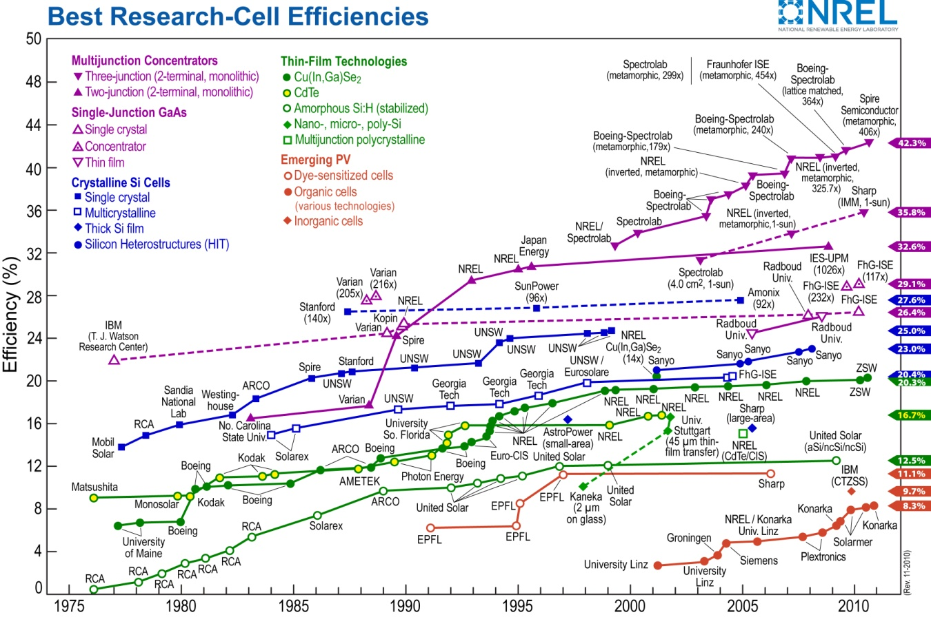

*Figure 3.2.10.1 - Trend of Best Research-Cell Efficiencies (reprinted with permission from the National Center for Photovoltaics, Golden, CO)*

Make note of the blue and green trend lines. The blue trend lines relate to crystalline silicon cells, while the green trend lines relate to the advances in thin film technologies. As of the latest data in this chart, the top efficiencies for these materials; this is assumed to be done under lab controlled situations. Mono-crystalline silicon has a top efficiency of 27.4%. Multi-crystalline silicon has a top efficiency of 20.4%. Now for the thin film technologies, amorphous silicon has an efficiency of 12.5%, CdTe with 16.7%, and CIGS shows an efficiency of 20.3%. GaAr is not shown on this graph. With CIGS efficiency only one tenth of a percent away from multi-crystalline silicon, CIGS shows great promise to be able to overtake silicon in efficiency standards. This makes this thin film material the top contender for use in this design project.

The efficiency of GaAs also compares well to silicon. Figure 3.2.10.2 shows the relationship of the efficiency of GaAs, amorphous silicon, and crystalline silicon over various intensities of light. Even though GaAs does much better in terms of efficiency over silicon cells, the price is not worth the gain for our design.

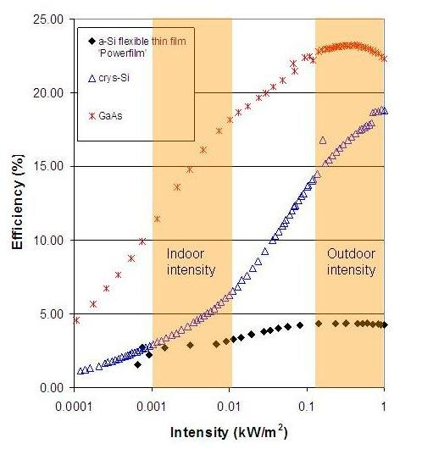

*Figure 3.2.10.2 – Trend of Cell Efficiencies Versus Intensity for GaAs and Silicon (reprinted with copyright permission from IMEC)*

Table 3.2.10.1 below summarizes the materials used in the production of thin films. When choosing a material, the pros, cons, and usually the price were taken into consideration to make the best decision.

*Table 3.2.10.1 - Table of Available Materials In Use In Solar Thin Films*

|  |  |  |  |  |
| --- | --- | --- | --- | --- |
| **Material** | **Band Gap** | **Thickness of Material** | **Pros** | **Cons** |
| a-Si | 1.70eV | 1 micron | common material; performs well at lower temperatures; low cost | efficiency drops at higher temperatures |
| CdTe | 1.47eV | 1-2 microns | low cost | cadmium is toxic to humans |
| CIGS | 1.04-1.67 eV | 2-3 microns | handles higher temperatures | indium is rare and harder to mine |
| GaAs | 1.43 eV | 3-4 microns | handles higher temperatures | expensive material |
| DSSC | Unknown | Fairly thick | Low cost of material  Easily manufactured | Newer technology- not on market |
| Organic/Polymer Solar Cells | Unknown | Very thin | Manufactured easily and cheaply  Low impact on environment | Very low efficiency |

With multiple options of composites to choose solar thin films from, example products were chosen based on efficiency, price, size, and output voltage. For this project, a solar panel from Global Star Energy (GSE) Systems was chosen. It’s a thin film panel made with CIGS. The maximum power rating is 30W. For a price of $179.99, it fits well into the budget.

**3.2.11 Concentrated Photovoltaics**

Concentrated photovoltiacs (CPV) are one of the latest forms of solar energy technology available today. Concentrated PV systems focus a large amount of sunlight onto a small area of solar photovoltaic material to generate electricity. CPV systems use a Fresnel lens that is placed between the sun and the solar cells to focus and magnify sunlight onto the solar cells that are 250 to 500 times smaller than the traditional PV solar panels. Hence, CPV systems are often very economical.

There are three types of CPV systems: low CPV, medium CPV and high CPV (HCPV). They are categorized according to the amount of their solar concentration. It is measured in "suns" (the square of the magnification).

* Low concentration PV have a range of solar concentration of 2 to 100 suns. Typically, conventional or modified silicon solar cells are used. The cells do not require active cooling due to the low heat flux.
* Medium concentration PV have a range of solar concentration of 100 to 300 suns. The CPV systems require two-axis (passive or active) solar tracking and cooling. More complex than low concentration CPV.
* High concentration PV systems have solar concentrations leading to 500 suns. These systems are extremely expensive and very sensitive.

**3.3 Battery Bank Research**

Battery selection has a direct correlation to the cost and complexity of the solar module. In this project, a simple to charge and cost effective battery is the most desirable. Perhaps the most important feature of a battery for this project is robustness. The battery needs to resist charge capacity degradation under testing conditions, which may include undercharging and overcharging while the design is fine tuned. Size and overall energy density are a non-issue, as the battery bank remains stationary and only be used to run the solar tracking motor and the test equipment. Future iterations may call for a more complex battery type and/or a lighter/smaller battery, but these cases are be considered here. With these traits in mind, it is necessary to discuss the strengths and weaknesses of the following battery types: nickel cadmium, nickel metal hydroxide, lithium ion, lithium polymer and lead-acid.

Nickel cadmium batteries are the workhorses of the battery world. This battery type is widely known for being the most rugged battery under stressful conditions, and can be used pretty much anyway the designer pleases so long as the battery is exercised. If left unchanged for extended periods of time, nickel cadmium batteries develop formations on the cell plates which decrease capacity, a phenomenon known as memory effect. In addition to its durability, the nickel cadmium battery has a very low cost per cycle; among the lowest of all the battery types available. The ramifications of this are that the battery is easily replaced and can last for a long time if deep cycled occasionally to prevent the formations. However, this battery type contains chemicals that are extremely poisonous to the environment, so much so that many countries are restricting its use. Also, it has a very high self-discharge rate, which means that if left off the charger for extended periods, it will cycle itself out. In the context of this project, that means that it is not necessarily true that the battery will be charged enough to start up the testing equipment each day, and this is something to be explored further if this technology is chosen. Overall though, this is a less favored option for this design due to the memory effect, high discharge, and toxicity. [8]

Nickel metal hydride batteries are known for their high energy density, which is 40% greater than its sister technology, the NiCd battery. This leads to smaller battery sizes for the same energy storage. This battery type is also environmentally friendly and non-toxic, which works greatly to its advantage in cases where the battery needs to be stored for long periods of time unused or is in a device prone to collisions, like a vehicle. It does however, require a very complex charging algorithm compared to other battery types to prevent degradation, especially when the battery is near max capacity. In addition, if the battery is deep cycled (or drained fully) repeatedly, the battery life is greatly reduced. Thus shallow discharge cycles are preferred. This design option is less favorable due to its tendency to degrade in improper conditions. All other features, while desirable, are not required for this project, and thus do not offset the stated disadvantage. In addition, this battery is moderately more expensive on average, and thus a cheaper alternative was considered. [9]

Lithium Ion batteries are now commonly being considered for a wide range of applications due to their high energy density, which reduces the size of the device considerably. In addition, lithium ion batteries have little “memory effect”, where if the battery is not charged fully it loses its capacity. Lithium Ion batteries also discharge very slowly. This makes them more ideal for portable electronics in that they can be charged whenever the consumer has time and they will keep that charge for a considerable time period, without losing effectiveness. However, there is a build-up of deposits in the battery that eventually make the battery unusable and it is prone to thermal runaway if used in applications where there may be a lot of heat, such as when overcharged with large currents. Should the batteries be installed or charged improperly, there is a possibility that it may become a safety concern with the amount of power coming out of the solar array. Perhaps the largest detriment to using this battery type, however, is its cost. Manufacturing this battery technology is more complicated than other battery types, and that translates to high cost for the consumer, something that is counteractive to the goals of this project and makes this technology very unlikely to be used. [10]

The lithium polymer technology is very similar to the lithium ion battery in that its energy density is still its major feature, though not as pronounced as the lithium ion battery. What it sacrifices in overall energy density and number of cycles in its lifetime, though, it makes up for in safety when compared to the Li-Ion technology. It is more resistant to overcharging and less prone to failures when charged inappropriately. However, like the lithium Ion battery, it is extremely expensive to manufacture and purchase for many applications, which makes it less of a candidate for this design. [11]

Sealed lead acid batteries are without a doubt the most commonly used and most understood rechargeable battery system. They are traditionally favored because they are cheap, have low self-discharge rate, and have no maintenance to keep them functional. Working to their detriment is the batteries low energy density ratio, tendency to thermal runaway like the lithium ion battery when charged improperly, and the environmental impact of a ruptured cell. Taking this into account, they are best suited for applications where the device is stationary or on wheels, making their weight a non-issue. In stationary applications, such as the one in this project, it is also very unlikely that the battery will become damaged externally, thus making its environmental impact null. Also, because this technology is mature, charging algorithms that are reliable and prevent breakdown are readily available for use. This may in fact be the most cost effective and safest way to implement a battery bank for this design. [12]

A summary of the pros and cons for each of the battery technologies can be found in Table 3.3.1 and Table 3.3.2. By comparing the advantages and disadvantages of each, it has been determined that the sealed lead acid battery is the proper choice for this design. Its low cost and simple charging algorithm compared to the other battery technologies was the primary reason for this selection. However in all other criteria that matter to this project, the sealed lead acid battery performs well enough for it to not be considered a detriment, such as its durability, maintenance requirements and low energy density. The energy density in particular was of no concern, because the application being considered here is stationary.

*Table 3.3.1 - Comparison of Battery Technologies*

|  |  |  |
| --- | --- | --- |
| **Technology** | **Advantages** | **Disadvantages** |
| Nickel Cadmium | * Low cost per cycle. * Simple to charge. * Resistant to stress. | * Memory effect pronounced * High self-discharge rate * Toxic |
| Nickel Metal Hydride | * High energy density * Low Cost * Less memory effect | * Complex charging algorithm * Toxic * Deep cycle degradation |

*Table 3.3.2 - Comparison of Battery Technologies cont’d*

|  |  |  |
| --- | --- | --- |
| **Technology** | **Advantages** | **Disadvantages** |
| Lithium Ion | * Highest energy density * Versatile shapes | * Very complex to charge * Potentially failure * Extremely Expensive |
| Lithium Polymer | * Very high energy density * Less prone to failure | * Still very expensive * Complex to charge |
| Sealed Lead Acid | * Very low cost * No maintenance * Simplest to charge | * Low energy density * Potential thermal runaway |

To further narrow down our selection of batteries, the next thing to consider is the properties of the battery. Batteries must cater to the demands of the system as a whole to ensure everything runs smoothly, therefore a designer must determine the voltage required for the inverter, the battery’s capacity (or Ah), the maximum current drain and the total running time for the devices. The inverter that will be used in this design requires either a 12V or 24V input, so any battery chosen must be 12V. If it is necessary to bring the voltage up to 24V, the batteries can be placed in series or fed through a summing amplifier. To determine the battery capacity for the system, the following formula can be used:. The solar array will only be running in full swing during daylight hours, therefore the time that the battery packs are charging is limited to between 10 and 14 hours a day. The drain wattage will depend on the systems power requirements, which are enough to run a computer (which expends 300W) continuously for 2 hours. The total Ah to run this system via the formula given above is roughly 13Ah for a 24V system. [13]

Now that all the battery requirements have been researched, a cost analysis of the contenders is in order. In Table 3.3.3 and Table 3.3.4, the available batteries, their cost and the Ah rating for that particular device is laid out.

*Table 3.3.3 - Battery Comparison by Cost and Ah*

|  |  |  |
| --- | --- | --- |
| **Model Name** | **Capacity (Ah)** | **Price** |
| SLA-12V1-3 | 1.3 | $12.95 |
| SLA-1039 | 2.3 | $29.95 |
| SLA-HR-1221W-F2 | 5.0 | $19.95 |

*Table 3.3.4 - Battery Comparison by Cost and Ah Cont’d*

|  |  |  |
| --- | --- | --- |
| **Model Name** | **Capacity (Ah)** | **Price** |
| SLA-12V9-F2 | 9.0 | $26.95 |
| SLA-12V10-F2 | 10.0 | $27.95 |
| SLA-12V12-F2 | 12.0 | $29.95 |
| SLA-12V14-F2 | 14.0 | $36.95 |
| SLA-12V18 | 18.0 | $34.95 |
| SLA-12V22 | 22.0 | $46.95 |

**3.4 DC/DC Converter Research**

The use of dc/dc converters is an integral part of solar module efficiency. If one were to hook a solar module directly to a battery array, the interaction between them would be completely dependent on the voltage differential between the current operating voltage of the solar module and the voltage level of the battery array. In an extreme case, if the solar module voltage was less than that of the battery array, the charge current through the battery array would become negligible and the batteries would charge slowly, if at all. To prevent this from occurring, solar module manufacturers generally design solar modules with higher operating voltages than that of the battery arrays that they are designed for. However, when the solar module voltage is higher than that of the battery array, the solar module is dragged down to the voltage level of the batteries and any excess power gathered in the module is wasted. This is where dc/dc converters come in.

The goal of a dc/dc converter is to step up or down the voltage in a module such that it matches the charge in a battery array at any given point, with a negligible loss in power. It has been determined that the three simplest, smallest and cheapest methods of implementing such a design are as follows: the buck converter, synchronous buck converter and current controlled charger.

In a basic buck converter, a switch separates the input source from the output source. The switch is turned on and off by an oscillator with pulse widths dependent on the voltage differential between the current output voltage and a desired output voltage. If the current output voltage exceeds that of the desired, the pulse width is shortened, and if it is lower, the pulse width is lengthened.  The inductor and capacitor in the output of the system ensure that the output voltages and currents remain relatively stable, with a small ripple current.  This ripple output current is generated in relation to the pulse width.  The current is boosted when the oscillator is ‘on’ and discharges when the oscillator is ‘off’, however it varies around a given value. In the case of the solar module being designed in this project, the value the ripple should vary around is the optimal charge current for the battery in its current state to reduce power loss.

The result of using such a system in solar arrays is a reported 20-30% increase in efficiency. This efficiency can be maximized by lowering the power losses within the buck converter.  The most significant source of power losses in a classical buck converter design is in the rectifying diode.  If the rectifying diode were replaced with a second switching MOSFET, then the efficiency of the buck converter can be increased, as the voltage drop across a MOSFET is less than a diode.  Such a design is called the synchronous buck converter. This configuration, however, greatly increases the complexity and cost of the design. There is also a chance that the gates become out of sync, which could potentially cause damage to the system or significant losses in power.  As such, this option is less favored by this design due to fund limitations restricting the availability of replacement parts as well as time limitations, in that it would draw focus from the core of the project: the array, data acquisition, and the user interface. [14][15][16]

Since it is likely that this design will include lead acid-batteries, there is yet one more circuit to consider: the current-controlled charger.  This system stems from the fact that the lead acid battery has a relatively simple charging algorithm, shown in Figure 3.4.1, in which the optimum charging voltage remains fairly constant up until the battery is near capacity, at which only a trickle charge is needed to account for self-discharge. This design philosophy prevents overcharging and ensures that the battery is always being charged at its fastest possible rate.  The disadvantage of this system is that it does not account for slight variations in solar array and battery voltage, and thus is less efficient than matching voltages using a buck converter would be.

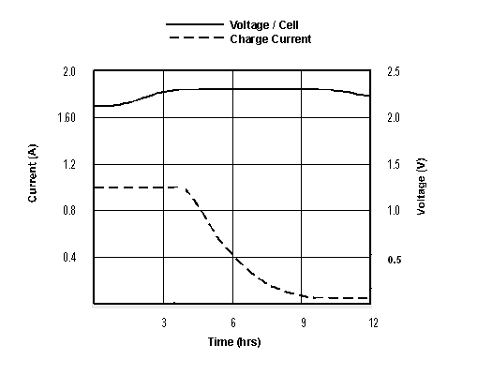

*Figure 3.4.1 - Charging voltage and current for lead acid batteries versus time.*

All of these systems are equally effective at achieving the goal of the converter: to protect the other hardware while transferring maximum power.  However, each of the systems discussed has its own design challenges and benefits.  Table 3.4.1 displays the comparison of the design concepts, so that one can be chosen to move forward with in the design section.  After weighing these options, it was decided that the most prudent action was to pursue a design based on the current-controlled charger.  This decision was made on the basis that the batteries being used are sealed lead acid and do not necessitate much monitoring beyond cutting off the voltage when fully charged to avoid damage. The circuit that best does this with as little complexity and danger to the other systems involved is this option.

*Table 3.4.1 - Comparison of DC/DC Converter Design*

|  |  |  |
| --- | --- | --- |
| **Design Technology** | **Advantages** | **Disadvantages** |
| Basic Buck Converter | * Highly efficient * Moderately safe to systems | * Requires microcontroller * Diode losses are greater than Synch. Buck Converter |
| Synchronous Buck Converter | * Most efficient of 3 options | * Requires Microcontroller * Strict Timing guidelines to avoid system damage |
| Current-Controlled Charger | * Simplest to implement * Does not require microcontroller | * Least efficient * Only viable with SLA batteries. Otherwise losses become too great. |

**3.5 Inverter Research**

Choosing the right inverter for the power needs is an integral part of any solar array design. Without one that is tailored to the needs of the system, devices that are powered by it may not start up, function properly, and may even become damaged by the resulting AC power. When deciding on an inverter, there are three things to consider: the frequency of the output, the type of wave that is produced and the maximum power usage expected from the system.

The frequency required for electronic devices to be functional varies from country to country, and even from region to region as is the case of Japan. Simple electrical devices like light bulbs and heating elements will be unfazed by a difference in frequency; however, anything that requires timing may run faster or slower depending on the frequency input. The end result of this is devices may attempt to function faster or slower than their components allow, causing lost data and unnecessary feedback, which may in turn destroy the device. Being aware of the frequency used in the country the device is intended for can prevent a lot of damage and increase safety overall.

The next most important thing to consider is the type of wave created by the inverter. There are three types of waves produced by inverters: square, modified sine and sine. The square wave inverter is the cheapest of the three types, but can only be used with very simplistic devices without doing damage to the components involved. If a design contains only lights or purely resistive loads, this would be a viable option, but that is not the case here. A modified sine wave is a compromise between the square and sine that provides greater functionality for less cost than a sine wave inverter would. Most electrical devices would work fine with a modified sine wave; however, anything with timing components that use the power frequency to synchronize would cease to function properly. The sine wave is the most expensive option, but is the most reliable. All electrical devices should in theory work with this type of inverter.

The last thing to consider when looking to purchase an inverter is the expected power usage. Naturally, a design will require an inverter that can supply the required wattage continuously, but there is one more power requirement to be met: the start-up power. An electrical device consumes the most power when it is first turned on, so it is in the best interest of the designer to assume that all the devices will turn on at once and make sure the max power output meets that demand. As for the solar array design, it will be necessary to tally the total power requirement for the motor, router, sensors, processors, and any other devices that are localized to the array itself. The user interface and data storage devices will likely be run on conventional power.

Now that all the criteria for selecting a power inverter have been researched, an informed decision on which model to purchase can be made. Table 3.5.1 and Table 3.5.2 contain a list of potential candidates for the power inverter in this design, and in the design section will be a discussion of the model selected.

*Table 3.5.1 - Inverter Comparison by Model, Wattage, Waveform, Input Voltage and Price.*

|  |  |  |  |  |  |
| --- | --- | --- | --- | --- | --- |
| **Model Number** | **Output Type** | **Input Voltage (V)** | **Continuous Power (W)** | **Maximum Power (W)** | **Price** |
| PW900-12 | Mod. Sine | 12 | 900 | 1800 | $74.99 |
| PW1100-12 | Mod. Sine | 12 | 1100 | 2200 | $104.99 |

*Table 3.5.2 - Inverter Comparison by Model, Wattage, Waveform, Input Voltage and Price cont’d.*

|  |  |  |  |  |  |
| --- | --- | --- | --- | --- | --- |
| **Model Number** | **Output Type** | **Input Voltage (V)** | **Continuous Power (W)** | **Maximum Power (W)** | **Price** |
| PW1500-12 | Mod. Sine | 12 | 1500 | 3000 | $169.99 |
| APS30012V | Pure Sine | 12 | 300 | 500 | $174.99 |
| APS60012V | Pure Sine | 12 | 600 | 1000 | $229.99 |
| APS100012V | Pure Sine | 12 | 1000 | 2000 | $379.99 |
| ML400-24 | Mod. Sine | 24 | 400 | 800 | $39.99 |
| ML900-24 | Mod. Sine | 24 | 900 | 1800 | $89.99 |
| ML1500-24 | Mod. Sine | 24 | 1500 | 3000 | $189.99 |
| APS30024V | Pure Sine | 24 | 300 | 500 | $179.99 |
| APS60024V | Pure Sine | 24 | 600 | 1000 | $249.99 |
| APS100024V | Pure Sine | 24 | 1000 | 2000 | $429.99 |

**3.6 Sensor Research**

The sensitivity of a sensor indicates the changes in output when the measured quantity changes. As the sensitivity of a sensor increases, it can measure very small changes in a device. Thus, the output signal of a sensor is proportional to the value of the measured property. There are different types of sensors in the market. For this project, a photo sensor will be used to track movement of the sunlight, a current sensor to detect DC current, and a voltage sensor to detect the voltage.

A photo-resistor is a device that is able to convert the luminescence from the sun into a voltage. Photo-resistors are typically made from cadmium sulfide (CdS), a semiconductor material. This is a resistor that is photo (or light) sensitive and its resistance changes due to the amount of light that is shining on it. The resistance of the photo-resistor will be very high with no light, in the range of millions of ohms in some cases, to very low, such as a few hundred ohms, when it is shined on with a bright light. To make use of a photoresistor in a circuit, a voltage divider circuit is used. As a reminder, a voltage divider circuit works by having  tap between two resistors that are in series from a  to ground.

The equation to solve the circuit is . When exchanging a photo-resistor with one of the resistors in a voltage divider, there ends up being two combinations. Each circuit depends on the purpose of the design. Figure 3.6.1 shows the schematic for each voltage divider with a photo-resistor. For the voltage divider on the left,  in the circuit will increase with the light intensity for a given  and R. The voltage divider on the right will have the  decrease with an increase of light intensity.

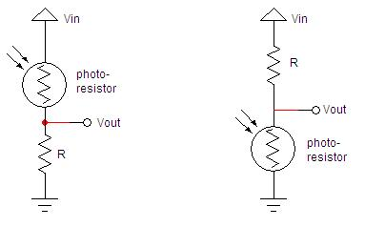

*Figure 3.6.1 - Voltage Divider Circuits with Photo-resistor*

For this design, it would be beneficial if the motor moved in the direction of more light. That would mean that  would increase when the amount of light increases. Using the voltage divider circuit on the left in Figure 3.6.1 will accomplish that. Photo-resistors are fairly common in design. Table 3.6.1 and Table 3.6.2 show a variety of photo-resistors that were found through Digikey to choose from for the project’s applications.

*Table 3.6.1 – Photo-resistor Comparison by Model, Max Voltage, Resistance, and Price.*

|  |  |  |  |  |  |  |
| --- | --- | --- | --- | --- | --- | --- |
| **Manufacturing Part Number** | **Max Voltage** | **Rise Time** | **Fall Time** | **Cell Resistance @ Dark** | **Cell Resistance @ Illuminance** | **Unit Price** |
| PDV-P9004 | 150 VDC | 60 ms | 25 ms | 2 MOhms @ 10 seconds | 27 ~ 60 kOhms @ 10 lux | $1.58 |
| PDV-P9001 | 150 VDC | 60 ms | 25 ms | 300 kOhms @ 10 seconds | 4 ~ 11 kOhms @ 10 lux | $1.58 |

*Table 3.6.2 – Photo-resistor Comparison by Model, Max Voltage, Resistance, and Price Continued*

|  |  |  |  |  |  |  |
| --- | --- | --- | --- | --- | --- | --- |
| **Manufacturing Part Number** | **Max Voltage** | **Rise Time** | **Fall Time** | **Cell Resistance @ Dark** | **Cell Resistance @ Illuminance** | **Unit Price** |
| PDV-P9200 | 150 VDC | 70 ms | 15 ms | 5 MOhms @ 10 seconds | 10 ~ 50 kOhms @ 10 lux | $1.58 |
| PDV-P9007 | 150 VDC | 60 ms | 25 ms | 1 MOhms @ 10 seconds | 10 ~ 100 kOhms @ 10 l | $1.58 |

Please note that lux is the SI unit for luminance. Photo-resistors don’t vary by voltage thresh holds or rise and fall times that much. The choices come into play as to what range of resistance the designer chooses for the voltage divider circuit.

Current sensors come in two types, open loop or closed loop, and each have their advantages and disadvantages.  Open loop sensors are very low power and can withstand current overload better than their closed loop counterpart.  Closed loop sensors, however, provide results with less delay and with more accuracy and less noise.  Regardless of the type, current sensors perform the same function: to measure a current and provide a scaled output voltage, output current or manipulate a switch or waveform modulation.  In the context of this project, the most important thing in a sensor is accuracy, so the closed loop sensor is the obvious winner.  In addition, it will be interfacing with a PIC microcontrolled with built in A/D converters, so an output voltage, rather than current or other logic would be ideal to represent the measurements.  Several current sensors available at Digikey fit this description, and a comparison of those components can be found in Table 3.6.3.

*Table 3.6.3 - Comparison of Current Sensors by Range, Accuracy and Cost*

|  |  |  |  |  |
| --- | --- | --- | --- | --- |
| **Model** | **Current Range** | **Sensitivity** | **Accuracy** | **Cost** |
| 620-1237-ND | +/-50A | 40mV/A | +/-1% | $6.35 |
| 620-1238-ND | +/-100A | 20mV/A | +/-1% | $6.44 |
| 620-1239-ND | +/-50A | 40mV/A | +/-1% | $6.44 |

From the comparison, it can be seen that the current sensors available are very similar to each other.  The only difference between the first and the last, in fact, is the temperature range in which they operate.  The last sensor has wider operational temperature range of -40 to 125 degrees, where as the first operates only in the -20 to 85 degree range.  At this time, the temperature that the device will be subjected to is unknown; therefore it is well worth it to pay an extra 11 cents for the added security.  In addition, the currents the device will be measuring is in the 0-5A range, therefore it is unnecessary to have a range of +/-100A for one of the sensors in this design.  The smaller range of +/-50A will suffice.

Measuring voltage is a much simpler task than current, and as such a specifically designed sensor is not necessary.  In its stead, an instrumentation amplifier such as the AD620 already is being purchased for the solar tracking subsystem.  By comparing the voltage difference across the panel, the instrumentation amplifier will output the difference, which can be fed directly into the PIC as the voltage measurement.  In addition, it has a gain resistance option that will allow the output to be modified should the output not be in a range that the PIC can safely take in.  Since some of these amplifiers are already being purchased, buying more of them will save in cost and as such, this component is the likely choice for the voltage sensor.

**3.7 Solar Collector Research**

Another way to dramatically increase the efficiency of solar panels relies not on the electrical components but on secondary collector devices designed to focus as much sunlight on the panel as possible without heating the panels to the point of failure or their efficiency nosedives.  There are two basic types of collectors available for this purpose: lenses and mirrors.  For each of these collectors, there are innumerable ways to design the shape of the collector such that it performs the same function but at a differing efficiency or another angle.  In this section, a few of the more efficient iterations of these core concepts are discussed in the context of using them as a solar collector for thin film panels.

Before discussing the different technologies, it is important to fully understand the impact of using collectors on the photovoltaic system itself, to determine if it is worth attempting to use solar collectors at all.  In standard silicon based systems, the temperature of the device reduces the overall efficiency of the system by limiting the voltage across the panel that is produced by incident sunlight. This always warrants the question of whether or not the greater incident sunlight can generate enough power to offset the reduction in efficiency due to temperature increases.  This, however, is where thin film technologies shine and one of the major reasons why this technology was chosen over the standard silicon models. Thin films are reportedly more resistant to increases in temperature than silicon models, therefore greater amounts of sunlight can be focused on the device without degrading efficiency as much. Since this design is in a great part an effort to improve thin film’s efficiency, in the context of this design there is a glimmer of hope in this fact.

Now that it has been determined that there is a great enough reason to attempt solar collecting, the discussion of technologies can begin.  The first collector type to look at is the concave mirror.  These devices operate under the principle that any ray incident on a reflective plane, curved or not, bounces off at the exact same angle relative to the tangent.  Taking advantage of this property, a concave mirror focuses any incident light towards a central point, called the focal point, which results in a large area of sunlight being gathered at that point.  If one were to place a photovoltaic system there, it is entirely possible to collect much greater amounts of energy than would be possible without the concave mirror.  Exactly how much extra sunlight can be collected is completely dependent on the shape and size of the mirror.  The most predominant shapes for mirrors in this application are the parabolic dish.

The parabolic dish shown above is being used in a high concentration solar design. Although the design being implemented here is low concentration, it is believed that a page can be taken from the higher efficiency models in this regard.  Use of systems like these is uncommon in the context of publicly available thin films, but perhaps the adaptation is worth the effort.  This design is in all likelihood the most efficient of the reflective solar collector designs; the reason being is that it has the greatest potential area while still ensuring that any sunlight that is incident on the dish makes it to the solar panel.  To make the connection between area and efficiency, a sample scenario can be enacted.  Assume that a solar panel has dimensions of one foot by one foot, and is placed in constant sunlight coming in at a right angle.  Any sunlight incident on that panel is considered in this scenario to be one sun worth of coverage.  Now, assume that panel is then placed above the center of a 2 foot radius dish in front of its focal point and that the panel casts a perfect pitch dark shadow on the center of the dish.  By just calculating the added area around the dish, the calculations for which are shown in Figure 3.7.1, it can be found that the panel receives 11.6 suns worth of coverage.  This does not even take into account diffusion of light under the panel that reduces the effect of the pitch dark shadow concept.  It should also be noted that the increase in efficiency is not necessarily linear, however in the solar panel world, an extra five percent efficiency makes the difference if it can be attained cheap enough, which brings the topic back into the real world.

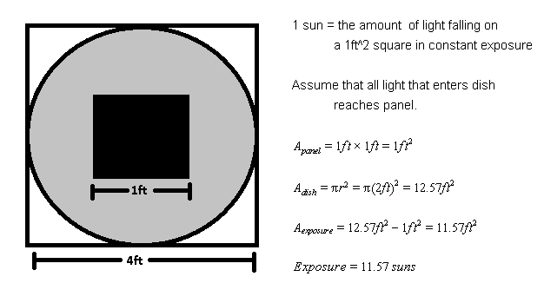*Figure 3.7.1 - Sun exposure with parabolic dish calculations.*

Is the parabolic dish cost effective, and does it coincide with the design goals? The answer to that lies in the materials that the dish is made out of.  If it is made out of any sort of high polished galvanized metal, then in order to get dishes large enough they must be handcrafted which translates to a lot of money, both in materials and labor.  Not to mention the added weight of the dish would greatly increase the torque required by the solar tracking motor, which translates to a more expensive motor that would require more power input to run.  These two facts alone make a galvanized metal option seem lackluster.  However there is an alternative in the form of a lightweight plastic dish coated in highly reflective Mylar.  This would reduce the strain on the solar tracking motor considerably.  A 50”x25’ roll of Mylar costs $13.95, and is a great cheap alternative to metal. However, cutting a rectangular shape in such a way that it form fits a parabolic bowl would be a task unto itself, and any deviation in the plane can have the opposite effect and direct sunlight away from the panels.  Perhaps a different design would be more realistic to manufacture, such as the parabolic trough in Figure 3.7.2.

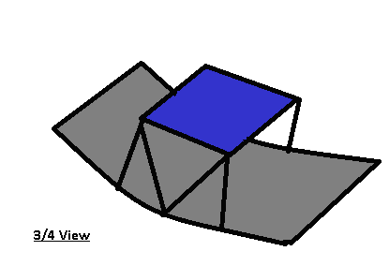

*Figure 3.7.2 - Parabolic Trough Solar Collector Design*

As with the parabolic dish, the parabolic trough is used almost exclusively in high concentration photovoltaics, as is shown, but again this concept can be adapted for low concentration as well to save the consumer money on the more expensive solar cells. The parabolic trough works in the same way as the parabolic dish, except with a reduced area.  If the same scenario were enacted with the one foot by one foot panel this time set at the center of a 2 foot radius parabolic trough, the solar panel would receive only 3 suns worth of energy (calculations are shown in Figure 3.7.3).  However the size of the device is greatly reduced, which meets the design goal of keeping the overall space the array takes up smaller for residential applications.  Again, by looking at the feasibility of the materials, we find that using galvanized metal is still cost prohibitive.  Although the cost of labor is cut out completely, as a piece of sheet metal can just be bent into shape by the designers, the weight of a large enough piece of sheet metal would again increase the motor cost and power consumption.  However, the highly reflective Mylar can still be used in this design to keep cost and weight low, which is probably the direction that will be taken.

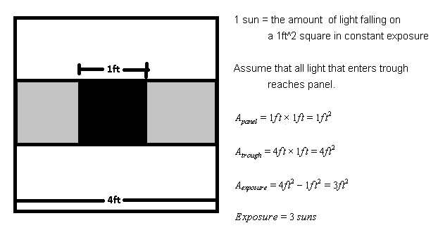

*Figure 3.7.3 - Sun Exposure with Parabolic Trough Calculations*

A good designer cannot stop at the first viable solution, however. It is still important to look at the other class of solar collectors, lenses.  As with the reflective solar collectors, lenses come in many different forms that perform the same function.  The most commonly known lens that focuses light is the convex lens.  This lens works using the concept of refraction, which means that any incident ray is bent to a different angle relative to the a line perpendicular to the tangent based on a function of the proportion of the materials index of refraction.  By curving the lens outward, light can be directed to a focal point behind the lens.  If the same experimental scenario were to take place as before, the math would be identical to the parabolic dish, except that area that was shaded by the panel can now be considered lit and add to the total sun coverage, bringing the total up to 12.6 suns.

The problem with this design philosophy is that for an application of this size, the lens become very large, heavy and difficult to mount due to the shape.  Most lenses of this type are manufactured for small scale applications for these reasons, and any attempt to use a large lens would mean special manufacturing and would require the funds to purchase such a service.  In the scope of this project, those funds are not available and would deviate significantly from the design goal of making the end result cost effective for residential applications.  A thinner, less dense lens option would be preferable to this one, which brings the discussion to the Fresnel lens, shown in Figure 3.7.4, though in the context of a smaller optics design.  Like with the reflective designs, a Fresnel lens can be adapted in the context of low concentration photovoltaic systems to great effect.

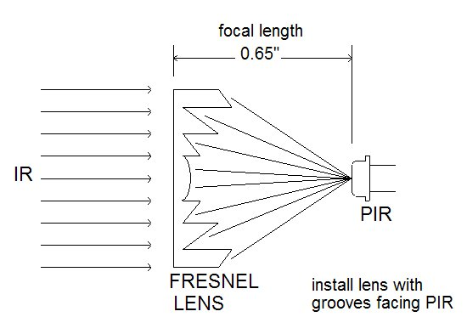

*Figure 3.7.4 - Fresnel Lens Collector Example (reprinted with permission from GloLabs Inc.)*

The Fresnel lens works under the same principles as the convex lens, except that the slanted surfaces that refract light inward are etched in a ring pattern on a flat plane of glass or acrylic.  The end result is exactly the same as a convex lens, except the weight and cost is cut down considerably due to less materials being necessary.  Again, if one were to examine the sample scenario with a one foot by one foot panel set behind a four foot by four foot lens, shown in Figure 3.7.5, the panel would receive 16 suns worth of energy, which is considerable. This increase in coverage is incredible and could very well be the future of solar collectors, but is it readily available and economical at the time to be incorporated into this design?

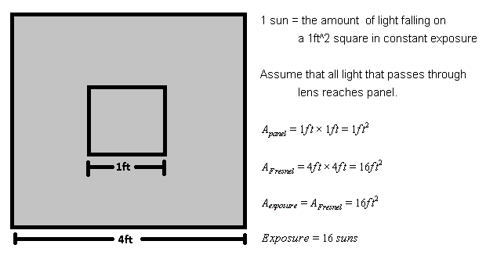

*Figure 3.7.5 - Sun Exposure with Fresnel Lens Calculations*

Fresnel lenses of this size, though uncommon, are starting to become available commercially for the exact purpose of a solar collector, whether it be for a solar panel or for a solar water heater.  However, this technology is still in its infancy as a solar collector, and thus is still incredibly expensive.  At Edmond Optics, a four foot by five foot Fresnel lens costs $652, which is as much as three and a half of the solar panels used in this design.  Though, this idea is clever and provides the most sun collection, it is not economical at this time to use it.  Perhaps if interest is exerted in this area, future iterations of the large Fresnel lens will become more cost effective as demand goes up.

After considering the major options, it has been determined that the simplest and cheapest solution to the implementation of a solar collector is the parabolic trough design with sheets of highly reflective Mylar bonded to the inside.  To get the parabolic shape, a large sheet of plastic was bent into place and bolted with crossbars to keep it in the correct shape.  The crossbars are the foundation for the solar panel mount after the focal point has been determined and adjusted.  By using a $13.95 roll of Mylar, and plastic panel, which costs $34.95 at the local Home Depot, it is believed that the price can be kept affordable for home applications and the weight can be kept down to reduce the problem of motor size, strain and power consumption.  A comparison of all the options is given below in Table 3.7.1, which corroborates this decision.

*Table 3.7.1 - Comparison of Solar Collector Technologies*

|  |  |  |
| --- | --- | --- |
| **Design Technology** | **Advantages** | **Disadvantages** |
| Parabolic Dish | * Highly Efficient * Lower cost than lens | * Difficult to implement to great accuracy |
| Parabolic Trough | * Cheapest to implement * Least space for design * Simplest to build/mount | * Lowest efficiency |
| Convex Lens | * More efficient than reflectors | * Heavy, puts strain on motor * Highly expensive (custom manufacturing) * Fragile/Difficult to mount |
| Fresnel Lens | * Highest Efficiency possible of these choices * Easier to mount than Convex lens | * Heavy, puts strain on motor * Highly Expensive |

**3.8 Solar Tracking Research**

The thin film solar panels are able to track the sun each day with a solar tracker. With tracking, power output can increase by a factor of 30 to 50 percent. Solar trackers are made with three main components: solar sensors, a solar tracking circuit, and a motor. The majority of solar trackers are either single axis or dual axis. Single axis trackers can increase the output of a solar panel by thirty percent on average. The dual axis solar trackers can increase that average by an additional five to six percent.

The solar panel receives the most light when the angle of incidence of the light source or sun is ninety degrees to the surface of the solar panel. If a solar panel is flat on the ground with no tracking, the panel will see very little power in the morning and evening compared to its peak power during midday, when the sun is right above the solar panel. When tracking, the front face of the solar panel is continuously tilted towards the sun to maximize its power output. The use of single and dual axis solar trackers helps keep the sun’s angle of incidence to be zero degrees on the face of the solar panel.

For a single axis solar tracker, there are two solar sensors that are situated as east/west. The sensors work by each comparing the intensity of light each detects to the other. The one with the greater intensity directs the motor, via the solar tracker circuit, to move in that direction. This is done at a sampling rate that is determined by the designer of the solar tracker circuit. The dual axis solar tracker works similarly, but with two sets of single axis sensors and circuits (east/west and up/down) in order for it to have two axis of movement. It must also be noted that the solar tracker will have to reset itself after the sun sets each day to be ready for the sunrise the following morning. Figure 3.8.1 shows an example of a single axis tracking circuit.

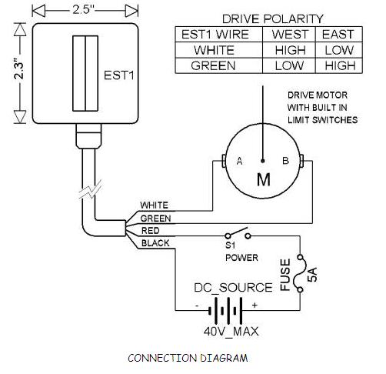

*Figure 3.8.1 - Single Axis Solar Tracker Circuit (reprinted with permission from www.theanalogguy.com)*

Examples of electric motors are DC motors and stepper motors. A DC motor is a simple electric motor that works based on the properties of electro-magnetics. For smaller motors, the stator is a permanent magnet, while the rotor tends to be an electromagnet. The electromagnet is made by wrapping a conductive wire around a soft iron core. When there is no current going through the wire, the electromagnet does not polarize and there is no motion in the motor. When current is applied, a magnetic field is produced in the area around it, which would be in the soft iron core. Once the magnetic field is formed, the current-carrying wire will have a force produced on it. This force is what causes the rotor to turn, thus giving motor action. In typical DC motors, the voltage is applied to the rotor through terminals which are called brushes, which ride along slip rings, which are connected to the rotor. This is done because the wires would get tangled during rotation. With higher power motors, the winding wire would burn out as well. The brushes are made with carbon composite and last long to keep the life of motor going.

The stator also has a curved face and an even air gap between it and the rotor. This is done to guide the magnetic flux to take the shortest path, the perpendicular distance from the stator to the rotor, and also for the flux to be constant as the rotor turns. The input voltage is usually AC. Having the magnetic flux perpendicular to the rotor at almost the entire circumference, allows the voltage induced on the rotor to flatten out the AC sine wave to give a flat-topped sine wave appearance. DC motors apparently need DC voltage. In order to fix this problem, commutation is used. Commutation is the process of switching connections between loops of conductive wire on the rotor of the machine just when the voltage in that loop will switch polarity. The resulting voltage going to the motor is all positive.

In order to have better DC voltage, the gaps in the duty cycle need to decrease. This is done by increasing the number of loops on the rotor. However, DC motors tend to not do well with pulses of voltage. They are designed to spin at a constant RPM. Stepper motors work well with rotating at fixed amounts of rotation.

Stepper motors are another way to power the movement of the solar panel. Stepper motors have a permanent magnet that rotates inside the presence of a fixed amount of electromagnet pairs. By powering the individual electromagnets in either a clockwise or counterclockwise fashion, the rotor will align itself with the electromagnet and move 90 degrees for each turn in the case of a two phase stepper motor. This is called full stepping. Table 3.8.1 shows the steps for a four phase bipolar motor.

*Table 3.8.1- Full Stepping for Four Phase Motor*

|  |  |  |  |  |
| --- | --- | --- | --- | --- |
| **Step** | **Magnet 1** | **Magnet 2** | **Magnet 3** | **Magnet 4** |
| 1 | On | Off | Off | Off |
| 2 | Off | On | Off | Off |
| 3 | Off | Off | On | Off |
| 4 | Off | Off | Off | On |

A more accurate way for a stepper motor to operate is a case called half stepping. This is done by having the permanent magnet move at angle of 45 degrees instead of 90. Table 3.8.2 shows the steps for a half stepping motor. This design happens to be more accurate than a full stepping motor. With the case of a full stepping motor, the rotor could slip during the change in magnetization. With half stepping, there is a very low practicality of the rotor slipping.

*Table 3.8.2- Full Stepping for Four Phase Motor*

|  |  |  |  |  |
| --- | --- | --- | --- | --- |
| **Step** | **Magnet 1** | **Magnet 2** | **Magnet 3** | **Magnet 4** |
| 1 | On | Off | Off | Off |
| 2 | On | On | Off | Off |
| 3 | Off | On | Off | Off |
| 4 | Off | On | On | Off |
| 5 | Off | Off | On | Off |
| 6 | Off | Off | On | On |
| 7 | Off | Off | Off | On |
| 8 | On | Off | Off | On |

When choosing a stepper motor, the amount of torque required needs to be determined. After choosing the 60W 12V thin film solar panels from GSE, the weight per panel was given as 5kg. The torque equation is given as: . With the given force of 5 kg per solar panel, the radius of the tracking unit would need to be known to determine the torque needed to move the unit. Since the design has not been been finalized, an ideal length will be determined. Just for extra safety, a safety factor will be multiplied in to make sure that the motor will have lifting capacity to raise the solar panel from a horizontal position to a vertical position. To find a stepper motor that meets the needs of this project, the minimum torque will be:. Much research was done to find a stepper motor with such torque specifications. Table 3.8.3 and Table 3.8.4 give a comparison of similar motor models.

*Table 3.8.3- Comparison of Stepper Motors*

|  |  |  |  |  |
| --- | --- | --- | --- | --- |
|  | **Keling Co.** | **Baldor** | **Omega** | **Superior Electric** |
| Model Number | KL34H2160-62-8A | DSMS34F-2B | OMHT34-505 | KML093Fxx |

*Table 3.8.4- Comparison of Stepper Motors*

|  |  |  |  |  |
| --- | --- | --- | --- | --- |
|  | **Keling Co.** | **Baldor** | **Omega** | **Superior Electric** |
| Model Number | KL34H2160-62-8A | DSMS34F-2B | OMHT34-505 | KML093Fxx |
| # of Phases | 4 | 4 | 4 | 4 |
| Input Voltage | 6.6V | 12V-75V | 4.2V | 2.45-4.9 |
| Input Current | 4.4A | 4A | 3.18A | 3.4-6.8 |
| Torque (oz-in) | 1810 | 575 | 849 | 1155 |
| Price | $179.00 | Call Dealer | $290.00 | Call Dealer |

The stepper motors from Keling looks to be best option. Baldor Co.’s motors come with specialized software and input cables, which are not necessary and could raise the price into a range too high for our design. The motor choices from Omega seemed overpriced. Superior Electric’s link to get a price quote on the website was down. A call has been made for a quote and still waiting on a response. Even though the Keling stepper motors do not have enough torque, they were still a viable contendor.

From the graph, it would appear that the torque needed is too low for the group’s design. This can be changed by adding a gearbox to the motor axle. This device attaches to the shaft of the motor and reduces the speed and increases the torque by a predetermined ratio. Once the motor is chosen, the gear ratio will be determined and purchased.

The options for wiring a stepper motor are parallel or series. It was decided to go with a series wiring design. The reasoning is that parallel winding produce highers torque at higher speeds, which is undesirable. Series winding will give you the same torque, but at a lower speed, which helps the motor track more accurately.

Sometimes stepping motors can have a tendency to slip and rotate the opposite way if the steps are not exact. This could cause your motor to not run smoothly. For solar tracking, the motor must be able to move precisely where the solar sensors indicate where there is a stronger light intensity or the solar panel will not get the most sun. In order to have the stepper motor move in accurate increments, it will need to have a program instructing it when and which direction to turn. This can be done with a micro-controller. A microcontroller can regulate the direction and speed of the steps of the motor. There are microcontrollers designed for this function, along with prewritten open-sourced code to program the microcontroller. There are a few companies that specialize in microcontrollers, and even include packages that include the programmer/debugger, which enables the user to install the program onto the microchip itself. The company Microchip has a program where students can receive free microcontrollers, and a group member already has the debugger, which can cost up to forty dollars. So it was decided to use Microchip’s microcontroller line. Table 3.8.5 compares different models of the microcontrollers that Microchip offers. Microchip currently offers four different models: PIC10 family, PIC12 family, PIC16 family, and the PIC18 family.

*Table 3.8.5- Comparison of Microchip’s PIC Microcontroller Line*

|  |  |  |  |  |  |
| --- | --- | --- | --- | --- | --- |
| **Product Family** | **Memory (KB)** | **RAM** | **I/O Pins** | **# of A/D Converters** | **Operating Voltage Range** |
| PIC10 | 0.375-0.5 | 16-24 | 4 | 0-2 | 2.0-5.5V |
| PIC12 | 1.5-7.0 | 25-256 | 6 | 0-4 | 2.0-15.0V |
| PIC16 | 0.75-14 | 25-512 | 12-55 | 0-28 | 1.8-3.6V |
| PIC18 | 4-128 | 256-4096 | 15-54 | 2-24 | 1.8-5.5V |

The outputs of the microchip are lower voltage, with the maximum being 5V typically. The motor needs 12V to work, so a motor driver chip is needed. The microcontroller then connects to a motor driver chip which is able to power the motor. A motor driver circuit is needed to increase the voltage to power the motor. Motor drivers have a higher power supply, which allows it to send the signal from the microcontroller to the motor itself. Motor drivers can be designed using transistors and diodes, or buy a chip predesigned for the creator’s needs. For better control of the stepper motor, a motor controller will be purchased. This completes the solar tracking circuit.

**3.9 Data Storage Research**

The data storage unit is to store the current, voltage, and temperature values that are logged from the sensor units attached to the project design. It is expected that the data storage will be consistently updated with new information on a timely basis of one hour so as to allow up-to-date access from the user interface. The unit is to store a log of at least three months of data for consistent reference. As well, if the project is to have wireless capabilities, the data storage unit might have to able to support a wireless connection. The question comes down to what kind of storage unit could accomplish these goals. Two kinds of storage units have been chosen for further analysis.

The first storage unit that came to mind was a pocket-sized data logger. In order for the sensors to connect and send data to the logger, the logger would have to have input channels for connectivity. The logger would store the data and provide an output to a LCD screen, allowing for immediate feedback.

One particular series of data loggers that came up was the Testo 175 series that contained separate loggers for temperature and current/voltage. In general, a Testo 175 series data logger is able to save up to 16,000 readings in memory, have a measuring rate ranging from 10 seconds to 24 hours, have a battery life up to two and half years, a one line LCD display, and dimensions of 3.25 x 2 x 1.2 in.

For this project, when choosing data loggers from the Testo 175 series, two loggers are needed. The first logger is the Testo 175-T2 module. This module is a temperature sensor, having the capability to measure an external source with a range of -40 degrees Fahrenheit to 250 degrees Fahrenheit with an accuracy of 0.5 degrees. Another positive aspect for this data logger is that the power needed to run this logger only requires a Lithium battery that is equivalent to one AA battery, being 1.5V. As was previously stated, the battery life would be two and a half years. Table 3.9.1 amd Table 3.9.2 shows the 175-T2 module’s extra technical data.

*Table 3.9.1- 175-T2 Module Technical Data*

|  |  |
| --- | --- |
| **Specification** | **Data** |
| Parameter | Temperature(C/F) |
| Sensor | NTC (internal + external) |
| # of Channels | 2 (interal + external) |
| Measuring range | -31F - +170F (internal)  -40F - +250 (external) |
| Resolution | 0.9F of -40 to +160F  0.3F rem range |
| Accuracy/System Internal ±1 digit | ±0.5F (-4 to +160F)  ±1.8F (-31 to -4F) |

*Table 3.9.2- 175-T2 Module Technical Data cont’d.*

|  |  |
| --- | --- |
| **Specification** | **Data** |
| Accuracy/System External ±1 digit | ±0.5F (-13 to +160F)  ±0.5F rem range |
| Memory | 16000 readings |
| Application Temperature | -31F to +160F |
| Storage Temperature | -40F to +185F |
| Battery Type | Lithium (1AA) |
| Weight | 3 oz |
| Protection Class | IP68 |

The second logger is the Testo 175-S1 module. This module is a current and voltage logger, having the capability to measure an external source. There are two features of measurements used. The first range is of 0 to 1V, with an accuracy of ± 2mV, and 0 to 20mA, with an accuracy of ± 0.05 mA. The second feature has ranges of 1 to 10V, with an accuracy of 20mV, and 4 to 20 mA. The power needed to run this logger only requires a Lithium battery that is equivalent to half of an AA battery, being 0.75V. Again, the battery life would be roughly two and a half years. Table 3.9.3 and Table 3.9.4 show the 175-S1 module with extra technical data. [17]

*Table 3.9.3- 175-S1 Module Technical Data*

|  |  |
| --- | --- |
| **Specification** | **Data** |
| Parameter | Current/Voltage |
| # of Channels | 1 (external) |
| Measuring range | 0 to 1V / 0 to 10V  0 to 20mA / 4 to 20mA |
| Resolution | 1mV (0 to 1V)  10mV (1 to 10V)  0.01mA (0 to 20mA) |
| Accuracy/System ±1 digit | ±2mV (0 to 1V)  ±20mV (1 to 10V)  ±0.05mA (0 to 20mA) |
| Memory | 16000 readings |

*Table 3.9.4- 175-S1 Module Technical Data cont’d.*

|  |  |
| --- | --- |
| **Specification** | **Data** |
| Probe | Built-in screwed contact socket |
| Application Temperature | 13F to +120F |
| Storage Temperature | -40F to +160F |
| Battery Type | Lithium (1/2 AA) |
| Weight | 3 oz |

The temperature range for the first logger should be adequate for this project; however, the voltage and current ranges for the second logger are not up to par with the project’s scope. This being one type of voltage/current logger, the same problem arose among other modules. Loggers seem to be more for a smaller scale endeavor. And even if just the temperature logger was used, the price for that sophisticated kind of data logger is beyond the price range that was set for this material in the budget. Therefore, a better option had to be found.

The second data storage unit that came to mind was using a microcontroller that could connect to the sensors via USB data cables. The microcontroller’s built in RAM or ROM would be used as the storage facility for the data. The idea is to program the microcontroller to read in the data brought in by the sensors and sort the data in an organized manner. The microcontroller would then connect to either a laptop for a wired solution, or to a router or wireless transmitter that would route the data to a defined web server for access from a local location. The goal would be to find a microcontroller that could be used for both a wired and a wireless solution to the problem, mostly due to possible timing constraints.

Three microcontroller sets were considered for the data storage unit. The first was a PIC32 General Purpose Starter Kit. This starter kit utilizes the PIC32MX360F512L 32-bit microcontroller as the central controller. The microcontroller consists of 512KB flash program memory, 32KB RAM, and possesses a max speed of 80MHz, which accounts for a small, but useful size memory for the storage and fast speed for quick access. The microcontroller also includes features such as 256 Byte caches, for fast data access, multiple switchable clock modes for each of the power modes (RUN, IDLE, SLEEP), enabling optimal power settings, and a fail-safe clock monitor, allowing safe shutdown if the clock fails. The three power modes also allow for optional running modes, more specifically the IDLE mode and SLEEP mode. These two modes will prove useful if needed to shut down the microcontroller temporally during operation, since gathering data for the data storage will most likely be running at time intervals rather than continuously. [18] The PIC32 General Purpose Starter Kit also utilizes the PIC18LF4550 USB microcontroller as the on-board debugging controller. This microcontroller consists of 32KB flash program memory, 1KB Dual Port RAM, 1KB RAM, and possesses a max speed of 48MHz. [19]

The PIC32 General Purpose Starter Kit requires a +3.3V power supply, which can be connected via a USB port or an expansion board. The inverter could be used to power the expansion board, but an expansion board that provides a power supply, or even a power adapter that can be connected via USB cable, will suffice if need be. The starter kit does offer connectors for connecting various expansion boards, such as for the power supply or for an LCD display. Also, these connectors can be used for connecting I/O expansion boards to provide extra input ports that could be used for additional input connections for more sensors, a power supply, or even a connection to a router.

The second microcontroller set that was considered was the PIC32 USB Starter Kit II. This starter kit utilizes the PIC32MX795F512L 32-bit microcontroller and a PIC32MX440F512H USB microcontroller, which both consist of 512KB of flash program memory, 128KB RAM, and possess a max speed of 80MHz. The two microcontroller system features also include 256 Byte caches, for fast data access, multiple switchable clock modes for each of the power modes (RUN, IDLE, SLEEP), enabling optimal power settings, and a fail-safe clock monitor, like the previous kit. [20][21] The PIC32MX795F512L is specifically used as the central controller in the starter kit, while the PIC32MX440F512H is used for on-board debugging.

The main feature that distinguishes the PIC32 USB Starter Kit II from the PIC32 General Purpose Starter Kit is the USB connectivity. A feature that this project needs is some method of connecting the sensors to the data storage. One way to do this is to use sensors that can be connected via an USB cable. By using a USB cable, the data can be transferred from the sensors to the microcontroller, allowing for data storage. Also, the USB port could be used for a second method of data storage: using an USB flash drive. The flash drive would be connected to the USB port and the microcontroller would then store the data directly to the flash drive.

The PIC32 USB Starter Kit II requires a +3.3V power supply, which can also be connected via a USB port or an expansion board just like the PIC32 General Purpose Starter Kit. As before, the inverter can be used to power the expansion board, but an expansion board that provides a power supply, or even a power adapter that can be connected via USB cable, will suffice if need be. The starter kit also offers connectors for connecting various expansion boards that can be used for connecting an LCD display or an I/O expansion board for the sensors or router connections.

The third microcontroller set that was found was a PIC32 Ethernet Starter Kit. This kit also utilizes the PIC32MX795F512L microcontroller as the central controller and the PIC32MX440F512H as the on-board debugger. Since the PIC32 Ethernet Starter Kit uses the same microcontrollers as the PIC32 USB Starter Kit II, the same technical data in terms of memory, cache size, speed, etc. applies. The starter kit also supports USB connectivity for gathering the data from the sensors or storing data to a flash drive.

An additional feature is the Ethernet port. If the project is to be able to support wireless capabilities, one of the options to use would be a router, and there has to be a way to connect the starter kit to a router via an Ethernet connection. Fortunately, with an Ethernet port, an Ethernet cable can be used for this function. The microcontroller would connect with the Ethernet cable and determine the IP address needed to map to the router, which in turn would route to the user interface. Now, another option for the design to have wireless capabilites would be using a wireless transmitter and receiver. In that case, an Ethernet cable would not be needed, since the transmitter would be connected to the sensor circuits directly.

The PIC32 Ethernet Starter Kit requires a +3.3V power supply, which can also be connected via a USB port or an expansion board. As before, there are multiple options for the power supply. The starter kit also offers connectors for connecting various expansion boards that can be used for connecting an LCD display or an I/O expansion board.

The following list refers to the actual parts labeled on the top side of the PIC32 Ethernet Starter Kit board shown in Figure 3.9.1 The most important parts to consider are the two microcontrollers, the USB connectivity port, the Ethernet port, the three push button switches, the three user-defined indicator LEDs, and the USB host connection port for connecting to a laptop for programming the device.

1. PIC32MX795F512L 32-bit microcontroller
2. PIC32MX440F512H USB microcontroller for on-board debugging
3. Green power indicator LED
4. On-board crystal for precision microcontroller clocking (8 MHz)
5. USB connectivity for on-board debugger communications
6. Orange debug indicator LED
7. Three push button switches for user-defined inputs
8. Three user-defined indicator LEDs
9. USB Type A receptacle connectivity for PIC32 host-based applications
10. HOST mode power jumper
11. RJ-45 Ethernet port
12. Ethernet 10/100 bus speed indicator LED
13. 50 MHz Ethernet PHY oscillator
14. 32 kHz oscillator (optional)
15. USB Host and OTG power supply for powering PIC32 USB applications [22]

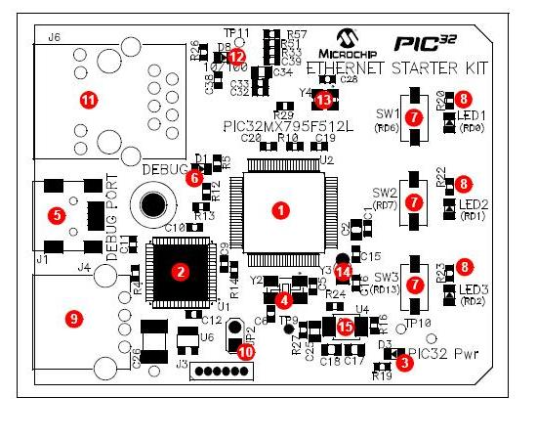

*Figure 3.9.1 - PIC32 Ethernet Starter Kit Layout (Top Side)(reprinted with permission from* Microchip Technology Inc.)

The following list refers to the actual parts labeled on the bottom side of the starter kit board as shown in Figure 3.9.4.

1. Regulated +3.3V power supply for powering the starter kit via USB or expansion board
2. Connector for various expansion boards
3. USB Type Micro-AB receptacle for OTG and USB device connectivity for PIC32 OTG/device-based applications
4. External Ethernet PHY [23]

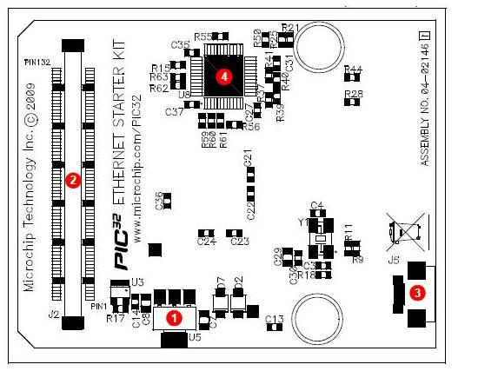

*Figure 3.9.2 - PIC32 Ethernet Starter Kit Layout (Bottom Side)(reprinted with permission from* Microchip Technology Inc.)

Whether the project’s design will include wireless capabilities or not, the microcontroller must still be connected to a host computer in order to communicate with, and program, the starter kit. Requirements for the host computer that must be met include:

1. PC compatible system
2. Two available USB ports on PC or powered USB hub
3. Microsoft Windows® XP® or Windows® Vista® operating system. The PIC32 Ethernet Starter Kit has not been tested with older versions of Windows® operating systems, however that should not be an issue. [24]

So, using just the data logger previously discussed does not seem to be a feasible decision, due to both the price of the devices and the maximum measurement capability. By using sensors that measure voltage, current, and temperature output, and connecting these to a breadboard with a microcontroller, the microcontroller can be used to gather, sort, and save the data to memory for data storage. And in particular, the PIC32 Ethernet Starter Kit seems to be the best choice among the starter kits researched.

Table 3.9.5 and Table 3.9.6 shows the comparison information of key features of the microcontroller sets as a quick rundown of the similarities and differences between them.

*Table 3.9.5 - PIC32 Starter Kits’ Comparison*

|  |  |  |  |  |  |  |  |
| --- | --- | --- | --- | --- | --- | --- | --- |
| **Starter Kit** | **Flash Program Memory** | **RAM** | **Speed** | **Cache** | **Power Supply** | **USB Port** | **Eth.**  **Port** |
| PIC32 General Purpose Starter Kit | 512KB | 32KB | 80MHz | 256 Byte | 3.3V | No | No |
| PIC32 USB Starter Kit II | 512KB | 128KB | 80MHz | 256 Byte | 3.3V | Yes | No |

*Table 3.9.6 - PIC32 Starter Kits’ Comparison cont’d*

|  |  |  |  |  |  |  |  |
| --- | --- | --- | --- | --- | --- | --- | --- |
| **Starter Kit** | **Flash Program Memory** | **RAM** | **Speed** | **Cache** | **Power Supply** | **USB Port** | **Eth.**  **Port** |
| PIC32 Ethernet Starter Kit | 512KB | 128KB | 80MHz | 256 Byte | 3.3V | Yes | Yes |

A few last features for the PIC32 Ethernet Starter Kit that have yet to be brought to attention includes the fact that the starter kit can be programmed with either assembly language or C, allowing for easy to use programming. C programming will most likely be used due to relative comfortability. The kit also comes with a MPLAB C Compiler with no code size limit. And for the wireless solution, the starter kit can be installed with free TCP/IP software provided on the Microchip website. So the PIC32 Ethernet Starter Kit seems to be the best choice for the data storage aspect of the project.

If the sensors are unable to connect to the data storage unit via an USB cable, then a pin connection must be used. However, this cannot be done directly with the data storage unit. Instead, an I/O expansion board must be connected to the storage unit; the sensors’ output pins will then be able to connect to the expansion board. The expansion board chosen must be compatible with the PIC32 Ethernet Starter Kit, since that is the choice for the concept of data storage in this project.

The only choice found was the PIC32 I/O Expansion Board. This board provides full access to MCU signals, additional debug headers, and connection of PICtail Plus daughter cards. The daughter cards feature is not going to be used for the project, but the PICtail connectors are used to connect the expansion board to the data storage unit. The sensors are connected to the MCU signals, which provide automatic analog to digital conversion.

This expansion board does not have a microcontroller unit. Therefore, all application code that is running the board is programmed through the data storage unit microcontroller. Also, the PIC32 Ethernet Starter Kit can also provide the power supply needed to run the expansion board, which could be powered by the power system developed for the final project design. The amount of power that would be needed is determined by the drive capability of the USB port connected to the data storage unit’s debugger at connector J1. If more power is required, a 9V power supply can also be connected to the expansion board. [25]

**3.10 Router Research**

A wireless local area network links two or more devices using some wireless distribution method, and usually providing a connection through an access point to the wider Internet. [26] Simply, there is at least one access point, which is usually a router that is connected to an Internet service provider with an Ethernet cable. This router sends a limited range signal, allowing any computer that is within range that has the WEP or WLP keys for secure access (assuming a secure network is being used) to be able to connect. Typically there is a client that acts as the home device by being directly connected to the Internet service provider just like the router. This home client could then be used to connect to a WI-FI® bridge, extending the range of the network signal sent out by the router as shown in Figure 3.10.1.

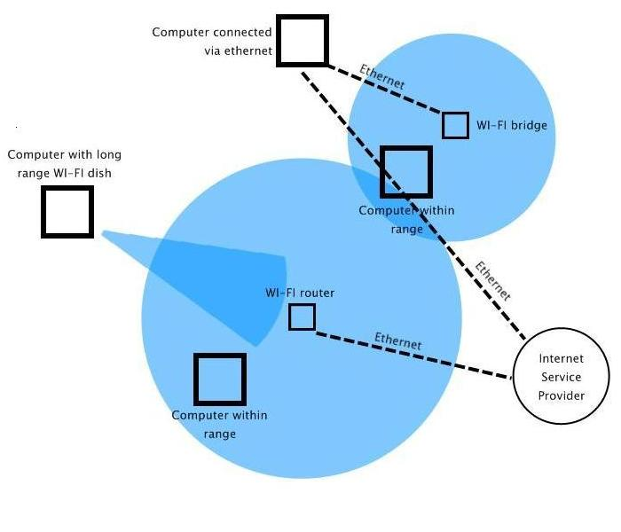

*Figure 3.10.1 – WI-FI® Network Diagram*

There are two types of wireless local area networks that were looked at for the scope of the project. The first type was peer-to-peer, which allows wireless devices to directly communicate with each other. Wireless devices that are in range will connect without the use of an access point, which at this point will just be assumed to be a router of some kind.

IEEE 802.11 is a set of standards that carry out wireless local area network computer communication. [27] The 802.11 uses two different kinds of modes when dealing with peer-to-peer connections. The first is the ad-hoc mode that allows transmission directly between mobile units. The second is the infrastructure mode that allows transmission between units through a router that acts as a bridge to a wired network. Though the ad-hoc mode could be used, the infrastructure mode will most likely work better. Having a single router serving as an access point for wireless connections allows for more widespread connections from several machines rather than using the ad-hoc mode that would be limited in range and machines that could access the network.

The second type of wireless local area networks was the wireless distribution system. The wireless distribution system is a more complicated version of the infrastructure mode for peer-to-peer systems. The main difference between the two is that while the infrastructure mode uses one router that serves as the access points for all clients in range, the wireless distribution system uses multiple routers. Each router serves as a bridge connected to each other, connecting the wireless network among themselves. This allows for a broader range for the network, which entails more clients that can be connected to the network.

With how the bridge scheme works, though the routers act as a bridge for the network, and multiple clients are connected to the network, routers that are not directly connected within the bridge are not aware of each other. This can be compared to a graph of nodes; nodes that are not directly connected are not aware of each other. Assuming that the central router in the bridge is the central location, this design allows the fact that if one router connected to the central unit fails, the other router that is not directly connected to the failed router will not be aware of the failure and will still run actively. However, there is still the problem of the central router; if this one fails, all the others will fail since they are not within range of the network source. Figure 3.10.2 shows the bridge concept.

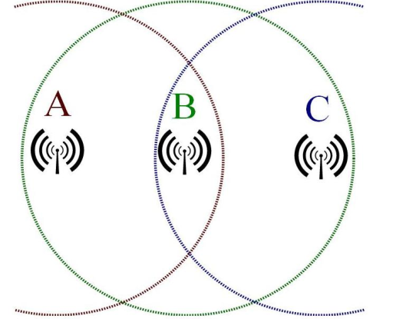

*Figure 3.10.2 – WI-FI® Bridging*

The point of the wireless portion is to be able to access the data from the data storage unit from a distant location, rather than having to be directly connected to the device. Using a wireless distribution system would be beneficial to allow a larger range of clients to access the data. However, since the scope of the project won’t require more than a fifty foot network range, the wireless distribution system is not needed. Instead, a peer-to-peer wireless system that uses infrastructure mode would be sufficient. A single router that acts as an access point for the data storage unit and a laptop would be ideal. The data storage stores the data in its internal memory and when a user accesses the laptop, he or she will then be able to access the data stored in the data storage unit via the router.

Since the PIC32 Ethernet Starter Kit can be installed with free TCP/IP software, it would seem the best option would be to have the kit connected to the router. The laptop will be connected to the local Internet via an Ethernet cable, and the laptop will be able to access the data storage by using the router to access the TCP/IP software.

The wireless capabilities that were needed for the project are to be a final aspect that is added, since the data storage could be connected to the interface laptop directly. Because of this, router selection has been lightly researched. If more storage is needed, a LINKSYS router that has USB storage capability might be the choice; however, for ease with router installation, CISCO Valet may be used. The decision also depends on if the router needs to be re-programmed in any way for the data storage and the laptop to communicate, though this shouldn’t be likely. However, if need be, then a LINKSYS router will be the best choice. Table 3.10.1 shows some comparisons among a few choice routers.

*Table 3.10.1 - Comparison of Routers*

|  |  |  |  |
| --- | --- | --- | --- |
| **Router** | **Price** | **USB Storage** | **50 ft Range** |
| ASUS WL-520GU Wireless Router | $48 | Yes | Yes |
| Linksys WRTSL54GX | $55 | No | Yes |
| Cisco Valet | $60 | No | Yes |
| Linksys WRTSL54GS | $100 | Yes | Yes |

**3.11 LCD Research**

After the data storage unit is prepped for gathering the data from the sensors, it would be beneficial if there was a way to output the data before working on the user interface and wireless transmission. The reason being is that it would be helpful for testing purposes so that there is certainty that the data storage is correctly gathering and storing data. An LCD display module would be useful for this purpose.

There are numerous varieties of different LCD display modules that can be considered, ranging from different character line sizes, touch-screen capabilities, power supply, and prices. These four characteristics will be the driving point in the choosing of an appropriate LCD module.

The particular brand of LCD modules that was researched was the Hitachi HD44780 Character LCD. HD44780 refers to the particular driver that is used in the character LCD module designs. This particular brand is highly used for interfacing with embedded systems. Configurations, or character line sizes, determine the size of the screen. For example, a 16 x 2 character line size means that there can be two rows of sixteen characters printed on the screen at once. Typically, the most common configuration manufactured is the 40 x 4 screen. However, the Hitachi HD44780 Character LCD can only address up to 80 characters. So with a 40 x 4 screen, there are actually two individual HD44780 controllers with expansion chips. [28] This design, though the most commonly manufactured, is not necessary in terms of how this project will use the intended LCD module. Therefore, the only configurations that will be considered are the 8 x 1, 16 x 2, and 20 x 4 character LCDs.

Hitachi HD44780 character LCDs use a standard 14-pin interface. However, character LCDs that use backlights use 16 pins, due to the fact that one pin has to be connected to the backlight anode and the other pin has to be connected to the backlight cathode. The way these are designed, 8-bit characters are used. Therefore, eight of the pins are used for an input and output 8-bit data bus (D0-D7). There is a pin used for Read/Write capability (R/W), a pin used for a clock enable that is usually falling edge triggered (CE), and a pin for a Register Select (RS). The RS determines if the LCD is running on a command or off of the data bus. Two pins are used for the power supply of a range of +3.3V to +5V (VCC) and the ground connections, respectfully. And finally, the last pin is used for contrast adjustment of the screen (VO). Considering that all of the LCD modules that will be considered will be using the Hitachi HD44780 driver, it is helpful to know that all the pins and pin functions of the modules will be the same. Table 3.11.1 and Table 3.11.2 show a concise list compilation of the pins and their functions, assuming a backlight is used.

*Table 3.11.1 – Hitachi HD44780 Character LCD Pin Numbers and Pin Functions*

|  |  |
| --- | --- |
| **Pin Number** | **Function** |
| P1 | Ground |
| P2 | VCC |
| P3 | VO |
| P4 | RS, RS = 0: command, RS = 1: data |
| P5 | R/W, R/W = 0: Write, R/W = 1: Read |
| P6 | CE |
| P7 | D0 |
| P8 | D1 |

*Table 3.11.2 – Hitachi HD44780 Character LCD Pin Numbers and Pin Functions cont’d.*

|  |  |
| --- | --- |
| **Pin Number** | **Function** |
| P9 | D2 |
| P10 | D3 |
| P11 | D4 |
| P12 | D5 |
| P13 | D6 |
| P14 | D7 |
| P15 | Backlight anode (+) |
| P16 | Backlight Cathode (-) |

The first LCD module that was considered was a Yellow-Green backlight character LCD. This LCD is configured to have an 8 x 1 character line sized screen. The screen size is 64.5 x 16.4mm with character size of 3 x 5.23mm. Though the sizes are not being considered as a major decision factor when choosing the LCD module, it is still important to know that the screen can be read clearly. With these screen and character sizes, the information printed will be legible. The power supply that is needed to power the device is +5V, which can be powered by the same power supply that will be used for the data storage unit, since they will be part of the same circuit. The module does not have touch screen capabilities. Finally, the asking price for this device is $10, a very affordable price.

The second LCD module that was considered was an Arduino character LCD. This LCD is configured to have a 16 x 2 character line sized screen. The screen size is 30.4 x 14mm with character size of 2.95 x 4.15mm, making the output legible. The power supply that is needed to power the device is +5V, which can be powered by the same power supply that will be used to power the data storage unit, since they will be part of the same circuit. The module does not have touch screen capabilities. Finally, the asking price for this device is $11, also an affordable price.

The third LCD module that was considered was an Alphanumeric character LCD. This LCD is configured to have a 16 x 2 character line sized screen. The screen size is 61 x 15.8mm with character size of 2.96 x 5.56mm, making the output legible. The power supply that is needed to power the device is +5V. The module does not have touch screen capabilities. Finally, the asking price for this device is $21, which is more expensive than the previous two, but still doable.

The next LCD module that was considered was a blue backlight white character LCD. This LCD is configured to have a 16 x 2 character line sized screen. The screen size is 64.5 x 13.8mm with character size of 3 x 5.02mm, making the output legible. The power supply that is needed to power the device is +3.3V. The module does not have touch screen capabilities. Finally, the asking price for this device is $7, so far the least expensive.

The final LCD module that was considered was also a blue backlight white character LCD, but this is configured to have a 20 x 4 character line sized screen. The screen size is 76 x 26mm with character size of 2.94 x 4.74mm, making the output legible. The power supply that is needed to power the device is +5V. The module does not have touch screen capabilities. Finally, the asking price for this device is $8, an affordable price.

Table 3.11.3 shows the comparable aspects of the different LCD modules considered for this design.

*Table 3.11.3 – Comparable Table for LCD Modules*

|  |  |  |  |  |
| --- | --- | --- | --- | --- |
| **LCD Module** | **Character Line Sizes** | **Touch-screen** | **Power**  **Supply** | **Prices** |
| Yellow-Green Backlight | 8 x 1 | No | +5V | $10 |
| Arduino | 16 x 2 | No | +5 V | $11 |
| Alphanumeric | 16 x 2 | No | +5V | $21 |
| Blue Backlight/White HD44780 | 16 x 2 | No | +3.3V | $7 |
| Blue Backlight/White HD44780 | 20 x 4 | No | +5V | $8 |

None of the LCD modules that were considered had touch-screen capabilities. Though having a touch screen LCD module would have been a nice extra feature, it has been determined that having that capability is not necessary for the design purpose of having the LCD module. So, that feature will not affect the decision to have a module with a touch screen. Power supply is relatively the same throughout the choices, save for the fourth module. So, in essence that also will not affect the choice.

What do affect the choice, given the differences in the chart, are the character line sizes and the costs. The output must both be useful for testing purposes and legible. In order for the output to be useful, there has to be some sort of prompt that shows the voltage, current, and temperature. A simple statement like this will be used: V = xxV I = xxA T = xxF. In order for the output to be legible, the ordering of the output will require two lines. Because of this, the first LCD module cannot be used because its character line size is 8 x 1 and each line will have to require at least sixteen characters. All of the other LCD modules can accomplish this.

With the price factor, the last two LCD modules are the best choices. The final decision between the two comes down to whether the difference in the power supply needed for the devices truly matters or if the character line size difference matters. For easy to read outputs from the LCD, the best choice would be the blue backlight white character LCD with the 20 x 4 character line size. With more lines and more character spaces per line, the output that will appear on the LCD module will be clear to read for testing purposes.

**3.12 Wireless Data Transmission Research**

The basic principles of data transmission are the physical transfer of data from one device to another. The wireless data transmission is one of the integral parts of the wireless communication section of the project and is an alternative to using a router. Table 3.12.1 below is showing the scaling of four different types of wireless data transmission chips based on seven categories; power, distance, data rate, data delivery, cost, learning curve and size, respectively.

*Table 3.12.1: Scaling Variables Associated with Wireless Transmission Chip*

|  |  |  |  |  |  |  |
| --- | --- | --- | --- | --- | --- | --- |
| **Device** | **Power1** | **Distance2** | **Data Rate3** | **Data Delivery4** | **Cost5** | **Learning Curve6** |
| Zigbee | 4 | 1 | 4 | 2 | 4 | 2 |
| Bluetooth® | 3 | 3 | 2 | 4 | 3 | 5 |
| WiFi® | 2 | 3 | 1 | 5 | 2 | 3 |
| XBee | 3 | 3 | 3 | 3 | 4 | 4 |

1. Power Scale: 5 (lowest) – 1 (highest)

2. Distance Scale: 5 (longest) – 1 (shortest)

3. Data Rate Scale: 5 (lowest) – 1 (highest)

4. Data Delivery Scale: 5 (guaranteed delivery) – 1 (may not deliver)

5. Cost Scale: 5 (cheapest) – 1 (most expensive)

6. Learning Curve Scale: 5 (hardest to learn) – 1 (easiest to learn)

Four different types of wireless data transmission chips had been researched in search of the best possible chip for the wireless data transmission. The scales on the table were based on how they match up compared to the others. The columns that were of interest for this project are cost, distance and learning curve. All of the columns were taken into consideration but these three columns were at the top of the list in decision making.

Zigbee

Zigbee communications was the first option for wireless data transmission. It had many pros but the cons overwhelmingly dominated the perception of the technology. The range was very good. Zigbee was also very fast in communication. However, a separate modem was required which wasn’t cost effective. It also had some stability issues that disqualified it.

Bluetooth®

Bluetooth® technology was another option taken into consideration. Bluetooth® had a reasonable amount of pros and cons. Its high speed enables sufficient bandwidth for web browsing, file transfer and even data streaming between computers. A Bluetooth® RF/RFID chip, RN-21 was the next one to research.

The current flowing through the Super Module Bluetooth® Chip while it is in sleep mode is 90 μA. The receive supply current is typically 35mA with a max at 60mA and the transmit supply current is typically 65mA with a max at 100mA. When it is discoverable, it will run with about 1mA through it and when it is connected and running, it will have approximately 40 mA running through the device. The supply voltage runs between 3.0 and 3.6V with a temperature range of -40 0C to 85 0C, which works as long as the humidity is below 90%. It runs at 2.4GHz which seems standard at all levels of wireless telecom chips. It seems like a viable option for the project but it consumes a high amount of power relative to other options available, which is a turnoff. The main problem was the learning curve. It seems like the learning curve is extremely high relative to other options, and with three months to construct the device as a whole, a high learning curve is not desired when there are so many components that need to be worked on within such a time frame.

Wi-Fi®

A Wi-Fi® add-on chip was the next possible means for the wireless data transmission. The chip on the add-on kit is an IEEE 802.11b, 11 Mbs/s, 2.4 GHz Linksys chip. The dimensions of the Compact Flash Wi-Fi Board are 55 x 66 x 11mm and the dimensions of the RCM3000 RabbitCore Board are 55x41x14mm. The current running through the kit is approximately 285 mA at 3.3V. The operating temperature is between 0 0C and 55 0C. The storage temperature has a range from -200C to 650C.

The Linksys Wi-Fi® chip would have to be mounted on a Wi-Fi® Board. Then, the interposer board would be combined with the Wi-Fi® board. A ribbon cable would be used to connect the interposer board to the Wi-Fi® Board. All of the pieces combined with the RabbitCore Module would need to be assembled properly in the motherboard to work correctly. The Dynamic C®, a software program, as stated in the user manual would be necessary.

XBee

The XBee provides two friendly modes of communication. One is a simple serial method of transmit or receive, another is a framed mode providing advanced features. It runs at 2.4 GHz frequency band. It has up to 115.2 kbps interface data rate. The max data rate is 250kbps with a range of the voltage from 2.8-3.4V. The current when it is receiving data is 50mA. While it is transmitting information, the current is flowing at 45mA and while it is in power-down mode it runs below 10μA. Its sensitivity is at -92dBm. The chip’s operating temperature has a range between -400C and 850C. A big positive was that even the most basic of the chips has a range of up to 100 ft or 30 meters. It is more than enough for the project wireless communication unit.

XBee Explorer USB

After running through different forms of boards that would complement the XBee chip properly, it was decided to go with the XBee Explorer USB. It is a USB to serial base unit for the XBee line. This unit works with all XBee modules including the series 1, series 2.5, standard and pro version.

After examining the four, it was found out that ZigBee will be the worst possible choice due to its stability issues. Bluetooth® was next to being removed as a choice because it was good for certain wireless telecommunication applications, but it would not be the ideal choice for this project. Finally, XBee was chosen after comparing XBee and WiFi®, due to its accessibility.

**3.13 User Interface Research**

The main purpose of a user interface is to receive the data transmitted wirelessly from the storage device and then format it in such a way that it is presented to a remote user via a laptop. A user interface provides useful information about the operation and what should be done to improve performance of the system. The user interface reports real time voltage, current, power and array temperature to the user.

As stated in Section 3.12 above, XBee was chosen instead of the other innumerable options. The XBee sends the raw data to the laptop. The code that is written for the user interface analyzes what the calibrated voltage and current are for each sample. It then multiplies each point of voltage and current together to get the power in watts for that particular data. Since the power usage remains unchanged from one cycle to another, probably once in every few seconds a snap shot will be send to the XBee receiver.

XBee Configuration

The XBee module needs to be configured through the X-CTU utility for it to work with a PC or laptop. Since the interface runs from a laptop, it is essential to configure the XBee module. The X-CTU operates strictly with Windows® platforms. The versions of Windows® which are compatible with X-CTU are Windows© 98, Windows® 2000, Windows® ME and Windows® XP. The X-CTU is not compatible with Windows® 95, Windows® NT, UNIX and Linux.

Coding

The interface will be coded in C or in Python. However, to run a Python script in a Windows® environment requires Python 2.5 along with other necessary Python packages, so those need to be installed in the laptop before running the script.

**3.14 Research Summary**

Photovoltaic Research

The group has decided to use a CIGS solar panel for its design, with its efficiency only one tenth of a percent below crystalline solar panels when tested under strict laboratory conditions. The model chosen has a great potential to increase efficiency at higher temperatures, which is necessary since the design will incorporate a solar collector which will increase the amount of sunlight on the face of the panel.

Battery Bank Research

A sealed lead acid technology was chosen to be used for the battery bank due to its robustness to testing conditions, simple charging algorithm, and low cost for the group. This technology sufficient energy storage for the needs of the project and its low density is not a hindrance to the success of the design.

DC/DC Converter

The current controlled charger was decided upon mostly due to the battery choice of a sealed lead acid battery. Since the SLA is relatively simple to charge, this design is the easiest and lowest cost of the other options. It requires no micro-controlling, as well as no programming. It is completely self regulating.

Inverter

A modified sine wave inverter is sufficient for the power needs of the design. A 24V inverter of at least 300W continuous will be chosen among this inverter technology.

Sensors

Photo-resistors were chosen to assist the solar tracker in collecting more sunlight. The values of resistance vary greatly and samples pairs of different resistances will be ordered to use for testing. Power characteristic sensors, as well as temperature sensors, require a USB adapter to interface with the data storage system.

Solar Collector

A low cost iteration of the parabolic trough design has been chosen to be implemented in this design. Instead of using heavy, high cost materials, plastic paneling and a highly reflective Mylar coating for the bulk of the design. Lenses were too costly to be considered.

Solar Tracking

A solar tracking circuit design was chosen to be customized by the group to move at speeds safe enough for the solar panels. Solar sensors were chosen to compare voltages to each other and order the tracker to move in the direction of more light through programming. The motor chosen to move the solar panels is a stepper motor. This was chosen for the project due to its nature of moving at specific increments of angles.

Data Storage

The PIC32 Ethernet Starter Kit was chosen to be used as the data storage unit due to its USB and Ethernet connection capabilities. The sensors are expected to connect to the starter kit using USB cables to allow the data to be stored and the large RAM memory. If not, the sensors will be connection via pin connection with the I/O Expansion Board that will attach to the starter kit. The Ethernet connections are to be used for the router to allow wireless transmission of the data, unless if the design calls for the use of a wireless transmitter/receiver system instead.

Router

The Cisco Valet router was chosen because it happens to be owned by a member of the group. The router’s job is to transmit the data the user interface. In case the Cisco Valet does not meet the design specifications for the router, the ASUS WL-520GU wireless router was chosen to become the chosen model for the design. This router has a low price and multiple USB ports. However, it was later decided that a wireless transmitter and receiver alone (which is part of the wireless data transmission researh/design) would suffice for the project design, so the router is no longer part of the final design.

LCD

The blue backlight white character LCD display was chosen for its low price and character line size. In order to make sure the data is being correctly stored into memory, the LCD display must print out an output that represents the data being stored. With the 16 x 2 line size, this output will be clearly displayed and easily organized in a legible manner.

Wireless Data Transmission

XBee 1mW chip antenna was chosen because it was easy to use, most reliable RF device discovered during the research. Also chosen was the XBee Explorer USB board because this unit works with all of the XBee modules.

User Interface

The XBee module needs to be configured through the X-CTU utility which only runs in Windows® 98, 2000, ME, and XP. Because the X-CTU utility only operates in these OS, Python and C programming languages will be used to code the user interface.

**Project Design**

**4.1 Design Overview**

The design of this project can be broken into two sections made up of a bunch of subsections: the solar power section and the monitoring section. These two sections will be connected through the sensor array, as things that occur in the solar power section need to be tracked and displayed for the user. In this section of the paper, the overall design of the project will be fleshed out, including parts, design schematics, data structures and pin-outs for each of the sections. The final schematics will be located in the Section 5 (Design Summary) for easy reference.

The solar power section, of which a block diagram is given in Figure 4.1.1, is the part of the design that deals exclusively with collecting energy from sunlight and converting it to a form that is usable by modern electronics as efficiently as possible. This section includes the solar panels themselves, the dc/dc converter, battery bank and inverter. Each of these subsections will be explained fully down to part diagrams in the following sections, so that once the parts have been ordered, it can be assembled and efficiency analysis can begin.

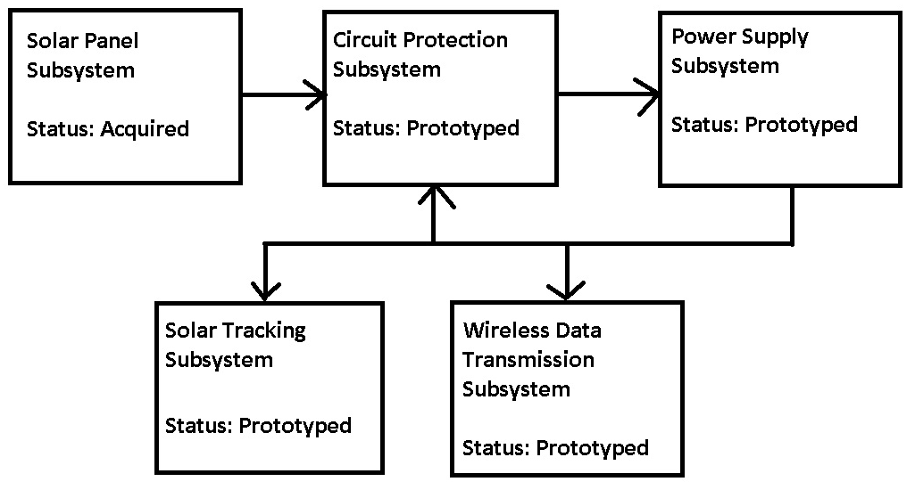

*Figure 4.1.1 - Solar Power Section Block Diagram*

The monitoring section, shown in the block diagram of Figure 4.1.2, is the part of the design that deals with monitoring the properties of the solar array, displaying the data for the user, and/or modifying the positioning of the solar array for greater efficiency. This section includes the sensor arrays, storage devices, wireless access, user interface and solar tracking. As with the solar power section, each of these subsections will be discussed fully down to their unit parts, so that the design can be assembled as quickly as possible.

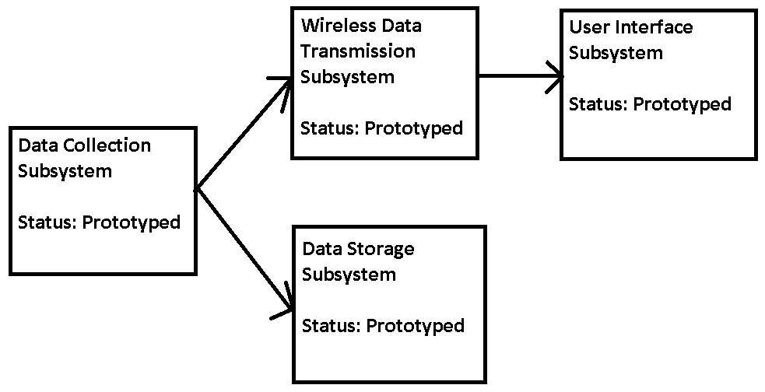

*Figure 4.1.2 - Monitoring Section Block Diagram*

**4.2 Solar Film Design**

After the group decided to base the project on increasing the efficiency of solar thin films, the group did a search to find comparable panels of different composites. The group spent a lot of time researching thin film solar panels and decided to go with the GSE 30W 17.5V thin film solar panel. This panel was chosen because of its high output at higher temperatures. This particular solar panel material can operate at temperatures up to 62 degrees, which is equivalent to 143.6 degrees Fahrenheit. Even at higher temperatures, the CIGS material operates in a range very close to 25 degrees Celsius, which is the standard testing condition (STC). It was calculated that the output power produced at 25 degrees Celsius was 30.63W. At 62 degrees Celsius, the power output dropped only to 26.25W. This gives the group great hope that this panel can perform just as well at higher temperatures with solar tracking and optics. Since it is not known at what temperature the panel’s efficiency will decrease, tests will be done to determine the temperature range that the design needs to avoid for optimum power production.

To summarize, the specs for the GSE Solar thin film panel are:

PN 33030-O 30W 12V Solar Panel

* Maximum power: 30W
* Current at Operating Voltage: 1.7A
* Operating Voltage: 17.5V
* Temperature Coefficient for Power: -0.5% / °C
* Temperature Coefficient for Voltage: -0.5% / °C
* Cost $179.99

With the power output not affected too much by higher temperatures, this solar panel looks to be ideal for the design. Keeping the panel cooler in order for it to generate more power will be noted, so there will be a gap between the two mounted panels in order for heat to be displaced quickly from each panel.

**4.3 Battery Bank Design**

The batteries and the inverter are integrally connected, as the main source of power draw from the batteries will be the inverter. Therefore, to ensure that this is taken into consideration, the important specifications of the inverter will be copied and analyzed here as well. The Powerbright ML-400-24 power inverter provides 400W continuously at 90% efficiency with a maximum power output of 800W. In order to power a 300W computer system, the inverter must draw 333W to make up for the 10% power expended in the inverter. A reasonable time to have this system running for is 2 hours continuously, therefore by using the equation , it is determined that for a 24 V system, the total amp hours must be 25. Batteries of this amp-hour rating however are significantly more expensive and if one were to examine the charging time of batteries of this rating with our chosen solar panels, it can be found that the batteries would be charged in almost 18 hours at peak operation. This is unacceptable according to our specifications; therefore a tradeoff between charging time and run time was met.

In order to meet the maximum acceptable charging time of 10 hours at peak operation of our solar panel system, the maximum amp-hour rating the batteries can have is 18 AH. Plugging this value back into the capacity equation above, we find that this will give the system a 1.3 hour battery life at peak draw. If one also consider that the system is likely to be charging while in operation, it can be seen that this is not necessarily as much of a loss in operation time as quoted. A battery of this rating was selected and purchased from an online distributor. The specifications of the selected battery are detailed below.

SLA-12V14-F2 Twelve Volt Sealed Lead Acid Battery

* Provides 12V Average
* 18 amp-hours
* Operating temperature of -40ºC to 60ºC
* Terminal Female M6 Insert
* Costs $34.95 each ($19.31 shipping)

Given that the inverter selected requires 24 volts for operation, two of these batteries were purchased and installed in the final design.

**4.4 DC/DC Converter Design**

It was decided that the simplest and most cost effective way of converting the most power while still protecting the sealed lead acid batteries from overcharging damage is to use a voltage controlled charging circuit, whose simplified schematic is shown in Figure 4.4.1.  The idea of this circuit is the battery is exposed to the solar panel’s full power with a small buffer resistor to prevent thermal overload due to the voltage differential, as well as modulate the charging current base on the voltage drop across it.  The switches in the top and bottom line were designed to turn off when the battery on the respective line nears its maximum charge, which is roughly 13.3V for the selected 12V sealed lead acid battery. The switches on the center line are tied to one of the other two switches and close when they open, allowing current to flow through one of the batteries should the other reach max charge first.  In order to decide when to open and close, the switches will receive an input from a voltage comparing circuit and behave accordingly.

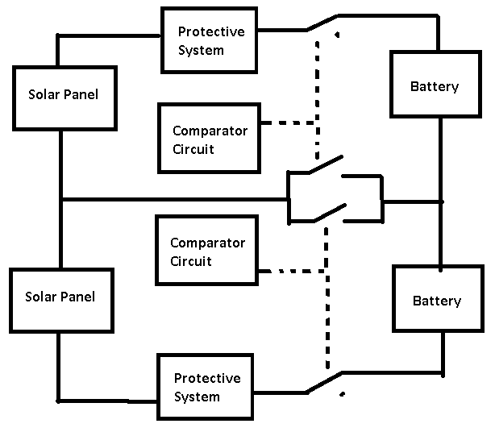

*Figure 4.4.1 - DC/DC Converter Block Diagram*

To begin the design, one should start with the very basic circuit.  In this case, the most basic form of this circuit is two solar panels in series connected to two 12V batteries in series with a resistor and diode in between them, shown in Figure 4.4.2. The center line provides the current route when the switches on the top or bottom is open and one of the switches in the center closes.

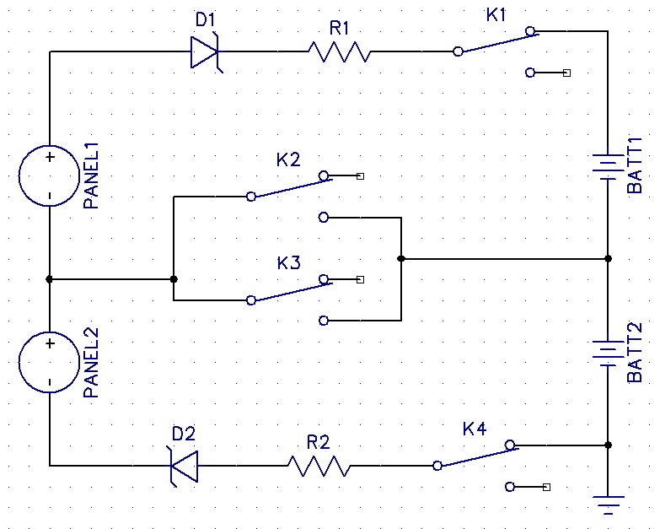

*Figure 4.4.2 - Basic Voltage Controlled Charger Schematic*

The way this circuit works is if the solar panels are not producing power, at nighttime perhaps, the battery voltage exceeds the solar panel voltage and the series diode creates opens in the lines, blocking current flow in the opposite direction through the positive terminal of the solar panel, protecting the solar panel from destructive back current.  However, during operating conditions, the panel voltage exceeds that of the diode’s junction voltage and the battery voltage, thus allowing current to flow through each of the arms.  If the switch is assumed to have no voltage drop, the current through the branches will be dependent on the voltage drop across the resistor, which is the panel voltage minus the diode junction voltage and the battery voltage.  The maximum voltage drop across the resistor will occur when the battery is fully discharged and the panel is operating near maximum voltage. Knowing these values (17.5V max for the panel and 11.8V minimum for the batteries) the resistor values were chosen so as not to exceed the maximum current allowed through the panels given this voltage drop, resulting in a value of 3.35Ω for each resistor. Two 3Ω resistors with a power rating of 10W were chosen for these components. The diode chosen was a Schottky diode with a voltage drop of 500 mV. A Schottky diode was used because they traditionally have a low forward bias, reducing the power they consume. In addition, the reverse breakdown voltage for these components is 40V, well above the maximum battery voltage, which means the diode will never allow current in the opposite direction.

The switches used in Figure 4.4.2 were selected to be double pole double throw latching relays. These components were chosen primarily because they latch into position when one of the coils is energized, consuming no power at any other time. In addition, each component contains two logically connected switches. Since the top and bottom switch are logically tied to one of the switches on the center line, the ability to control both at the same time using the same logic is a good feature. The specifications for the particular relays chosen are given below:

TX2-LT-4.5V-TH: TX Series 4.5V/2A DPDT 2-Coil Latching Relays

* 2A rating for the input and output pins.
* 30mA nominal coil current at 4.5V.
* Turn on voltage of 3.38V
* Costs $5.54 each from Digikey.

These relays were chosen because they can handle the max operating current of 1.7A on the contact pins. In addition, they operate on transistor to transistor logic, which is fairly simple to implement using a standard comparator circuit.  This comparator was designed such that it will switch whenever the voltage in the battery indicates that it has reached its maximum charge or dropped below it. The schematic for this design is given by Figure 4.4.3.

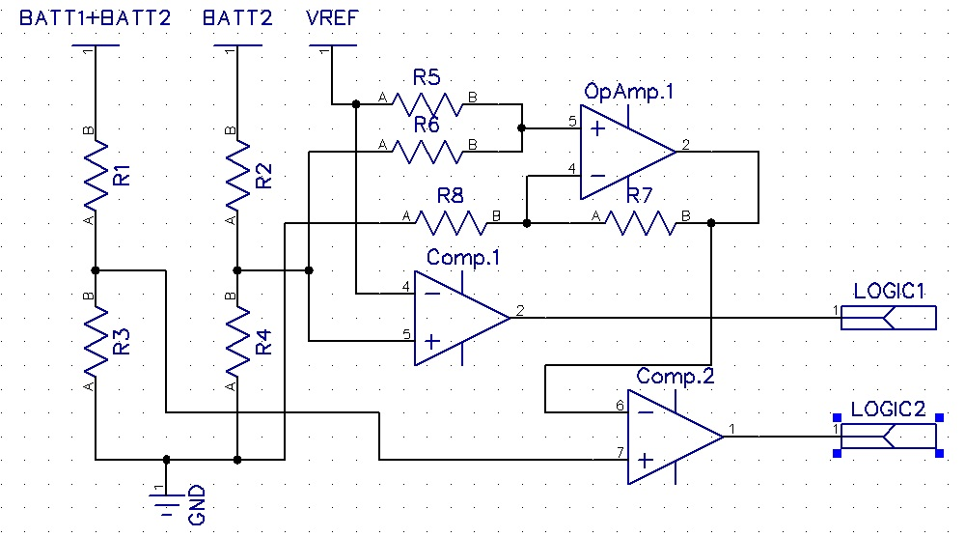

*Figure 4.4.2 - Basic Voltage Controlled Charger Schematic*

The way this circuit is designed to work is that it reads the current voltage of the battery system and halves it to make sure the input of the comparators is less than the supply voltage being supplied to them. It is then compared against a reference voltage set to 6.45V, half what was decided to be the max battery voltage allowed in this design. The output of the comparator is forced into TTL logic, reading high when the battery voltage exceeds the reference voltage. The op amp show in the circuit serves only as a summing amplifier to add the reference voltage to the voltage reading of the bottom battery, whose output is used as the proper reference voltage for logic of the top set of switches. All resistor values were chosen such that the maximum draw from the batteries does not exceed 10mA, limiting the power lost for this system. The logical breakdown for this circuit in relation to the switches in Figure 4.4.1 is given in Table 4.4.1.

*Table 4.4.1 – Summary of Relay Logic*

|  |  |  |  |  |  |
| --- | --- | --- | --- | --- | --- |
| Logic1 | Logic2 | K1 | K2 | K3 | K4 |
| L | L | Closed | Open | Open | Closed |
| L | H | Closed | Open | Closed | Open |
| H | L | Open | Closed | Open | Closed |
| H | H | Open | Closed | Closed | Open |

It was determined very early in the semester that the output of the comparators does not have enough current to drive the relays. Therefore, a line driver was selected to drive the relays. One was chosen based on the fact that it outputs not only a high current logical high TTL logic in response to a logical high TTL input, but also a logical low TTL output as well. This is perfect for the selected two coil relays. Placing each of these outputs on one of the coils provides the proper operation of a two coil relay in that one of the coils becomes energized to provide the switching action, while the other is de-energized. These connections of the line driver to the comparators and relays can be seen in Figure 4.4.3.

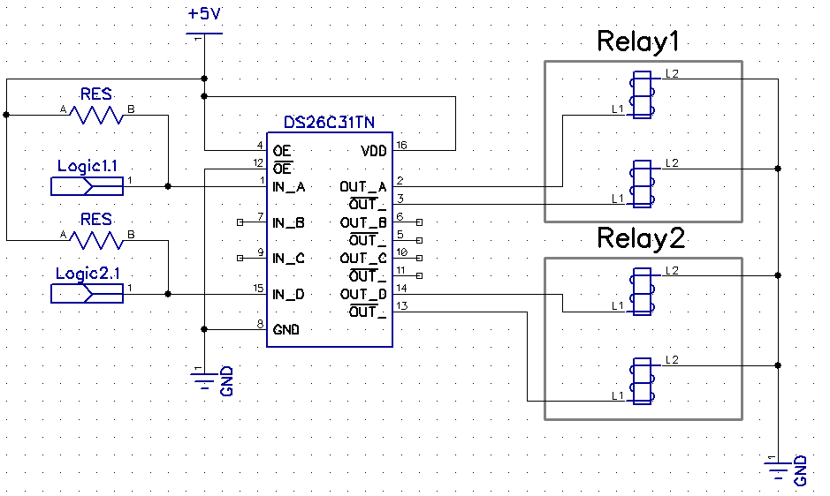

Figure 4.4.3 – Line Driver Logic and Coil Schematic

In addition to the logic and relays in the above figure, resistors were included to force the TTL logic by functioning as pull-up resistors for the comparator outputs. A resistor value of 470Ω was selected in the end because it seemed to provide the least voltage drop at high logic, maintaining the 5V at the line driver input.

The specifications for the comparator, op-amp and line driver described above are:

LM139AJ Quad Low Power L Off V Voltage Comparator

* Supply voltage of 36V or ±18V dc
* Differential input voltage of 36V dc
* Max input current of 50mA
* Variable output voltage adjustable between 1.24V and 60V
* Temperature Range of -55 to 125 degrees
* Costs $8.20 at Digikey

LM124J Quad Low Power L Off V Voltage Comparator

* Supply voltage of 36V or ±18V dc
* Max output current of 40mA
* Temperature Range of -55 to 125 degrees
* Costs $8.25 at Digikey

DS26C31TN CMOS TRI-STATE Differential Line Driver

* Supply voltage of 5V
* Maximum output of 150mA per pin.
* Uses TTL logic for operation.
* Temperature Range of -65 to 150º C
* Costs $2.33 at Digikey.

All the parts above were selected because of their ability to use a single supply voltage and/or the ability to operate using TTL logic. The line driver mentioned was also selected because its maximum output current exceeds the nominal coil current of the relays being used.

In order to maintain independence from grid power and other external voltage sources, all integrated circuits must receive power from an internal system of linear regulators. In addition, the reference voltage for the logic described previously must be generated as well as 12, 9 and 5 volt lines is made available to the solar tracking, data storage and wireless transmission systems. The power supply circuit is shown in Figure 4.4.3.

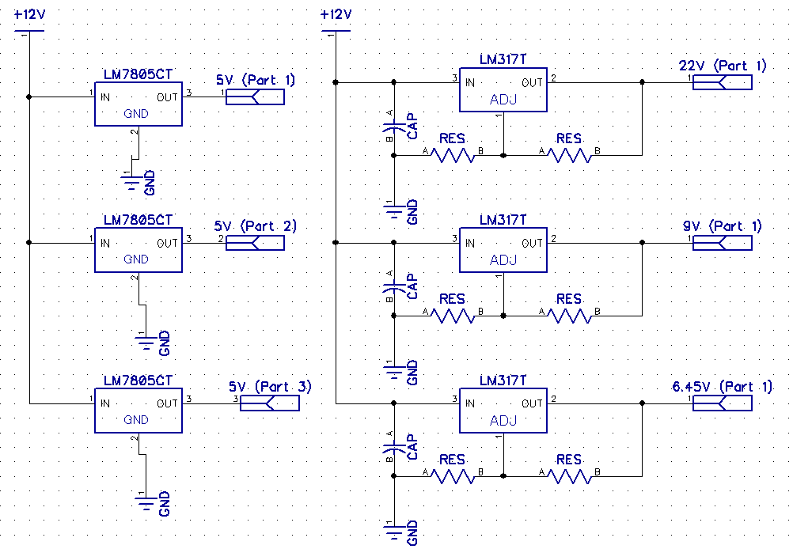

*Figure 4.4.4 - Schematic for IC Power Supplies*

All the power supplies for the integrated circuits are supplied by an array of 5V and adjustable linear regulators. A few of the chips, specifically the operational amplifier and comparator integrated circuits need to have a fairly high supply voltage to take in voltages from the batteries as inputs. 22V was selected for these, as this is always attainable even when the batteries are nearing fully drained even with the voltage drop in the regulator itself. The 9V power supply is for use in the solar racking circuit detailed in Section X.X. The 6.45V voltage was generated for use as a reference voltage for the comparator circuit. All of the adjustable regulator use a filter capacitor at the input to keep the voltage constant and output voltages based on resistance values, chosen by the formula



where is a value between 240 and 5000 ohms. The specifications for the adjustable regulator are as follows:

LM317T - Adjustable Linear Regulator

* Input voltage range of up to 36V
* Adjustable output voltage of 1.24V to 24V DC
* Output current of up to 1.5A
* Costs $2.49 from Radioshack

For the 5V regulators, one of the supplies is to be used on the power board to force the TTL logic in the comparators and supply power to the line driver as well as the enable pin for that part. The other two 5V regulators were reserved for use by the solar tracking and data storage subsystems. The

LM7805 - 5V Linear Regulator

* Input voltage range of up to 36V
* Output of 5V DC
* Output current of 1A
* Costs $0.60 from Digikey

In addition to the supplies shown above, additional components in the solar tracking and wireless transmission subsystems will require 12V of unregulated voltage for various applications. This will be attained directly from the batteries themselves.

The total cost of components used in the final design can be found in Table 4.4.2. Additional expenses were incurred due to redesigns, shipping and part failures throughout the course of prototyping. Also included in the table is the cost of the manufacturing of the printed circuit board, purchased from Advanced Circuits under the student discount of $33 per board.

*Table 4.4.1 - Cost of materials for DC/DC Converter and Power Supplies*

|  |  |  |  |
| --- | --- | --- | --- |
| **Component** | **Price per unit** | **# of units needed** | **Total Cost** |
| TX DPDT Relays | $5.54 | 2 | $11.08 |
| LM139AJ | $10.00 | 1 | $8.20 |
| LM124J | $2.93 | 1 | $8.25 |
| DS26C31TN |  |  | $2.33 |
| LM7805 | $0.60 | 3 | $1.80 |
| LM317T | $2.49 | 3 | $7.47 |
| 1/4W Resistors | ~$0.10 | 14 | $1.40 |
| 10W Resistors | $ | 2 |  |
| Capacitors | ~$0.30 | 3 | $0.90 |
| PCB | $33.00 | 1 | $33.00 |
| **Total Price** | - | - | $74.43 |

**4.5 Inverter Design**

It has been determined that for the the purposes of this project, the inverter that is necessary needs only to be a modified sine wave. None of the devices we intend to power require a pure sine wave for their timing circuits so everything should function as expected. The energy needs decided upon was enough to power a computer continuously, or 300 W of continuous power. The battery design from previous has two 12 volt batteries in series, therefore to hook the inverter to them, the inverter must be 24V itself. By referring to Table 3.5.1, it can be seen that the inverter that fits this description is the Powerbright ML400-24. It provides 400W of power continuously, giving a little extra power as a buffer to our expected power output, and costs $39.99. The specifications for this device are given below:

Powerbright ML-400-24 Power Inverter

* Modified sine wave
* 400W continuous/800W peak
* Provides up to 3.3 A with a <0.08A no load current draw.
* 90% efficiency
* Input range of 20-30V (low/high voltage shutdown at 20V/30V respectively)
* Low voltage alarm at 20.6V
* Two 120V AC (three-pronged) outlets built-in
* Price of $39.99

The above device meets all design specifications in question. It outputs in the range 110-127V at 60Hz, so the output requirement is met. It can provide the expected power output of 300W continuously as long as the battery input is sustained, theoretically indefinably.

**4.6 Solar Collector Design**

In this project, an effort was made to use low cost solar collector solutions. However, low cost often means designing and constructing it with these specific goals in mind. The collector technology that was chosen to meet these specific design goals was the parabolic trough.  Ideally, the collector would be made from plastic paneling, available at local hardware stores for $30.00 for a 10x15 panel. However, for the prototype, the group decided to use a cardboard box to use as the base of the reflective trough. The box was inexpensive and easier to manipulate. The parabolic trough was sized to be roughly 2ft x 4.25 ft, so the rest of the materials will go towards creating a waterproof shelter for the design electronics. This trough will be coated on the inside with highly reflective Mylar, available in 25 x 4 ft rolls for $13.95.  The Mylar has a reflectivity of 95%, which is sufficient for the application being implemented here.  The cardboard was bent into shape then reinforced with rigid aluminum framing which was attached to the solar panels. The overall orientation of the final dish design is depicted in the conceptual drawing in Figure 4.6.1.

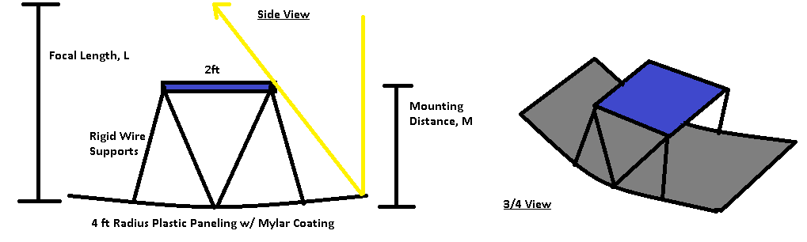

*Figure 4.6.1 - Final Solar Collector Design Concept*

The values for the focal length and the mounting distance will be determined via direct measurement during the construction and testing of the trough, detailed in the test plan. Overall, this was the simplest and cheapest possible design that met the design requirements for the solar collector of high reflectivity to cost ratio and had the most probable chance of success in the form of accuracy.  The total cost of this design is shown in Table 4.6.1, which lists the materials and their cost per unit.

*Table 4.6.1 - Cost of Materials for Solar Collector*

|  |  |  |  |  |
| --- | --- | --- | --- | --- |
| **Material** | **Unit Size** | **# of Units Needed** | **Price per Unit** | **Total cost** |
| Cardboard | Large | 2 | $1.37 | $2.74 |
| Mylar Coating | 25ft x 50in | 1 | $13.95 | $13.95 |
| Angle Iron | 6 ft | 2 | $6.64 | $13.28 |
| **Total Price** | - | - | - | $29.97 |

Additional expenses not included in the cost of materials are the taxes, as well as miscellaneous building materials needed, such as nuts and bolts.

**4.7 Sensor Design**

There are two common ways to connect photoresistors in order to achieve accuracy in moving the solar panel in the direction of sunlight. The first is to have a solar sensing circuit on the east and west sides of the panel facing outwards. This design works by when the first light of the day appears, the east sensor will absorb more sunlight than the west facing sensor. With programming, this will cause the solar panel to move in the direction of the east facing sensor. The sun will continuously move and the two sensors will continue to try and be equal by moving the solar panel so the angle of incidence is zero.

Another way is to have two sensors that are separated by a vertical opaque material. When the sun is shining right up above, both sensors receive an equal amount of sun, and no shadow is created which means the panel remains fixed. Once the sun moves across the sky, a shadow will be cast on one of the sensors. This will mean that one sensor will have more sunlight shining on it than the other. This will allow the solar tracking circuit to move to its steady state, or when there is no shadow cast on either sensor.

Both designs work well. During the final design, the group decided to go with a design that has a vertical shade. Photoresistors do not perform well in direct sunlight. So when there is shade on a single photoresistor, the voltage inputs to the microcontroller are varied enough to determine which direction to have the motor turn.

Advanced Photonix Inc Photo-resistors:

* High max voltage (150VDC) so they will not fail due to voltage spikes
* High resistance as high as 2 M-ohms
* Low resistance as low as 3 k-ohms
* Multiple resistance range pairs will be purchased for experimentation
* Price is $1.58 to $2.64 each

When designing, the ideal range of resistance of the photoresistor will be determined for the solar tracking circuit.

In order to gauge the efficiency of the solar panel system as a whole and collect data for display in the user interface, a series of current and voltage sensors were implemented in the final design. These sensors and their sections were selected on a few parameters:

* Must output voltages of less than 3.5V for use with the PIC microcontroller and the Xbee wireless transmitter.
* Must have less than 5% error in relation to the actual value.

The final schematic for the power sensors is shown in Figure 4.7.1 followed by a discussion of its operation.

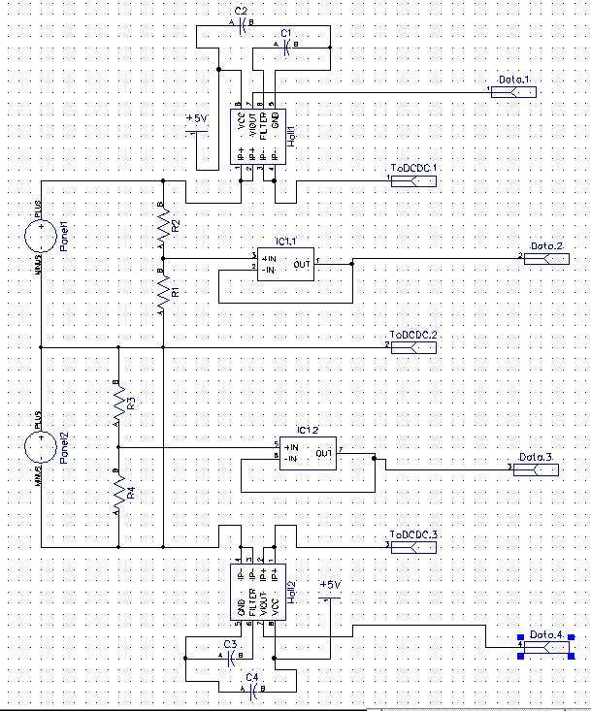

*Figure 4.7.1 – Schematic for the Power Sensors (Voltage and Current)*

It was decided that since the DC/DC Converter is designed to allow the solar panels to operate independently of one another, a set of voltage and current sensors would be needed for each of the panels in case one line is open, while the other is closed and still allowing current.

Originally, the voltage sensor design was intended to include differential amplifiers; however, during testing the chips were fried. Running short on time to order another set, an alternative method was developed to get a voltage reading. This method is not as precise as the differential amplifier would have been, but initial testing indicated that it does still fall within our error margin of 5%. The method used was to apply a voltage divider to the positive terminals of each of solar panels, and feed the output of the voltage divider into the a unity gain operational amplifier to isolate the output resistance of the voltage divider from the PIC microcontroller and the Xbee wireless transmitter. The voltage divider was designed to cut the effective voltage of the solar panel readings down to under 3.5V (by a factor of 6 for the bottom panels positive terminal voltage and by 12 for the top panels positive terminal voltage), so as not to over-volt the data storage and transmission. The original voltage is then reconstructed in the code using the formula () for the bottom panel and () for the top panel. The operational amplifier used as the unity gain buffer is the same operational amplifier used as a summing amplifier in the DC/DC converter.

For the current sensors, the ACS714 Hall Effect Linear Current Sensor was chosen for use in the final design. This part was chosen based on the fact that it reads a current between -5 and 5A and outputs a voltage between 1.5V and 3.5V with a linear gradient. Since the main lines are not expected to exceed 2A, this part will operate well under all conditions. Also, since the output voltage is under 3.5V, it is in no danger of overloading the data storage or data transmission systems. The fact that its response is linear is also a great positive in that it greatly simplifies the code that will reconstruct the original current value. With a sensitivity of 185 mV/A and an output of 2.5V corresponding to 0A, the formula used to retrieve the original current value is (). The capacitors seen in the schematic above serve only as filters to stabilize the output and keep the power supply steady. The specifications for this part are as follows:

ACS714 - Hall Effect Linear Current Sensor

* 5V single supply operation
* Output sensitivity of 185 mV/A
* Accuracy of 1.5%
* Operating temperature of -40 to 150˚C
* Costs $4.66 from Digikey.

Once the voltage and current readings are obtained the power of the system will be calculated for each panel using (P=IV) and the power of each panel will be summed for the final power reading.

A summary of expenses for the sensor system is given in Table 4.7.1. In addition to these expenses, additional costs were incurred for shipping, part failures and circuit redesigns. Not included in this table is the unity gain operational amplifier, as this part has already been declared in the budget for the DC/DC Converter.

*Table 4.7.1 - Cost of materials for Sensor Array*

|  |  |  |  |
| --- | --- | --- | --- |
| **Component** | **Price per unit** | **# of units needed** | **Total Cost** |
| ACS714 | $4.66 | 2 | $9.32 |
| Photoresistors | $3.00 pack | 1 | $3.00 |
| Resistors | ~$0.10 | 6 | $0.60 |
| Capacitors | ~$0.30 | 4 | $1.20 |
| Total Price | - | - | $14.12 |

**4.8 Solar Tracking Design**

The solar tracking needs to have a few functions. It needs to start working at dawn, the first sunlight of the day. It will continue to track throughout the day as usual, but stop moving if the sun is blocked, usually by clouds. At night when the sun goes down, the tracker should not be tracking. This was best be done with a PIC controller or another logic device.

The solar sensors will feed into a microcontroller. With programming, the microcontroller converted the two incoming analog voltages todigital voltages. With internal logic and programming, the microcontroller will send voltages to a DC motor through a motor controller to turn the motor clockwise or counterclockwise. Figure 4.8.1 shows a block diagram of the solar tracking circuit.

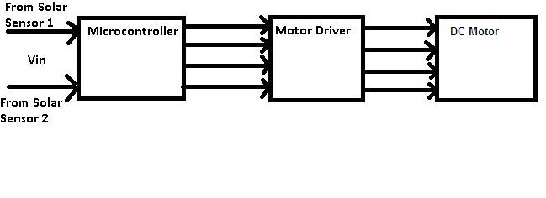*Figure 4.8.1- Solar Tracking Block Diagram*

The voltages from the each of the photoresistors were fed into a Peripheral Interface Controller (PIC) microcontroller. The one going to be used is a Microchip PIC18F4520. This part was chosen for its multiple options, mostly for the reason that a group member happens to own a few. It contains five 10-bit analog to digital converters, so an external one is not needed. And with an operating range of 2 to 5.5V gives the option of multiple levels of voltage to power the chip. A summary of the important features of the PIC18F4520 are shown.

Microchip PIC18F4520

* 256 bytes of EEPROM data memory
* Wide operating voltage range: 2.0V to 5.5
* 13 channels of 10-bit Analog-to-Digital (A/D) converter
* Selectable frequency range of 8 MHz to 32 kHz
* Power-saving sleep mode
* In-Circuit Debug (ICD) via two pins
* 2 analog comparator modules

The outputs from the photoresistors will feed into pin. Pin 1 is the master clear. Pins 2 and 3 are being used as the two inputs for the photoresistors. The output voltages will come from pins 21 and 22 which will feed into the driver. The motor driver circuit chosen is from ST Microelectronics. It is the L298, or a dual full-bridge driver. The two outputs from the microcontroller feed into the driver chip and output to the two output pins. The Sense A connection is connected to a resistor to ground to control the current in the motor. Enable A is used to disable bridge A. This driver has the ability to amplify the output signals from the microcontroller efficiently.

ST Microelectronics L298 Dual Full Bridge Driver:

* Operating voltage supply max is 46V
* DC current up to 4 amps
* High temperature protection, has thermal shutdown

The motor chosen for this design was one that a group member owned, which belongs to a water pump. The motor is a DC motor, which means that in order for it to track the sun efficiently, the microcontroller will need have its output voltage pulsed before it goes into the driver. It was decided that the motor will have three modes of operation: clockwise, counterclockwise, and off. This is done by having the microcontroller output TTL logic. One output of the microcontroller will be a high voltage, while the other will be off. This will allow the motor to turn in either direction. If both outputs are off, the motor will seize and stop moving. To not let the motor spin uncontrollably, the outputs will be pulsed from the microcontroller.

ShurFlo Diaphragm Pump DC Motor:

* Operates at a range up to 12VDC
* Current up to 7.5A max

The schematic for the solar tracker is shown in Figure 4.8.2.

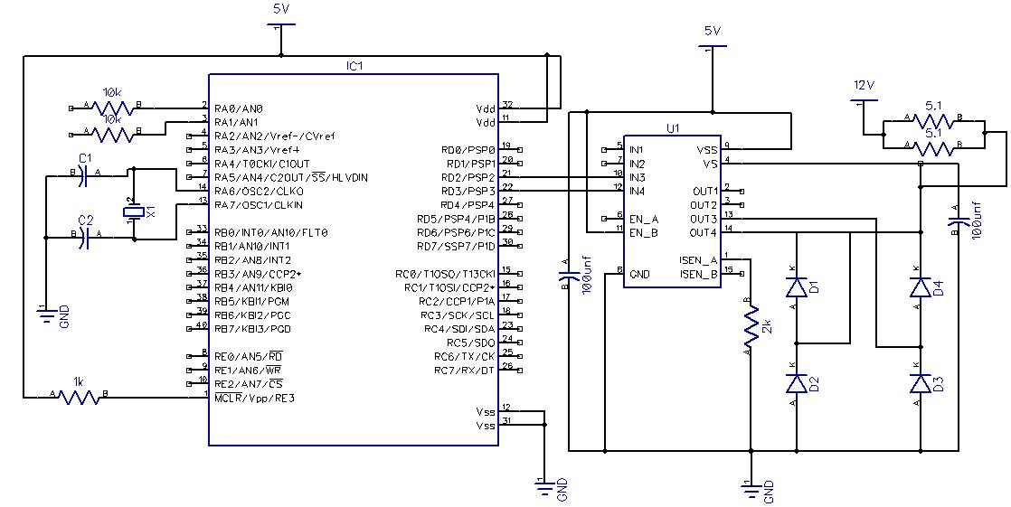*Figure 4.8.2- Solar Tracking Schematic*

The above circuit was created with the software DipTrace, which is a program that allows the user to create a schematic as well as the PCB layout of the design. Below in Figure 4.8.3 is the Solar Tracking PCB design.

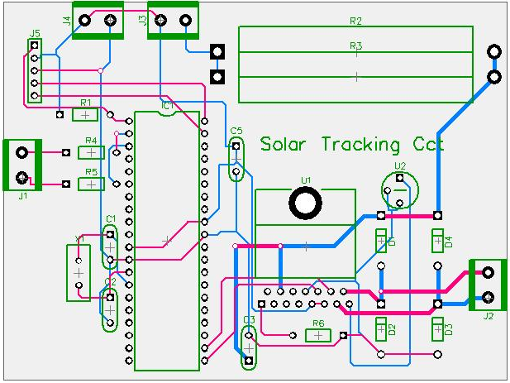

*Figure 4.8.3- Solar Tracking PCB Layout*

The board was created to save as much board space as possible, therefore saving on costs on production. The connector J1 will receive the inputs from the two photoresistors. The J2 connector is the outputs that drive the DC motor. Connectors J3 and J4 are the power supply connectors, which receive 5V and 9V, as well as a ground connection. However, when testing, the driver chip (L298) was getting too hot for comfort when handling higher voltages. So it was decided to create a separate circuit consisting of relays to connect between J2 and the DC motor. This way the circuit is thermally safe and can still operate effectively.

The total expected cost of this design is given in the Table 4.8.1, which lists the materials and their cost per unit.

*Table 4.8.1 - Cost of materials for Dual Axis Solar Tracking Unit*

|  |  |  |  |
| --- | --- | --- | --- |
| **Component** | **Price per unit** | **# of units needed** | **Total Cost** |
| Photo-resistors | $3.00 | 1 | $3.00 |
| Resistors | $0.00 | 4 | $0.00 |
| PIC18F4520 | $0.00 | 1 | $0.00 |
| L298 | $4.67 | 1 | $4.67 |
| Relays | $4.49 | 2 | $8.98 |
| Weatherproof box | $4.99 | 1 | $4.99 |
| PCB board | $68.82 | 1 | $68.82 |
| **Total Price** | - | - | $94.45 |

The testing was done on a breadboard, so through-hole parts will be ordered. After testing, a PCB board will be made with the final circuit design while using the original through-hole parts to save on costs. Additional costs not included in the above table would be the extra pieces needed for the circuit to be installed correctly, such as alligator clips, extra wire, nuts and bolts, etc. The PIC microcontroller is free due to Microchip’s free sample program for students. Resistor values will be used to create the voltage divider circuit with the photo-resistors. These will be supplied by the UCF Senior Design Lab. Final values are shown in the schematic in the figure above.

**4.9 Data Storage Design**

The data storage design is comprised of both hardware and software design aspects. The first section that will be discussed is the hardware section, where both hardware choices and implemenations will be discussed in more detail. The second section will go into more detail about the software program design.

**4.9.1 Data Storage Hardware**

It was decided to use the PIC32 Ethernet Starter Kit for the data storage unit that will store the voltage and current from the attached sensors, as well as the computed power from the resulting data. Unforunately, temperature had to be taken out of the design due to complications with the digital output. Also, originally the design for the data storage was that the microcontroller would store the data in its RAM. However, it was decided to use instead a USB flash drive that would be connected to the USB connection port. The reason for this was that it seemed easier for the user to access the back-up data storage via a flash drive rather than accessing the microcontroller’s RAM. The user would simply take the USB flash out of the microcontroller and upload the text files containing the stored data.

The block diagram shown in Figure 4.9.1.1 shows the higher level design for the starter kit. The idea is that the PIC32MX795F512L microcontroller handles most of the USB connection ports, switches, LEDS, and Ethernet ports that are built-in to the board, along with the main programming code for the software design. The PIC32MX440F512H microcontroller is used simply for the debugging USB port and connecting to the 3.3V power supply, thereby distributing the power needed for the board as a whole.

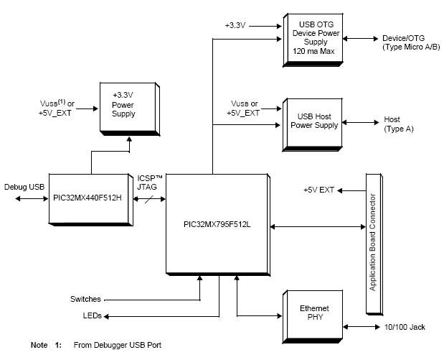

*Figure 4.9.1.1 – High-Level Block Diagram for the PIC32 Ethernet Starter Kit (reprinted with permission from* Microchip Technology Inc*)*

The PIC32MX795F512L microchip is the essential piece in the starter kit for this project. This microcontroller holds the logic that determines how to read the data transmitted from the sensors, places that data into the flash drive, and outputs the data to the LCD screen. This microcontroller was also going to be responsible for communicating with the user interface wirelessly. However, for simplicity of design, this feature was taken out of the overall design, which the reason for this will be discussed later in the wireless transmission section of the design section.

The LEDs are promptly be used for indicators to show the stages of run modes the microcontroller might be in during runtime. The push-button switches will be used for controlling the different states, like entering into either the idle state or the reset state. The idle state is useful if there needs to be a manual pause in the data transmission from the sensors to the microcontroller, or the microcontroller to the flash drive. The reset state is useful for a safety override method in case an unexpected event occurs. Figure 4.9.1.2 shows the schematics for the LEDs and switches.

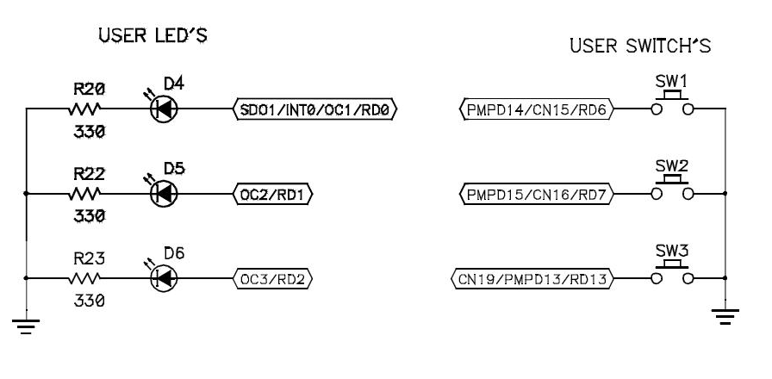

*Figure 4.9.1.2 –User LEDs and Switches Schematic (reprinted with permission from* Microchip Technology Inc*)*

The final thing to look at specifically is the +3.3V power supply. As shown in Figure 4.9.1.3, essentially the design de-amplifies a +5V input to a +3.3V output voltage by using various diodes, capacitors, and other components. The design originally called for the microcontroller to be powered by the power system designed for this project. However, this was changed due to an over abundance of current to the microcontroller. Further details will be discussed later in the discussion about the I/O Expansion Board.

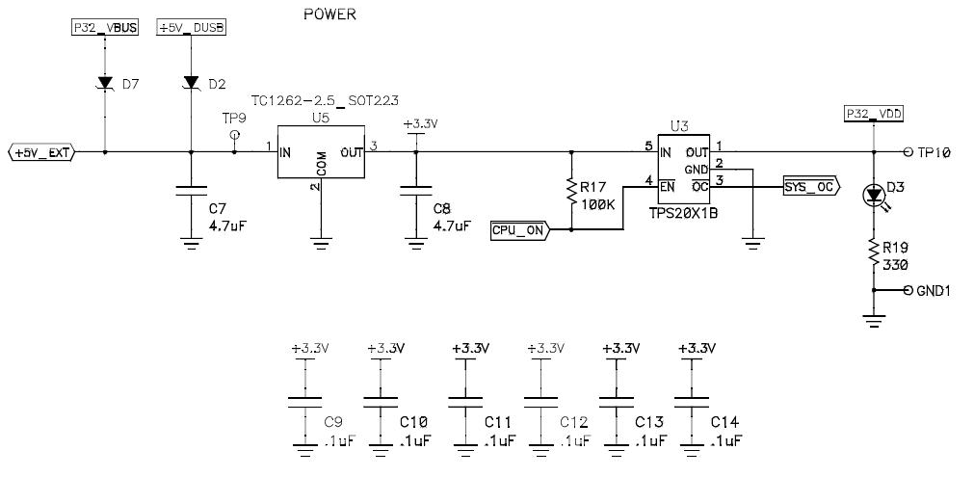

*Figure 4.9.1.3 –Power Supply Schematic (reprinted with permission from* Microchip Technology Inc.*)*

Now, it was determined to use sensors that do not have USB connectivity. Therefore, in order for the data storage unit to gather the data from the sensors in the design, the PIC32 I/O Expansion Board is used. The expansion board has MCU signal connections, allowing for the sensors to be connected directly. The data storage software gathers the data from the sensors by following the pin connections between the application board to the expansion board and then the expansion board to the sensors.

Figure 4.9.1.5 and Figure 4.9.1.6 show the pin connections between the PIC32 Ethernet Starter Kit’s application board and the PIC32 I/O Expansion Board. The left portion of the figures represents the application board pin setup, while the right portion of the figures represents the expansion board pin setup. The labeled portions on the right that are bracketed connect with the pin connections on the left that are labeled (wire connections were not drawn due to complexity in the figure). Notice that there seem to be double the amount of labeled pins on the application board, such as SPI1. This is because the figures only shows one of the PICtail connectors; the other connector is labeled exactly the same way, taking the other half of the labeled pins on the application board. The power supply values on the PICtail connectors would be connected to the power supply on the application board.

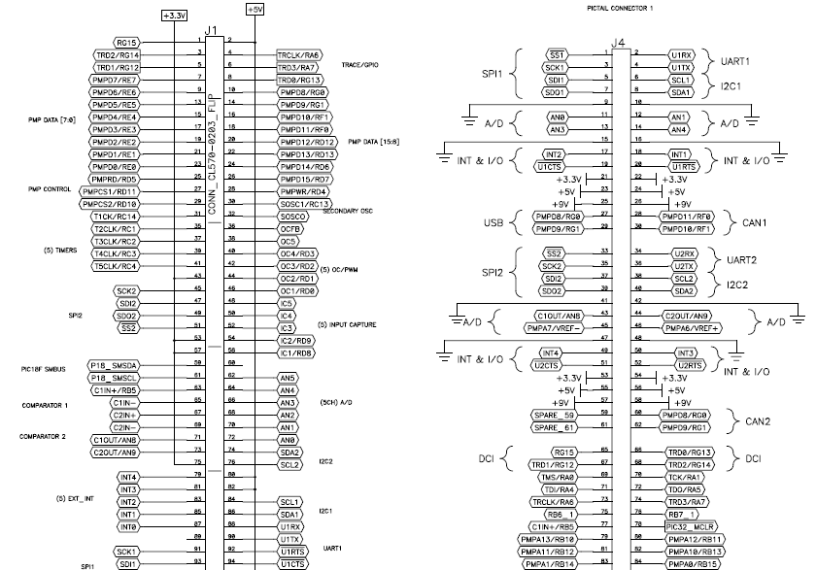

*Figure 4.9.1.5 Pin Connections Labeled – Top Half (reprinted with permission from Microchip, Inc)*

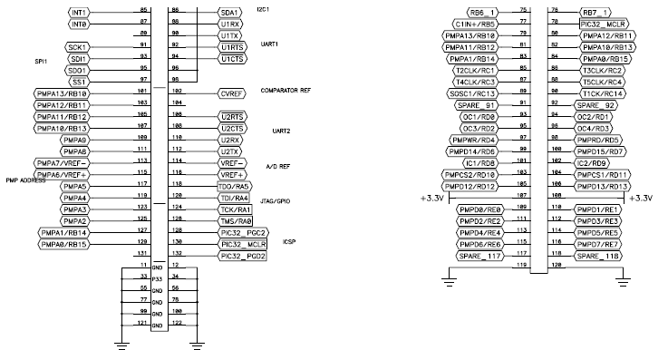

*Figure 4.9.1.6 Pin Connections Labeled – Bottom Half (reprinted with permission from Microchip, Inc)*

Figure 4.9.1.7 shows the pin connections between the PIC32 I/O Expansion Board and a sensor. Obviously there are more sensors that are connected, since there are sensors for current and voltage for each panel. The pin connections shown are just an example; for the actual design, the sensors are connected to the analog to digital converter pins (AN0-AN3).

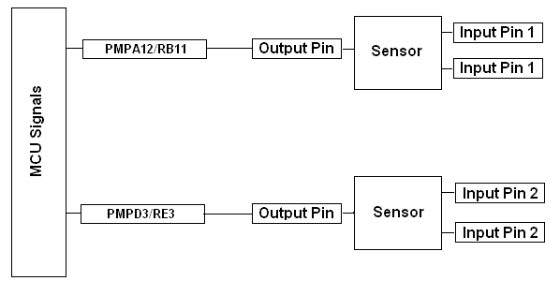

*Figure 4.9.1.7 Sensor Connections with I/O Expansion Board: MCU Signals Inputs*

As was mentioned before, the power that runs the data storage system was going to be provided by the power system of this design. However, it was decided to use a 9V power supply adapter, which will in turn power the microcontroller. This power supply is connected to the inverter, so it actually will be getting power from the solar panels themselves. Figure 4.9.1.8 shows the power supply connections for the expansion board if using this extra supply unit.

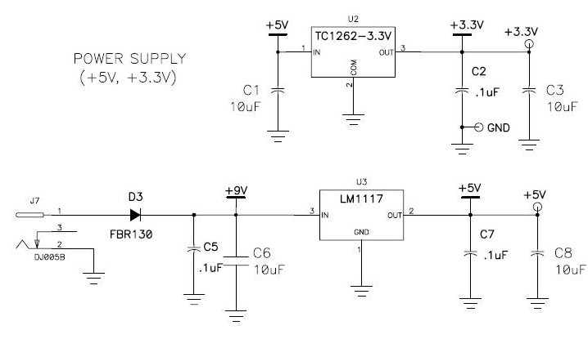

*Figure 4.9.1.8 I/O Expansion Board Power Supply (reprinted with permission from Microchip, Inc.)*

**4.9.2 Data Storage Software**

With the design of the hardware comes the design of the software. The software that the data storage unit runs basically involves gathering and storing the data given by the voltage and current sensors. First, since all of the sensors are connected to the analog-digital converter pins, the ADC channel parameters are initally set before anything else. After the ADC conversion channel parameters are set, the channels are enabled and the program goes into an infinite loop that will continously run the rest of the program until the power supply is cut.

The first thing the main program does at this point is check to make sure that a USB flash drive is plugged in, and if that flash drive is compatable with the microcontroller. The flash drive used within this design is a simple 4GB drive that can be purchased at any tech store/department. Once these conditions are met, a text file that has permission to be written to is created within the flash drive. An outlined table is created that holds voltage, current, and computed power values along with the timestamp of when these values were written to the file. Once the outlined table is created, it is time for the program to start running the ADC pins by starting another infinite loop. With the sensors connected to the pins, the program reads in the data from each sensor and stores them into four different floating point registers, with a one second time delay in between. The reason for this time delay is that the ADC pins are connected within the same circuit, causing residual voltage to leak to each pin. The time delay ensures that the readings from the pins don’t mix with each other. For example, without the time delay, it is possible that when the voltage from the first panel is outputted, it could be outputted to the register that is supposed to contain the voltage from the second panel. The time delay prevents this from happening.

The next step after storing the sensor values into the corresponding floating point registers is the logical conversions. First and foremost, to note, the PIC32 microcontroller can only reference up to 3.3V. This means that the circuitry for the voltage sensors have to dereference the voltage to a maximum of 3.3V. This is not necessary for the current sensors’ outputs since the maximum voltage of 3.5V corresponding to 5A should never be reached. So, since the voltage is dereferenced to that maximum of 3.3V, a mathematical conversion is completed to reference that voltage back to the correct value. The circuitry used to dereference the voltage has been designed to dereference that voltage by a factor of six for the bottom panel, while the voltage for the top panel is dereferenced by a factor of twelve, with the bottom voltage added to it. So, the voltage that is passed through the ADC for the bottom panel is multiplied by six to contain the true voltage value. The voltage for the top panel that is passed through the ADC is multipled by twelve, and then subtracts the bottom panel voltage.

Next, the current values have to be converted. The current sensors output a voltage value, with a conversion rate of .185V per amp. The minimum voltage outputted by the sensors for a conversion of 0A is 2.5V, while the maximum, as stated previously, is 3.5V for 5A. So, a liner mathematical conversion is used to determine what current is actually being read from the sensors. The program runs this conversion, with the minimum and maximum ranges taken into consideration. Also, the program does take into consideration negative current values; 1.5V represents -5A in comparision to the minimum value of 2.5V to 0A. After these conversions are accomplished, the only other mathematical operation to complete is the operation for power. The total power of the system is the voltage multiplied by the current for each panel, and then those two results are added together.

After these conversions are completed, the program now starts outputing these values to the flash drive. The floating point register values are converted into strings, since writing to the text file in the flash drive require string inputs. Then the strings are written to the text file, following the table setup that was initially created. So, after all this is done, for one timestamp, voltages, current, and power data that is outputted by the solar panels are stored onto a backup flash drive. The program then goes into a delayed state for 10 minutes, not reading in any data for that alotted time, representing an idle state. Once that time is up, the data storage program starts reading in new values from the voltage sensor circtrity and current sensors and repeats the cycle. If at any time throughout the program the flash drive is disconnected, the program breaks out of the main infinite loop and goes back to the previous loop that continously checked if a USB flash drive is plugged in and is in the right format. Figure 4.9.2.1 shows the flow chart of the software design of the data storage unit just described.

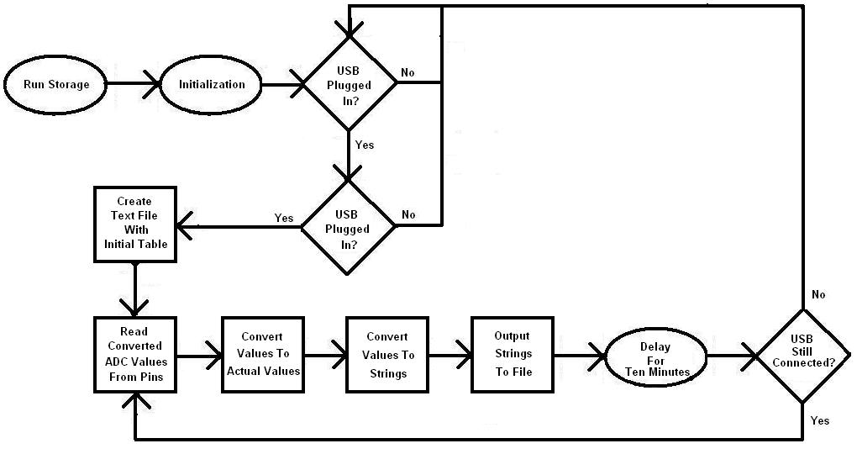

*Figure 4.9.2.1–Data Storage Flow Chart*

Table 4.9.2.1 shows the overall budget plan for the parts needed for the data storage unit. It is assumed an Ethernet Cable will have to be bought for the wireless connection.

*Table 4.9.2.1 Data Storage Budget*

|  |  |
| --- | --- |
| **Part** | **Price** |
| PIC32 Ethernet Starter Kit | $72 |
| PIC32 I/O Expansion Board | $72 |
| AC16203 9V supply | $24 |

**4.10 LCD Design**

The LCD module that was chosen was a Hitachi HD44780 blue backlight white character LCD based on its character line size, power supply, and price range. Earlier in the research, it was determined that no matter the choice among the LCD modules, all the pin layouts were roughly the same, dependent on whether or not there was a backlight in the design. Table 3.11.1 gave a summary of what the pins in the pin layouts actually did. The pin functions included: ground connection, power supply connection (VCC), contrast adjuster (VO), register select (RS), read-write (RW), clock enable that was falling edge triggered (CE), 8-bit data bus (D0-D7), backlight anode, and backlight cathode.

The LCD requires a +5V power supply to be connected to its VCC pin. This voltage is sent to the LCD drive voltage selector, which in turn sends power to the segment signal driver. The segment signal driver powers SEG1 to SEG40, which represent the forty segment signals that will display the output in the design. The segment signal driver in turn communicates with the common signal driver, which uses COM1 to COM16 to determine corresponding locations in relation to the segment signals to determine which character in a character space within the 20 x 4 character line size is to turn on. The power will be drawn from the I/O Expansion Board, powered by the 9V power adapter.

The LCD module has two 8-bit registers, an instruction register and a data register. The instruction register stores both instruction codes that are used to run the LCD and address information for the display data RAM and the character generator RAM. The data register is used as a temporary location for data that is to be both written to and read from the display data RAM and the character generator RAM. Data written to the display data RAM and the character generator RAM is automatically written by an internal instruction. When address information is written into the instruction register, data is read from the display data RAM and the character generator RAM and stored into the data register.

The RS signal is used to determine which of the two registers are selected. When RS = 0, the instruction register is selected, and when RS = 1 the data register is selected. When the instruction register is selected, the address information is sent from the register to the address counter, which in turn selects the data display RAM and character generator RAM data. The address counter is automatically incremented after the instruction is performed and it is sent to the data bus of D0-D6. When the data register is selected, the address counter is automatically decremented by one. While the LCD module is reading an instruction and acting upon it, a busy flag is set in D7 to state that it is in internal operation mode, stopping the next instruction from being read until the first is completed. [29] Table 4.10.1 shows the register selection operations in correspondence to the read-write value.

*Table 4.10.1 – Register Selection (reprinted with permission pending from Hitachi)*

|  |  |  |
| --- | --- | --- |
| **RS** | **R/W** | **Operation** |
| 0 | 0 | IR write as an internal operation |
| 0 | 1 | Read busy flag (D7) and address counter (D0-D6) |
| 1 | 0 | DR write as an internal operation |
| 1 | 1 | DR read as an internal operation |

Figure 4.10.1 shows the block diagram for the design of the LCD module.

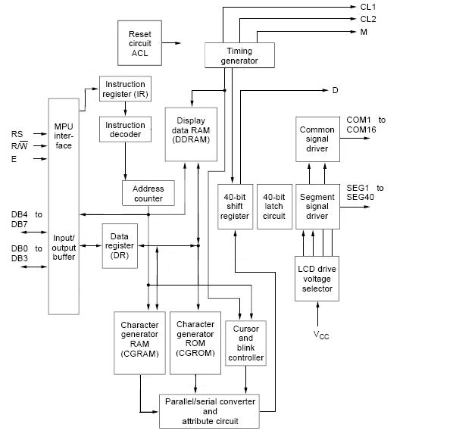

*Figure 4.10.1 – Hitachi HD44780 Character LCD Block Diagram*

The character generator RAM and ROM, after reading in the appropriate values from the address counter and the data display RAM, are then parsed into a 40-bit data bus that also contains the cursor location and blink status gained by the cursor and blink controller. These bits are fed into a 40-bit shift register, along with bit data from the timing generator. The timing generator takes in a timing step from an external clock; the timing step is not only used for the 40-bit shift register, but also for external extension drivers that may be connected to the LCD module. The 40-bit register shifts the data taken from the timing generator, character generator RAM and ROM, and the cursor and blink controller to appropriately print to whatever character line size screen is currently in use. One more element to the design is the Reset circuit ACL, which controls the resetting of the module if needed.

The purpose of having an LCD display connected to the data storage unit is to have a way to read the data that is being stored into the unit’s memory before having to create a user interface. In this way, the data storage unit’s capabilities can be properly tested right after its design. The I/O Expansion Board contains multiple pins that are used for a number of different pin connection applications on the application board connector. The Hitachi HD44780 blue backlight white character LCD module is connected to the application board connector. This allows the microcontroller in the starter kit to control what is outputted to the LCD screen.

In order for the output to be properly outputted, certain pins of the LCD module areconnected to open registers on the application board. This allows for the software design of the microcontroller to interact directly with the pins. The particular pins that need to be directly manipulated by the microcontroller are the RS, R/W, CE, and the data bus pins. The ground pin and the backlight cathode are connected to ground, while the VCC and the backlight anode are connected to the one of the +5V pin connections that allows for a power supply connection. The contrast adjustment is attached to a device that allows for multiple contrast selections by adjusting the power supply to the pin between ground and +5V.

Figure 4.10.2 shows the schematic layout for the connections between the application board connector of the PIC32 Ethernet Starter Kit to the HD44780 blue backlight white character LCD module. The registers chosen for the pins in the figure, that must be directly manipulated, stemmed from a previous design, that used a LCD 16 x 2 module, developed by an Application Engineer in Lighting Control named Joao Melo. However, as long as a register is available for connection on the application board, it can be used. For simplicity of design, the figure uses Joao Melo’s connections as inspiration. One thing about the figure to notice is that the first four bits in the 8-bit data bus are not connected. The reason is because the LCD module supports both 4-bit mode and 8-bit mode. The characters that are outputted to the screen only involve 4-bit characters in the character generator RAM and ROM. Therefore, only four bits are needed to be connected to registers. Since D7 is typically used for the busy flag bit, the four bits that are connected are D4 – D7.

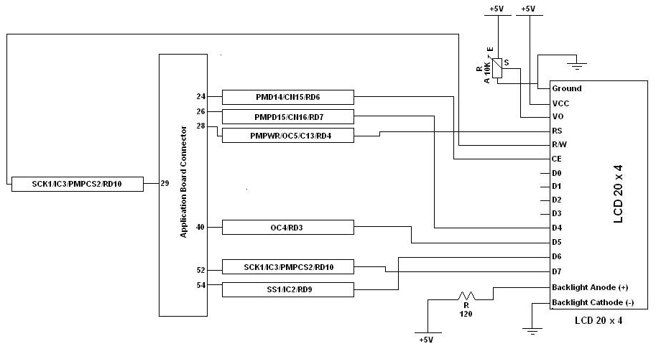

*Figure 4.10.2 – LCD Connected to PIC32 Ethernet Starter Kit Schematic*

After connecting the LCD module to the application board, all which is left in the design is the software aspect. Again, the reason why an LCD module is being implemented in the project design is for an easy way to check the data that the data storage unit is gathering and storing into memory.

Previously discussed in the data storage design, the flow of the data starts from the data gathered by the sensors. That data is sent to the microcontroller, where the data storage determines which information is which: current or voltage. After correctly identifying the data, the storage unit starts the process of storing it into the USB flash drive by converting the voltage and current values into the actual values that are coming from the solar panels by using the previously discussed conversion rates. Then the storage unit converts the floating point numbers into strings and uploads these string values to a text file on the flash drive with a timestamp showing when the data was uploaded.

However, now that the LCD is connected into the design, the data also has to flow to the LCD so it could output the information to its screen. Figure 4.10.3 shows the flow chart of the software design of the data storage unit previously discussed. But a difference, circled in red, adds the LCD into the design. While the data is converted into strings and upload to a text file in the flash drive, the data is sent to the LCD along the 4-bit data bus that is connected. When the strings are analyzed, each string is broken up by its characters, which are then in turn broken up into bytes, then bits. These converted bits are what determine what character to output to the LCD screen. The converted bits are sent along the 4-bit data bus, resulting in the data being fully outputted on to the LCD screen in a readable fashion.

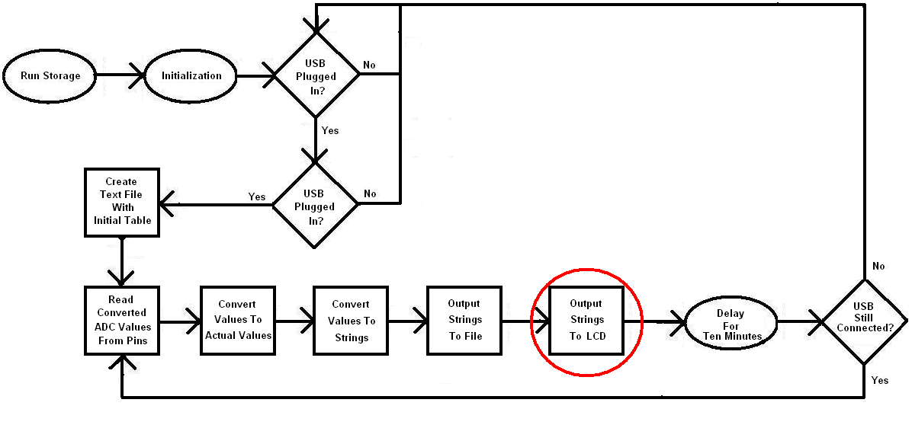

*Figure 4.10.3 – Data Storage Flow Chart with LCD Added to Design*

Table 4.10.2 shows the overall budget plan for the LCD design portion of the project.

*Table 4.10.2 LCD Budget*

|  |  |
| --- | --- |
| **Part** | **Price** |
| Blue Backlight/White HD44780 | $8 |

**4.11 Wireless Data Transmission Design**

The XBee was chosen as a means for wirelessly transmitting the data from the data storage to the user interface. There were a few other contenders but in the end, it was concluded that XBee would be the best suited for wireless telecommunications for the project. A total of four possible means of telecommunications were researched. Each form of technology was heavily scrutinized to ensure that, whichever piece was used, would be the best choice for this project. The basics of different forms of telecommunication technology were learned through that process. From all the research on all the different kinds of technology, it was clear why the XBee was the ideal choice. The four telecommunication technologies that were part of the research were XBee, ZigBee, WiFi®, and Bluetooth®.

Table 4.11.1 and Table 4.11.2 shown below, list parts that are projected to be used to design the data transmission section of the project, which will communicate with the data storage and the user interface.

*Table 4.12.1: List of Projected Parts for Data Transmission*

|  |  |  |
| --- | --- | --- |
| **Item Name** | **Quantity** | **Item Price** |
| XBee Explorer USB | 1 | $24.95 |
| USB Mini-B Cable (6′) | 1 | $3.95 |
| XBee 1mW Chip Antenna | 2 | $22.95 |
| Voltage Regulator (3.3V) | 1 | $1.95 |
| Coax Power Jack 1.3mm I.D | 1 | $0.35 |
| Breadboard | 1 | $8.99 |
| Solderless Breadboard Jumper Wire Kit | 1 | $5.99 |
| 10 ohm resistor | 1 | $0.99 |

*Table 4.12.2: List of Projected Parts for Data Transmission cont’d*

|  |  |  |
| --- | --- | --- |
| **Item Name** | **Quantity** | **Item Price** |
| 4.7 kilo ohm resistors | 2 | $0.99 |
| 10 kilo ohm resistors | 2 | $0.99 |
| 100 kilo ohm resistors | 2 | $0.99 |
| AA Batteries | 4 | $12.99 |
| 4 x AA Battery Holder | 1 | $1.79 |
| 9V Snap Connector | 1 | $2.69 |
| Blue 5mm LED | 2 | $3.49 |
| Total | | $94.05 |

All XBee modules require and work on 3.3V. This board provides regulated supply of 3.3V and a level translator for serial communication.

Pin point 1 is assigned for power supply where pin point 10 is assigned to the ground. All the pin points, from 1 through 20 will be attached with the XBee chip antenna. The end point XBee unit will be harvesting the data from the data storage. That data will be transmitted to a laptop. This is where the XBee explorer node comes in handy. It is connected to a laptop. The XBee end point will wake up every minute and will send the PV panel or battery ADC (analog to digital conversion) data to the XBee explorer unit which will be connected to a laptop.

**4.12 User Interface Design**

Figure 4.12.1 below displays the block diagram of the user interface. The user interface requests the data to be sent from the data storage. As soon as the user interface receives the data from the data storage, it will process the data and then display to the user.



*Figure 4.12.1: Block Diagram of the User Interface*

The goal is to design and construct a user interface that would display real time data (voltage, current, and power) from the data storage to the user. The ADC pins on the XBee module do the necessary analog to digital voltage conversion; thus allowing the group to analyze the voltage drop across the resistor. If the voltage and resistance is known, the current can be calculated using ohms law.

The software communicates to the XBee, and the XBee communicates over the serial port. Programming languages such as C or Python are used here. It is necessary to read the serial data and parse out the packet for it to work. XBee Explorer, attached with a mini USB cable, is plugged into a laptop. As a result, it has direct access to the serial and programming pins on the XBee unit.

General Architecture

In order to display data, the software first communicates with XBee. Then it validates the measured data before it displays them to the user. The general architecture is shown in Figure 4.12.2.



*Figure 4.12.2: General Architecture of the of the User Interface*

Scripting

The script will be written to receive data on a computer. Some of the functionalities of the script are as follows:

* Open up the serial port;
* Get data packet from the XBee module;
* Get ADC readings;
* Store data in arrays;
* Average all ADC values;
* Estimate voltage;
* Estimate current from voltage drop across the resistors;
* Calculate power from voltage and current value;
* Print voltage;
* Print current;
* Print power ;

**Design Summary**

The above design sections contain information needed to purchase parts to build this project. A summary will be given below.

Solar Panel

The solar panel chosen is from GSE Solar. With a maximum power rating of 30W 12V, two should be able to provide enough power for the needs of the load(s). Operating voltage is 17.5V and the current at the operating voltage is 1.7A. The temperature coefficients for power and voltage are both -0.5% / °C.

Cost: $179.00 each

Battery Bank

The battery bank will consist of two 12V sealed lead acid batteries. They are the easiest to charge and will withstand all the testing conditions subjected upon them. With a 14 amp-hour rating, the loads connected should be able to be powered continuous for a considerable amount of time.

Cost: $36.95 each

DC/DC Converter

The DC/DC converter will be designed by the senior design team. Analog switches, a voltage comparator, and a linear regulator will be integrated in the circuit to control the amount of charge that is going into the battery.

Cost: $19.04

Inverter

The inverter will be purchased, due to that the focus of the project is designing the optics and tracking. The inverters that are on the market today are relatively cheap for the amount of engineering it would take to create by the group.

Cost: $39.99

Solar Collector

The solar collector will be custom made for this design project. Due to price constraints, the design will consist of a highly reflective Mylar plastic sheeting over a custom formed over a piece of plastic in the shape of a parabolic trough. Scrap wood or other materials will be used to create the solar collector frame.

Cost: $29.97

Sensors

Multiple types of sensors will be used in order for this project to work. Photoresistors will be used in the design of the solar tracking circuit. Voltage, current, and temperature sensors will be used to monitor the solar unit to make sure the project is working correctly.

Cost: $14.12

The photo-resistors are not included in this quote. They are included in the solar tracking summary.

Solar Tracking

The solar tracking circuit will be designed by the senior design group. The tracking unit will be composed of hardware and software to create a very accurate tracking system in order to increase the efficiency of the solar panel as much as possible. The voltages from the solar sensors will feed in to a differential amplifier. The voltages will be compared to each other and the difference will be sent to a microcontroller. Programming will be sent to the microcontroller to transform the analog voltage input to a digital voltage. Through logic, an appropriate signal will go to a motor controller. This device boosts up the voltage in order to move the stepper motor.

Cost: $94.45

Data Storage

The hardware used for the data storage will be purchased, while the software will be designed. An expansion board will also be purchased to allow for the sensor circuits to be connected to the storage unit. The software will read in the data from the sensor circuits and determine where to place them into memory, allowing three months of data to be saved. The software will then send the data wirelessly to the user interface via an Ethernet cable, which will be purchased, and a router.

Cost: $173.00

LCD

The LCD will be purchased. The LCD’s functionality will be to output the measured current, voltage, and temperature, to the screen for testing purposes. This function will be useful to determine the accuracy of the storage unit’s storing capabilities. It will also determine accuracy for the values that are seen through the user interface. The LCD will be directly connected to the application board of the data storage unit; the logic in the storage unit will determine the output results on the LCD screen.

Cost $8.00

Data Transmission

The XBee was chosen to transmit the data wirelessly from the data storage to a user interface system on a laptop, which will have an XBee Explorer unit connected. The XBee unit will wake up every minute to send the data from the data logger to the PC.

Cost $94.05

User Interface

The user interface will request the data to be sent from the data storage. As soon as the user interface receives the data from the data storage, it will process the data and then display to the user. In order to display the data in a format that is clear to the user, a script will be written to organize the data to the user’s screen.

Cost $0.00

Final Budget:

The final budget is shown in Table 4.13.1. The goal is to make sure that the cost is worth the efficiency boost. Throughout the build, the group will look for lower cost options to decrease the price even more.

*Table 4.13.1 – Final Budget for Thin Film Solar Tracking Unit Using Optics*

|  |  |
| --- | --- |
| **Design Section** | **Price** |
| Solar Panels | $159.98 |
| Battery Bank | $73.90 |
| DC/DC Converter | $19.04 |
| Inverter | $39.99 |
| Solar Collector | $29.97 |
| Sensors | $14.12 |
| Solar Tracking Unit | $94.45 |
| Data Storage | $173.00 |
| LCD | $8.00 |
| Data Transmission | $94.05 |
| User Interface | $0.00 |
| **Total Price** | **$1081.57** |

**Build Plan**

The solar tracking unit was built in modules, which were connected together in the final stages of testing and integration. The solar tracking circuit, DC/DC converter circuit, and the user interface were built first, since these are the cornerstones of the project. Once the DC/DC converter and the solar tracking circuit are in order, the solar panel configuration with the solar collector will be built and installed on a portable unit for ease of use during testing. The sensors and the LCD, along with all other physical components (batteries, circuitry, inverter) was assembled just prior to testing. The LCD display was intended to show if the data is being recorded correctly. Once the data checked out, the wireless portion, along with the user interface, was connected to the design. The user interface was monitoring the data along with the LCD to make sure that the data is consistent through the wireless transmission. After the final design is working correctly, efficiency testing started.

**Testing**

**7.1 Testing Overview**

This section includes a plan for verifying that the design in this paper works as intended and meets the objectives and design specifications laid out in Section 2. In order to ensure that each subsystem works properly, the design was examined piecewise as it is assembled and the system as a whole was tested after all components are verified to be working as expected.

**7.2 Equipment**

In order to verify if the design subsystems are functioning before the design is completely assembled, some testing equipment was required to establish a baseline comparison. As the in system sensors were verified working and installed, some of the device listed become unnecessary except as redundancy or double checking the readings. The devices that were required are as follows:

* Oscilloscope
* Waveform Generator
* DC generator
* Voltmeter/Ammeter
* Light Source
* Light Intensity Sensor

**7.3 Environment**

The environment for this project was both indoor and outdoor. Initially, we met on campus (in the senior design lab) for building various components of the project until we had a working prototype ready for testing. When it was ready, we began testing it in the outdoor environment. We intended to test the system efficiency in various different scenarios.

Possible different scenarios:

* Warm day in an open air environment
* Warm day under a partly shaded area
* Hot sunny day in an outside environment
* Hot sunny day under a partly shaded area
* Cloudy day in an outside environment
* Cloudy day under a partly shaded area

We intended to collect about 30 days worth of data. In that case, we have to mount the PV system on a stable platform and leave it there for several days to collect and store data in some (possibly all) of above different scenarios. Moreover, since our system was built with thin film technology, it has few advantages over other PV technologies as far as efficiency level is concerned. The thin film PV system has better efficiency under in hot and cloudy climate. It is also less affected by dirt and dust compared to other PV systems. So, we even intended to let the thin film PV system accumulate some dust on the surface and see how much the efficiency is dropping compared to no dust scenario.

**7.3.1 Estimating PV System Output**

The power produce by the PV systems is proportional to the intensity of sunlight striking the solar array surface. The intensity of light on the surface of solar array varies throughout the day, as well as day to day. As a result, the actual output of a solar power system may vary substantial. There are also other factors that could affect the output of a PV system. These factors needed to be understood so that the output of the PV system can be realistically assessed under different weather conditions over time.

**7.3.2 Standard Test Conditions**

Solar modules produce dc electricity. This dc output is rated under Standard Test Conditions (STC). These conditions can be recreated in indoor conditions to compare the output of the solar array, but they need to be modified to estimate the output in outdoor operating conditions. STC conditions are: solar cell temperature (25°C), solar intensity (1000 watt/m2) and solar spectrum (as filtered by passing through 1.5 thickness of atmosphere). Solar intensity often referred to as peak sunlight intensity, compare to clear noon time intensity in summer under STC. A manufacturer may rate a solar module output as 100 Watts (under STC), but It will often have a production tolerance of +/-5% of the rating. So, the module can be called a 100 watt module even if it produces 95 Watts. For conservative estimation, it is suggested to use the low end of the power output spectrum.

**7.3.3 Temperature**

A solar module output power reduces as module temperature increases. A module will heat up significantly (reaching inner temperatures of 50-75°C) while operating on a roof. For crystalline modules, a typical temperature reduction factor is 0.89 (89%). So a 100 watt crystalline module will normally operate at about 85 watts (95 watts x 0.89 = 85 watts) in a spring or a fall day under full sunlight conditions. However, for a crystalline module, temperature reduction factor will decrease more in hot summer day. For a thin film module, a typical temperature reduction factor is 0.98. So a 100 watt thin film module will typically operate at about 93 watts (95 watts x 0.98 = 93 watts), in a spring or a fall day under full sunlight conditions. Temperature reduction factor for a thin film module will slightly decrease in hot summer day.

**7.3.4 Dirt and Dust**

Dirt and dust can accumulate on the solar module surface. As a result, some of the sunlight gets blocked and reduces the output of the module. Typical dirt and dust can be cleaned off every season. It is more realistic to estimate system output by taking into consideration the reduction due to dust buildup in solar module. For a regular solar module, annual dust reduction factor is 0.93. So, the 100 watt module may operate on average at about 79 Watts (85 Watts x 0.93 = 79 Watts) with some dust accumulated on the solar module surface. A typical thin film module is less affected by dirt and dust compared to a regular crystalline module but dust reduction factor still need to be considered.

**7.3.5 Module Mismatch and Wiring Losses**

The maximum output of the PV array is always less than the sum of the maximum output of the each module used in the array. This difference is due to slight inconsistencies in performance from one module to the next. It is called module mismatch. Generally, it causes at least 2% loss of power in a system. Power is also lost due to the resistance of the wiring in the system. These losses should be kept to a minimum while building the system. However, it is difficult to keep them below 3% for the system. So, the conservative estimate of the reduction factor due to these losses in a PV system is 0.95.

**7.3.6 Installation Effort**

Installation effort depends on house layouts and roofing types. Moreover, the installation effort for a system with large solar arrays is relatively less per watt of power than a smaller system. It is because the installation of the inverter and other hardware used in the PV system is spread over more solar modules. A system with battery backup is more labor intensive than a system without battery backup due to additional wiring required for the subpanel. A system with battery backup can add up 50% to 100% to the time required for the installation.

**7.3.7 Estimating Energy Savings**

One of the benefits of residential solar PV systems is a lower utility (electric) bill resulting from the energy production of that the solar system. The energy savings can be estimated by multiplying the annual energy (in kilowatt), a PV system might produce times the utility (electric) energy rate. These rates vary locally and are likely to increase from their current cost.

**7.4 Test Plan**

The following section will go into greater detail on how each individual subsection of the final design is tested to ensure that they match the required specifications listed in Section 2.3.

**7.4.1 Control Values for the Solar Panels:**

This test is designed to find the maximum operating voltage under a standard level of exposure.  The results of this test were used to aid in choosing values for the DC/DC converter. Specifically, the value of the series resistor in each branch, based on Ohm’s Law and the schematics contained in Section 4.4 were the chosen values for the DC/DC converter.

1. Label each of the solar panels on the side or underside with masking tape, so that they can be distinguished from each other.
2. Attach a light intensity sensor to the side of the panel securely with masking tape and cover the solar panels with a completely opaque fabric to avoid conduction as the first test is set up.
3. Attach a purely resistive load of known value between the terminals of the solar panel, making sure that the current expected in the resistor is not enough to degrade the component or the solar panel.  The maximum current for the panel is listed on the data sheet.
4. Set up the controlled light source and so that it is aimed directly at the face of the solar panel.
5. Uncover the panels and measure the voltage output across the load and the light intensity at that time.  Take readings every minute for 30 minutes.
6. Calculate the power output for each of the readings and graph the power output versus time and versus light intensity.
7. Calculate the average light intensity and the average power dissipated in the load.
8. Repeat steps 1-7 for each of the panels included in the design.
9. Take all test equipment outside in clear open area.
10. Repeat steps 1-8, except replace the light source with the sun.
11. The average voltage value obtain for both environments will be used to determine resistor values in the dc/dc converter.

**7.4.2 Control Values for the Battery Bank:**

This test is designed to determine the maximum and minimum values for the 12V battery bank.  The results of this experiment were used to aid in choosing resistor values for the DC/DC converter.  The maximum potential voltage will be used as the reference voltage for the comparators in the final DC/DC converter schematic.  The minimum potential voltage will be used in conjunction with the results of the first test to determine the value of the series resistance.

1. Label each battery using masking tape to identify the battery being tested, and attach a light bulb to the leads of each to drain the batteries to near empty.  Take voltage readings periodically during this process to determine when the voltage levels off.
2. Record this value as the fully drained voltage level for each battery.  These values will be used to determine resistor values in the dc/dc converter.  Immediately begin the next step as the sealed lead acid batteries cannot remain uncharged for long without permanent damage.
3. Apply a charging voltage to the device to bring the batteries back up to full.  Use a resistor in series with each battery to avoid damage to the battery.  As with the draining process, take voltage readings periodically to determine when the battery voltage starts to level off.
4. The value at which the voltage starts to level off should be recorded as the fully charged voltage.  This value will be used to determine the value of the reference voltage for the comparators in the dc/dc converter.
5. Store the batteries fully charged to avoid damage.

**7.4.3 Testing the DC/DC Converter:**

This test is designed to test the functionality of the DC/DC converter before it is used to connect the panels to the battery bank.  The evaluation of this test was based on whether or not the comparators output the correct TTL logic based on the relative position of the function generator output tot the reference voltage and whether the CMOS allows current flow.

1. Using the maximum voltage value for the solar panels and the fully drained voltage level for each battery, determine the value of the series resistors under the assumption that the current must be <30mA to pass through the switch.
2. Analyze the voltage divider used to obtain the power supply voltages from the linear regulator under the assumptions that the switch supply is 16V, the reference voltage is equal to the fully charged voltage for the battery, and the comparator supply voltage is 5V to find the resistor values for the divider.
3. Build the dc/dc converter using the calculated resistor values.  Use DC generators for the solar panels, and replace one of the 12V batteries with a function generator outputting a triangular wave oscillating around the reference voltage used.
4. Display the output of the comparators, the output of the function generator and the current flowing through each branch to determine if the device is switching properly.
5. Switch the battery with the function generator and in the function generators place, connect the other battery.  Perform step 3-4 again for this configuration.

**7.4.4 Determining How Long the Panels Need to Charge the Batteries:**

This test was only done once the panel, battery and DC/DC converters maximum range and functionality have been determined.  This test is designed to determine if the panels can charge the batteries in less than 10 hours as per the design specifications.

1. Attach a resistive load, such as a light bulb, to the terminals of both batteries and allow them to discharge fully.
2. Reattach the batteries to the DC/DC converter and set up a controlled light source just as was done in the test to determine the panels maximum voltage.
3. Attach the panels to the DC/DC converter and start a timer.  Monitor the battery voltage to determine when the battery has reached maximum charge, using the maximum voltage from the results of the battery voltage range tests.
4. Stop the timer and record the results as the deep cycle charge time for the system.

**7.4.5 Determining Focal Point of Mirror and Mounting Distance:**

This test is designed to determine the mounting parameters for the parabolic trough design as is shown in Figure 4.5.1.  The goal of this test is to curve the trough properly and mount the panel facing the trough in such a way that it is receiving the maximum exposure.

1. Setup the mirror against the wall with a floodlight pointing directly 90 degrees to the center of the trough.
2. Using a black sheet of paper, hone in on the position of the focal point by moving it further or closer until a thin line appears on the sheet.
3. Record this value as the focal distance.
4. Next, take a larger sheet of black paper and mark out a 2ft by 2ft square in the center.
5. Repeat step 2, this time trying to center the light reflection just within those boundaries.
6. If the top and bottom edge of the outline match the reflection, but the sides do not, adjust the curvature of the trough until all lines match.
7. Record this distance as the mounting position for the inward facing solar panel.  This value will be important when the final trough design is built.
8. Reinforce the positioning once the reflection fits in the outline so that the shape may be kept in the final design.

**7.4.6 Determining Resistance of Photo-resistors:**

This test is designed to determine the maximum and minimum resistances for the photo-resistor light sensors used in the solar tracking design.  The results of this test were used to choose resistor values for the voltage divider shown in Figure 3.6.2.

1. Cover the photo-resistor with something non-opaque, such as electrical tape, and measure the resistance across the leads.  This will be known as . This will simulate nighttime.
2. Have the photo-resistor in an average lit room and measure the leads.  This will measure average light sensing; not direct sunlight.
3. Shine a very bright light, such as a flashlight or a halogen lamp and measure the resistance across the leads.  This will be known as . This will help simulate direct sunlight so as to accurately simulate the final environment the design is expected to work in.

**7.4.7 Determining Maximum and Minimum Voltages for Photo-resistor Circuit Output:**

The results of the photo-resistor max and min resistance test were used in this section to find the value for the other resistor in the circuit.  These values were used in the final solar tracking design.

1. Choose the value of the complimentary resistor for the voltage divider circuit.
2. Maximum voltage: Vout=Vin(R/(R+Rmin))
3. Minimum voltage:  Vout=Vin(R/(R+Rmax))

**7.4.8 Testing the Movement of the Motor:**

This test evaluates the functionality of the motor used in the solar tracking.  The success of this experiment was based on whether or not the motor responded to differing light intensities and could be controlled accurately so as to move the solar panels in the correct direction towards the sun correctly.

1. Program the PIC microcontroller to convert incoming voltages to a digital “step” voltage. Include basic logic to determine if the motor should move clockwise or counterclockwise based on the sign of the voltage, and by how much.
2. Connect the PIC controller to the motor driver, which is connected to the driver.
3. Experiment with shining different intensities of light on the photo-resistors to see if the motor changes direction.
4. Monitor the speed of the motor and adjust if necessary.

**7.4.9 Testing the Data Storage Capabilities:**

This test was used to evaluate the functionality of the data storage programming. The success of this test is determined by whether or not the values stored in the memory properly represent the values measured by the sensors.

1. Program the PIC32 microcontroller to gather, organize, and save the data sent by the voltage sensor circuit and the current sensors to the USB flash drive.  Include timing logic so that the data storage unit gathers the data at a time interval of every ten minutes.  The organization of the data needs to be in a clear and concise manner.
2. Connect the LCD module to the data storage unit.
3. Monitor the output of the data, checking different time intervals to see if data has truly been stored into memory.

**7.4.10 Testing the Wireless Capabilities:**

The results of this experiment were used to evaluate the functionality of the wireless transmission system.  The success of this test was determined by whether the user interface can access the data from the voltage sensor circuitry and the current sensors remotely and retrieve information without data loss in real time.

1. Program the XBee transmitter and receiver to gather, organize, and save the data sent by the voltage sensor circuit and the current sensors.  Include timing logic so that transmitter gathers the data at a time interval of every ten minutes.  The organization of the data needs to be in a clear and concise manner.
2. Connect the XBee transmitter to the voltage sensor circuit and the current sensors.
3. Connect the XBee receiver to the laptop and begin running the data transmission.
4. Run a debug program that outputs a textual representation of the data transmitting from the transmitter to the receiver.
5. Ensure the data is accurate from the previous test of the data storage.  Also ensure that new data can be accessed in real time.

**7.4.11 Testing the User Interface:**

This test was used to evaluate the functionality of the user interface.  The success of this test is based on whether or not the user interface can retrieve the data stored in memory without data loss and can present the data in a clear and coherent manner in real time.

1. Program the XBee to gather, organize, and save the data sent by the voltage, current, and temperature sensors.  Include timing logic so that the data storage unit gathers the data at a time interval of every one hour. The organization of the data needs to be in a clear and concise manner.
2. Using the same program, have the program create graphical representations of the voltage, current, and power data. Have different time graphs that span over 1 hour, 24 hours, 1 day, and 1 week to have a wide variaty of time representations.
3. Connect the XBee transmitter to the voltage sensor circuit and the current sensors.
4. Connect the XBee receiver to the laptop and begin running the data transmission.
5. Check the website and ensure that the data is being read and uploaded in real time. Ensure the data is accurate from the previous tests of the wireless transmission and the data storage.

**7.4.12 Final Efficiency Testing:**

This is the final test of the system as whole to determine if the design specifications have been met.  The data collected in this experiment were intended to be used in a series of charts and logs analyzing the overall efficiency of the design, which was presented in the design showcase.

1. After the design has been fully assembled, set it up in the lab with a strong light mounted directly above the array.
2. Run the array through the entirety of its range of motion for solar tracking, stopping every few degrees to record angle relative to vertical and the power characteristics at that position.
3. Perform step 2 until at least 5 passes in both directions has been logged.
4. Compare the I-V and power data from this log to the the logs taken during the indoor testing of the panels.  Note any critical angles that seem to produce greater efficiency and if the efficiency has markedly increased from the original testing.
5. Supplement any findings with plots showing the efficiency gain or loss for the project conclusions.
6. Perform steps 1-5 in the outdoor environment around noon, so that the sun is as close to overhead as possible.
7. After initial testing is completed, set up the array to run autonomously and log for the entirety of a week.  These logs will form the bulk of the efficiency testing and truly be a measure of success or failure in this design.
8. Supplement any findings with long term plots of power, current, temperature and overall efficiency.

**7.4.13 Determine the Running Time for the System:**

This test was used to evaluate whether or not the design meets the specification of being able to supply power to a computer continuously for 2 hours without draining fully. The result of this experiment was considered successful if the computer remains powered for precisely 2 hours.

1. Set up the design in the controlled indoor environment with the strong light source overhead.
2. Plug a computer into the inverter and turn it on.  Start a timer to go off at the 2 hour interval.
3. Perform tasks on the computer that exercise the system, such as playing a computer game, to ensure that the power consumed is representative of a real world situation.
4. Observe whether or not the computer remains powered throughout the duration of the 2 hours.
5. Set up the design outside with the sun a light source and repeat steps 1-4.

**7.5 Evaluation Plan**

In order to properly determine if the design has been successful or not, it is important to choose several parameters on which to base the final verdict on, both for specific sections and the design as a whole.  In the context of this project, the design will be considered a success if all of the listed criteria following this description for each section are met during the testing process.

**7.5.1 DC/DC Converter**

Going back to the design specifications, the DC/DC converter must protect the system from damage, and transfer 90% or more of the power from the panel to the inverter. Therefore, the DC/DC converter was evaluated under the following conditions:

1. Does the system properly protect the panel from the batteries when not in operation?
2. Does the comparator logic properly and switch output represent what is expected for given battery voltages?
3. Is 90% or more of the power transferred from the source to the batteries?

**7.5.2 Solar Tracking**

A solar tracking required is required to support the weight of all panels and solar systems and be able to turn those components in the direction of a moving light source without fail.  Therefore, if the solar tracking system can perform the following this subsystem was a successful design.

1. Can the motor support and move the weight of the panel, solar collector and connections?
2. Does the tracking system properly monitor and follow light sources?

**7.5.3 Data Logging and Storage**

The data storage is an important subsystem to ensure that the final efficiency testing properly reflects what occurred in the real world.  This system must measure values accurately and store them without data loss or corruption for extended periods of time, therefore, the subsystem was evaluated under these conditions:

1. Do the data measurements taken represent the exact values of what is being measured to within 5% accuracy?
2. Does the data stored properly represent what is being measured?
3. Can the data be stored for 3 months without being overwritten or lost?

**7.5.4 Wireless Transmission**

The wireless subsystem must be able to transmit data to a remote access point such that it can be retrieved with no data loss or corruption.  Therefore, the wireless system was evaluated by the following criterion:

1. Can the data storage device be accessed from 50ft away?
2. Is the data retrieved representative of what is actually stored in the storage unit?
3. Can the data be retrieved in real time?

**7.5.5 User Interface**

The user interface is the system that allows the user to be aware of how much the design is benefiting them.  It must be easy to use, clearly displayed and accurately represent the data contained in the data storage.  Therefore, the following conditions determine if this system is a success:

1. Is the user interface easily accessible and have simple commands for operation?
2. Is the text and layout clear and easy to read from a reasonable distance from the screen?
3. Does the data displayed accurately represent the characteristics of the design?
4. Is the information displayed in real time?

**7.5.6 Final Design**

As this design is primarily an effort to increase the efficiency of thin film modules cheaply and in limited space environments, the final efficiency testing was the major decider in whether or not the design as a whole is a success.  The following criteria were used in the final evaluation:

1. Did the system increase the efficiency of the solar module by at least 10% in the laboratory conditions and 5% in real world conditions?
2. Is the system comparable in efficiency and cost to other thin film modules in standard fixed positions for the same area and wattage?
3. Is the system comparable to crystalline silicon modules in standard fixed positions in efficiency and cost for the same area and wattage?

**Project Operation**

**8.1 Mounting the Solar Panels**

The solar panels are mounted with the idea of saving space. Therefore, the panels are mounted back to back, which is shown in Figure 8.1.

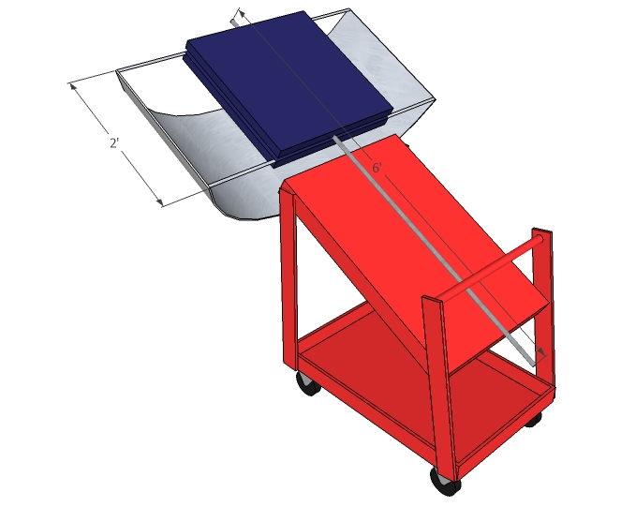

*Figure 8.1.1: Rendering of the solar tracking unit*

The idea when mounting the solar panels is to keep the weight on the steel pole as balanced as possible. This way, the load on the motor is as low as possible, allowing the motor to run as effieciently as it can. The panels should be mounted with washers, nuts, and bolts. The easiest way is to mount one solar panel onto the steel pole with the conduit hangers, and then mount the second panel to the first panel. Adjust the distance between the panels to make sure the weight is balanced. NOTE: there must be a counterweight on the bottom shelf of the cart near the handle so the unit does not topple over!

**8.2 Setting Up the Batteries**

First, locate the battery in block terminal (labeled 4Block1) on the printed circuit board, shown in Figure 8.2.1. The batteries need to be wired in a specific order (In alphabetical order according to the figure) to avoid circuit overload. In order to secure the wire safely and securely in the terminal block, the user will need a miniature flathead screwdriver. When screwing the terminal pins in, ensure that the wire is securely fastened so that it cannot be accidently dislodged from the terminal block.

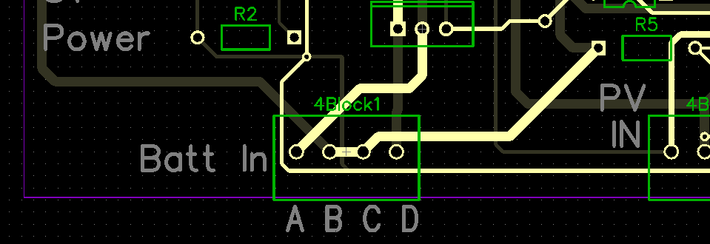

*Figure 8.2.1 – Battery Input Block Terminal Location and Terminal Designations*

Before wiring the battery, take all necessary safety precautions to avoid injury or damage to the circuit board. Locate the negative terminal of one 12V battery and wire it directly to terminal A. The positive end of that battery is then connected to terminal B. Next, locate the negative terminal of the secondary battery and attach it to terminal C. Lastly, terminal D is wired to the positive terminal of the same battery.

**8.3 Plugging in the Hardware**

The solar tracking circuit is self contained in the black box. The voltages that are needed to plug into the box are labeled. The outputs of the tracking circuit, as well as the power and ground for the motor, are also color coated and labeled. Please connect accordingly. The box with the circuit has velcro on one side. It should be attached to the cart under the motor. The photoresistors (which determine which direction the motor should rotate) also have velcro. Please attach the photoresistors to the solar panel with velcro attached. To test, plug in the required voltages for the motor. Cover up one photoresistor with your hand. One of the relays should be making a “clicking” noise, meaning that it is receiving a pulsing voltage. The motor should be moving at the rate of the pulses. If the clicking sound is not heard, check the connections for the 5V and 9V. If the clicking is heard, but the motor is not moving, check the connections to the motor, as well as the power supply for the motor.

**8.4 Setting Up the Data Storage**

The data storage program will be pre-installed on the microcontroller, so there will be no need for programming the memory of the microcontroller. The LCD is also pre-installed and connected to the data storage unit upon receiving the system as a whole. In its self-sustained state, the only thing that needs to be done for the data storage is plugging in the power supply. The 9V power supply adapter is to be plugged into the inverter so that it will draw its power from the solar panels themselves. As soon as the adapter is plugged in and the system is running, the microcontroller will automatically start gathering data. So, before setting up the solar panels make sure that a USB flash drive is plugged into the data storage so when turning on the entire system the data storage can start storing data as soon as possible. The data storage’s best data output comes from having the USB flash drive connected for at least one month.

**8.5 Finalize Preparation**

Take the now installed unit outside for testing. Make sure the unit is facing due south for the efficiency of the unit to be as high as possible. Turn on the unit by connecting the needed voltages. Make sure the solar panels are moving in the direction of the sun.

**8.6 Accessing the User Interface**

User can go to the pachube.com website then login with user name and password, as shown in Figure 8.6.1.

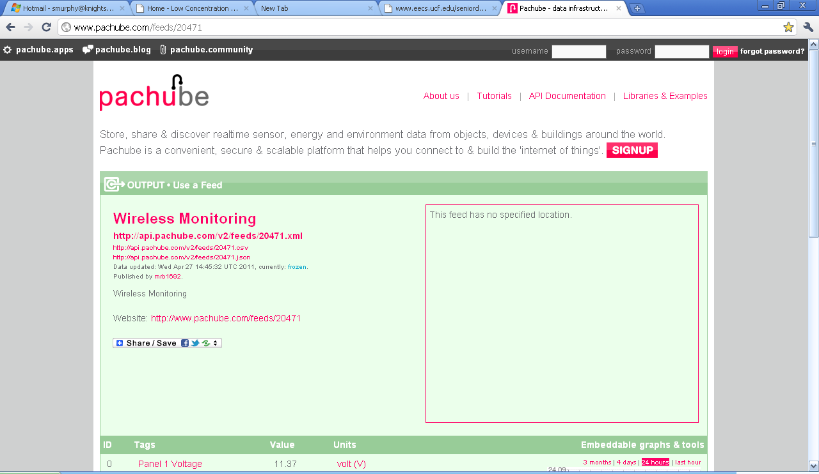

*Figure 8.6.1 –Website Home Page*

After they login they can click on the feed tab to view the graph of the real time data graphs, as shown in Figure 8.6.2.

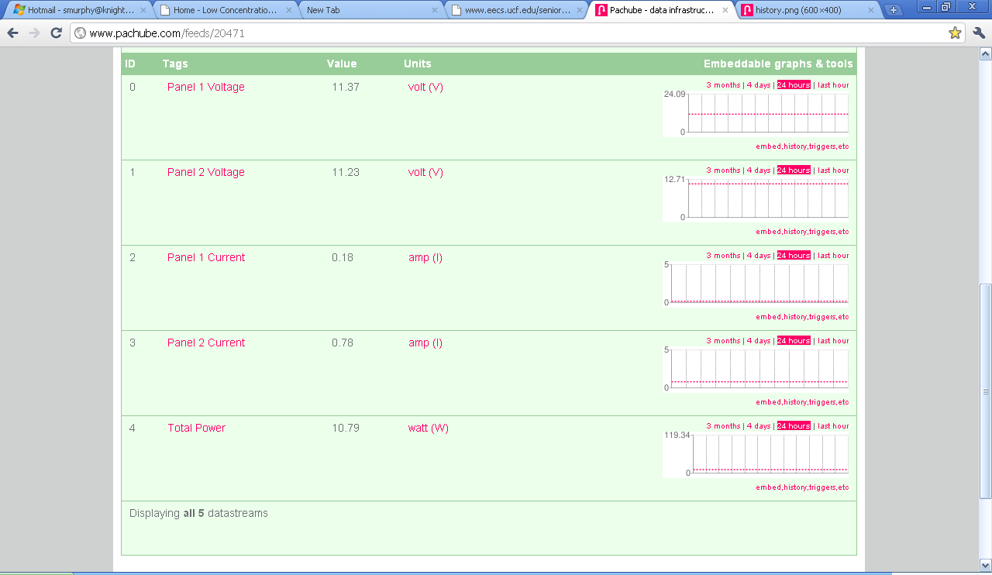

*Figure 8.6.2 –Live Feed Information*

Graphs can show feeds over three months, four days, 24 hours, and the last one hour. If the click on the graph it will make it full screen, as shown in Figure 8.6.3.

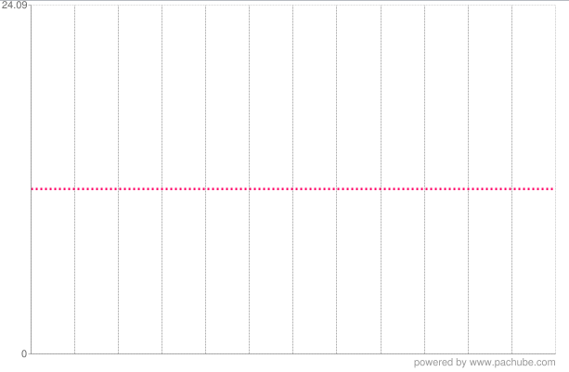

*Figure 8.6.3.- Example Graph*

**8.7 Accessing the Back-up Storage**

When accessing the data from the data storage unit, all that needs to be done is to unplug the USB flash drive from the storage and plug it in to a laptop. The data will be stored in text files labeled by the day they were stored for easy organizational access. The text files themselves will present a table that will show the voltage and current outputs of each individual panel as well as the total power output for the system. That way, the user can view the efficiency of the device. Also in the text file is a timestamp that shows when the data was stored in that day for easy look-up access. An example of format that was taken from actual testing data is shown in Figure 8.7.1.



*Figure 8.1: Text File Output for Back-up Data Storage Example*

Note that when unplugging the USB flash drive from the storage unit, the program will stop running so no data will be gathered during that time. Also, when unplugging the flash drive, any data that was being stored into a text file will unfortunately be deleted. This is why it is a good idea to wait until a full twenty-four hours have passed in order to receive the best possible output.

**Project Conclusions**

The focus of this project is increasing the efficiency of thin film solar panels. With research for the design it is believed that the group will be successful in increasing efficiency while keeping the cost of the design as low as possible. It is understood that the designs discussed in this document is not final and may change due to component changes, price changes, and cheaper and efficient designs that may be created in the future.

This project helped the group understand the process of designing a working project versus creating one. There were many instances where the design was changed to be able to build with materials that were cheap and easy to come by.

**Personnel**

Amanda Klein is a senior electrical engineering student at the University of Central Florida.  She is currently working with The Aerospace Corporation as a Telemetry Engineer intern.  She is a current member of the Tau Beta Pi engineering society.  After graduating this spring, she will pursue her career with General Dynamics Electric Boat in the Common Missile Department in Groton, Connecticut. She hopes to use her knowledge in power systems and electric machinery in particular.

E-mail: [aklein.inbox@gmail.com](mailto:aklein.inbox@gmail.com)

Jesse Trawick is a senior electrical engineering student at the University of Central Florida. He is receiving his BSEE degree in May 2011. After graduation, he intends to pursue a career in power systems or semiconductor devices.  After a few years working in industry, he wishes to return back to graduate school to obtain a Master’s Degree to complement his career path at that time.

E-mail: [jatrawick@hotmail.com](mailto:jatrawick@hotmail.com)

Motiur Bhuiyan is a senior computer engineering student at theUniversity of Central Florida and graduating in May 2011.  He is a member of the PHI SIGMA THETA National Honor Society. He will be interested in pursuing a career as an engineer, while would like to continue his studies in the Masters program in electrical engineering.

E-mail: [mmotiur@yahoo.com](mailto:mmotiur@yahoo.com)

Sean Murphy is a senior computer engineering student at the University of Central Florida. After graduation this May, he will be interested in pursing a career in gaming design, while continuing his studies in game programming at the Florida Interactive Entertainment Academy (FIEA). Specifically, his interests include artificial intelligence in game programming.

E-mail: [smurphy@knights.ucf.edu](mailto:smurphy@knights.ucf.edu)

**Appendices**

**A. Bibliography**

[1] *Thin Film Amorphous Silicon Solar Cells,*

<[http://www.rci.rutgers.edu/~dbirnie/solarclass/amorphousSi.pdf](http://www.google.com/url?q=http%3A%2F%2Fwww.rci.rutgers.edu%2F~dbirnie%2Fsolarclass%2FamorphousSi.pdf&sa=D&sntz=1&usg=AFQjCNHvPxRdj_cg7KVr5Nkj4voejEKnHA)>

[2] *Thin Film Solar Cells,* Copyright © 2010 Solar Buzz,

<[http://www.solarbuzz.com/Technologies.htm](http://www.google.com/url?q=http%3A%2F%2Fwww.solarbuzz.com%2FTechnologies.htm&sa=D&sntz=1&usg=AFQjCNGeh_4kDyeTzS3j1RzBcde5nRuqwA)>

[3] *Thin Film Amorphous Silicon Solar Cells,*

<[http://www.rci.rutgers.edu/~dbirnie/solarclass/amorphousSi.pdf](http://www.google.com/url?q=http%3A%2F%2Fwww.rci.rutgers.edu%2F~dbirnie%2Fsolarclass%2FamorphousSi.pdf&sa=D&sntz=1&usg=AFQjCNHvPxRdj_cg7KVr5Nkj4voejEKnHA)>

[4] *Concerned Citizen* <[http://www.nrel.gov/pv/cdte/citizen.html](http://www.google.com/url?q=http%3A%2F%2Fwww.nrel.gov%2Fpv%2Fcdte%2Fcitizen.html&sa=D&sntz=1&usg=AFQjCNGRfhq86m6qifr8TRsjjPMd36HKFw)>

[5] *CIS Photovoltaic Module,* Copyright © 2010 Solar Frontier, Daiba Frontier Bldg 2-3-2, Daiba, Minato-ku, Tokyo<http://www.solar-frontier.com/brochure_EU_Asia.php>)

[6] M. Gloeckler, J.R.. Sites, *Band-Gap Grading in Cu(In, Ga)Se2, Solar Cells,* Feb. 17, 2005, Elsevier Science,

<[http://www.physics.colostate.edu/groups/photovoltaic/PDFs/Markus%20JPCS.pdf](http://www.google.com/url?q=http%3A%2F%2Fwww.physics.colostate.edu%2Fgroups%2Fphotovoltaic%2FPDFs%2FMarkus%2520JPCS.pdf&sa=D&sntz=1&usg=AFQjCNHKxrJTTC23cZ4CEJlR04VYRxqLEA)>

[7] *Gallium Arsenide Solar Cells,* Copyright © 2002 Sandia National Labortories, <[http://photovoltaics.sandia.gov/docs/PVFSCGallium_Arsenide_Solar_Cells.htm](http://www.google.com/url?q=http%3A%2F%2Fphotovoltaics.sandia.gov%2Fdocs%2FPVFSCGallium_Arsenide_Solar_Cells.htm&sa=D&sntz=1&usg=AFQjCNHbPeP3PkUaIUCnegZKvRmNWG9YOw)>

[8] *What’s the best battery?,* Copyright © 2010 Isidor Buchmann, Barry University, <[http://batteryuniversity.com/index.php/learn/article/whats_the_best_battery](http://www.google.com/url?q=http%3A%2F%2Fbatteryuniversity.com%2Findex.php%2Flearn%2Farticle%2Fwhats_the_best_battery&sa=D&sntz=1&usg=AFQjCNHv_XqYIKCUNbKHBDwwq1X2sNeWug)>

[9] Professor Ilga Jurkelo, *Advantages and Disadvantages of the Nickel Metal Hydride (nimh) Battery,* Copyright © 2005-2010 E-Articles, Dec. 2006,

<http://e-articles.info/e/a/title/Advantages-and-disadvantages-of-the-Nickel-Metal-Hydride-%28NiMH%29-Battery/>

[10] *Lithium Ion Battery,* Trademark Wikipedia®, Dec. 4, 2010

<http://en.wikipedia.org/wiki/Lithium-ion_battery#Advantages_and_disadvantages>

[11] *What’s the best battery?,* Copyright © 2010 Isidor Buchmann, Barry University, <[http://batteryuniversity.com/index.php/learn/article/whats_the_best_battery](http://www.google.com/url?q=http%3A%2F%2Fbatteryuniversity.com%2Findex.php%2Flearn%2Farticle%2Fwhats_the_best_battery&sa=D&sntz=1&usg=AFQjCNHv_XqYIKCUNbKHBDwwq1X2sNeWug)>

[12] Professor Ilga Jurkelo, *Advantages and Disadvantages of the Lead Acid Battery,* Copyright © 2005-2010 E-Articles, Jan. 2007,

<http://e-articles.info/e/a/title/Advantages-and-disadvantages-of-the-Lead-Acid-Battery/>

[13] *How to Choose a Battery,* Copyright © 2000-2009 Powerizer,

<[http://www.batteryspace.com/howtochoosebattery.aspx](http://www.google.com/url?q=http%3A%2F%2Fwww.batteryspace.com%2Fhowtochoosebattery.aspx&sa=D&sntz=1&usg=AFQjCNFDRX4GojM7r0uPuTuafRwJ6Q_HjQ)>

[14] *Increase Solar Charging Wiith An MPPT Power Tracking Charge Controller,* Copyright © 2010 Wholesale Solar,

<[http://www.wholesalesolar.com/Windy/MPPT-article.html](http://www.google.com/url?q=http%3A%2F%2Fwww.wholesalesolar.com%2FWindy%2FMPPT-article.html&sa=D&sntz=1&usg=AFQjCNHTWJRru_GsOUHi9wP8pKyBZhMs6g)>

[15] *The Power Electronics Page,* Copyright © 2007 dtm Associates, Aug. 2007,

<[http://www.dtmassociates.com/power_electronics_page.htm](http://www.google.com/url?q=http%3A%2F%2Fwww.dtmassociates.com%2Fpower_electronics_page.htm&sa=D&sntz=1&usg=AFQjCNHK-A2vS4lD7HwT5mr-0maL3aB3zA)>

[16] *Application Note 6621 Simple Circuit Charges Lead-Acid Batteries,* Copyright © 2010 Maxim Integrated Products, June 1, 2001,

<[http://www.maxim-ic.com/app-notes/index.mvp/id/621](http://www.google.com/url?q=http%3A%2F%2Fwww.maxim-ic.com%2Fapp-notes%2Findex.mvp%2Fid%2F621&sa=D&sntz=1&usg=AFQjCNHMpLMLUbQMNnpP36uq5vavC-BB-A)>

[17] *Log, Save, Print and Analyze Data On-Site Quickly and Efficiently,* Copyright © 2003 Testo Inc., Pages 6-7, April 9, 2003,

*<*[http://www.instrumart.com/assets/108/175_177.pdf](http://www.google.com/url?q=http%3A%2F%2Fwww.instrumart.com%2Fassets%2F108%2F175_177.pdf&sa=D&sntz=1&usg=AFQjCNGDNZjuc3yYU9Vo46wbKoVHMfS1Lg)>

[18] *PIC32MX360F512L,* Copyright © 2009 Microchip Technology Inc., April 19, 2009, <<http://www.microchip.com/wwwproducts/Devices.aspx?dDocName=en532441#1>>

[19] *PIC18F4550,* Copyright © 2009 Microchip Technology Inc., Oct. 27, 2009, <<http://www.microchip.com/wwwproducts/Devices.aspx?dDocName=en010300>>

[20] *PIC32MX795F512L,* Copyright © 2009 Microchip Technology Inc., Dec. 1, 2010, <<http://www.microchip.com/wwwproducts/Devices.aspx?dDocName=en545660>>

[21] *PIC32MX440F512H,* Copyright © 2009 Microchip Technology Inc., April 19, 2010, <<http://www.microchip.com/wwwproducts/Devices.aspx?dDocName=en535591>>

[22] *PIC32 Starter Kit User’s Guide,* Copyright © 2010 Microchip Technology Inc., Mar. 26, 2009, Page 17, USA,

<<http://ww1.microchip.com/downloads/en/DeviceDoc/PIC32%20Starter%20Kits%20Users%20Guide_DS61159A.pdf>>

[23] *PIC32 Starter Kit User’s Guide,* Copyright © 2010 Microchip Technology Inc., Mar. 26, 2009, Page 18, USA,

<<http://ww1.microchip.com/downloads/en/DeviceDoc/PIC32%20Starter%20Kits%20Users%20Guide_DS61159A.pdf>>

[24] *PIC32 Starter Kit User’s Guide,* Copyright © 2010 Microchip Technology Inc., Mar. 26, 2009, Page 21, USA,

<<http://ww1.microchip.com/downloads/en/DeviceDoc/PIC32%20Starter%20Kits%20Users%20Guide_DS61159A.pdf>>

[25] *PIC32 I/O Expansion Board,* Copyright © 2010 Microchip Technology Inc.,

<<http://www.microchip.com/stellent/idcplg?IdcService=SS_GET_PAGE&nodeId=2615&dDocName=en535444>>

[26] *Wireless LAN,* Trademark Wikipedia®, Nov. 20, 2010,

<<http://en.wikipedia.org/wiki/Wireless_LAN>>

[27] *IEEE 802.11,* Trademark Wikipedia®, Dec. 4, 2010,

<<http://en.wikipedia.org/wiki/IEEE_802.11>>

[28] *HD44780 Character LCD,* Trademark Wikipedia®, Sep. 29, 2010, <<http://en.wikipedia.org/wiki/HD44780_Character_LCD>>

[29] *HD44780U (LCD-II) (Dot Matrix Liquid Crystal Display Controller/Driver) Hitachi,* Copyright © 1998 Hitachi, Ltd., Page 9, Sept, 1999 ,

< <http://lcd-linux.sourceforge.net/pdfdocs/hd44780u.pdf>>

Miscellaneous

*High Concentration Photovoltaic,* Copyright © 2005-2010 Renewable Energy Institute,

<<http://www.highconcentrationphotovoltaic.com/>>

*Concentrated photovoltaics,* Trademark Wikipedia®, Dec. 1, 2010,

<<http://en.wikipedia.org/wiki/Concentrated_photovoltaics>>

*Solar Panel,* Trademark Wikipedia®, Dec. 5, 2010,

*<*<http://en.wikipedia.org/wiki/Solar_panel>>

*Advantages and Disadvantages of Photovoltaics,*

<<http://www.cetonline.org/Renewables/PV_pro_con.php>>

*Solar 101* *Introduction to Solar in Non-Technical Terms,*

<<http://www.suncowboy.com/solar101.php>>

*Photovoltaic Modules,* Trademark ® pvresources, Copyright © 2001-2010 Denis Lenardic, April 18, 2010,

<<http://www.pvresources.com/en/module.php>>

*Solar ENERGY Basics,* Copyright © 2009 Rev2G Inc,

<<http://www.rev2g.com/resources_solar_basics.html>>

*Advantages and Disadvantages of Solar Power,* June 11, 2008

<<http://www.renewable-energy-sources.com/2008/06/11/advantages-and-disadvantages-of-solar-power/> >

*Concentrated Solar Power,* Copyright © 2005-2010 Renewable Energy Institute,

*<* <http://www.concentratedsolarpower.com/>>

Sarah Lozanova, *5 Surprising Facts About Concentrated Photovoltaics,* Copyright © 2009 TriplePundit, Jan. 7, 2009,

<<http://www.triplepundit.com/2009/01/5-surprising-facts-about-concentrated-photovoltaics/>>

Dr. Lewis Fraas JX Crystals Inc, *Concentrated Photovoltaics (CPV): Path to Affordable*

*Solar Electric Power,*

<<http://www.ornl.gov/sci/solarsummit/JXcrystals.pdf>>

*XBee Explorer USB,* Copyright © 2003 Oscommerce and CRE Loaded Team,

<<http://www.inmotion.pt/store/product_info.php?products_id=52>>

XBee 1mW Chip Antenna (802.15.4)*,* Copyright © 2003 Oscommerce and CRE Loaded Team,

<<http://www.inmotion.pt/store/product_info.php?products_id=189>>

Harry Zervos, Technology Analyst, IDTech Ex, *Shedding Light on Thin-Film Solar Cell Efficiency Research,* Copyright © 2010 PennWell Corporation, May 16, 2008,

<<http://www.powergenworldwide.com/index/display/articledisplay/328999/articles/power-engineering/business-2/2008/05/shedding-light-on-thin-film-solar-cell-efficiency-research.html>>

*Crystalline silicon solar cells,* Copyright © 2010 Solar Panels, April 3, 2010,

<<http://poweredbysolarpanels.com/crystalline-silicon-solar-cells/>>

*Monocrystalline Silicon,* Trademark Wikipedia®, Dec. 4, 2010,

*<*<http://en.wikipedia.org/wiki/Single-crystal_silicon>>

*Crystalline Silicon,* Copyright © 1998- 2010 Solar Home, <<http://www.solarhome.org/crystallinesilicon.html>>

*What is Monocrystalline Silicon?,*

<<http://ridders-solar.com/mono.shtml>>

*Polycrsytalline silicon,* Trademark Wikipedia®, Aug. 18, 2010

*<*<http://en.wikipedia.org/wiki/Polycrystalline_silicon>>

*Explain Ribbon Silicon,* Copyright © 2005 Mark McCracken,

<<http://www.teachmefinance.com/Scientific_Terms/Ribbon_silicon.html>>

*Solar Electric Power Systems,* Copyright © 2008-2009 Renewable Energy Institute,

*<*<http://www.solarphotovoltaicpanel.com/>>

*Thin film solar cell*, Trademark Wikipedia®, Dec. 1, 2010,

*<*[*http*://en.wikipedia.org/wiki/Thin_film_solar_cell](http://en.wikipedia.org/wiki/Thin_film_solar_cell)>

*Cadmium telluride,* Trademark Wikipedia®, Dec. 1, 2010,

*<*<http://en.wikipedia.org/wiki/Cadmium_telluride>>

*Cadmium telluride photovoltaics,* Trademark Wikipedia®, Dec. 2, 2010,

<<http://en.wikipedia.org/wiki/Cadmium_telluride_photovoltaics>>

A. Blazev, *Cadmium Telluride:  A toxic and deadly ingredient found in some solar panels?,* Copyright © 2008-2009 Renewable Energy Institute,

<<http://www.cadmiumtelluride.net>>

*Copper Indium Gallium Selenide,* Copyright © 2008-2009 Renewable Energy Institute,

*<*<http://www.copperindiumgalliumdiselenide.com/>>

*Copper Indium Gallium Selenide,* Trademark Wikipedia®, Nov. 27, 2010,

<<http://en.wikipedia.org/wiki/Copper_indium_gallium_selenide_solar_cell>>

*Photovoltaic Materials – Gallium Arsenide,* Copyright © 2000-2010 AZoM™, Jan. 4, 2002, <<http://www.azom.com/details.asp?ArticleID=1166>>

*It's a GaAs: Gallium Arsenide Solar Cells,* Copyright © 2009 CalFinder Contractors,

<<http://solar.calfinder.com/library/solar-electricity/cells/cell-materials/gallium-arsenide>>

*Organic solar cell,* Trademark Wikipedia®, Nov. 12, 2010,

<<http://en.wikipedia.org/wiki/Organic_solar_cell>>

*Polymer solar cell,* Trademark Wikipedia®, Aug. 7, 2010,

<<http://en.wikipedia.org/wiki/Polymer_solar_cell>>

*Solar cell,* Trademark Wikipedia®, Dec. 3, 2010,

<<http://en.wikipedia.org/wiki/Solar_cell#Organic.2Fpolymer_solar_cells>>

Von Ilka Kriegal, *Organic solar cells: Morphology correlated observation of charge transfer excitons at the polymer/fullerene interface,* Copyright © 2008 Elitenetzwerk Bayern, Feb. 22, 2010,

<<https://www.elitenetzwerk.bayern.de/ilkakriegel_organicsollarcell.0.html>>

*Silicon thin-film cell,* Trademark Wikipedia®, Nov. 12, 2010,

<<http://en.wikipedia.org/wiki/Silicon_thin-film_cell>>

*Thin film solar cell,*

*<*<http://www.daviddarling.info/encyclopedia/T/AE_thin_film_cell.html>>

User leventbras, *Thin Film vs. Crystalline Silicon PV Modules,* Nov. 16, 2010,

<<http://www.civicsolar.com/resource/thin-film-vs-crystalline-silicon-pv-modules>>

Erica Weliczko, *Solar-Electric Options: Crystalline vs. Thin-Film,* Oct-Nov, 2008,

<http://homepower.com/view/?file=HP127_pg98_Weliczko>

*Production and Manufacturing,* Copyright © Solar Power Melbourne Pty Ltd,

<http://www.solarpoint.com.au/c5/learn-about-solar/global-solar-industry/production-and-manufacturing/>

**B. Copyright Permissions**











