HydroCar: The Hydrogen Powered Vehicle
Andre Beckus, Bruno Pegoraro, James Choi, and Edwin Perez

Dept. of Electrical Engineering and Computer Science, University of Central Florida, Orlando, Florida, 32816-2450

Abstract — The objective of this project is to implement a proof-of-concept demonstrating a power management system which efficiently manages the consumption of power supplied from a renewable energy store, as well as from a conventional nickel–metal hydride battery store, to a consuming entity, in order to prolong/maximize the operation time of the system by making informed decisions based on external input data supplied to the system and using every opportunity to conserve energy. The energy sources available include a 60 watt PEM fuel cell that is powered by a tank of hydrogen and a 9 volt 300 milliamp-hour battery pack. Our system efficiently manages, supply and route power to any applicable resource demanding power from our system.

Index Terms — Fuel cells, battery management systems, hydrogen storage, power generation, vehicles.

I. Introduction
Sustainable energy is a major cause of concern for this generation. In these times of major technological revolutions that occur every day, many solutions are proposed to remedy this concern. It is generally accepted that there is no single solution to our dependence on non-renewable resources, but proposed technologies used in conjunction with the present technology can aid in the process. Our motivation for this project is to create a system that offers an efficient complement to the current conventional power generation and energy storage devices which provides a modular power management system that can be used in various applications designed without a single specific application which adapts to the load placed on the system.
The purpose of this project is to implement a proof-of-concept demonstrating a power management system that is capable of efficiently managing the consumption of power supplied to a consuming resource from a renewable energy store and a conventional 9 V battery store by making informed decisions based on information generated from external data provided. It will maximize the amount of time it can power a consumer by exploiting the data provided to it through its data bus in order to determine how and where it will route the power from the source to consumer and taking every opportunity to conserve energy.
The energy source of the vehicle is the 12 cell, 60 watt fuel cell, precisely a proton exchange membrane fuel cell (PEMFC). A PEMFC uses hydrogen and air to produce electricity, so no pollutant is emitted. Knowing that a fuel cell has a slow response time and that a frequent power variation needed for this case, another energy source is needed. The use of a battery is a good solution. The battery’s power density is high and can give the power needed to accelerate.

II. System Components
A picture of the car is shown in Fig. 1. Our entire system is composed of multiple sub systems. The best way to present out system is to explain each subsystem. This section provides a semi-technical introduction to each of these components.

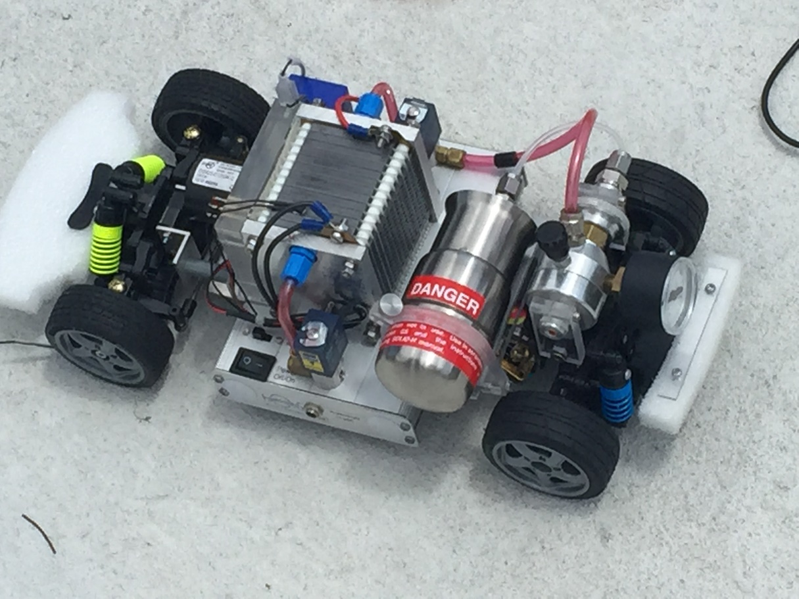
Fig. 1 Picture of Hydrogen Powered RC Car
- Fuel Cell
The fuel cell has a hydrogen inlet port and a purge outlet port. Atmospheric oxygen is provided and water is expelled by blowing air laterally between the plates. There are large terminal lugs at each end of the stack which output the power. There are two valves that allow hydrogen to enter and exit the fuel cell stack. The blower fan is used to supply oxygen to the stack, as well as to purge water that results from the reaction. It also cools the stack. For the storage of hydrogen that will be used to flow through the fuel cell we are going to use a metal hydride tank.

- Power
The power system is responsible for performing the necessary DC-DC conversions and power routing. Our power system has two power sources: the battery and the fuel cell. The power system will include a switch for selecting which source is the active source. It will also provide the following power outputs: 3.3V, 5V, and 12V. The power system will control the battery charging system, which is included on the same board. This system outputs a DC power of 12V from the DC-DC converter. The car also is able to take in an input from an external outlet. While the fuel cell is off, the battery will be the default power supply to this system.
- Controller
The brain of our system will be an on board computer, BeagleBone black. The Beaglebone Black is running an AM335x processor by Texas Instruments which incorporates two onboard Programmable Real-Time Units (PRU). The onboard PRUs are a 200Mhz 32-bit RISC processor which operate independent of the AM335x ARM CPU and each other and are capable of interoperating with each other and the CPU through shared memory space, and also have the capability of accessing most of the I/O pins on the Beaglebone Black. The PRUs are essential in our system as the responsiveness of our system would be compromised if only the CPU were to be used to handle critical I/O due to its non-deterministic nature; whereas the PRUs are essentially microcontrollers capable of handling operations within a fixed amount of time that is predictable and guaranteed.
Since the CPU would need to display live telemetry data from a variety of sensors through a webserver during runtime, handling critical I/O operations while executing the server software may introduce latency between the time the power is demanded and when it is delivered depending on the load placed on the server by connected clients. To resolve this issue, the first PRU unit, PRU0, will strictly be used to receive input signals originating from the radio and the second PRU unit, PRU1, will be used to send output signals to the electronic speed controller which routes power from the two power sources to the motors that drive the RC car.
A more in-depth explanation would be that when PRU0 receives a control signal from the radio, it writes the signal received to a memory space shared with PRU1 and the CPU, then triggers an interrupt on PRU1 which immediately reads from the shared memory space and writes it to the output. During all this, the CPU is hosting a webserver which is displaying live temperature, speed, usage, and voltage data through a web page. Whenever the CPU needs new usage data, it reads from the shared memory space to retrieve the data that was exchanged between the PRUs. Since all three subsystems, PRU0, PRU1, and the CPU are operating independently, latency is not experienced by the end-user regardless of how much load is placed on the web server. And since all three subsystems are able to share data, the systems are capable of interoperability.
In the userspace running on the CPU, the temperature, voltage, and speed are being monitored to keep the fuel cell in operating conditions. Based upon all the data gathered, the CPU is most importantly in charge of power source selection and triggering the fuel cell inlet and purge valves during operation.
- Drive
The drive system consists of the Motor, steering servo, radio receiver, and the electronic speed controller (ESC). We are using a standard RC steering servo and a brushed motor. The receiver supports a Battery Eliminator Circuit (BEC) which means that the power is supplied by the ESC.
III. System Concepts
A. Architecture
In order to demonstrate the proof-of-concept outlined in our project objective, modularity and separation between power sources and power consumers need to be taken into consideration during the design of the system architecture. Segregation between the power management system and the energy consuming entity, the RC car components, demonstrate our proof-of-concept; showing that the implemented power management system can be used against any other power consuming entity to deliver power as efficiently as possible regardless of the variable load placed on the system. A diagram can be seen in Fig. 2.
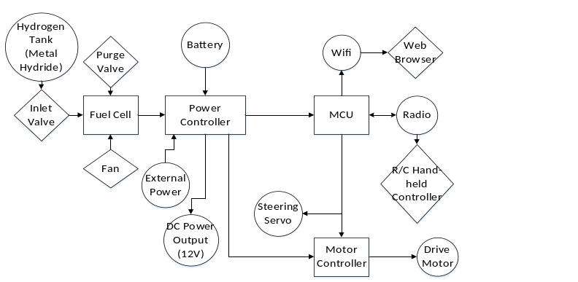Fig. 2 System Architecture Diagram

The components of the power management system includes the computation unit, the renewable energy source (the fuel cell), and the alternative power source (the battery), as well as all the components attached to these components required to deliver power output. The components of the consuming entity include all the parts that compose the consumer of the energy supplied by our system; in the context of this project, it includes all the parts that composes a regular RC car minus its gasoline engine.
The only information our power management system should know about are the sensor data attached to its power sources and any external sensor data provided to it. It does not know that it is specifically used for an RC car. The only means of maintaining modularity and adaptability without implementing a static and specific hardware and software configuration would be to use a data bus for the input sensor signals and output control signals to maintain extensibility and keep the power management system components internal and unexposed. In software engineering terms, our system needs to maintain the lowest degree of coupling possible with the highest amount of cohesion possible; meaning that our power management system needs to maintain the lowest amount interdependence between its internal components and the components of the RC car, all while keeping the modules of the power management system grouped together as closely as possible.
B. Fuel Cells
Fuel cells have the ability to generate electricity through a chemical reaction with an oxidizing agent. A fuel cell is an electrochemical energy conversion device which is typically two to three times more efficient than a typical engine in converting fuel to power. In a fuel cell, fuel (hydrogen gas) and an oxidant (oxygen gas from the air) are used to generate electricity, while heat and water are typical byproducts of the fuel cell operation. A fuel cell typically works on the following principle: as the hydrogen gas flows into the fuel cell on the anode side, a platinum catalyst facilitates oxidation of the hydrogen gas which produces protons (hydrogen ions) and electrons. The hydrogen ions diffuse through a membrane (the center of the fuel cell which separates the anode and the cathode) and, again with the help of a platinum catalyst, combine with oxygen and electrons on the cathode side, producing water. The electrons, which cannot pass through the membrane, flow from the anode to the cathode through an external electrical circuit containing a motor or other electric load, which consumes the power generated by the cell. The resulting voltage from one single fuel cell is typically around 0.7 V. This voltage can be increased by stacking the fuel cells in series, in which case the operating voltage of the stack is simply equal to the product of the operating voltage of a single cell and the number of cells in the stack.
There are many ways to extract energy from fossil fuels that are pretty wasteful. A range of different devices that can be used for producing useful energy from fuels. Devices such as Fuel cells, diesel electric hybrid, gasoline electric hybrids, and gas/steam turbines. Fuel cells produce more power and are more efficient than that of even the best hybrid solutions and turbine applications. The advantage is that with clean energy and hydrogen, carbon dioxide and toxic pollutants are eliminated from the process, with the only things entering and exiting to and from the natural environment being water and oxygen.
The electrochemical reaction inside a fuel cell takes place on both sides of the membrane almost at the same time. A careful examination of the chemical reactions that happen at the anode, cathode and both combined are as follows.
At the anode:
 | H₂ → 2H⁺ + 2e⁻ | ()
At the cathode:
 | ½ O₂ +2H⁺ + 2e⁻ → H₂O | ()
Overall:
 | H₂ + ½ O₂ → H₂O + heat | ()
This overall reaction is the same as a hydrogen combustion reaction. Given that there is energy being released as heat in this reaction makes it an exothermic reaction. The optimal temperature of a proton exchange membrane fuel cell varies between 75 °C and 80 °C. A proton exchange membrane (PEM) does not need to be at a certain temperature to be operational but if the fuel cell is operated above the optimal temperature its performance will greatly diminish. Car companies have researched with these fuel cells all the way to temperatures reaching the -30°C. The maximum temperature at which a fuel cell can be operated at is set by the membrane. The efficiency of the membrane is driven by its humidity therefore after the fuel cell reaches a certain temperature it will not operate efficiently and can even be damaged. This is the reason why PEM fuel cells are typically not operated higher than 90 °C and other types of membranes are used for higher temperatures.
Temperature needs to be monitored continuously for the fuel cell and the power management system components in order to maintain safe operating conditions and protect the equipment during operation in the case of unpredictable failure. In the case that the temperature increases beyond normal operating conditions, a hardware fail-safe is triggered which will halt all operations as reliably as possible. The hardware fail-safe is completely independent and does not have any dependencies on any other subcomponents of the system. It is also low-powered and has its own power source. The way this is done is by incorporating a temperature sensor which will shut everything off when unsafe temperatures are reached.
When the fuel cell stack’s temperature is below optimal operating temperature, it keeps the inlet valve open to let H₂ enter the fuel cell stack while keeping the purge valve closed increasing the pressure within the fuel cell stack. The result is an increase in temperature from the exothermic reaction that is due to the internal pressure within the fuel cell increasing as well as the concentration of hydrogen. When the target temperature is met, the purge valve opens for a brief second before being closed again.
C. Fuel Cell Polarization Curve
Due to internal resistances, the fuel cell will have a varying voltage as a function of current. The plot of voltage versus current is known as the polarization curve. The curve is not flat because the different types of internal resistance will vary with current. From the polarization curve, we can also create a plot power versus either voltage or current. An example plot for a single cell is shown in Fig. 3 (based on those found in [1]). Note that when operating at peak power, increasing current or decreasing voltage will cause the power to drop. The internal resistances also have different time dependencies; the current output of the fuel cell can change very quickly, but the voltage will have a more gradual response.

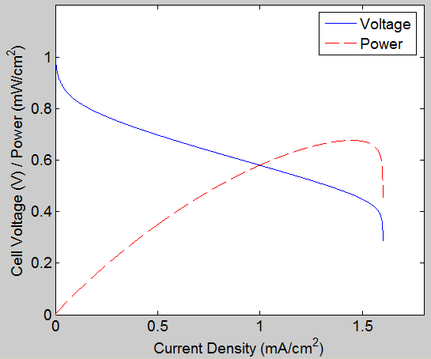
Fig. 3 Polarization Curve with Power versus Current

D. Fuel Cell Instrumentation
The fuel cell has built-in electrodes which measure the voltage across the last two cells of the stack (the cells near the discharge side of the fuel cell stack). The theory is that when the voltage across these two cells differs by more than 50mV, water vapor needs to be discharged and fresh hydrogen allowed to replace it.
The fuel cell also has an analog temperature sensor glued to one of the graphite plates. It is an NTC type of thermistor. We decided to use a DS18B20+ digital thermistor which communicates via a one-wire interface.
E. Fuel Cell Control Algorithm
We have some information about the existing control algorithm used on the car. Based on this, we developed a control algorithm for the new system. A simplified version is shown in Fig. 4. To turn on the fuel cell, the inlet valve opens up to allow the hydrogen to pass through. Once the stack voltage of the fuel cell becomes greater than 6V then the fuel cell becomes activated and the car becomes functional. As long as the temperature of the fuel cell below 45ºC it will remain active. If not then the fuel cell will shut down. If the last two cells in the stack has a differential voltage greater than 50mV then the second inlet valve begins to pulse to allow the hydrogen to pass through until the voltage of the last lowers. While active the fuel cell will have a shutdown command that will shut off the fan and inlet valves and thus disabling the load.
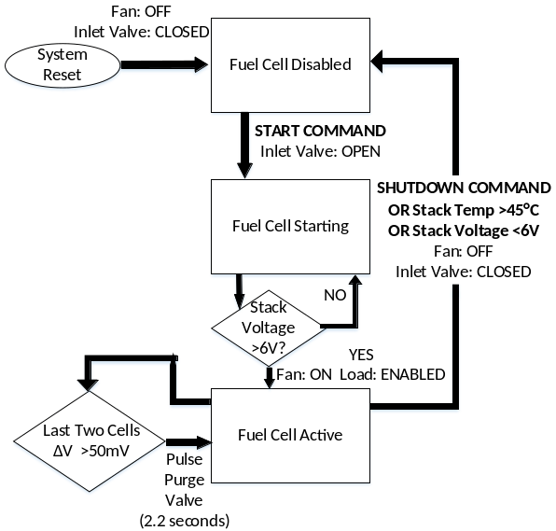
Fig. 4 Simplified Fuel Cell Control Algorithm
F. Modes of Operation
The system must be flexible enough to run in several different modes. The modes are shown in Table 1 along with the configuration details. The first mode is an idle mode where the system is running off of battery power. In this mode, the main controller is active, but the drive system is disabled. This mode is the same as idle mode, except the fuel cell is going through the startup process. The third mode is a fuel cell powered driving mode. The fourth mode is the same as the fuel cell drive mode, except the car is being used to power an external device.
Mode | 1 | 2 | 3 | 4
Name | Idle | Fuel Cell Starting | Fuel Cell Drive | External Power Only
Main Bus Source | Battery/  External | Battery/  External | Fuel Cell | None
Fuel Cell (valves and fan) | Off | On | On | On
Drive System | Disabled | Disabled | Enabled | Enabled
Battery Charge | Off | Off | On | On
External Output | Disconnected | Disconnected | Disconnected | Connected
Table 1 List of Modes of Operation for Car
G. Power System
The power system is a central part of this project. A diagram can be seen in Fig. 5. It consists of the power sources, switches, relay, battery charger, and voltage regulators.

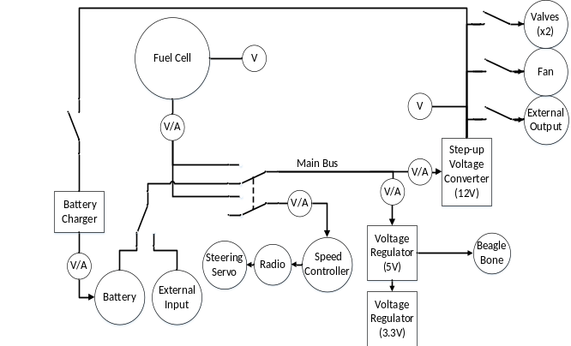
Fig. 5 Power System Diagram (V and V/A symbols represent points where voltage/current is measured)
H. Power Source Selection
The main bus is powered by the either the battery, external power, or the fuel cell, and provides power to all components: the main controller, fan, valves, radio, steering servo, drive motor, and battery charger. The selection of battery or external power is performed by the user through a toggle switch. The controller then must select between battery/external power and the fuel cell. We considered using either a solid-state switch or a relay switch. We experimented with both P-MOSFETs and N-MOSFETs (using the latter with a high side driver chip). However, due to the high currents, we decided to use a relay.
I. Main Bus Under-voltage Protection
One weakness with the existing car design is that if the drive motor pulls too much current from the fuel cell, the fuel cell voltage will drop too low and the system will reboot. While we have attempted to throttle the speed control in order to prevent this from happening, we also decided to include an under-voltage protection circuit. This circuit will switch the relay back to the battery when the fuel cell voltage drops too low. In this way, the valves, fan, and main controller will continue to operate and the controller can switch the relay back to the fuel cell once its voltage rises again.
The circuit can be seen in Fig. 6. First a voltage divider/transistor provides a digital output indicating whether the fuel cell voltage is above a certain threshold. This charges a capacitor to provide a time delay (we do not want to immediately trigger the protection if there is only a short transient). The output of the RC filter drives a NOR-gate based logic circuit which controls the relay. When the protection is not triggered, the relay will be driven directly by the controller. However, when the protection is triggered, the gates form a latch which will keep the relay off until the controller cycles the enable signal.

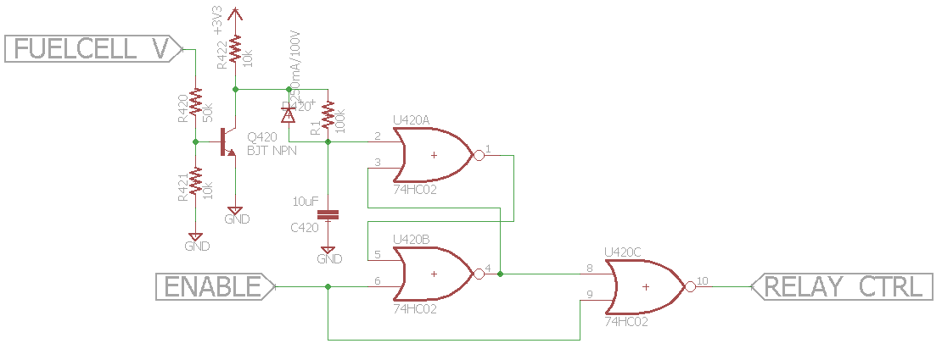
Fig. 6 Under-voltage Protection Circuit

J. Multiport Converter Concept
We originally considered using a simple multiport converter which would allow power to be sourced from both the battery and the fuel cell at the same time. Fig. 7 shows one such circuit: a buck converter which has multiple MOSFET inputs.

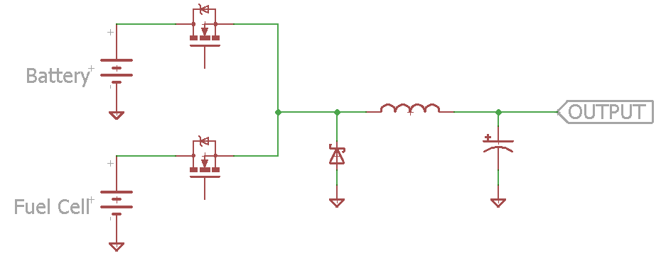
Fig. 7 Multiport Buck Converter Concept

We also considered using a multi-input H-bridge circuit in place of the Electronic Speed Controller to drive the motor (this circuit uses the same buck topology as in Fig. 7 but using the motor in place of the inductor). A schematic can be seen in Fig. 8. Note that we also could have included a super-capacitor which would allow for regenerative braking.

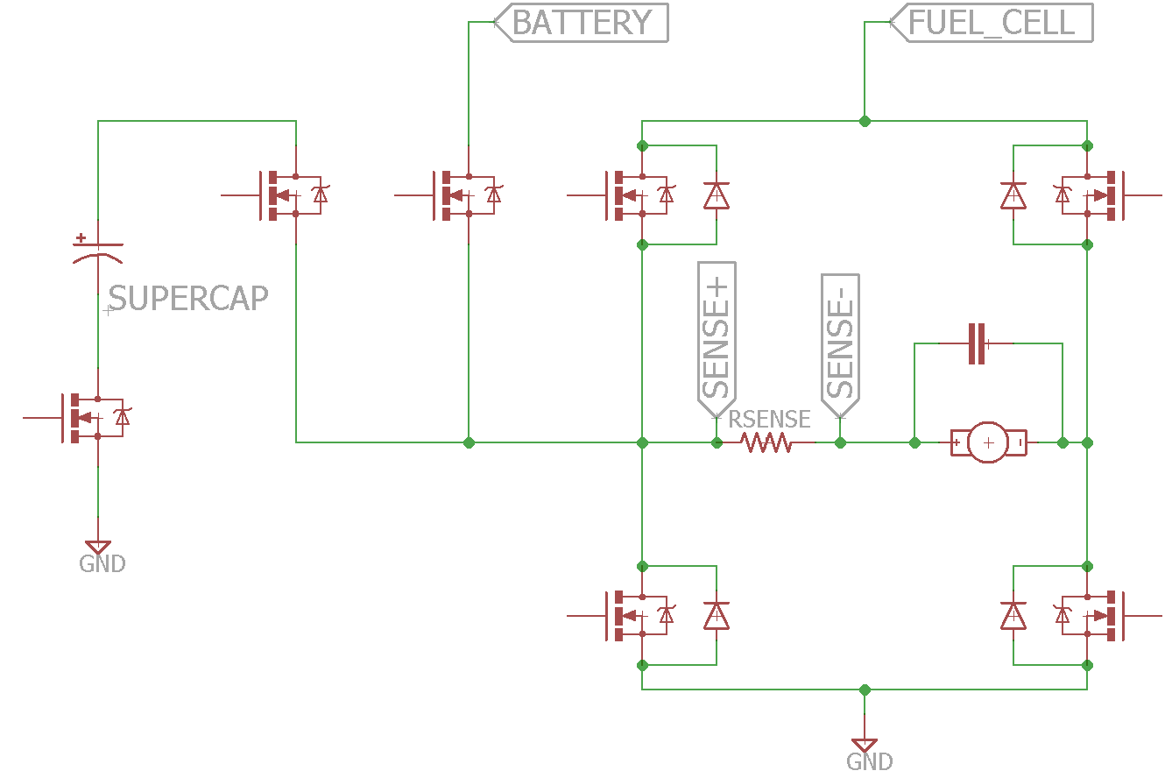
Fig. 8 Multiport Motor Driver Concept

Both circuits would operate similar to a buck converter, except that the switches would alternate so that on each cycle a different power source would be used. The control algorithm for the switches could be made quite complex using both Pulse Frequency and Pulse Width Modulation. Ultimately we decided not to use these circuits to issues with control and complexity.
K. Super-capacitor Concept
We also considered the attachment of super-capacitors to our main bus. The circuit can be seen in Fig. 9. This circuit includes a buck converter used to charge the super-capacitors. Once the capacitors have charged close to the main bus voltage, then the capacitors can be clamped directly to the main bus using a different set of transistors. Then, the super-capacitors will provide extra energy when too much current is drawn from the fuel cell. Once the super-capacitors are discharged, then the charge circuit would be re-activated to charge the super-capacitors again.

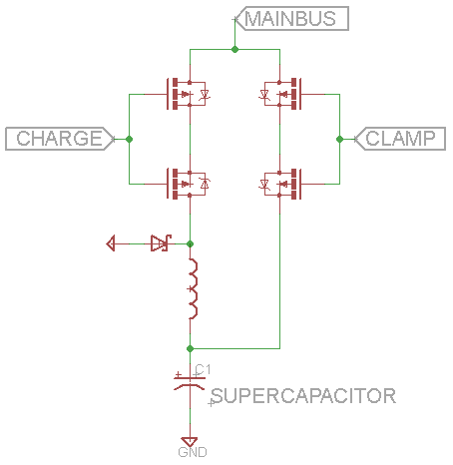
Fig. 9 Supercapacitor Buffer for Main Bus

We prototyped this circuit, but did not end up using it due to difficulties with implementing the charger, and due to space constraints.
L. Voltage and Current Measurement
At various points in the power system, we measure current using shunt resistors along with INA219 digital current monitor chips. The main controller interacts with the INA219 chips using an I2C bus. The INA219 also allows us to measure voltage, and includes a multi-sample averaging function.
We designed resistor pads which incorporate four-terminal sensing. This configuration minimizes inaccuracies due to solder joint resistance, especially in the high current paths.
M. NiMH Battery and Charger
Our original design included a Lithium Ion battery and charger. However, we ended up using a NiMH battery system. We did this mainly due to safety concerns with thermal runaway. We also wanted to place the battery inside the electronics box. However, most Lithium Ion batteries in our target voltage range come in sizes larger than a 9V battery and would not fit in the box. We ended up using a BQ2002 NiMH charger IC and based our circuit design on the DV2002L2 development board. This circuit uses an LM317 voltage regulator as a constant current source. The BQ2002 either turns the current source constantly on during fast charge, or pulses the current source on and off to provide a PWM controlled current. The battery charger can be enabled or disabled by the main controller. When disabled, the charger inhibit signal is asserted. While this disables fast charge, the IC will still perform trickle charge even when inhibited. Therefore, we included a MOSFET on the input to the constant current source so that current can be completely cutoff. The IC provides a status signal, although this only indicates whether fast charge is enabled or disabled. We included a thermistor to shut down the IC in case of over-temperature. We placed the temperature sensor on the circuit board near the battery.
The charger operates off of the 12V bus. We encountered an issue, where the LM317 regulator and reverse-current protection diodes drop too much voltage. Due to this limitation, while the charger operates, it is not able to charge the battery to its full voltage.
N. Boost Converter
A boost converter is needed on the remote controlled car as there is a 9 volt battery on the system that powers a 12 volt fan and a valve that can range between 12 to 24 volts. This requires stepping up of the voltage from the battery to be able to provide enough voltage to these components. The other system of power in the remote controlled car comes from the fuel cell but the fuel cell is only able to produce between 6 and 10 volts which means that to power some of the components in the car we would still have to step up the voltage.
For simulation purposes and wanting to get familiar on how boost converters work we built a circuit on Multisim. In getting familiar with designing a power supply we believed it was a good idea to use a way to design a power supply with some of the basic specifications. To do this we used Texas Instruments’ Webench and provided this tool with basic information about our circuit. Fig. 10 is the circuit that we were able to obtain after the program did some calculations.

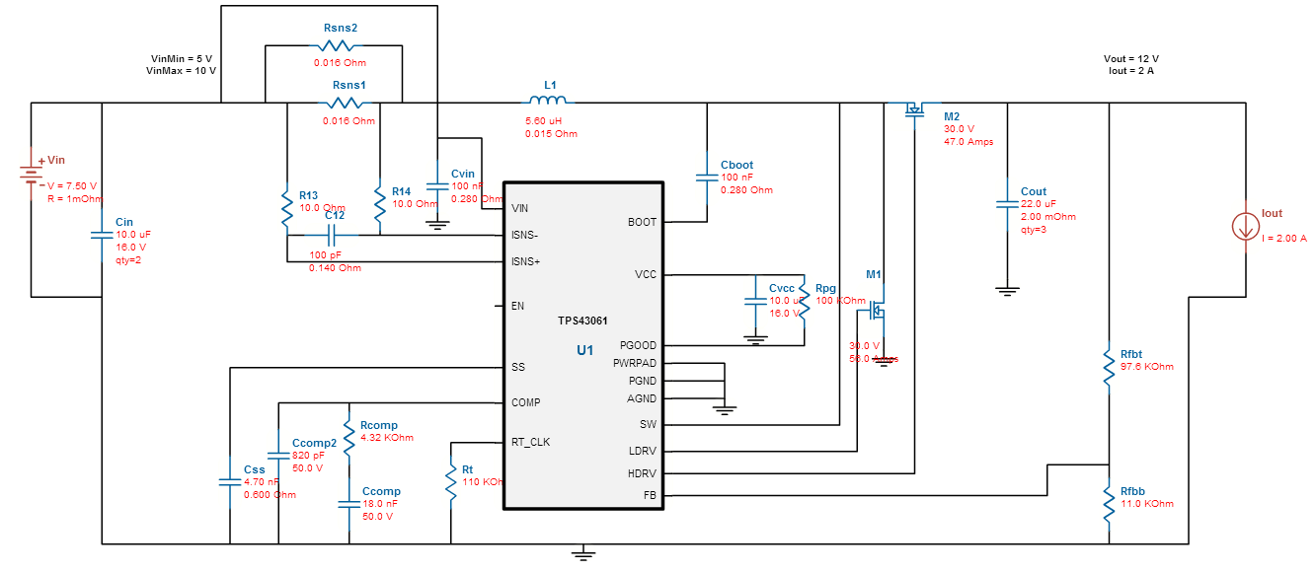
Fig. 10 Circuit with TPS43061 boost converter

This boost converter design was more complex than we needed it to be so we decided to go with a different chip with a more simple design.
Table 2 contains some boost converter chips that we considered buying to build our own power converter. Our team ended up choosing the LM2577 chip for our boost converter. Even though the Webench design did not include the same chip, the chips are very similar in nature.

Name | Cost  ($) | Input Voltage (V) | Output Voltage  (V) | Output Current  (A) | TJMax  (°C) | Eff.  (%)
LM2577 | 11.88 | 3.5 to 40 | 11.6 to 12.4 | 3 | 150 | 80
MAX608 | 4.25 | 1.8 to 16.5 | 3 to 16.5 | 1.5 | 150 | 87
MAX669 | 6.15 | 1.8 to 28 | 3 to 28 | 6 | 150 | 94
Table 2 Boost Converter Chips
O. Speed Measurement
One feature we wanted to add to the car was the measurement of speed. To do this, we are using a hall effect sensor in combination with magnets to generate a pulse train indicating speed. We purchased an 8-pole magnet mounted on a rubber hub which can be pressed onto a drive shaft. However, we had trouble finding a suitable location for the hub, and were also concerned that it would wobble too much. Therefore, we decided to glue small magnets directly to the wheels of the car. We then added a hall effect sensor to one of the wheel struts in close proximity to the magnets.
P. Fuel Cell Simulation for Testing
In order to unit test our circuits and controller, we needed a way to simulate the voltages put out by the electrodes on cells 1 and 2 of the fuel cell stack. To do so, we designed the op amp circuit shown in Fig. 11. The circuit is designed such that the cell 2 voltage is proportional to the stack voltage, and the cell 1 voltage is proportional to the cell 2 voltage. The exact proportionality ratios are adjustable via potentiometers.
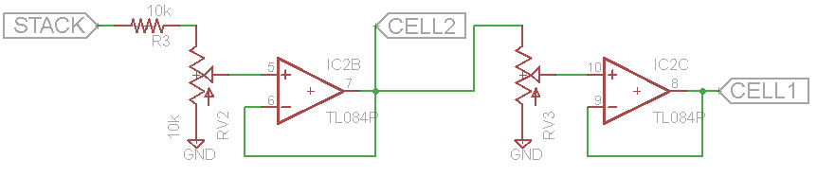
Fig. 11 Fuel Cell Simulation Circuit used for testing
Q. Circuit Board
The existing car has metal box with dimensions 4.5” X 6.5” X 1.25” where the switches, circuit boards, battery, and motor speed controller are mounted. We decided to make a circuit board that would fit in the same space. The final circuit board design is shown in Fig. 12. The circuit board dimensions are 4.1” X 4.8”, with a cutout where the 9V battery is placed.
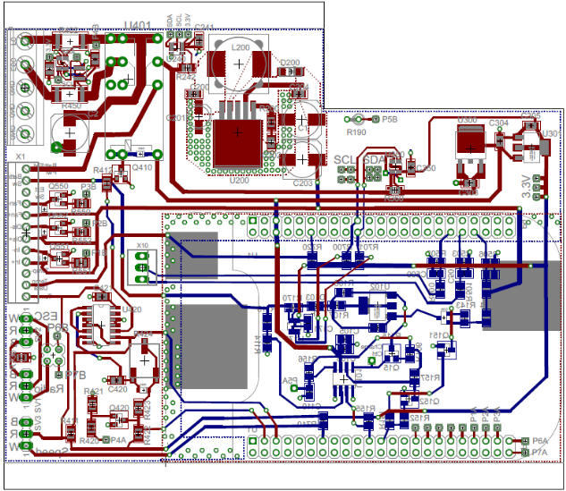
Fig. 12 Final Circuit Board
VII. Conclusion
This two-semester long project is a valuable experience for the group in terms of how to work in a group, how to conduct professional meetings and how to professionally write a technical report. All of which we will be required to do in the real world.
In the meetings, contributing ideas to the group, discussing various issues, designing and troubleshooting have given us valuable experience that we did not obtain as much from sitting in class or even during labs. We have also observed that the little pieces we have learned from our engineering courses have become a big picture in reality. From designing and building a boost converter to a battery charger, we have implemented parts from different classes taken at the University of Central Florida.
It can be observed from this project different roles working for a company. The management works conceptually on projects, the design engineers design the project, and the technicians create the project. As a group we played a part of each of these roles.

Acknowledgement
The authors wish to acknowledge Dr. Paul Brooker of the Florida Solar Energy Center for providing us with the RC car that is the basis of our project, and for generously offering his time to answer questions and assist us with our project.

Biography

Andre Beckus has a degree in computer science and is working towards a second bachelor's degree in electrical engineering. He plans on pursuing a master's degree in mathematics starting in spring 2016.

James Choi is an undergraduate working towards a computer engineering major with interests in software engineering and computer science. He has experience and interests in web application development and plans on pursuing a degree in computer science in 2016.


Bruno Pegoraro, a 25 year old senior student of the electrical engineering department at University of Central Florida. He is presently working at Lockheed Martin in the components engineering group.


Edwin Perez is a Computer Engineering student and an intern at Northrop Grumman. He has an interest in web designing and hopes to open his own business making websites for businesses in the near future. He is pursuing a career at Northrop Grumman as a Cyber Security Engineer after graduation.

References
[1] | F. Barbir, PEM Fuel Cells: Theory and Practice, Amsterdam; Boston: Elsevier Academic Press, 2005.
[2] G. Harper, Fuel Cell Projects for the Evil Genius, McGraw-Hill Education, 2008.
[3] R. Sclupbach, "Design methodology of a combined battery-ultracapacitor energy storage unit for vehicle power management," Power Electronics Specialist Conference, IEEE, 2003.

