Initial Project Document
Senior Design
Group 1

Andre Beckus
James Choi
Bruno Pegoraro
Edwin Perez

PEM Fuel Cell RC Car
Project proposal:
The purpose of this project is to implement a proof of concept demonstrating a system which efficiently manages the consumption of power supplied from a renewable energy store as well as from a conventional lithium-ion battery store in order to prolong the operation time of the system used in an environment of unpredictable energy demand. This concept will be demonstrated through the implementation of a scaled-down application of a trending consumer automotive industry technology on a a RC car: Energy management of an electric hybrid vehicle. The car in this project is roughly five times smaller than an actual vehicle with a significantly lower energy requirement, but the problem in managing the different power supplying sources remains. In this project, the energy sources available will be a 60W hydrogen fuel cell that is powered by a tank of hydrogen and a 5000mAh lithium-ion battery pack made for a conventional RC car. Our system should be able to efficiently manage and supply power to any applicable resource demanding power from our system; in the scope of this project it will be an RC car, but in the scope of a larger-scale real-world application it can be a house and a car.
Project narrative description:
The energy source of the vehicle is a 60 W fuel cell, precisely a PEM Fuel Cell. A PEMFC uses hydrogen and air to produce electricity, so no pollutant is emitted. Knowing that a fuel cell has a slow response time and that a frequent power variation needed for this case, another energy source is needed. The use of a battery or a supercapacitor is a good solution. The battery/supercapacitors power density are high and can give the power needed to accelerate and also can stores the energy in a regenerative braking system. We would also want to add a GPS for it to drive a specific route if needed to. Also possibly add sensor for the car to be able to avoid obstacles.
A brief explanation of the fuel cell that will be our primary engine; Fuel cells have the ability to generate electricity through a chemical reaction with an oxidizing agent. Specifically, a fuel cell is an electrochemical energy conversion device which is typically two to three times more efficient than an internal combustion engine in converting fuel to power. In a fuel cell, fuel (hydrogen gas) and an oxidant (oxygen gas from the air) are used to generate electricity, while heat and water are typical byproducts of the fuel cell operation. A fuel cell typically works on the following principle: as the hydrogen gas flows into the fuel cell on the anode side, a platinum catalyst facilitates oxidation of the hydrogen gas which produces protons (hydrogen ions) and electrons. The hydrogen ions diffuse through a membrane (the center of the fuel cell which separates the anode and the cathode) and, again with the help of a platinum catalyst, combine with oxygen and electrons on the cathode side, producing water. The electrons, which cannot pass through the membrane, flow from the anode to the cathode through an external electrical circuit containing a motor or other electric load, which consumes the power generated by the cell. The resulting voltage from one single fuel cell is typically around 0.7 V. This voltage can be increased by stacking the fuel cells in series, in which case the operating voltage of the stack is simply equal to the product of the operating voltage of a single cell and the number of cells in the stack.

Motivation for the project:
Sustainable energy is a major cause of concern for this generation. In these times of major technological revolutions that occur every day, many solutions are proposed to remedy this concern. Of one such proposition is “Fuel Cell” technology. Our motivation for this project is to create a system that offers environmentally friendly and efficient complement to the current conventional power generation and energy storage devices. Also, to be able to provide a modular power source that can be used that can be used in applications in addition to its main intended purposes.

Project goals and requirements:
- A long-lasting power source that is able to leverage ability for energy consumption through hydrogen source or conventional energy stores.
- Modular design that allows capability to use in varying applications.
- Configurable
  - Self-powered LCD display for configuration.
- Exploits opportunities for energy generation and conservation
  - Regenerative braking system
  - Power management system
- Stable energy supplied regardless of energy source in operating conditions.

Finance:
We are going to finance this project all ourselves. The RC car and fuel stack, however, will be made available by the Florida Solar Energy Center.
Temperature Sensor | $14.95
Voltage Sensor | $5
GPS | $40
PCB Fabrication | $200
Controller Parts | $70
Single-Board Computer | $40
Power Converter Parts | $100
Motor Control Parts | $70
3.5” TFT LCD Display | $45
Misc | $200
TOTAL | $784.95

Block Diagrams:
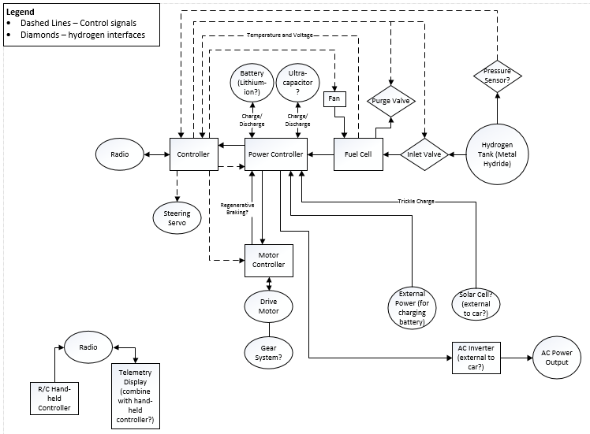

Milestones:
This Semester:
- Get the RC car to run
- Have all components purchased
- Plan for a power management system

Next semester:
- Redesign the layout of the car to fit all components perfectly
- Be able to output enough power to function as a generator
- Power efficiency of the entire system
- Regenerative braking system

