PEM Fuel Cell

Senior Design Project Documentation

Fall 2015

Group 1

Andre Beckus

James Choi

Bruno Pegoraro

Edwin Perez

Technical Advisor:

Dr. Paul Brooker, PhD

Florida Solar Energy Center, University of Central Florida

1679 Clearlake Road, Cocoa, FL 32922-5703

Phone: 321.638.1000 | E-mail: [pbrooker@fsec.ucf.edu](mailto:pbrooker@fsec.ucf.edu)

Website: [www.fsec.ucf.edu](http://www.fsec.ucf.edu)

Submitted: December 11, 2015

Table of Contents

1.0 Executive Summary 1

2.0 Project Description 3

2.1 Project Motivation 3

2.2 Goals and Objectives 4

2.3 Requirements Specifications 5

2.3.1 Power Specifications 6

3.0 Research Related to Project Definition 7

3.1 Existing Similar Projects and Products 7

3.1.1 Horizon Fuel Cell Kits 7

3.1.2 Previous Senior Design Projects 9

3.1.3 Toshiba Dynario 10

3.1.4 Joule Box 10

3.2 Fuel Cell Market Analysis 11

3.3 Fuel Cell Cars 12

3.4 Relevant Technologies 13

3.4.1 Hydrogen Detection Sensor 13

3.4.2 Fuel Cells 14

3.4.2.1 Theory of Operation 14

3.4.2.2 Power Curves 15

3.4.2.3 Materials 16

3.4.2.4 Why a Hydrogen Fuel Cell? 17

3.4.3 Ultracapacitors 17

3.4.4 Multiport and Bidirectional DC-DC Converters 18

3.5 Generating Electrical Power from Fuel Cell Vehicles 19

4.0 Related Standards 21

5.0 Realistic Design Constraints 22

5.1 Electromagnetic Interfaces 22

5.1.1 Electromagnetic Fields Source 22

5.1.2 Reducing the Generated Electromagnetic Fields 22

5.1.3 Electromagnetic Interference (EMI) 23

5.2 Hydrogen Storage 24

5.3 Environmental, Social, and Political Constraints 24

5.3.1 Hydrogen Accumulation in Enclosed Area 24

5.4 Ethical, Health, and Safety Constraints 24

5.4.1 Hydrogen Safety 24

5.4.1.1 Recharging the Hydrogen Tank 25

5.4.1.2 Flammability 25

5.4.1.3 Embrittlement 25

6.0 Project Hardware and Software Design Details 26

6.1 Existing RC Car Design 26

6.1.1 Overview 26

6.1.2 Fuel Cell Stack 27

6.1.3 Temperature Sensor 28

6.1.4 Hydrogen Valves 28

6.1.5 Blower/Cooling Fan 29

6.1.6 Radio Receiver 29

6.1.7 Steering Servo 30

6.1.8 Electronic Speed Controller (ESC) 30

6.1.9 Motor 31

6.1.10 Circuit Boards 31

6.2 Architecture of New System 31

6.3 Steady State Speed 33

6.4 Voltage and Current Measurement 34

6.4.1 Analog Implementation 34

6.4.2 Digital Implementation 37

6.5 Temperature Measurement 37

6.6 I2C Communications 40

6.7 Power System 41

6.7.1 Overview 41

6.7.2 Modes of Operation 42

6.7.3 I2C Communications 42

6.7.4 Power Source Selection 43

6.7.4.1 Main Bus Switch Design 45

6.7.4.2 Battery combined with Fuel Cell 47

6.7.5 Microcontroller Software 49

6.7.6 Power Converters 50

6.7.6.1 Dc to Dc Buck Converter 50

6.7.6.2 Dc to Dc Boost Converter 52

6.7.6.3 Dc to Dc Buck-Boost Converter 55

6.7.6.4 Dc to Ac Inverter 56

6.7.6.5 Cuk Converter 59

6.7.6.6 Duty Cycle 62

6.7.6.7 Pulse Width Modulation (PWM) 62

6.7.6.8 Pulse Frequency Modulation (PFM) 63

6.7.7 Advantages and Disadvantages of Switching Regulators 64

6.7.8 Microcontroller 66

6.7.9 Microcontroller Interface 68

6.7.10 Universal Asynchronous Receiver/Transmitter (UART) 70

6.7.11 Serial Peripheral Interface (SPI) 70

6.7.12 Inter-integrated Circuit (I2C) 72

6.7.13 CPU Registers 74

6.7.14 Addressing Modes 75

6.7.15 Regenerative Braking 75

6.8 Battery System 78

6.8.1 Battery Selection 78

6.8.2 State of Charge Measurement 79

6.8.3 Circuit Design 81

6.9 Electronic Speed Controller (ESC) 83

6.9.1 Overview 83

6.9.2 Commercial ESC Study 83

6.9.3 I2C Communications 83

6.9.4 Motor Control 84

6.9.5 Circuit Design 86

6.9.6 Prototyping and Experimentation 87

6.9.7 Microcontroller 88

6.10 Testing of RC Components 88

6.10.1 ESC 89

6.10.1.1 External Measurements 89

6.10.1.2 Teardown Plan 91

6.10.2 Steering Servo 91

6.11 Hydrogen Storage 92

6.11.1 Tank 92

6.12 Fuel Cell 93

6.12.1 Voltage-Current Characteristics 93

6.12.2 Water Management 93

6.12.3 Temperature Management 94

6.12.4 Air Flow’s Contribution to Evaporation 96

6.12.5 Fuel Cell Control Algorithm 96

6.13 Wiring 97

6.13.1 Power Board Connectors 97

6.13.2 System Wiring Diagram 99

6.14 Software Architecture 100

6.14.1 Runtime Environment 100

6.14.2 Characteristics 102

6.14.3 Implementation 105

6.14.3.1 Initialization 105

6.14.3.2 Runtime 106

7.0 Project Prototype Construction and Coding 106

7.1 Heliocentris R/C Car Kit 106

7.2 PCB Manufacturing 106

7.3 Parts Acquisition and BOM 107

8.0 Project Prototype Testing 109

8.1 Hardware Specific Testing 109

8.1.1 Fuel Cell Simulation 111

8.1.1.1 Overview 111

8.1.1.2 Circuit Design 112

8.1.2 Load Testing 113

8.1.3 Power System 113

8.1.3.1 Fuel Cell 113

8.1.4 Battery System 114

8.1.5 Integration: Fuel Cell, Battery, Power System 115

8.1.6 ESC 115

8.1.7 Motor Stand 116

8.2 Software Specific Testing 116

8.2.1 Test Framework 117

8.2.2 Version Control 117

9.0 Administrative Content 117

9.1 Milestone Discussion 117

9.2 Budget and Finance Discussion 120

10.0 Appendix 122

10.1 Appendix A: References 122

# Executive Summary

A fuel cell is a device that uses stored chemical energy and directly converts it to electrical energy. A fuel cell is made from a cathode, an anode, an electrolyte and catalysts. Hydrogen flows into the fuel cell and through the anode. The anode’s catalyst will then split the hydrogen atom into a proton and an electron. The electrons are not capable of going through the anode’s catalyst and are redirected to the electrical circuit which in turn produces power. The protons are allowed through the electrolyte and move to the second electrode, the cathode. The protons and electrons are combined back in the cathode and oxygen surrounding the fuel cell flows into the cathode. The combination of both water and hydrogen creates water vapor which leaves the fuel cell. This is a very clean and efficient way of providing power to a system and continues to be researched as it is one of the best options for renewable energy.

At the beginning of senior design our group was set on going through the complete process of building a fuel cell. As none of our group members had any past experience with renewable energy we decided to reach out to somebody that might be able to help us. This is when we were able to contact Dr. Brooker from the Florida Solar Energy Center located in Cocoa. The Florida Solar Energy Center is a research institute of the University of Central Florida and their objective is to research and provide energy solutions that improve the state and the nation’s economy and the environment. We had the opportunity to meet with Dr. Brooker in Cocoa where he explained to our team that while building a fuel cell was possible there are many complications to building a stack which are many fuel cells stacked on top of each other. The biggest complications that we would have building the stack would be to have a heat dissipating structure and time constraints as we were told that a good approximation of building this fuel stack would be around two years. One fuel cell by itself would only be able to provide anywhere from 0.5 volts to 0.8 volts. This amount of voltage was not sufficient for the type of project that our team wanted to accomplish and building a stack was out of the question. Dr. Brooker was generous enough to allow us to use a fuel cell that he had attached to a remote controlled car, as shown in Figure 1. The only catch with using this fuel cell was that it was attached to a remote controlled car that used to work in the past but was not working properly anymore. We would not have to build the circuit that the remote controlled car was already equipped with and our team figured that we had lost some complication to the project since we did not have to build the fuel stack anymore so we decided to take on this project.

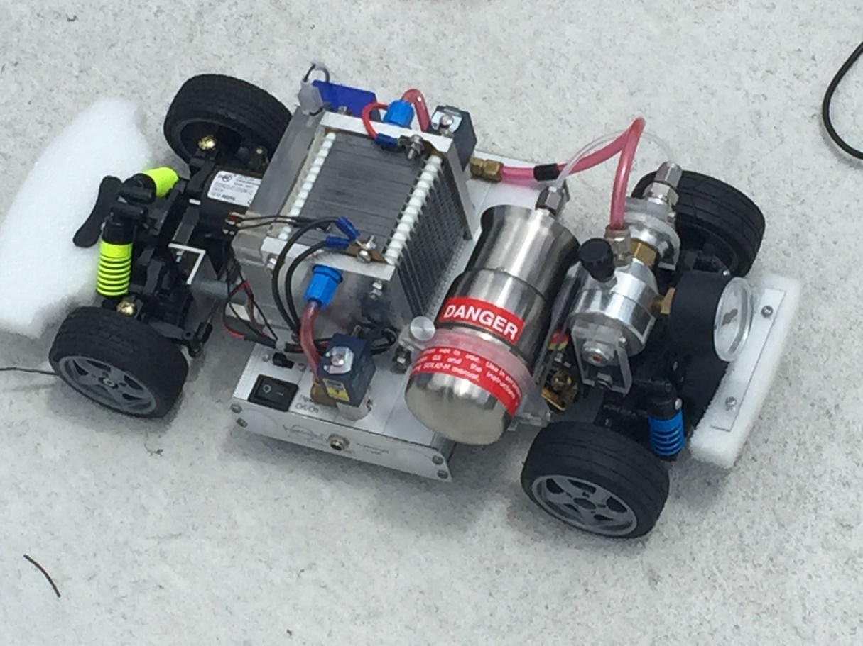

Figure 1: Fuel Cell RC Car Given by Dr Brooker

The main purpose of this project is to implement a proof-of-concept demonstrating a power management system which efficiently manages the consumption of power supplied from a renewable energy store, as well as from a conventional Nickle Metal Hydride battery store, to a consuming entity, in order to prolong/maximize the operation time of the system by making informed decisions based on external input data supplied to the system and using every opportunity to conserve energy. It is necessary to have the battery in addition to the fuel cell as the system will operate in an environment of unpredictable energy demand and a secondary power source possesses advantages and disadvantages which contrasts those of the fuel cell. The concept an efficient power management system will be demonstrated through the implementation of a scaled-down application of a trending consumer automotive industry technology on a RC car. The car being used in this project is roughly five times smaller than an actual vehicle with a significantly lower energy requirement, but the problem in managing the different power sources remains and once an acceptable solution is implemented, it could one day be applicable to a larger system on bigger scale. In this project, the energy sources available include a 60 watt hydrogen fuel cell that is powered by a tank of hydrogen and a 9 volt 300 milliamp-hour battery pack. Our system will be able to efficiently manage, supply and route power to any applicable resource demanding power from our system; in the scope of this project it will be a radio controlled car, but in the scope of a larger-scale real-world application it can be a house, generator, or any other power consuming device.

# Project Description

The energy source of the vehicle is the 60 watt fuel cell, precisely a proton exchange membrane fuel cell (PEMFC).  A PEMFC uses hydrogen and air to produce electricity, so no pollutant is emitted. Knowing that a fuel cell has a slow response time and that a frequent power variation needed for this case, another energy source is needed. The use of a battery or a supercapacitor is a good solution. The battery/supercapacitors power density are high and can give the power needed to accelerate and also can stores the energy in a regenerative braking system. We would have wanted to add a GPS for it to drive a specific route if needed to and also add some sensors for the car to be able to avoid obstacles. Unfortunately given the time we had to complete the project we were not able to add these features. Perhaps for a future senior design project.

A hydrogen fuel cell is used as the primary power source of the remote controlled car rather than just the battery itself or a gas powered engine. The byproducts of a hydrogen fuel cell is only water and heat and the fuel sources are only hydrogen and air which are easier to handle then battery acid and gasoline. The fuel cell is applicable to today’s consumer needs because a hydrogen fuel cell is much quieter, is lighter (mass power ratio) and is more environmental friendly. Also the efficiency of hydrogen fuel cells is higher than gas powered engines.

We are using the typical components found on a remote controlled car. Such as a chassis, front and rear mounts, shocks, and a servo. The only difference between our design and your typical remote controlled car is that ours will be powered by a PEM fuel cell. The benefit of having a remote controlled car powered by a fuel cell is that it will last a lot longer than if it were powered by a battery if the power management system is able to route the power from the battery or the fuel cell in an efficient way depending on varying circumstances.

## Project Motivation

Sustainable energy is a major cause of concern for this generation.  In these times of major technological revolutions that occur every day, many solutions are proposed to remedy this concern.  It is generally accepted that there is no single solution to our dependence on non-renewable resources, but proposed technologies used in conjunction with the present technology can aid in the process. Our motivation for this project is to create a system that offers an efficient complement to the current conventional power generation and energy storage devices which provides a modular power management system that can be used in various applications designed without a single specific application which adapts to the load placed on the system.

The purpose of this project is to implement a proof-of-concept demonstrating a power management system that is capable of efficiently managing the consumption of power supplied to a consuming resource from a renewable energy store and a conventional 9 V battery store by making informed decisions based on information generated from external data provided. It will maximize the amount of time it can power a vehicle by exploiting the data provided to it through its data bus in order to determine how and where it will route the power from the source to consumer and taking every opportunity to conserve energy.

## Goals and Objectives

In order to get an overall quality product out of our project certain goals and objectives were set. These objectives include competitive performance, output power for external use, conserve energy, a system that is easy to charge. The objectives included in this helped define the core for the rest of the project. The different goals are discussed below as well as illustrated in Table 1.

|  |  |
| --- | --- |
| Goal/Objective | |
|  | The system will provide power output performance on par with commercial applications. |
|  | The system will be capable of outputting power for external use. |
|  | The system will demonstrate adaptability in power routing and storage that maximizes energy conservation. |
|  | The system will be easy to charge. |

Table 1: General Project Goals and Objectives

**Competitive Performance** – The RC car demonstrates a system which places a load on our power management system. In a real life, in a larger scale implementation of our project, this can be anything; not necessarily a RC car or even a real car. Using only the fuel cell and hydrogen tank provided to us, our system would not be able to run for any longer than consumer grade RC cars. However, by utilizing two energy sources and performing computations to manage them, we would like to create an implementation that will be far more energy efficient and provides power for a longer duration of time than the conventional system.

**Output Power**- One of the requirement that was ask by our technical advisor was to create a system that can output power to an external load. So our goal is to be able to output 12V DC power from multiple power sources including the fuel cell which will utilize the sources in the most efficient manner as to conserve energy to the fullest extent. The idea coming from if we made the car on a larger scale for consumer use we would be able to power anything that places a load on the system in the most efficient manner. Ideally we would want an AC output but for the simplicity of this project and due to the time constraint we are satisfied with a 12V DC output.

**Conservation of Energy** - We want our system to be able to conserve as much energy as possible and not let any go to waste if possible. Our goal is to be able to utilize the latest technologies to take advantage of the strengths and weaknesses of each power source to maximize the length of time our power management system can keep the system running. We would need to exploit every opportunity to conserve energy by making informed decisions on how power is delivered and from where it is delivered from all while showing unnoticeable drop in performance to the consuming system.

**Easy to Charge** – If we are unable to pair the fuel cell with an ultracapacitor then our plan B is to have a battery in place that can assist the fuel cell and/or power the PCB while the fuel cell is not operating. We want to make the charging of this battery as easy as possible. We want the user to be able to plug it into an outlet and once it’s charged, unplug the power source and go.

## Requirements Specifications

There are a few requirement specification the go along with our objectives and goals. The requirements specifications for our project can be seen in Table 2. We want our RC car to be the best fuel cell vehicle that is out there. To do so we set some specifications that we think will help us accomplish this. This includes having the ability of our car go 8 MPH, have the fuel cell output 60W of power, an output power of 12V DC with a current of 200 mA, and have our vehicle withstand an input of ±20V.

**Speed** – The original specification of the original RC car states that it is able to reach speeds of * MPH. So with our modifications to the car we want to at least have the same speed. At the end of the day this will still be a car so there’s no point in making it slower even though it is more efficient.

**Fuel Cell Output** – The fuel cell that was given to us claims to have an output power of 60W. So along with the speed we would like to maintain this specification. However, we are not aware of how old this fuel cell is nor the condition that it was kept. With that being said if the membrane of the fuel cell is not kept in good condition then it can affect the output power.

**Output Power** – As stated before we want to have an output power of 12V DC. Along with a current of 200 mA. We believe with the right DC/DC converter this output specification will be doable.

**External input** - The external input will be able to withstand an input voltage between -20V (i.e. reverse voltage) and 20V. We don’t want to limit the user to the types of input that is required to power or charge the RC car. We want it to be as universal as possible.

|  |  |  |  |
| --- | --- | --- | --- |
| Goal / Objective | Requirement Specification | | Justification |
| 1 |  | The system will be capable of powering the RC car system to achieve performance on par with consumer applications | This is the specifications for the original car. |
| 1 |  | The fuel cell will be output power provided with a supply of hydrogen. | These are the specifications of the fuel cell we have available |
| 2, 3 |  | The system will output power for external use | This is a standard voltage level for inverters (for compatibility with cars). |
| 4 |  | The external input will be able to withstand positive and negative input voltages |  |

Table 2: General Requirements Specifications

This next table, Table 3, are the specifications for the battery if we are unable to implement the ultracapacitor. The batter we have chosen to use is a 9V nickel-metal hydride battery with at least a 300 mAh of current. We want to be able to fully charge the battery in less than 10 hours. A 10 hour charge rate is slow by most standards. However, we must balance charging time with power required for charging, and so will require a longer charge time. If quicker charge time is required, an external charger will be used. We want to also be able to remove the battery easily from the vehicle if an external charger is needed. The battery will have protection so that it cannot be connected in reverse. We would like the system to allow charging of the battery at a current of at least 500 mA, from either the fuel cell (while driving) or from an external source. While RC batteries can be charged at higher rates, we will need to limit the rate in order to prevent overuse of the fuel cell, and to provide for a simpler design.

|  |  |  |  |
| --- | --- | --- | --- |
| **Goal / Objective** | **Requirement Specification** | | **Justification** |
| 1, 3 |  | The system will support the usage of a 9V nickel-metal hydride battery with at least a 300 mAh capacity. | A voltage of 9V is required for a simpler design. |
| 3 |  | The system will charge the battery in 10 hours or under. | A 10 hour charge rate is slow by most standards. However, we must balance charging time with power required for charging, and so will require a longer charge time. If quicker charge time is required, an external charger will be used |
| 3, 4 |  | The battery will be removable without requiring tools. | The battery should be removable for easy external charging. |
| 4 |  | The battery will have protection so that it cannot be connected in reverse. |  |
| 3 |  | The system will allow charging of the battery at a current of at least 500 mA, from either the fuel cell (while driving) or from an external source. | While RC batteries can be charged at higher rates, we will need to limit the rate in order to prevent overuse of the fuel cell, and to provide for a simpler design. |

Table 3: Battery Requirements Specifications

### Power Specifications

The design of power in any project is usually one of the last considerations. Many projects have goals of minimizing the power consumption in order to reduce heat dissipation and operating costs. Clever ways of dissipating heat, such as using a heat sink or light bulb, have been taken into consideration to ensure parts do not overheat and burn up. Reducing power consumption has been achieved to minimize operating costs. Power, cost, and long term operating costs were considered in the design. Often-times performance and power are proportional. High performance requirements usually lead to higher power requirements and vice versa. In design, it is common to meet the desired performance specifications and then try to minimize the power consumption. The design specifications of any project are the first considerations since requirements need to be met such as desired temperature, speed, etc. The minimal power required to obtain these specifications are then considered and integrated into good designs.

There were multiple power source options to consider for the use in this project. The most common power sources considered included batteries, solar, and AC power from a wall outlet. The use of batteries was considered since it has been used in previous projects; therefore this source of power was known to be achievable to meet the design specifications. Solar power was also considered to be able to power an electrolysis to produce the hydrogen for the fuel cell, however we discovered that the amount of energy that was needed to produce enough hydrogen for the fuel cell was greater than the output power that the fuel cell generated. So that would not have made it very efficient. The use of a boost converter may have solved the problem of low voltage from the solar panels, however this would still have resulted in low power. The use of solar power also depends on weather conditions and direct sunlight. Therefore, the use of power from solar panels was not considered. Power from a wall outlet was the primary consideration since this power is steady and readily available. The downside to using power from a wall outlet was requiring a close proximity to a wall outlet. The use of an extension cord allowed the proximity to increase, however extension cord length restrictions kept this project within a limited range. The use of a generator would have been possible but was not considered since generators can be expensive and would have been an unnecessary and irrelevant consideration in the design.

We decided on using a hydrogen tank to power the RC car was the best and most efficient way. Along with that we do not want to worry about having an outside source from our system to provide initial power for the RC car as it initially was. So we decided that the fuel cell would provide the power to everything onboard the system as well charge the battery and we would only use an external power source if needed.

# Research Related to Project Definition

## Existing Similar Projects and Products

### Horizon Fuel Cell Kits

A product that mostly relates to our project would be a product that Horizon Fuel Cell Technologies have called the H-Cell 2.0, as shown in Figure 2, which allows you to create your own hybrid hydrogen-electric applications. It is designed with a 30W hybrid fuel cell to provide power to model cars, boats, robots, and more. Horizon’s H-Cell replicates the technology of real-scale hybrid vehicles improving electrical batteries with the addition of hydrogen fuel that has extremely high energy density. Acceleration is still drawn from the existing batteries while the H-Cell provides hydrogen power for cruising.

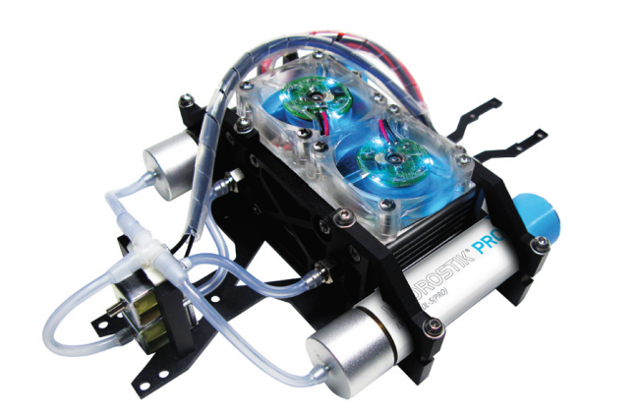

Figure 2: Horizon H-Cell 2.0

This is not Horizon’s first product into hydrogen-powered toys. The original H-Cell power train came out in 2006, along with the complete H-Racer car, that got an H-Racer 2.0 upgrade in 2008, which gave it more power and infra-red remote control. In 2008 Corgi also launched its H2GO RC car, which was powered by a Horizon-designed fuel cell. The new feature on the 2.0 are the Hydrostiks, which are refillable battery-shaped hydrogen cartridges. They store hydrogen as a solid hydride, within their internal alloy matrix. According to Horizon, this is the highest-density method of hydrogen storage. The sticks are also safer and more practical than a traditional compressed hydrogen tank, as their internal pressure is relatively low. Each cartridge takes one hour to charge, and stores 15 watt-hours of energy. Together with the lithium battery, two Hydrostiks have a combined operating time of approximately 60 minutes.

Horizon Fuel Cell Technologies have another product called i-H2GO. The i-H2GO, shown in Figure 3, it uses a hydrogen refueling station generates hydrogen through water electrolysis, refuels the car and charges the super capacitor. A PEM fuel cell converts hydrogen to electrical energy and the super capacitor engages when the car accelerates. The car is controlled by a smartphone through a free app.

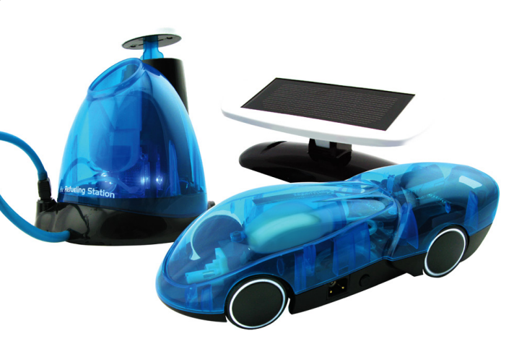

Figure 3: Horizon i-H2GO

This car comes with an included refueling Station. The user pours purified water into that device, and it proceeds to electrolyze the H2O, separating it into hydrogen and oxygen. A plunger on the station rises as hydrogen fills its temporary holding compartment. Then the user connects the car to the station using a built-in hose, and manually pumps the hydrogen from the station into the car. The car's fuel cell combines the hydrogen with oxygen from the air around it, producing a flow of electrons that powers its motor.

### Previous Senior Design Projects

The only senior design project using a fuel cell was done by The Department of Mechanical and Aerospace Engineering here at UCF. The group built upon preexisting mechanical conditions that produce electrical power in Proton Exchange Membrane Fuel Cells. Previous system designs hindered efficiency due to mass transport within two bipolar plates of the fuel cell. They attempted to recondition the bipolar plates to maximize the electromechanical reaction evenly along the membrane by finding mass transport voltage loss. Figure 4 shows the custom grooves in the fuel cell plates.

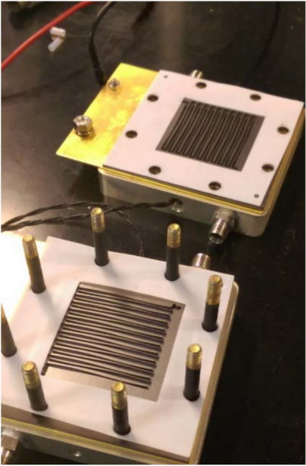

Figure 4: Custom PEM Fuel Cell

### Toshiba Dynario

We plan on being able to power other devices using the fuel cell as well as the RC car. A portable product that was created by Toshiba called Dynario. The Dynario, showed in Figure 5, is a portable fuel cell power generator. It can produce enough power in 20 seconds to charge two mobile phones. The power is stored in in-built lithium ion batteries and can be transferred via a USB cable to your mobile phone or digital media player when needed. This device uses a methanol fuel cell that, in liquid form, methanol reacts with water to create hydrogen ions and electrons. The hydrogen ions travel through a thin plastic film polymer and react with oxygen, creating electricity.

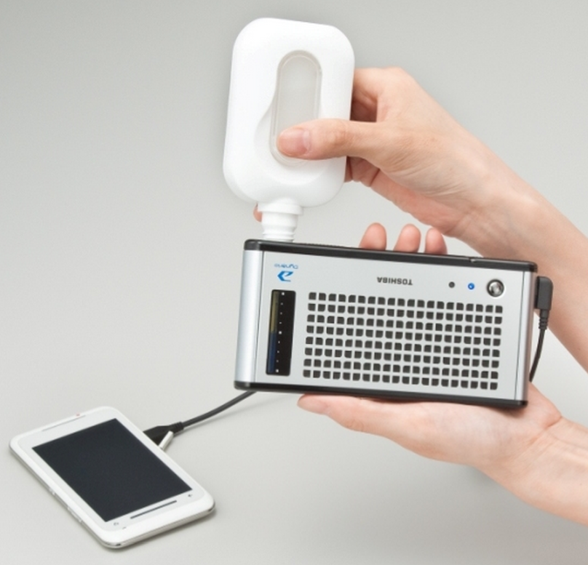

Figure 5: Toshiba Dynario

A drawback of the Dynario is that it’s probably most useful only for frequent travelers or heavy users of cell phones as a convenient way to charge while on the move but if that travel involves an airplane it becomes less useful. With its 14ml reservoir fully loaded, it can be taken in an airplane cabin but not put in checked luggage.

### Joule Box

The Joule Box (Figure 6), is a portable charge station capable of providing continuous off-grid electricity. With the Joule box you are able to replace a typical gasoline generator and never have to buy another gallon of fuel. It features tracking solar panels with GPS technology and battery back-up power generation that can provide extra energy production and energy storage. Optional wind turbine and onboard hydrogen gas generation upgrades can provide extra energy production and storage capacity. This unit can be used for many things but is perfect for emergency preparedness and disaster prepping.

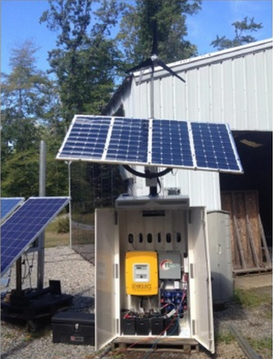

Figure 6: Joule Box

## Fuel Cell Market Analysis

Hydrogen Fuel Cell technology has advanced to the point where companies in the industry can be profitable. The market demand for fuel cells continues to grow at a fast pace. A big factor for the success of fuel cells is the cost and efficiencies. Since the year 2000, where there was a big hype around fuel cells, the efficiencies have increased greatly and the costs have come down. According to the US Department of Energy they have expended efforts in this area and reported on some of the improvements in the industry [1]. Some of those facts are:

1. For stationary fuel stacks, there has been a 25% increase in system power density since 2008.
2. A 50% decrease in the cost of gas diffusion layers since 2008.
3. Reduced the cost of producing hydrogen from natural gas as well as from renewable resources. Example: the cost of electrolyzer stacks by more than 80% since 2002.
4. Reduction in the cost of delivering hydrogen by improving the capacity that trailers can carry hydrogen by 30% since 2011.
5. Advanced materials have reduced the cost of storage for hydrogen.
6. Reduced the cost of automotive fuel cells by more than 50% since 2006 and 30% since 2008.
7. The number of durability hours for fuel cells in vehicles has more than doubled since 2006.

These are some of the improvements in the technology recently and they continue to improve every day. The last few refer to vehicles, which is becoming a hot market of interest, due to some of the facts listed above it has become a real possibility. Figure 7 shows the trend for transportation fuel cell system costs.

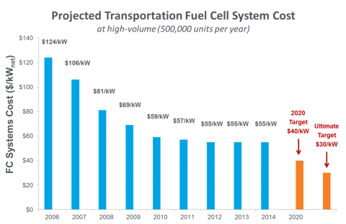

Figure 7: Trend for transportation fuel cell system costs [1]

As the costs of manufacturing a fuel cell have decreased from $124/kw in 2006 to $55/kw in 2012. This means that there has been a 56% direct cost reduction for companies producing fuel cells.

Another big use of a fuel cell is for portable power. The application of fuel cells for portable uses has been a successful area for manufacturers. Portable fuel cell applications tend to fall into three areas: fuel cells for charging consumer electronics, most notably mobile phones, for power units in applications, such as camper vans, and for military use for soldier power and other small power uses such as certain unmanned aerial vehicles. Fuel cells are also used at very small power levels for educational uses and toys.

## Fuel Cell Cars

To really appreciate the differences between fuel cell vehicles and other types of vehicles, we have to understand some of the energy transfers that are taking place. We talk about transport, we need to produce mechanical energy to turn the wheels of the car and make it go. However, although internal combustion engines can produce mechanical power directly, they only do so efficiently over a narrow power band, whereas electric motors produce a high torque over a wide power band. This is why car manufactures are looking into hybrid vehicles to combine the strengths of both the power density that can be stored in fuels for the internal combustion engine, and the efficiency over a range of loads of the electric motor [2]. In Figure 8 and Figure 9 below you can see how battery vehicles and fuel cells fit into this energy conversion sequence.

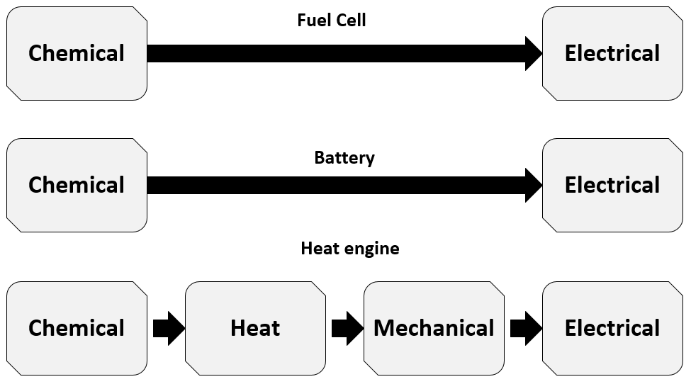

Figure 8: Production of electrical power

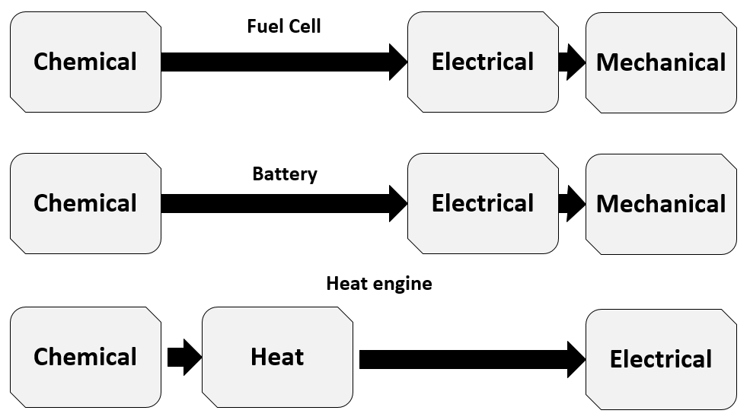

Figure 9: Production of mechanical power

Cars today tend to use an internal combustion engine. These engines either burn gasoline or diesel, but in a more limited capacity, some engines will burn biodiesel, or bioethanol. While the effects of releasing carbon into the atmosphere can be mitigated by using different fuels it does not change the fact that petrol engine, being a heat engine, is horribly inefficient, and converts not a lot of the chemical energy embodied in the fuel into actual delivered power. There are other good reasons for rejecting the internal combustion engine. Just take a look at the different byproducts that pollute our environment that come out of an exhaust pipe of a car.

## Relevant Technologies

### Hydrogen Detection Sensor

The MQ-8 hydrogen sensor can be used for detecting hydrogen leaks. This sensor is low cost and readily available from a number of sources. The sensor is of the semiconductor type and uses a thin layer of Tin Oxide. The Tin Oxide absorbs oxygen from air which will then react and be released in the presence of various chemicals. Because the Tin Oxide’s conductivity varies with the amount of oxygen absorbed, a decrease in resistance indicates that one of the target chemicals is present. According to the datasheet, the MQ-8 sensor reacts with several chemicals including: hydrogen, alcohol, carbon monoxide, Liquid Petroleum Gas (LPG), and methane. However it is most sensitive to hydrogen, which is why it is labeled as a hydrogen sensor. Other sensors in the MQ family are tuned for the detection of various chemicals other than hydrogen.

The sensor can detect concentrations of hydrogen between 100 and 10,000 ppm. As a point of comparison, air has approximately 0.5 ppm of hydrogen. The sensor has four pins, two of which connect to tin oxide resistive layer, and two of which power a heating element. The sensor is designed to form a voltage divider with a variable load resistor. The variable resistor is nominally 10k-ohm, but can be adjusted as a part of a calibration process. Charts are given for the part from which we can get a general idea of how the sensor will behave in relation to the 1,000 ppm calibration point. The datasheet suggests calibrating the sensor using a 1,000 ppm hydrogen mixture after letting it preheat for 24 hours. It will be difficult for us to attain these exact conditions. In addition, the sensor is sensitive to both temperature and humidity, and thus there may be even more variability. Therefore, trial-and-error testing is probably needed.

The heating element will dominate the sensor’s power usage. Therefore, the power supply requirements for the part will be as follows (approximately):

|  |  |  |  |
| --- | --- | --- | --- |
| Voltage | Resistance | Current | Power |
| 5V | 31 ohms | 160 mA | 800 mW |

Table 4: MQ-8 Hydrogen Sensor Specifications

Using the MikroElektronika “Hydrogen click (tm)” measurement board schematic as a reference, the load resistance should be made adjustable between approximately 470 ohms and 10 k-ohms. There are two options for using output voltage of the circuit: the controller can sample the analog voltage so that an exact concentration can be calculated, or a comparator circuit can be used to provide the controller with a digital alarm signal.

### Fuel Cells

#### Theory of Operation

Fuel cells have the ability to generate electricity through a chemical reaction with an oxidizing agent. A fuel cell is an electrochemical energy conversion device which is typically two to three times more efficient than a typical engine in converting fuel to power. In a fuel cell, fuel (hydrogen gas) and an oxidant (oxygen gas from the air) are used to generate electricity, while heat and water are typical byproducts of the fuel cell operation. A fuel cell typically works on the following principle: as the hydrogen gas flows into the fuel cell on the anode side, a platinum catalyst facilitates oxidation of the hydrogen gas which produces protons (hydrogen ions) and electrons. The hydrogen ions diffuse through a membrane (the center of the fuel cell which separates the anode and the cathode) and, again with the help of a platinum catalyst, combine with oxygen and electrons on the cathode side, producing water. The electrons, which cannot pass through the membrane, flow from the anode to the cathode through an external electrical circuit containing a motor or other electric load, which consumes the power generated by the cell. The resulting voltage from one single fuel cell is typically around 0.7 V. This voltage can be increased by stacking the fuel cells in series, in which case the operating voltage of the stack is simply equal to the product of the operating voltage of a single cell and the number of cells in the stack.

#### Power Curves

Due to internal resistances, the fuel cell will have a varying voltage as a function of current. The plot of voltage versus current is known as the polarization curve. The curve is not flat because the different types of internal resistance will vary with current. From the polarization curve, we can also create a plot power versus either voltage or current. Example plots for a single cell are shown in Figure 10 and Figure 11 (based on those found in [3]). Note that when operating at peak power, increasing current or decreasing voltage will cause the power to drop. The internal resistances also have different time dependencies; the current output of the fuel cell can change very quickly, but the voltage will have a more gradual response.

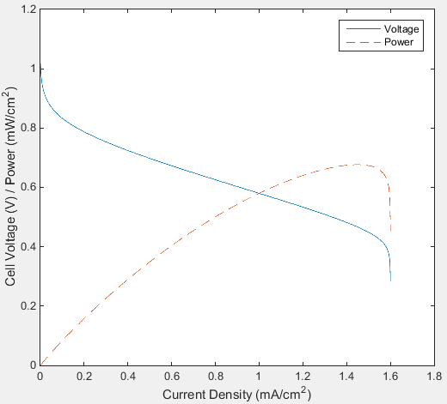

Figure 10: Polarization Curve with Power versus Current

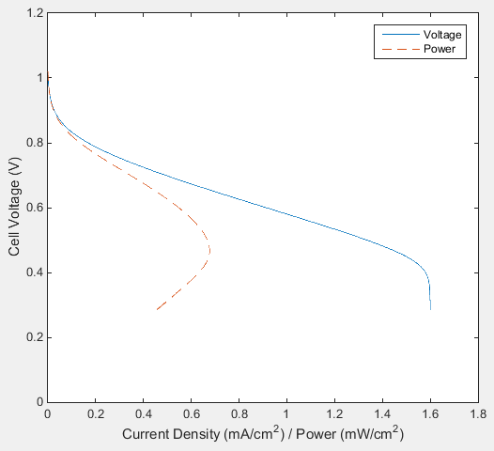

Figure 11: Polarization Curve with Power versus Voltage

#### Materials

Typical materials of a fuel cell are:

* Catalyst - Fuel cells create power by oxidizing hydrogen atoms into protons and electrons on the anode electrode and reduced oxygen atoms with protons on the cathode electrode.  Generally, in a Polymer Electrolyte Membrane Fuel Cell (PEMFC), Platinum is used as the catalyst.
* Electrodes - Generally hydrophobic to reduce flooding issue during fuel cell operation.
* Gas Diffusion Layers – A thin porous sheet that provides high electrical and thermal conductivity and chemical / corrosion resistance, in addition to controlling the proper flow of reactant gases (hydrogen and air) and managing the water transport out of the membrane electrode assembly.
* Membrane - The Membrane Electrode Assembly (MEA) is the core component of a fuel cell that helps produce the electrochemical reaction needed to separate electrons. A membrane electrode assembly is the 3 Layer MEA which is composed of a polymer electrolyte membrane with catalyst layers applied to both sides, anode and cathode.
* Gaskets - Gaskets provide correct compression and act as a ‘barrier’ for potential fuel leaks; maximizing the highest possible efficiency.
* Plates
  + End Plates - End plates are needed at either end of the stack to apply pressure on the cells to maintain the structure as well as to prevent the gases from escaping from between the plates.
  + Graphite Plates - Graphite plates are attached to the electrode backings of a fuel cell stack on either side.  These plates serve a double purpose within the fuel cell stack.  One purpose of the graphite plate is to act as a conductor by receiving the energy from the electrodes.  The other purpose is to guide the flow of the hydrogen and oxygen through their respective ends of the stack, making sure that the maximum amount of the gasses and moisture comes in contact with the membrane.

#### Why a Hydrogen Fuel Cell?

There are many ways to extract energy from fossil fuels that are pretty wasteful. A range of different devices that can be used for producing useful energy from fuels. Devices such as Fuel cells, diesel electric hybrid, gasoline electric hybrids, and gas/steam turbines. Fuel cells produce more power and are more efficient than that of even the best hybrid solutions and turbine applications. The problem at the moment, as stated in the market analysis section of this paper, is the technology and price.

If you look at Figure 12, you can see how a prospective hydrogen economy could work. The advantage is that with clean energy and hydrogen, carbon dioxide and toxic pollutants are eliminated from the process, with the only things entering and exiting to and from the natural environment being water and oxygen. In Eq. 1, hydrogen and oxygen being the elements of water.

2H2 *(g)* + O2 *(g)* 🡪 2H2O *(aq)* (1)

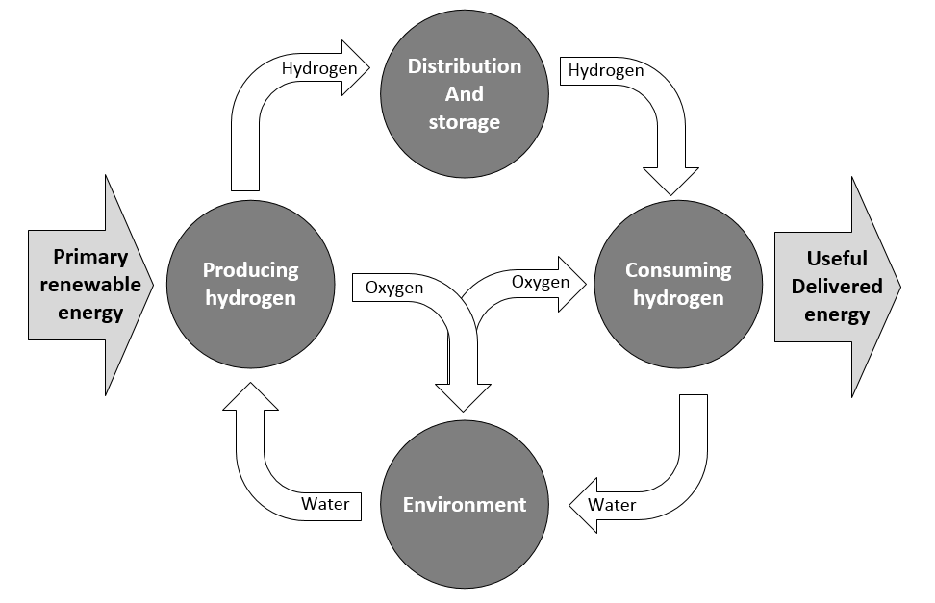

Figure 12: Hydrogen economy

### Ultracapacitors

Electrochemical double layer capacitors (EDLCs), also known as ultracapacitors or super capacitors, act like any other kind of capacitor, only they can store tremendous amounts of energy. Super capacitors can be used in solar power applications, battery back-up applications, battery applications, etc. Aside from the fact that the super capacitor can be charged very quickly due to their low internal resistance (ESR), but they can just as quickly be discharged. Batteries contain harmful chemicals, and die over time. Super capacitors do not give off gas like lead acid batteries, but they cannot store as much power either. You can place capacitors in series or in parallel to either up the maximum charge voltage, or total capacitance.

Each application of an ultracapacitor needs to be evaluated based on its requirements. Below is a summary of some of the advantages and disadvantages when considering the use of EDLCs:

Advantages:

* High energy storage. Ultracapacitors possesses orders of magnitude higher energy density. This is a result of using a porous activated carbon electrode to achieve a high surface area.
* Low ESR. Compared to batteries, ultracapacitors have a low internal resistance, hence providing high power density capability.
* Low Temperature performance. Some manufactures are capable of delivering energy down to -40°C with minimal effect on efficiency.
* Fast charge/discharge. Since ultracapacitors achieve charging and discharging through the absorption and release of ions and coupled with its low ESR, high current charging and discharging is achievable without any damage to the parts.

Disadvantages:

* Low per cell voltage. Ultracapacitor cells have a typical voltage of 2.7V. Since, for most applications a higher voltage is needed, the cells have to be connected in series.
* Cannot be used in AC and high frequency circuits. Because of their time constant ultracapacitors are not suitable for use in AC or high frequency circuits.

### Multiport and Bidirectional DC-DC Converters

Future power conversion systems need to be interfaced with alternative energy sources such as fuel cells along with energy storage devices such as batteries and super capacitors. Multiport converters are a promising concept for alternative energy systems. It has attracted increasing research interest recently [4]. Compared with the conventional approach that uses multiple converters, a multiport converter promises cost-effective, flexible, and more efficient energy processing by utilizing only a single power stage.

For dc-dc power conversion. The dual-active-bridge (DAB) has some good features such as low device stresses, bidirectional power flow, fixed-frequency operation, and utilization of the transformer leakage inductance as the energy transfer element [5]. The main drawback of the DAB converter is that it can’t handle a wide input voltage range. In such a case the soft-switching region of operation will be significantly reduced. In addition, a phase shift plus pulse-width modulation control applied to the DAB converter, where the converter uses two half-bridges to generate asymmetrical in order to deal with the voltage variation. However, for the multiport topologies, with this method only one port may have a wide operating voltage because all the bridges operate at the same duty ratio. A Front-end boost converter can be used to solve the port voltage variation [6]. Other circuit topologies are suggested for a three-port converter such as the current-fed topologies that have more number of magnetic and fly back converter topologies that are not bidirectional [7].

If we source power from the fuel cell and want the car to quickly accelerate, we may want to pull current from both the battery and fuel cell at the same time. A binary on-off switch gives us some control, but we need dynamic sharing in order to achieve optimal efficiency and performance. There are multi-port converter designs available with a variety of topologies, however these may be beyond the scope of this project.

## Generating Electrical Power from Fuel Cell Vehicles

Our project will be able to power a load while the RC car is idle. The reason for us wanting to do so is eventually this could happen with a regular size car. While a fuel cell powered cars is parked on a drive way of just sitting in a parking lot it would be able to generate power for your house or a building nearby.

Many automotive manufacturers are working on prototype cars which will contain fuel cell power plants as their prime motive power. The electrical energy generated by these fuel cells will energize an electric motor or motors thus propelling the car. Natural gas, hydrogen, or other light gaseous can be used to provide a fuel input to the fuel cells.

This Idea is focused on the process that fuel cell powered cars can not only generate electrical energy for motion, but when at rest or parked the fuel cells can be energized and its energy harnessed and focused through an electric power grid, or straight to your home, so as to provide a unique electrical power for local use. Traditional combustion engine power plants in cars can also be used to provide extremely limited or nominal amounts of alternating current electrical power through an inverter. Still relatively small amounts of direct current electrical power are produced by these cars, typically utilized to sustain the electrical needs of the car and its accessories. However, it is difficult to obtain useful electrical power from these engines: their low conversion efficiency, their need for cooling by their generated air flow during locomotion, and pollution emissions make them not a candidate for meaningful power generation. They are designed to be a device for the purpose of locomotion. Hybrid vehicles or turbine powered vehicles are a technology stretch at this point.  However, this could spur the further commercialization of and near term modification of the hybrid vehicle. Fuel cells have high conversion efficiencies, relatively low emissions, and can be run continuously without the mechanical problems normally encountered with running combustion engines for long periods of time.

A 40kW fuel cell is typical of the size fuel cell utilized in certain fuel cell powered vehicles. The locomotion function of the vehicle may become secondary to its power generation function. For example, a small parking lot containing 100 parked fuel cell powered cars each with a 40 kW power plant can generate 4,000 kW of power, or 4 megawatts (MW). This amount of power is typically equivalent to the delivery capability of two standard 4,160 volt electric utility feeder circuits, or half of a 13,200 volt circuit. These voltage level circuits are rather common in electric utility industry practice. Each of these types of circuits can normally handle hundreds of houses and/or commercial or light industrial loads. A small parking lot can become a significant source of localized electric power generation. In a downtown area, such power generation can easily supply large office building loads. A five level parking deck with 100 cars per deck can provide 20 MW of power, which is the size of an entire utility substation designed to feed thousands of homes or a mixture of residential/commercial/industrial load in a region measured in square miles of size.

Consider a single fuel cell powered car or other vehicle, parked in a parking lot where its 40 kW on board fuel cell is working 8 hours per day generating electricity which is in turn then supplying the normal electrical load of an adjacent building-such as an office building.

The energy output of the fuel cell is

|  |  |  |
| --- | --- | --- |
|  | *40kW×8 hours=320kWh* | (2) |

If this energy was sold directly to a local electric utility, the car owner would be paid what is termed the marginal generating rate, which for a typical Florida utility would be approximately $0.117/kWh. Therefore, if the 320 kWh was sold at the marginal rate, the realized revenue would be $37.44; assuming of course that there was a convenient way to convert the DC electrical output of the fuel cell into the AC electrical standard of the utility grid. Now, if the output of the fuel cell is sold to the parking lot owner who installs all the necessary interface equipment to allow the energy generated to be sold to a local and ready customer like an office building, the economics of the transaction described above becomes quite different and beneficial to all parties concerned. The owner of the fuel cell powered car may want to sell his 320 kWh to the parking lot owner for greater than what the local utility would give him for the same energy. If the parking lot owner agrees to buy for that rate, the car owner would receive a certain amount for the daily output of his car. The parking lot owner would then be free to retail the 320 kWh of electrical energy to the building owner. The parking lot owner might be motivated to sell it at a greater cost than what he paid for to cover all the costs invested in the parking lot electrical interface wiring and natural gas fuel grid, and daily operating costs. The building owner would then realize the savings on the normal cost of his electricity by buying it cheaper than from the local utility.

This process can be extended to other types of parking lots. It could be easily used at large factories or commercial establishments so that employee cars parked in the lot can provide the electricity to run the facility. Virtually anywhere a fuel cell powered car is parked it can become a generating station which provides electrical energy to local loads. Cars parked in the garages of a home could significantly offset the use and cost of electricity in the home. For the purpose of our project we will only focus on our 60W fuel cell producing a constant 12V DC power supply.

# Related Standards

There are plenty of standards that relate to our project. I could have written an entire page on the standards there were to work with hydrogen and fuel cells but I limited it down to just a few. Standards are such a big part in creating something that the average individual gives little or no thought to products we all use on a daily basis. Table 5 shows a set of characteristics that describes features of our project. We made an effort to provide a variety of standards from different developers.

| Document # | Title | Developer |
| --- | --- | --- |
| ISO 14687-2:2012 | Hydrogen fuel - Product specification - Part 2: Proton exchange membrane (PEM) fuel cell applications for road vehicles | ISO |
| ISO/TC 197 | Hydrogen technologies | ISO |
| ISO/CD 20100 | Gaseous hydrogen -- Fueling stations | ISO |
| ISO/FDIS 26142 | Hydrogen detection apparatus -- Stationary applications | ISO |
| ISO/PWI 10783 | Hydrogen compatibility testing for metals | ISO |
| BSR/AIAA G-095A-200x | Guide to Safety of Hydrogen and Hydrogen Systems | AIAA |
| ANSI FC 1-2012 | Stationary fuel cell power systems | CSA |
| ANSI/CSA America FC 3-2004 | Portable Fuel Cell Power Systems | CSA |
| SAE J 2578-2014 (SAE J2578-2014) | Recommended Practice for General Fuel Cell Vehicle Safety | SAE |
| SAE J 2579-2013 (SAE J2579-2013) | Standard for Fuel Systems in Fuel Cell and Other Hydrogen Vehicles | SAE |
| SAE J 2594-2011 (SAE J2594-2011) | Recommended Practice to Design for Recycling Proton Exchange Membrane (PEM) Fuel Cell Systems ( Stabilized: Sep 2011 ) | SAE |
| SAE J 2617-2011 (SAE J2617-2011) | Recommended Practice for Testing Performance of PEM Fuel Cell Stack Sub-system for Automotive Applications ( Stabilized: Aug 2011 ) | SAE |
| BS EN 62282-2:2004 | Fuel cell technologies. Fuel cell modules | BSI |
| IEC 62282-2 Ed. 2.0 b:2012 | Fuel cell technologies - Part 2: Fuel cell modules | IEC |
| BSR/TUV-R 15.07-201X | Commercial/Industrial Autonomous Battery Operated Material Handling Robotic Drive Units - Design Qualification and Type Approval | TUV-R |
| CISPR 14-2 Ed. 2.0 b:2015 | Electromagnetic compatibility - Requirements for household appliances, electric tools and similar apparatus - Part 2: Immunity - Product family standard | IEC |
| ANSI/CSA HGV 4.1-2013 | ANSI/CSA HGV 4.1-2013 - Hydrogen dispensing systems | CSA |
| ISO 11519-3:1994 | Road vehicles -- Low-speed serial data communication -- Part 3: Vehicle area network (VAN) | ISO |
| IEEE Std 1609.1-2006 | IEEE Trial-Use Standard for Wireless Access in Vehicular Environments (WAVE)-Resource Manager | IEEE |

Table 5: Related Standards

# Realistic Design Constraints

## Electromagnetic Interfaces

Electromagnetic fields are everywhere and they usually don’t cause any problem, but sometimes they are strong enough to be called “interferences” and can affect some things such as our electronic circuits. In this project some interference could be detected and this issue has to be tackled.

### Electromagnetic Fields Source

On our RC car there are a lot of electronic circuits and cables, therefore many electromagnetic fields sources can be found as well as electromagnetic fields victims.

The most suitable sources are boards and cables that work with high intensities and with frequent and fast voltage changes (high frequencies). In this case those sources are the motor power supply system components: Motor, motor controller, buck, ultracapacitors, fuel cell, fuel cell controller and all the cables that link them.

On the other hand, the most suitable victims are boards and cables that work with lower intensities, less than 100 mA, but also with high frequencies. In this project the victims are: control board, buck and all the cables connected to them. The buck is in both lists which means that at the same time it’s a source and a victim of electromagnetic interferences. That happens because the buck is in charge of changing the fuel cell voltage and to manage the ultracapacitor, if we choose to use some, power that cause electromagnetic interferences.

### Reducing the Generated Electromagnetic Fields

There are several ways to helped improve the electromagnetic compatibility of the car. These next aspects will be considered while designing the PCB and the wire placement:

* PCB
  + On a two-layer board, for both power and ground, the length-to-width ratio should not exceed 3:1 for any traces between the IC and the voltage source
  + Power and ground should be run directly over each other, which reduces impedance and minimizes loop area
  + Route power traces radially from the power supply
  + Route power and ground traces parallel to each other
  + Signal flow should parallel the ground paths
* Wire placement
  + Spiral wiring to reduce the closed circuit loops. If an electromagnetic field goes through a closed circuit loop a current is induced in the circuit loop and cause many problems

Sensitive wires must be protected from electromagnetic interferences to avoid unexpected and undesired errors and accidents.

### Electromagnetic Interference (EMI)

Electromagnetic interference takes place when an electronic device is disrupted by being in the proximity of an electromagnetic field caused by an external device. The ultimate goal of an electronic device is to be able to operate at optimum levels while having high immunity against electromagnetic forces. There are many ways of classifying the different types of electromagnetic interference. Some of these classifications are, man-made vs naturally occurring, continuous vs impulse, and narrowband vs broadband. These different classifications are explained in detail on Table 6.

|  |  |  |
| --- | --- | --- |
| Categorization |  |  |
| Creation | Man-Made: Usually comes from circuits or large current switching | Natural: Can come from lightning or other atmospheric interference |
| Duration | Continuous: Can be caused by a circuit transmitting a current signal | Impulse: Can come from sources such as lightning, electrostatic discharge and switching systems |
| Bandwidth | Narrowband: Can be caused by intermodulation and other disruptions with the transmitter | Broadband: Can come from sources where a spark is continuously generated or caused by interruption of satellite transmission |

Table 6 - Electromagnetic Interference Sources

According to the textbook, Advanced Materials and Design for Electromagnetic Interference Shielding, most of the electromagnetic issues are caused by energy in the radio frequency range which extends from 100000Hz to about 1 billion Hz. One of the main reasons why electromagnetic interference takes place is because of how close two or more components are on an electrical board, this decreases the propagation path and increases the chances of interference. One of the regulations that is in place to help people think about the different scenarios of dealing with electromagnetic interference is IEC 61000-4 which is used for standardizing test methods. There are other sections of interest within this regulation, IEC 61000-4-2 deals with electrostatic discharge, IEC 61000-4-4 deals with fast transients and IEC 61000-4-5 used for high-energy transients. The measure of electromagnetic interference is a hard task to accomplish and it is easier to guard against this type of interference than to look for the source producing it.

One way to avoid electromagnetic interference is by making sure that all the electronics in the circuit are operated with a good ground system. Another precautionary measure against interference would be to keep cables, wires and cords shielded to prevent unwanted radio frequency energy from getting in or out. To be most effective in guarding against electromagnetic interference our team needs to think about preventing interference as soon as we start designing the circuit. To do this we must block disturbances from entering other devices, ground any possible disturbances, and make sure to keep sensitive circuitry as far as possible from devices that might produce interference.

## Hydrogen Storage

For the storage of hydrogen that will be used to flow through the fuel cell we are going to use a metal hydride tank. The body of a Metal hydride tank usually are materials are generally aluminum alloy or stainless steel. The hydrogen being stored at low pressure in the vessel. They provide a safe and reliable energy storage, particularly for portable applications like in-board storage. The hydrogen is not only compressed, in fact is absorbed into a crystal structure of a metal hydride. That absorption makes this type of storage suitable for lots of usual conditions: between 1 and 10 bar and between 25ºC and 120ºC.

The performance of a metal hydride tank mainly includes the following aspects:

* Capacity
* Releasing rate
* Recharging time
* Cycle life

## Environmental, Social, and Political Constraints

### Hydrogen Accumulation in Enclosed Area

Metal hydride tanks are ideal for indoor use thanks to their low storage pressure. However users should consider the volume of the room where the vessel is stored compared to the volume of hydrogen stored. Hydrogen has a Lower Flammable Limit (LFL) of 4% diluted in air. It is recommended that the uncompressed total volume of hydrogen stored does not exceed 2% (half of the LFL) of the total volume of the room. Some tanks are delivered filled with argon to comply with air transportation security rules. Therefore, they need to be charged before being usable.

## Ethical, Health, and Safety Constraints

### Hydrogen Safety

We will be using a SOLID-H metal hydride rechargeable hydrogen container for our project. This container can hold hydrogen pressures up to 500 psig and should not be connected to, or used with, any device that cannot withstand that type of pressure. We cannot allow the container temperature to exceed 125ºF (52ºC). Overheating it will cause the release of hydrogen gas through the pressure relief valve. We must make sure that we not attempt to charge the container with hydrogen gas of purity less than 99.95%.

#### Recharging the Hydrogen Tank

The Hydrogen inlet/outlet fitting on our tank is a female Swagelok QM Series quick-connect. Commercial purity hydrogen is at least 99.95% pure. The performance and capacity of the container will be reduced if the hydrogen contains water vapor, air, or any other impurities. When recharging we must always purge the recharge plumbing before connecting it to the container. A way to do this is to pressurize the entire system, except the container, to at least 150 psig with hydrogen, close the tank valve, and vent the plumbing to a safe location at atmospheric pressure. Repeating the pressurizing/vent procedure six times will reduce air contamination to an acceptable 1 part per million. After the sixth vent procedure we couple the quick-connect on the hydrogen supply hose to the container and begin fueling at the appropriate pressure.

#### Flammability

Hydrogen burns with a nearly invisible bluish flame, unless it is contaminated with impurities, in which case a pale-yellow flame is easily visible in the dark. The temperature of burning hydrogen in air is high, and warm hydrogen gas rises rapidly because of its buoyancy. Hydrogen forms a flammable mixture over a wide range of concentrations in air and requires a minimum ignition source, only one-tenth of the energy required for gasoline vapors. The combination of these factors that contributes to the flammability hazard associated with hydrogen gas.

#### Embrittlement

Because of its small molecular size, hydrogen can easily pass through porous materials and is capable of being absorbed by some containment materials, which can result in loss of ductility or embrittlement. At elevated temperatures, this process is accelerated. Because of the possibility of hydrogen embrittlement of some materials, piping and component materials that are not subject to this form of degradation should be selected. Table 7 shows the physical properties and characteristics of Hydrogen.

| Property/Characteristics | Values (approximate) |
| --- | --- |
| Color | None |
| Odor | None |
| Toxicity | Nontoxic |
| Density, liquid (boiling point) | 4.4 ${ft}/{{ft}^{3}}$ (0.07 $g/{{cm}^{3}}$) |
| Boiling point (1 atm) | -423.2°F (-252.9°C) |
| Critical temperature (188.2 psia) | -400.4°F (-240.2°C) |
| Stoichiometric mixture in air | 29 vol % |
| Flammability limits in air | 4-75 vol % |
| Detonation limits in air | 18-60 vol % |
| Minimum ignition energy in air | 20 $μ$ J |
| Auto ignition temperature | 1,085°F (585°C) |
| Volume expansion:  Liquid (-252.9°C) to gas (-252.9°C)  Gas (from -252.9°C to 20°C)  Liquid (-252.9°C) to gas (20°C) | 1:53  1:16  1:848 |

Table 7: Physical Properties and Characteristics of Hydrogen

# Project Hardware and Software Design Details

## Existing RC Car Design

### Overview

The RC Car was manufactured by Heliocentris in Germany. It is an older model from the early 2000’s and we do not have any documentation or schematics for the car. Figure 13 is a diagram of the RC car as built by the manufacturer, and Table 8 is a list of components and information. On top of the car is the fuel cell, hydrogen tank, inlet valve, fan, and two purge valves. The hydrogen inside the tank goes travels to the inlet valve to get a pressure reading and then to the fuel cell. There is a purge valve that stays open the entire time while the hydrogen gets injected into the fuel cell. The other purge valve is on the opposite side of the fuel cell and it opens when there is a need for the hydrogen to pass through the stack. The fan supplies the fuel cell with oxygen the entire time. A brushed DC motor sits underneath the inlet valve in the back of the car. The steering servo sits underneath the fan at the front of the car. Alongside of the fuel cell is the radio receiver.

The connection wires for all the components listed above runs to a circuit box that sits right underneath the fuel cell. Inside are the rest of the components in the diagram below. There are two boards inside a power board and the controller board. The electronic speed controller sits next to the two boards on one end and a 9V battery on the other end.



Figure 13: Diagram of RC Car as built by manufacturer

|  |  |  |  |  |
| --- | --- | --- | --- | --- |
| Description | Manufacturer | Model Number | Extra Information on Label | Electrical Connections |
| Fuel Cell | Unknown | Unknown |  | 2 large connectors at each end  3 small connectors on last 3 plates |
| Temperature Sensor | Label Hidden | Label Hidden |  | 2 wires |
| Hydrogen Valves | Sirai | Z030C (coil) | W2,5  ED: 100%  V 12 | 2 wires |
| Fan | Micronel | D343T | 12 VDC | 2 wires |
| Radio Receiver | Sanwa Electric Co. | SRC-2322RS | AM Receiver  27 MHz  BEC | 1 connectors with 2 prongs (labeled B)  2 connectors with 3 prongs each (labeled 1 and 2) |
| Steering Servo | Hitec | HS-81MG |  | 3 wires |
| Electronic Speed Controller (ESC) | Carson | Unknown | 20 Speed  Set Button  Green/Red LEDs | 4 large wires  3 small wires |
| Drive Motor | Team Orion | Label Hidden |  | 2 wires |

Table 8: RC Car Components

### Fuel Cell Stack

The fuel cell has a hydrogen inlet port and a purge outlet port. Atmospheric oxygen is provided and water is expelled by blowing air laterally between the plates. There are large terminal lugs at each end of the stack which output the power. Three terminals are provided to measure the voltage across the last two cells at the outlet end of the stack. Due to hydrogen flow gradients from the inlet to the end of the stack, these cells should be most sensitive to hydrogen depletion. The estimates specifications of the fuel cell are shown in Table 9.

|  |  |  |
| --- | --- | --- |
| Cells | Voltage Range | Power |
| 12 | 6V to 10V | 60W |

Table 9: Fuel Cell Specifications

Upon turning the on/off-switch to the on position, the logic board in the current system initially opens up the input valve while keeping the purge valve closed which lets hydrogen enter the fuel cell stack and increase in concentration and pressure within. As the pressure increases, the processor is actively monitoring the voltage drop at three different points across the fuel cell stack; across the entire stack, between the third to second to last cells, and between the second to last and the last cells furthest from the input valve. The processor is also actively monitoring the temperature about the last fuel cell stacks. When the voltage across the cell reaches an optimal value the processor powers on the fan, and switches all loads to run off of the fuel cell instead of the battery/grid. During operation the processor is actively monitoring the voltage across each of the last two cells. When the voltage across the last cell is more than 50mV below the voltage of the second to last cell, the purge valve is opened for a split second. It is unclear whether this pulse time is fixed, or if the controller holds the valve open until the voltage difference is reduced (although we suspect that the time is fixed). The processor also actively monitors the temperature, and will shut the fuel cell down if its temperature exceeds 45°C. Note that the inlet valve is kept open continuously while the fuel cell is on.

### Temperature Sensor

The temperature sensor is cemented directly to the top of the fuel cell. If there is a part number printed on the sensor, it is on the face that is attached to the fuel cell, so we cannot see it. Because of the package type (TO-92) and wiring (it only has two wires) we will assume the sensor is an NTC thermistor. On the control circuit board, there is a potentiometer in series with the thermistor (on the high side). We assume that this forms a voltage divider with the thermistor.

### Hydrogen Valves

The valve uses a Sinai Z030C solenoid coil. The metal valve body (on the bottom), and the coil (mounted on top of the valve) have different part numbers and are designed to be interchangeable with other coils/valves. We do not know the part number of the valve body. We will assume that the valve is a normally closed type. We cannot find much information about the coil but did find the following specifications in Table 10.

|  |  |  |
| --- | --- | --- |
| Voltage Range | Voltage tolerance | Power |
| 12V - 24V | +10%, -5% | 2.5W |

Table 10: Hydrogen Valve Specifications

The specific conditions for the power rating are not given, but if the coil is driven at 12V with a power dissipation of 2.5W, then the current would be approximately 208 mA. However, if the power rating is for 24V and we assume constant resistance, then the required current at 12V would be approximately 104 mA. The solenoid has three prongs, but only two appear to be connected. The third prong should be a ground connection, which may be attached to the circuit ground via the valve body and RC Car frame. The solenoid should work regardless of voltage polarity, but we should probably use the same polarity to be safe. We do not see any rating regarding time of operation, and will assume no damage will occur if the coil is continuously energized. This assumption is supported by the fact that the hydrogen inlet valve remains open while the car is powered on.

### Blower/Cooling Fan

The blower fan is used to supply oxygen to the stack, as well as to purge water that results from the reaction. It also cools the stack. The fan only has two wires and requires a 12V supply, and so will be run at a constant speed. The fan is version T; the datasheet says that the Q version has a third wire that allows for PWM speed control (there is also a 10 wire R version with braking, direction, tachometer, etc.). The relevant specifications from the manufacturer’s product datasheet are shown in Table 11.

|  |  |
| --- | --- |
| Voltage (V) | 9-15  12 (nominal) |
| Current (mA) | 80 (nominal)  100 (max)  900 (blocked) |
| Speed (RPM) | 13000 |
| Airflow Rate (I/min) | 276 |
| Pressure stat. (Pa) | 220 |
| Noise (db (A)) | 46 |
| Mean time to failure (hr.) | 5000 |
| Operating Temperature (F) | -5 to +150 |

Table 11: Axial blower D343 Specifications

### Radio Receiver

We can find pictures of this unit, but only a little bit of information. It does not appear that the manufacturer supplies specifications, but instead assumes the module will be used with supported hardware, and so no details are necessary. We will assume that the B connector is a battery connection. In the RC car, it remains disconnected. The label suggests the receiver supports a Battery Eliminator Circuit (BEC) which means that the power is supplied by the ESC. We will assume the 1 and 2 connectors are for channels 1 and 2. Study of RC car components suggests that the radio provides PWM outputs along with power through these two channels. Channel 1 is connected to the ESC. The connector appears to be a JR type with the wire coloring scheme: orange = signal, red = positive supply, brown = ground. Older Sanwa receivers may have used different wiring, but this receiver appears to be standard. We will assume that the radio is receiving power from the ESC via the red and brown wires, and using this for its internal power and for power to the servo. Channel 2 is connected to the steering servo. This uses a different color scheme with yellow = signal, red = positive supply, and black = ground. The radio supplies power to the servo via the red and black wires. There is a switch available to the user of the car which controls power to the radio receiver.

Similar radio receivers are programmable: in particular they allow transmitter binding to be performed, and the failsafe mode to be set. Binding is used to pair the receiver with a particular transmitter. The failsafe mode indicates what position the servo should be set to when the connection to the transmitter is lost. We will assume that we cannot change these settings. The transmitter has a small black cover. Photos of other receivers suggests there are two connectors behind the cover, although we do not know their purpose. Many receivers work off of a nominal 6V supply voltage, although they are able to work off a range of voltages. From a store webpage, we found that the SRC-2122RS (a similar model) is rated for 4.8V to 8.4V for a NiCD battery, and 6V for a dry cell battery.

### Steering Servo

The car uses a Hitec HS-81MG servo (which has since been deprecated by the manufacturer in favor of the improved HS-82MG). The MG in the model number appears to indicate the servo uses metal gears. The servo specifications are shown in Table 12. Some ratings are dependent on the supply voltage and are given in Table 13 (note that some specs came from the HS-82MG and thus only provide an estimate).

|  |  |  |  |
| --- | --- | --- | --- |
| Voltage Range | Pulse amplitude (peak-to-peak) | Pulse Refresh Rate (frequency/period) | Pulse duration |
| 4.8V - 6V | 3V - 5V | 50 Hz / 20 ms | 0.9 ms - 2.1 ms  1.5 ms (center) |

Table 12: Steering Servo Specifications

|  |  |  |  |
| --- | --- | --- | --- |
| Voltage | Torque | Speed | Current  (for HS-82MG [7]) |
| 4.8V | 36.1 oz-in / 2.60 kg-cm | 0.11 sec/60० | 8.8 mA (idle)  220 mA (no load) |
| 6V | 41.6 oz-in / 3.00 kg-cm | 0.09 sec/60० | 9.1 mA (idle)  280 mA (no load) |

Table 13: Steering Servo Performance Specifications

### Electronic Speed Controller (ESC)

The speed controller is not labeled with a part number, so we have limited information. It is capable of going forward or reverse. As discussed under the radio receiver section, the ESC contains a BEC which provides power to the radio. Some controllers include a circuit that will detect when the battery is running low (by monitoring input voltage) and shut down the drive motor, while still providing power to the radio and servo. This allows steering to be maintained, which is more important for RC aircraft. We are not sure if this controller has such a feature. There is a red and green triangle on the box. These maybe LEDs which indicate forward or reverse operation, and which may provide other notifications. There is also a set button, which is used for calibrating the ESC against the controller. Configuration is accomplished pressing the set button and moving the controller throttle through its range of motion in a specific sequence.

### Motor

The motor has two large wires attached from the ESC. Because there are only two wires, rather than three, we assume that it is a brushed motor. The motor does have a label on it which, which hopefully contains a part number. However, the label is hidden why the motor is installed. Therefore, we do not yet know specifications such as voltage and current ratings. There are two capacitors, each soldered between one of the terminals and the housing of the motor.

### Circuit Boards

The circuit board contains a MAX608 low-voltage step up DC-DC controller, which we assume provides a 12V bus. It appears this circuit also contains a 4466 N Type MOSFET (surface mount) along with a large inductor. There appears to be an LC filter circuit at the output of the 12V bus.

The controller board appears to have a large through-hole microcontroller. A master on/off switch controls power to the board. It is a double-pole-double-throw type switch which connects both battery/grid power and fuel cell power. An additional switch is used to switch between battery and grid power. A relay is used on the control board to select whether the power supply is using battery/grid battery or fuel cell battery. Grid/battery power is used to turn on the fuel cell, and then once the fuel cell is stable, the relay switches to the fuel cell. In addition, the relay also connects the fuel cell to the ESC (when the fuel cell is disconnected, the ESC does not receive power). A second relay is used to attach the external power output and fan to the 12V bus. It appears that the valves are controlled by individual transistors. The control board includes a fuse, and what appears to be a linear regulator.

## Architecture of New System

In order to demonstrate the proof-of-concept outlined in our proposed project objective, modularity and separation between the components that are related to the power sources and the components that are related to the entities that consume the energy need to be taken into consideration during the design of the system architecture. Segregation between the power management system and the energy consuming entity, the RC car components, demonstrate our proof-of-concept; showing that the implemented power management system can be used against any other power consuming entity to deliver power as efficiently as possible regardless of the variable load placed on the system. The components of the power management system includes the computation unit, the renewable energy source (the fuel cell), and the alternative power source (the battery), as well as all the components attached to these components required to deliver power output. The components of the consuming entity include all the parts that compose the consumer of the energy supplied by our system; in the context of this project, it includes all the parts that composes a regular RC car minus its gasoline engine. The system architecture can be seen in Figure 14.

Figure 14: Architecture of New System

Although modularity is of high priority and a requirement, an overlap between the subsystems of the major components exists and is unavoidable but necessary. In order to efficiently manage power where the energy demand is variable and unpredictable, our system must know more than just the amount of energy a consumer is demanding at a single instant of time and exploit this information to the fullest extent to conserve energy as much as possible to maximize the amount of time it can keep a consumer powered. It needs to be able to take into consideration the consumer’s prior requests for energy and use this information to modify the response provided as an output, or use this information to predict future energy demands in order to prepare itself ahead of time. If our system determines that there is a possible pattern in energy demand it should be able to increase its confidence in its prediction every time the prediction is validated and make bigger decisions based on it.

The only information our power management system should know about are the sensor data attached to its power sources and any external sensor data provided to it. It does not know that it is specifically used for an RC car. The only means of maintaining modularity and adaptability without implementing a static and specific hardware and software configuration would be to use a data bus for the input sensor signals and output control signals to maintain extensibility and keep the power management system components internal and unexposed. In software engineering terms, our system needs to maintain the lowest degree of coupling possible with the highest amount of cohesion possible; meaning that our power management system needs to maintain the lowest amount interdependence between its internal components and the components of the RC car, all while keeping the modules of the power management system grouped together as closely as possible.

## Steady State Speed

First of all the overall efficiency must be estimated. Our goal is to achieve an 80% efficiency. To do such thing we must know all the systems between the fuel cell and the wheels:

FC→DC/DC→Motor→Transmission→Wheels

No loses between systems are supposed. The most common efficiencies of each system are shown:

DC/DC converter: 90%

Motor: 80%

Transmission: 98% [8]

Now the overall efficiency is: 0.9 * 0.80 * 0.98 = 0.7497 ≈ 0.75 = $η_{global}$

Considering that the fuel call has a constant power of 60W and that the global efficiency (from the fuel cell to the wheels) is 80%, the propulsion power can be found:

|  |  |  |
| --- | --- | --- |
|  | $$P_{p}=P_{FC}∙η_{global}=60∙0.8=48W$$ | (3) |

Solving the static equilibrium equation the steady state speed is found:



Figure 15: Car force distribution

In Figure 15 Constant speed and horizontal plane rolling are supposed. These are the forces applied to the car (vertical forces are not shown because they cancel each other and don’t help to find the steady state speed):

* Propulsion force: $F_{P}$
* Drag force: $F_{D}=\frac{1}{2}ρ_{air}∙A∙C_{x}∙S^{2}$

With air density [9], $ρ_{air}=1.2 {kg}/{m^{3}}$, the reference area, $A≈0.08m^{2}$, drag coefficient, $C_{x}=0.34$, and the steady state speed, $S in m/s$.

* Rolling friction force [10]: $F_{RF}=\frac{f∙m∙g}{R}$

With the car mass, $m≈6 kg$, gravity, $g=9.81 m/s$, the coefficient of rolling friction, $f=0.01 m$, and the wheel radius, $R≈0.05 m$.

Static solving the equation:

|  |  |  |
| --- | --- | --- |
|  | $$\sum{\vec{F}}=0$$ | (4) |

Over $\vec{x}$ axis:

|  |  |  |
| --- | --- | --- |
|  | $$F_{p}=F_{D}+F_{RF}$$ | (5) |

The car has 4 wheels, a uniform weight distribution is considered, and with a mean radius of 0.06 m.

|  |  |  |
| --- | --- | --- |
|  | $$P_{p}=F_{P}∙S$$ | (6) |

Then

|  |  |  |
| --- | --- | --- |
|  | $$P_{p}=48W=(F_{D}+F_{RF})∙S$$ | (7) |

Results: S = 4 m/s = 8.947 mph

This speed is perfectly possible because the theoretical maximum speed for the RC car is approximately 8 mph.

## Voltage and Current Measurement

### Analog Implementation

There are several places where we will measure voltages and currents, and this can be accomplished by using the ADCs. However, there is still some external circuitry required in order to provide appropriate voltage levels. Several such circuits are given in this section. All circuits include a low-pass filter and schottky protection diodes in case the voltage goes out of range.

The standard circuit we will use for measuring voltages is shown in Figure 16. This circuit allows both positive and negative voltages to be measured. The ADC voltage is given by the following equation.

|  |  |
| --- | --- |
|  | (8) |

This allows the resistance to be calculated as

|  |  |
| --- | --- |
| $$R_{20}=R_{21}(1-\frac{3.3V}{V_{input\left(max\right)}})$$ | (9) |
| $R_{22}=-\frac{3.3V}{V_{input\left(min\right)}}$. | (10) |

The DC input resistance is given by the equation

|  |  |
| --- | --- |
|  | (11) |

The cut off frequency is given by the equation

|  |  |
| --- | --- |
|  | (12) |

If the voltage is only positive, then R22 and D21 can be omitted.

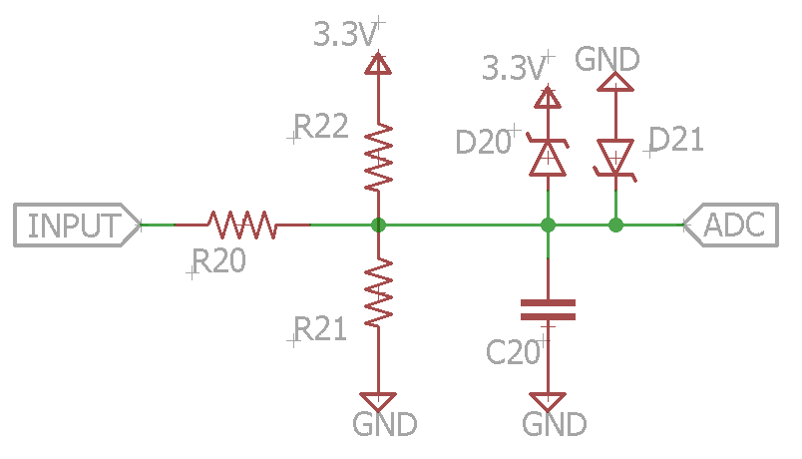

Figure 16: Voltage Measurement

A circuit for measuring high side current using a shunt resistor is shown in Figure 17. This circuit uses a 1NA21X which can amplify a voltage differential even when the common mode input voltage is outside of the supply rails. The 1NA21X comes in several versions, each with a different gain (gains range from 50 to 1000). The ref pin can be used to adjust the zero current output voltage (thus allowing both positive and negative currents to be measured. From the datasheet, the voltage is given as

|  |  |
| --- | --- |
| $$V_{ADC}=\left(I_{shunt}R_{shunt}\right)Gain+V_{ref}$$ | (13) |

The low-pass filter cutoff frequency is

|  |  |
| --- | --- |
| $$f_{0}=\frac{1}{2πR_{2}C_{2}}$$ | (14) |

According to the datasheet, a filter can also be placed on the inputs, although the extra series resistance on the inputs can increase errors. Therefore, we will keep the filter on the output. A filter can also be added at the *Input A* low side current measurement circuit is shown in Figure 18. This circuit uses a rail-to-rail op amp since the shunt voltage will remain close to ground. The op-amp is in a non-inverting configuration, so

|  |  |
| --- | --- |
| $$V_{ADC}=I_{shunt}R_{shunt}(1+\frac{R_{12}}{R_{11}})$$ | (15) |

The low-pass filter cutoff frequency is

|  |  |
| --- | --- |
| $$f_{0}=\frac{1}{2πR_{13}C_{11}}$$ | (16) |

The circuit is limited to measuring positive currents although a bidirectional version could be created. R3 is included as protection in case the voltage goes outside the supply rails. Note that for both devices, the protection diode is only required if the devices are attached to a supply rail higher than 3.3V.

On the PCB, the sense wires should be connected to the shunt resistor using a four-terminal scheme. This means that each shunt resistor pad should be split into two parts. One part will attach to the power line, and the other part will attach to the sense line. This is necessary because the shunt resistor will have a low value and the solder junction resistance will come to be significant relative to the resistor. This means that with higher current flow, the voltage drop as measured on power lines will be significantly larger than the voltage drop across the resistor itself. However, because the sense current is low, the voltage measured across the sense lines is approximately equal to the voltage across the resistor. Also, the sense lines need to be designed such that the area enclosed by the traces is small and such that the traces are not long (i.e. the IC needs to be close to the sense resistor. For the low side circuit, we only sense one side of the resistor. Therefore, there is no way to account for the junction resistance on the ground side with this circuit (we could use a more complex op amp circuit in a differential configuration).

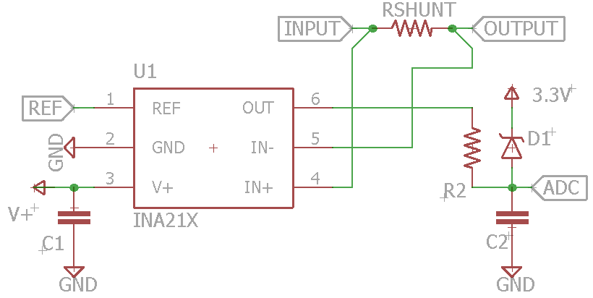

Figure 17: High Side Current Sense

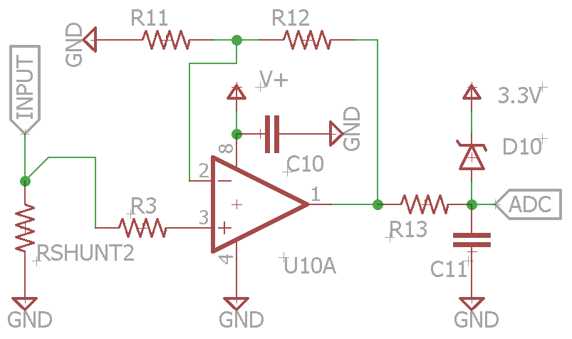

Figure 18: Low Side Current Sense

### Digital Implementation

The INA219 is a high-side current shunt that also provides means for power monitoring and allows for communication through I2C. It is capable of monitoring both shunt drop and supply voltage with programmability for configuring the conversion times, filtering, and calibration value for direct readouts in amperes. Internal current and voltage registers are capable of storing the values of current and voltage read from the source. An interesting feature of the INA219 IC is the fact that it internally contains a multiplier which takes inputs from the current register and the voltage register to calculate the power and store it in a power register.

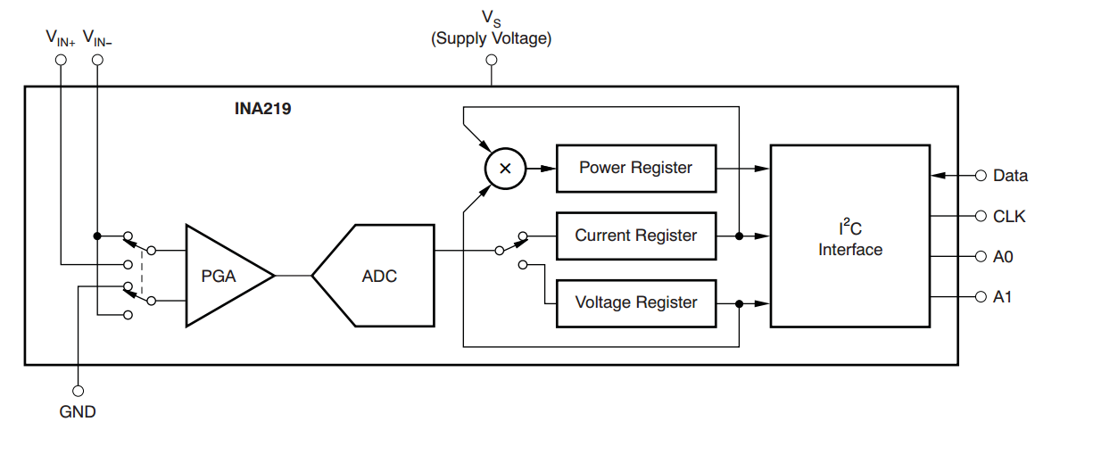

Figure 19: INA219 Internals [11]

A benefit to using INA219 to measure the current and voltage as opposed to using any other solution is the fact that it capable of being assigned a wide array of addresses unlike other IC available which only give four different addresses to select from.

## Temperature Measurement

The temperature will be measured using DS18B20 Digital Temperature Sensor which will be used to measure the temperature of the Fuel Cell to determine if adequate temperature conditions are met in order to initially and continuously close and open the solenoid valves which control the hydrogen input and outputs to the fuel cell unit. The DS18B20 communicates over a 1-Wire bus (DQ shown in Figure 20) which requires only one data line and common-ground for communicating with a central microprocessor unit. A 4.7kΩ resistor is used as a pull-up for the data-line/power-line.

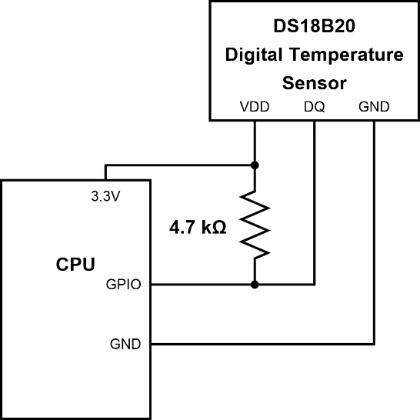

Figure 20: DS18B20 Connection to CPU

Based on the specification sheet for the model, it is capable of measuring temperature within the range of -55°C to +125°C with an accuracy of ±0.5°C within a range of -10°C to +85°C. It is also capable of “Parasite Power” that allows the temperature sensor to derive power directly from the data line. This adds the benefit of not requiring an external power supply unit for the temperature sensor. For our use case, the specification seems to be ideal as we do not expect the temperature of the fuel cell to exceed boiling point. However, this is based upon assumption at this point in the project and subject to change in the future. If temperatures of the fuel cell were to exceed +100°C during operation, it would result in changing the power supply of the temperature sensor to use external power supply instead of using “Parasite Power” from the 1-wire data bus since it may lead to the temperature sensor not being able to sustain communications as a result of higher leakage current that may exist. If the fuel cell were to reach temperatures over +100°C during operation, it would imply that there is a substantial amount of energy being lost through heat dissipation. In the context of our project, this scenario would be a non-ideal condition since it would also imply that a substantial amount of heat energy is not conserved during operation and the opportunity to reduce energy consumption will once again be lost.

The DS18B20 temperature sensor used for temperature measurement of the fuel cell stack is quite sophisticated despite its small size. The process required to send and receive data from the 1-wire bus of the temperature sensor involves several steps. Every time a data communication occurs between the temperature sensor and the master device, it begins with an “Initialization Sequence” (shown in Figure 21) which consists of the master device sending a “Reset Pulse” to the 1-wire bus and the temperature sensor responding with a “Presence Pulse” indicating that it is ready to operate. The “Initialization Sequence” begins by the master device pulling the 1-wire bus low for a minimum of 480 $µs$ to send the “Reset Pulse”, which is then followed by the DS18B20 responding with a “Presence Pulse” on the bus by waiting 15 $µs$ to 60 $µs$ and then pulling the 1-wire bus low for 60 $µs$ to 240 $µs$.

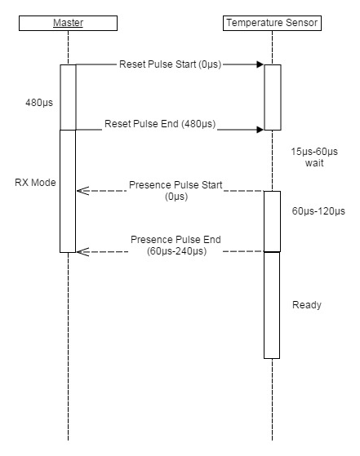

Figure 21: Initialization Sequence Diagram

Following the “Initialization Sequence”, the master device is able to read or writes data to the temperature sensor 1-bit at a time during read and write “time slots”. There are two types of “Write Time Slots”, a “write 1” time slot and a “write 0” time slot; “write 1” writes a logic 1 to DS18B20 while the “write 0” writes a logic 0 to a DS18B20. “write 1” is executed by the master device holding the 1-wire bus low for a maximum of 15 $µs$ before releasing, while the “write 0” is executed by the master device holding the 1-wire bus low for a minimum of 60 $µs$.

The temperature sensor has a 64-bit internal ROM (shown in Figure 22) which contains the device’s unique serial code which is used to uniquely identify the device in software to target messages to its 1-wire bus which is capable of being shared with other devices as well. Therefore, the first task of the microprocessor will be to identify the temperature sensor connected to its input port and retrieve its serial code.

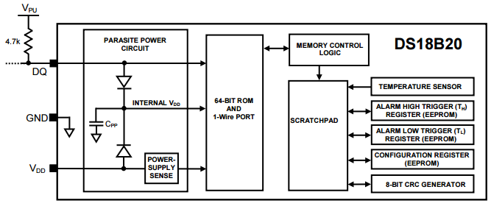

Figure 22: DS18B20 Internal ROM Structure (permission pending)

The DS18B20 temperature sensor has the feature of being user-configurable to 9, 10, 11 or 12-bit resolution thanks to its internal 1-byte configuration register located within its internal 2-byte “scratchpad memory” (shown in Figure 22). Therefore, the second objective the microprocessor will need to perform is to set the resolution of the temperature sensor to 9, 10, 11 or 12-bit resolution configuration. Despite the fact the “scratchpad memory” is EEPROM and therefore non-volatile, the resolution should be set anyways to verify that the temperature sensor will start operation in the same mode every time the device is powered on.

The third objective of the microprocessor will be to initiate a temperature measurement. To initiate the temperature measurement the master device (controlling device) will need to issue a “Convert T” command by sending 4416 (hexadecimal) or 10001002 (in binary) to the temperature sensor and then wait for a response from the temperature sensor. The response will be 0 while the temperature conversion is in progress and will be a 1 when the temperature conversion is finished. The converted temperature data will be stored internally within the temperature sensor’s 16-bit temperature register that is located within its “scratchpad memory” block. The 16-bit is a sign-extended two’s complement number where the sign-bit specifies whether the temperature is positive or negative; 0 for positive, 1 for negative.

It is also important to note that interpretation of data within the temperature register will need to differ based on the resolution the temperature sensor is configured to operate in. If configured for 12-bit resolution, all 16-bits in the temperature register will be valid data. For 11-bit resolution, bit-0 will be undefined. For 10-bit resolution, bit-0 and bit-1 will be undefined. For 9-bit resolution, bit-0, bit-1, and bit-2 will be undefined.

The final objective of the microprocessor will be to initiate a temperature read and read the data from the temperature register.

## I2C Communications

We will use an I2C bus for communication between the microcontrollers or any other devices. For the slave microcontrollers that we program, we will use a common messaging scheme. The interfacing will be accomplished through a series of application-specific registers. To avoid confusion, the read registers will be numbered 0x00 through 0x7F, and the write registers will be numbered 0x80 through 0xFF. The first data byte of a write operation will indicate the register number to write to. The subsequent data bytes will contain the data to be written into the register (there may be multiple bytes). A read operation will provide the data contained in register 1, followed by the data in register 2, and so on. When the last register is read, the data in register 1 will be read again, and the cycle will repeat. This scheme allows the master to read all statuses in one continuous read operation. If the master wants to read a particular register, it can write the desired register number into register 0x80, and then perform a read operation. The read operation data will start at the specified register number. For binary-valued registers, a value of 0x00 will represent low/false and any other value will represent high/true. The read and write message formats can be seen in Figure 23.



Figure 23: I2C Message Format

In addition to the I2C lines, there will be an alert line. This line will have a pull up resistor, and should be driven low with an open collector circuit when the slave wishes to send an alert to the master. A common alert bus may be used, or the master could receive separate alert signals from each slave. When an alert is received, the master can read register 0x00 from each slave. If a slave did not send an alert, this register will contain 0x00. Otherwise, an application-specific alter number will be provided. Once the register is read, the slave will clear the register.

## Power System

### Overview

The power system is responsible for performing the necessary DC-DC conversions and power routing. The architecture of the system can be seen in Figure 24. Our power system has two power sources which can be used to drive the car: the battery and the fuel cell. The power system will include a switch for selecting which source is the active source. It will also provide the following power outputs: 3.3V, 5V, and 12V. The power system will control the battery charging system, which may be included on the same board. Protection circuitry will be provided to protect the battery and fuel cell. While it is OK for many of the components to be powered off, it is essential that the microcontroller receive power at all times. Therefore, the microcontroller will be connected to several of the power sources.



Figure 24: Power System Architecture

### Modes of Operation

The power system must be flexible enough to run in several different modes. The modes are shown in Table 14 along with the configuration details. The first mode is an idle mode where the system is running off of battery power. In this mode, the main controller is active, but the car is not doing anything. In this mode, the fuel cell is not on, and thus the 12V bus will be powered off. The second mode is a battery powered driving mode. Like the idle mode, the battery is the main power source. However, in this mode, the 12V bus and all RC components are powered on. The third mode is a fuel cell powered driving mode. In this mode, the fuel cell, 12V bus, and all RC components are powered on. Since the battery is disconnected from the main bus, the charge circuit is enabled and charging the battery from the 12V bus. The fourth mode is an external charge mode in which the 12V bus is disabled, and the charge circuit is enabled to charge the battery from the external connector. The car will not be doing while in this mode. Note that during this time the microcontroller needs to use external power directly since there is no other power source available. The fifth and sixth modes are essentially like the drive modes, except the RC components are disabled.

|  |  |  |  |  |  |  |
| --- | --- | --- | --- | --- | --- | --- |
| Mode | 1 | 2 | 3 | 4 | 5 | 6 |
| Name | Idle | Battery Drive | Fuel Cell Drive | External Battery Charge | External Power from Battery | External Power from Fuel Cell |
| Main Bus Source | Battery | Battery | Fuel Cell | None | Battery | Fuel Cell |
| 12V Bus Enabled | No | Yes | Yes | No | Yes | Yes |
| Radio/Servo/ESC Enabled | No | Yes | Yes | No | No | No |
| Fuel Cell (valves and fan) | No | No | Yes | No | No | Yes |
| Battery Charge Source | None | None | Fuel Cell | External Power | None | None |
| Microcontroller Power Source | Battery | 12V Bus | 12V Bus | External Power | Battery | 12V Bus |

Table 14: Power System Modes of Operation

### I2C Communications

The board will be controlled and queried using the I2C bus. The power system will reside at I2C address 0x00 (7-bit addressing mode is assumed). The communication scheme described in section 0 will be used. The read registers can be seen in Table 15 and the write registers can be seen in Table 16.

|  |  |  |  |
| --- | --- | --- | --- |
| Reg. # | Description | Data Bytes | Values |
| 0x00 | Alert Status | 1 | 0x00 No alert  0x01 Fuel Cell Overcurrent  0x02 Battery overcurrent |
| 0x01 | Charger State | 1 | 0x00 None (off or fault)  0x01 Charging  0x02 Charge Complete |
| 0x02 | Battery Charge Current | 2 | 0A – 1A (10 bit) |
| 0x03 | Battery Temperature | 2 | TBD (10 bit) |
| 0x04 | Battery Discharge Current | 2 | 0A – 20A (10 bit) |
| 0x05 | External Power Source Connected | 1 | Binary |
| 0x06 | Fuel Cell Current | 2 | 0A – 10A (10 bit) |
| 0x07 | Power Switch Overcurrent | 1 | Binary |

Table 15: Power System I2C Read Registers

|  |  |  |  |
| --- | --- | --- | --- |
| Reg. # | Description | Data Bytes | Values |
| 0x80 | Read Register | 1 | Register # for next read |
| 0x81 | Select Source | 1 | 0x00 None  0x01 Battery  0x02 Fuel Cell |
| 0x82 | Enable 12V Boost | 1 | Binary |
| 0x83 | Enable Charger | 1 | Binary |
| 0x84 | Battery Current Limit | 2 | 0A – 20A (10 bit) |
| 0x85 | Fuel Cell Current Limit | 2 | 0A – 10A (10 bit) |

Table 16: Power System I2C Write Registers

### Power Source Selection

Our power system will require two sets of switches used for selecting power sources. The first set will select whether the battery or the fuel cell will power the main bus. This bus may pull a significant amount of current. The second set will determine whether the battery is charged from an external source or from the 12V bus. The charger bus will not pull as much current as the main bus, and so does not need to be as robust. The voltage and current requirements for the main bus switches are listed in Table 17.

|  |  |  |
| --- | --- | --- |
|  | Main Bus Switch | Battery Charge Switch |
| Maximum Voltage (forward and reverse) | 15V | 15V |
| Current | 10A nominal  15A peak | 1A nominal  1.5A peak |

Table 17: Switch Requirements

The main bus will need to remain active during the switching operation. When the fuel cell reaches stable operation, the main bus switch will need to select the fuel cell as the source. However, the 12V bus (which receives power from the main bus) needs to power the fuel cell fan and hydrogen valves, and so cannot be interrupted. For this reason, switching speed will be an important factor. Because there is a protection diode, we have the option of using a make-before-brake switching scheme. However, if the protection diode fails as a short circuit (some of the diodes may be passing high currents making them more likely to fail), then current can flow between the battery and fuel cell, so we would prefer to not connect both sources to the bus at the same time (or at least minimize the time that they are both connected).

We can use capacitors to allow the bus to continue to operate during the switch time. If we have a 1,000 µF capacitor, and the bus is pulling 1A, then the capacitor voltage would drop by 1V per microsecond. We can use this as a guideline when choosing a switch.

We have several options for the type of switch to use. The first main decision is whether to use a relay or a transistor based switch. If we choose a transistor based switched, there are even more options to choose from. There is a no clear winning strategy, and we will need to evaluate switches during the prototyping phase. A table of options is listed in Table 18.

|  |  |  |  |  |  |  |
| --- | --- | --- | --- | --- | --- | --- |
|  | Relay | N MOSFET | | P MOSFET | | Diodes |
|  |  | Single | Back-to-Back | Single | Back-to-Back |  |
| Control Current | 30 mA | Negligible | Negligible | Negligible | Negligible | N/A |
| On Resistance (m-ohms) | 75-100 | 3-20 | 6-40 | 4-75 | 8-150 | 0.7V Voltage Drop |
| Switch Time | 15ms | 250ns turn on  500ns off | 250ns turn on  500ns off | 50ns turn on  1700ns turn off | 50ns turn on  1700ns turn off | N/A |

Table 18: Power Source Selection Switch Options

The first option is a relay. The advantages to relays include physical isolation of the switched lines, and physical isolation between control and switched lines. However, the relay requires a high control current compared to MOSFETs, and is also slower. Also, the relays will probably take a little more space than power MOSFETs. Because relays generally have double-pole-double-throw contacts, we could use one signal. For the main bus, this would mean that when the relay is off the battery would be selected, and when the relay is on the fuel cell would be selected. This means that the main bus would always be connected to one source. If we want to disconnect both sources, then we could use two relays, although this would take more space (the current requirement would be about the same, since only one relay would be energized at a time). If we use a relay, we may need to use a capacitor/resistor combination to reduce arcing. We may also want to temporarily disable any high current devices (for example the ESC) during the switching so that less current is flowing through the relay. We could do this for a short period of time so that the user is minimally affected.

There are multiple possible transistor configurations. Because of the collector-emitter drop across a BJT, we will limit are choices to MOSFETs. Opto-couplers are another option, but research suggests that high current opto-couplers are beyond our budget. Major advantages of MOSFET switches including low switching current and high speed. However, semiconductors do not provide physical isolation of the switched circuits. MOSFETs allow current flow in both directions when turned on, but because of their body diode, they only block current in one direction when turned off. A way to avoid this is to connect the MOSFETs back-to-back so as to arrange the body diodes in opposite directions. However, this doubles the on resistance and takes more space. Because of the protection diode on the power sources, it would be possible to use a single MOSFET and rely on the protection diode, but as explained earlier, the diode could fail as a short. Therefore, it would be preferred to use a back-to-back configuration to provide an extra means of protection.

If we use a P-MOSFET, we could use a simple driver, where the microcontroller would control a BJT-resistor combination. However, the P-MOSFET transistor has a higher on resistance than an N-MOSFET. Therefore, to handle high currents, we may need to use P-MOSFETs in parallel. If we use an N-MOSFET, we will need a more complicated drive circuit to drive the gate of the N-MOSFET above the supply rail. To do this we can use a gate driver that incorporates a charge pump. An extra advantage to using a gate driver is that the switching will occur faster than with a BJT/resistor combination. Another option is to use an IC that incorporates an N-channel MOSFET. The Infineon BTS50055 would meet our current requirements and also includes a current measurement feature. However, it does not protect against reverse current. Note that for easier driving, we could put an N-MOSFET in the low-side ground path of the controlled circuit instead of the in the high-side. However, for the complex circuits that we will be using we will need direct connections to ground, so we will not consider this configuration.

A last option is to use put a diode in series with each power source. This provides a very simple circuit, and since we need reverse current protection diodes anyway, requires no extra components. The disadvantage of this option is that the source cannot be controlled. Whichever source has the higher voltage will be the “selected” supply. This may work for choosing a battery charge source, since the external power will only be connected when the battery needs to be charged.

#### Main Bus Switch Design

For the main bus switch, we will plan on using a PSMN1R2 N-MOSFET with a LTC1154 gate driver. Another leading candidate is the MAX1614, although we did not choose it because it is a little more expensive. These two drivers meet our voltage requirements, which is not the case for others we considered. The ICs are only available in surface mount packages, so we will need to use an adapter for prototyping. We also considered using a dual switch driver that is very similar to the LTC1154. However this chip is designed to run off one power source (the switch is for two loads), which will not work for our circuit. The MOSFET has a very low on resistance and also is cheaper fairly cheap. It meets our voltage requirements: it can withstand up to 30V drain-source, and is “optimized” for 4.5V gate drive (we assume driving with higher voltages will not hurt performance). The LTC1154 can drive the gate up to 25V above the source voltage, but none of the MOSFETs we considered could withstand a gate-source voltage of above 20V. Therefore we will need to use a Zener diode to limit the gate voltage – the gate drive pin has a high impedance and the “typical application” schematics include a 15V Zener diode, which we assume is used for voltage limiting purposes, although it is never discussed. The MOSFET comes in a surface mount package with larger leads, which makes it easier to solder. For prototyping, we can solder wires to the individual leads. Other MOSFETs are available at a lower cost but with a higher drain-source resistance. The IDP048N06L3 is the cheapest, and with its 4.8 mΩ drain source resistance, it still only drops 48mV at a current of 10A. We may consider using this or another MOSFETs.

The LTC1154 includes a current limit feature. RSENSE should be selected such that the voltage drop is 100mV at the maximum current. Note that at 1A current, this resistor would dissipate 0.1W. When the maximum current is exceeded, the switch will shut down, and the status pin will be pulled low (during normal operation the status pin is high impedance and will be pulled up). Once a shutdown occurs, the enable line needs to be toggled to re-enable the IC. The shutdown pin may be used to quickly shut the switch off (this performs a quicker shutdown then using the enable line. Note that there is a separate enable line that may be used, but we will not need it.

A schematic of the N-MOSFET driver circuit is shown in Figure 25. We will also experiment with a basic P-MOSFET circuit as shown in Figure 26. Note that we may have to use MOSFETs in parallel. Research suggests that we can put the MOSFETs in parallel without extra balancing resistors, but we would need to confirm this. While, our design uses back-to-back MOSFETs, we will also consider using a single MOSFET. We will also consider using a relay if we have trouble with the MOSFET circuits.

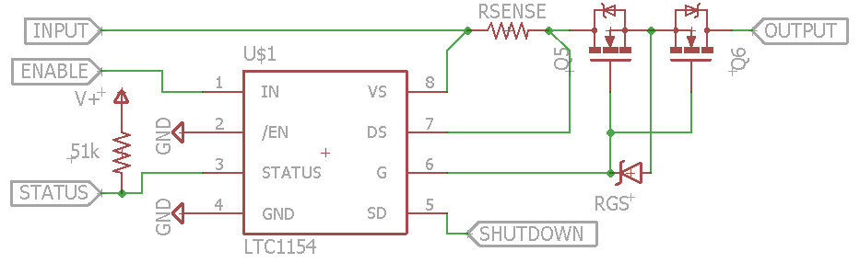

Figure 25: N-MOSFET Switch

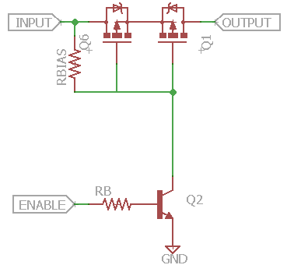

Figure 26: P-MOSFET Switch

We will need to measure the current that is being drawn from the main bus (and possibly the current being drawn from the fuel cell and the battery individually). In order to do this, we will use the high side current measurement circuit shown in Figure 17. We will use the INA213 IC which has a gain of 50 (the minimum available in the INA21X series).

#### Battery combined with Fuel Cell

A problem with using a PEM fuel cell as the main power of the RC car consists of two things. The first problem is pulse type, dynamic load change during acceleration would not be fulfilled. The second problem is regeneration of energy would not be fulfilled as PEM cell cannot change its current direction. To overcome these problems, the PEM fuel cell has to be extended with temporary energy storage. This storage can be battery or an ultracapacitor. In vehicles, combined energy source with battery or ultracapacitor is used most often. In a later section of this paper we will discuss regenerative breaking using an ultracapacitor. But for right now we will focus on using a battery to assist the fuel cell when accelerating. The battery charger will need to be turned off in order to draw current from the battery. We will need to investigate the length of time required between turning off the charger and discharging the battery.

A fuel cell combined with battery energy storage can be seen in Figure 27. A battery is connected to the output of the fuel cell with a DC/DC converter. The figure also shows a possible electric circuit for this DC/DC conversion (Buck-Boost). The circuit is similar if ultracapacitor is used instead of battery for secondary energy storing. With appropriate control we can reach that fuel cell works in optimal condition and with minimal fuel consumption during most of the normal operation, and battery takes the extra stress from pulse load change. Regeneration can be realized with combined energy source. About 40% fuel consumption saving can be reached with combined energy source and optimal load distribution. Economic operation in transient mode can be realized with correct control strategy.

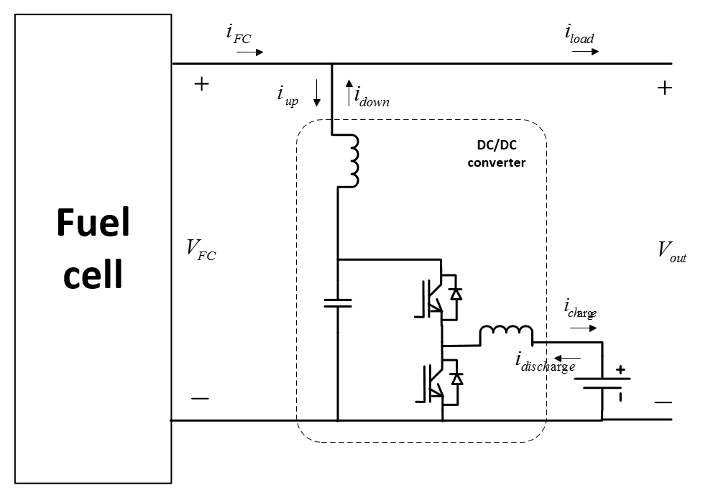

Figure 27: Fuel cell combined with battery energy storage (permission pending)

Load distribution between the fuel cell and battery can be controlled with the DC/DC converter. Operating states of the combined energy source are:

1. Steady state:  iload ≈ const. and iload ≈ iFC
2. During acceleration, when iload > iFC is required, battery can provide additional current, iload= iFC + idown
3. Purely battery operation is possible, for example during starting of the fuel cell or malfunction: iload = idown (iFC=0)
4. If load is lower than average iload < iFC, battery can be charged: iFC = iload + iup
5. Regeneration is possible during brake state of the vehicle: ibreak = iup (iFC=0)

The battery must be designed to bear current peaks higher than average and to store the resulting required energy. As battery can be with lower nominal power than total power required, it has to be protected with state of charge (SOC) control.

We are considering several other options for performing balancing. The voltages of the battery and fuel cell may differ significantly, which limits our options. One option would be to attach both the battery and fuel cell to the main bus at the same time via balancing resistors. However, this would be inefficient since the resistors would be dissipating power. This method also allows for limited control, since the current would be determined by the relative voltages of the battery and fuel cell. Another option would be to switch the sources on and off at a high speed using the switches that we have already designed. However, any bypass capacitors on the main bus will be charged up by the source with the higher voltage, thus not allowing the lower voltage source to provide any current. This issue could be resolved by adding an inductor in series with each source to provide a voltage drop - this would essentially turn the switching system into a buck converter. This approach would increase the complexity of the switching system. Also, in order for the converter to work properly, we would need a small voltage drop between the sources and the main bus, thus lowering the voltage of the main bus.

We could also piggyback on the existing switch circuit in the ESC. To do this we would include an extra transistor in our ESC’s H-bridge which would connect directly to the battery. This transistor would allow the battery to drive the motor in the forward direction. In order to reduce circuit size, we would only use one transistor, which would not allow balancing when driving in reverse. One transistor should be sufficient (as opposed to multiple parallel transistors) because the current draw would be limited in time. When the main bus is using the fuel cell, the ESC controller would need to monitor the instantaneous current going into the motor and determine whether the maximum power point of the fuel cell has been exceeded. If so, the controller would start pulling current from the battery during some cycles. An interleaved pattern would be best so as to maintain relatively constant current from each source. Because of the nature of the motor drive, having power sources at different voltages would not pose a problem. One disadvantage to this method is that current balancing would only be accomplished for the motor, but not for other components (such as the battery charger or valves). However, we anticipate that the motor will be the load that draws the largest current, so this approach may be sufficient (although not ideal). Also, this design would increase the coupling between the power system and the ESC, which we are trying to avoid. An extra wire would need to be run from the ESC to the power board, and the ESC software would need to be aware of the state of the system to determine when it could draw current from the battery (and likewise the main controller would need to know when the ESC is drawing current from the battery). We will plan on prototyping this method to determine its feasibility.

### Microcontroller Software

The software we plan on using for the microcontroller will be either Energia or Code Composer Studio. Everyone in the group has worked with Code Composer Studio before in our Embedded Systems course so we are all mostly familiar with the software. Energia is also a great option and is cross platform and supported on multiple devices. We will most likely use the LaunchPad as the platform for the MSP430.

Code Composer Studio is an integrated development environment (IDE) that supports all MSP microcontroller devices. Code Composer Studio comprises a suite of embedded software utilities used to develop and debug embedded applications. It includes an optimizing C/C++ compiler, source code editor, project build environment, debugger, profiler, and many other features. The intuitive IDE provides a single user interface. Code Composer Studio combines the advantages of the Eclipse software framework with advanced embedded debug capabilities from TI which is a compelling feature-rich development environment for embedded developers.

Energia is an open-source electronics prototyping platform started by Robert Wessels in January of 2012 with the goal to bring the Wiring and Arduino framework to the Texas Instruments MSP430 based LaunchPad. The Energia IDE is cross platform and supported on Mac OS, Windows, and Linux. Energia uses the mspgcc compiler and is based on the Wiring and Arduino framework. Energia includes an IDE that is based on Processing. It’s a portable framework layer so it can be used in other popular IDEs, such as Code Composer. Together with Energia, LaunchPad can be used to develop interactive objects, taking inputs from a variety of switches or sensors, and controlling a variety of lights, motors, and other physical outputs. Our project could either be stand-alone or can communicate with software running on our computer. Also we can add wireless modules to enable communication over various types of RF including Wi-Fi, NFC, Bluetooth, etc.

We are still unclear on which IDE we plan on using both Code Composer and Energia have features that are good for our project. The choice may come down to preference of who will do most of the coding. They both seem compatible with each other so at the end we don’t believe it will be an issue of which one we choose to go with. Since both products are Texas Instruments either one will work well with the MSP430.

Depending on the task the microcontroller will perform and considering the need for quicker response time, in order to reduce propagation time various libraries may be written in assembly. This will give us full control over the program and eliminate the possibility of higher level abstractions influencing compiled binaries due to optimization.

### Power Converters

A power supply is a type of electronic device that helps with providing electrical energy to a load.  There are two different topologies when dealing with converters.  A converter topology is how the elements in the converter are laid out. The two kinds of topologies are the transformer isolated and the non-transformer isolated.  Within these two topologies there are multiple topologies of implementation inside a power supply. The most prominent arrangements that could be realized inside a power supply are the step-up converter, step-down converter, step up and down converter and the Cuk converter. A big issue of dealing with electricity is that there tends to be spikes in power which can damage electronic devices. The simplest way to deal with these power spikes is to use a simple regulator. A voltage regulator is an electrical device that allows an input of unregulated voltage that spikes up and down over time and makes this spiking voltage into a constant voltage. The downside to doing this only with a regulator is that one is either trying to step up or step down the voltage which means that

Most power supplies act as regulators to be able to eliminate or decrease spikes in power. Power spikes can be caused by many different things including electrical devices that pull in a very high amount of electricity, weather conditions and faulty plugs.

#### Dc to Dc Buck Converter

A buck converter is a circuit designed to take in an input voltage and step down this voltage so that the average output voltage is lower. Buck converters can be used in many applications including digital still cameras, portable hard disk drives, mp3 players and mobile phones. Buck circuits operate under two modes, one of the modes is continuous mode and the other is discontinuous mode. This particular circuit is based off a Texas Instrument LM3671 chip. The circuit on Figure 28 is a buck converter which is able to deliver a constant voltage from a single lithium ion battery and its input voltage can range from a minimum of 2.7 volts to a maximum of 5.5 volts. The recommended base current varies from 0 to 600mA. This chip is equipped with automatic intelligent switching which allows the chip to switch from pulse width modulation to pulse frequency modulation allowing it to have a type of system control. This device operates in pulse width modulation mode with a load current of about 80mA or higher. The cause of a lighter load on there is that the device will automatically go into pulse frequency modulation which means that it will be consuming less current and a longer battery life. Some other things that this chip includes are undervoltage protection, current overload protection and thermal shutdown if the conditions are not as specified to operate. As part of our testing we were able to get a few measurements for the buck converter which is shown in Figure 29 and Figure 30. This shows the difference a resistor can make added to the output when implementing a buck converter.

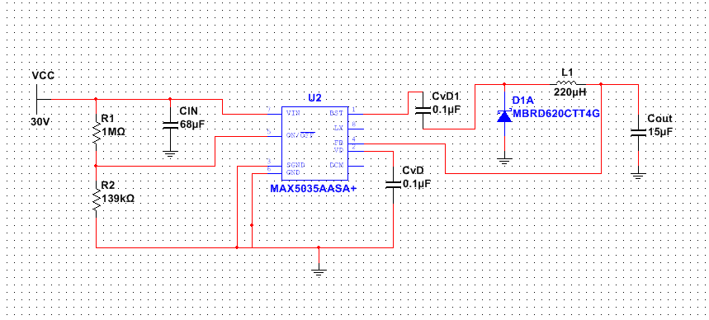

Figure 28 - Buck Converter

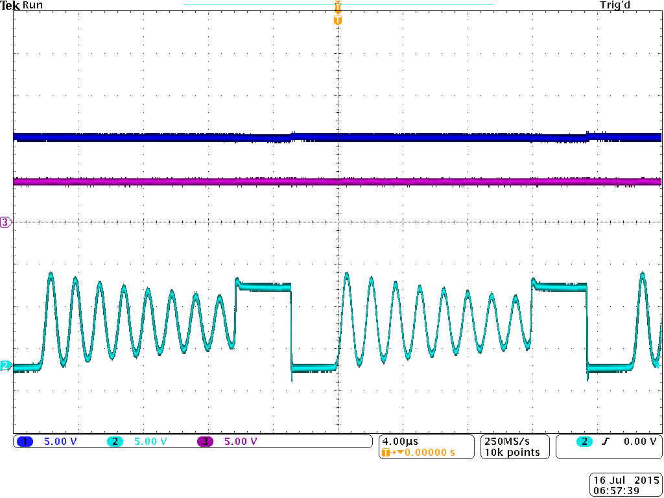

Figure 29 - Buck Converter With Load Resistor

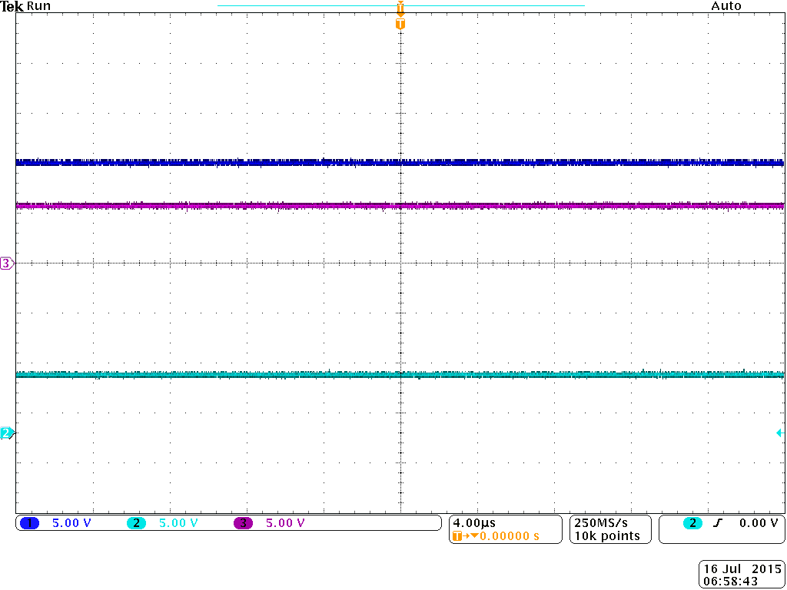

Figure 30 - Buck Converter Without Load Resistor

|  |  |  |  |  |  |  |
| --- | --- | --- | --- | --- | --- | --- |
| Name | Cost  ($) | Input Voltage (V) | Output Voltage (V) | Output Current  (A) | TJMax  (°C) | Efficiency  (%) |
| TPS65283 | 5.04 | 4.5 to 18 | 1.2 / 5 | 3.5/2.5 | 125 | Not given |
| MP1496 | 0.84 | 4.5 to 16 | 0.8V minimum adjustable | 2 | 150 | About 65% with external diode |
| TPS56x200 | 1.58 | 4.5 V to 17V | 0.76 V to 7 V | 2A/3A | 155 | Not given |

Table 19 - Buck Converter Chips

#### Dc to Dc Boost Converter

From the information that we have been able to acquire from the circuit that is already present on the radio controlled car we have drawn the conclusion that we will need to build a boost converter. The reasoning behind this is that there is a 9 volt battery on the system that powers a 12 volt fan and a valve that can range between 12 to 24 volts. This requires us to step up the voltage from the battery to be able to provide enough voltage to these components.  The other system of power in the remote controlled car comes from the fuel cell but the fuel cell is only able to produce between 6 volts and 10 volts which means that to power some of the components in the car we would still have to step up the voltage. From some pictures that were sent to us by Dr. Brooker we noted the fact that the radio controlled car already has a boost converter which strengthens our reasoning behind building this type of converter. So far we have implemented a boost converter in our efforts to understand how this circuits work. We implemented this circuit as part as our testing so far this semester but did not get great results as we were implementing a boost converter with a buck integrated chip.

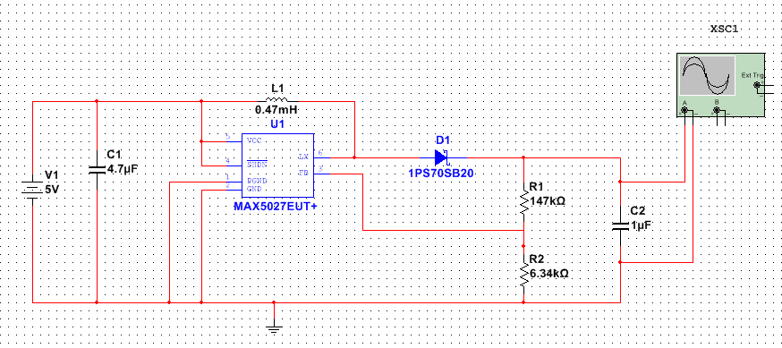

Figure 31: Boost Converter Simulation

For simulation purposes and wanting to get familiar on how boost converters work I built a circuit on Multisim.  This is a boost converter that outputs a constant voltage.  In our project we will need a similar boost converter but it would have to be adjustable. In getting familiar with designing a power supply we believed it was a good idea to use a way to design a power supply with some of the basic specifications. To do this we used Texas Instruments’ Webench and provided to this tool basic information about our circuit. Figure 32 is the circuit that we were able to obtain after the program did some calculations.

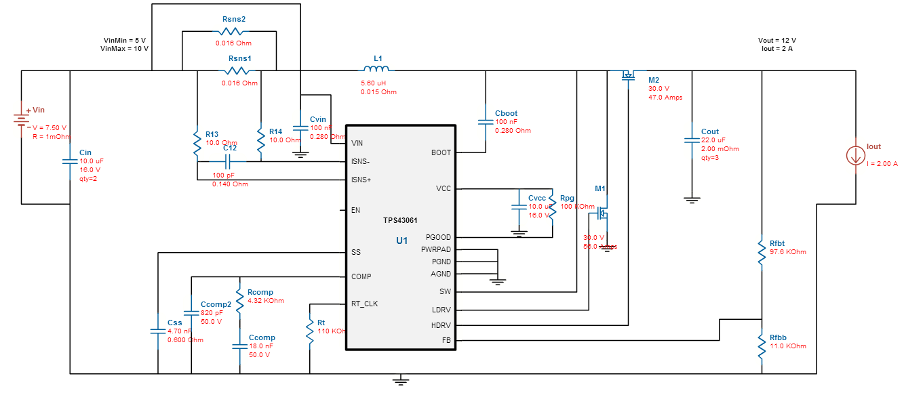

Figure 32: Circuit with TPS43061 boost converter

This boost converter is driven by a TPS43061 integrated chip. This chip is able to take in between 4.5V and 38V and the voltage output is a maximum of 58V. The maximum output current of this circuit is 2 A and it has a relative small quiescent current of 0.6A. This chip has an adjustable frequency which goes from 50kHz to 1MHz. This chip also has a cycle-by-cycle current limit and thermal shutdown which means that if the current goes past a certain predetermined point or the temperature surpasses a certain level the circuit will automatically shut down. This integrated chip is very affordable as it only costs about 4 dollars which is great as our team is trying to keep cost low.

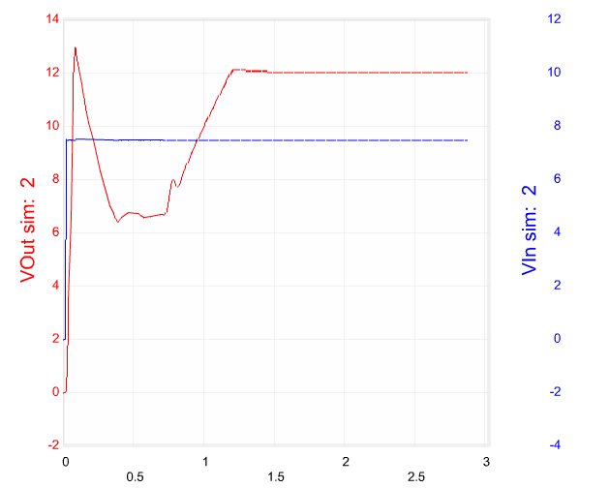

Figure 33: Input vs Output Voltage

This boost converter has the ability to know when it has surpassed its limits both with current as well as voltage. As seen on Figure 33 at time equals to 0.0000885seconds we see that the output voltage is higher than the expected output voltage this causes a ripple effect on the voltage as it wants to decrease as quickly as possible. Between time 0.0000885 and 0.000770250 seconds the output voltage drops significantly. Then after this the output voltage starts going up until it stabilizes at the output that is required of the converter. It takes about 0.0013 seconds for the system to stabilize itself. This means that during the initial process there is enough voltage to potentially damage a system that can only handle 12V as its maximum voltage. This is why running these tests is important since the designer does not want to damage the system they are working with and these tests give the designer a better understanding of what is going on with the system.

In Figure 34 one can see the efficiency percentages at various input voltages. It is surprising to see that the efficiency for this boost converter is extremely high and even in the worst case which is when the initial voltage is 5V and the output current is 2A the efficiency level is 94 percent. On the same figure one can also see the duty cycle percentage depending of two variables, the input voltage and the output current. Table 19 contains some boost converter chips that we are potentially looking at to buy to build our own power converter.

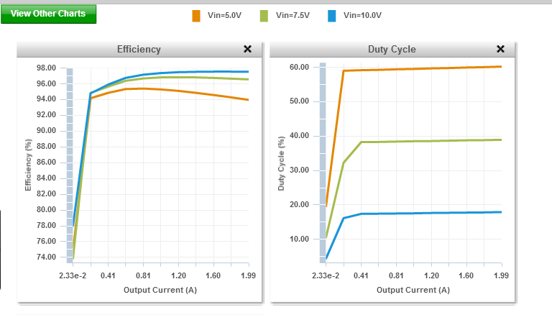

Figure 34: Duty Cycle and Efficiency

|  |  |  |  |  |  |  |
| --- | --- | --- | --- | --- | --- | --- |
| Name | Cost  ($) | Input Voltage (V) | Output Voltage (V) | Output Current  (A) | TJMax  (°C) | Efficiency  (%) |
| LM2577 | 11.88 | 3.5 to 40 | 11.6 to 12.4 | 3 | 150 | 80 |
| MAX608 | 4.25 | 1.8 to 16.5 | 3 to 16.5 | 1.5 | 150 | 87 |
| MAX669 | 6.15 | 1.8 to 28 | 3 to 28 | 6 | 150 | 94 |

Table 19: Boost Converter Chips

#### Dc to Dc Buck-Boost Converter

The Buck-Boost converter as pictured in Figure 35 is a converter that does both stepping up and stepping down of voltage. This converter combines both the boost and buck converter topologies into one. This means that Vout has an inverse polarity than that of the input voltage and the output has the ability to be higher or lower than Vin. The current that is seen by the input is not continuous and changes between zero and the current seen by the inductor. The current seen by the output is also not continuous and this is caused by the diode since the diode only allows current to flow through during one part of the cycle. C0 provides the current necessary for the case where the diode does not allow any current to flow through. The amount of the current being increased through the inductor can be calculated by rearranging the following formula.

|  |  |  |
| --- | --- | --- |
|  | $$V_{L}=L\frac{di_{L}}{dt}\underset{⇒}{}∆I_{L}=\frac{V_{L}}{L}∆T$$ | (17) |

When the inductor is doing work one can measure the increase of the current going through it by using the following formula. During the period where the inductor is on the current going through it is referred to as ripple current and during this time it is also when the capacitor is providing all of the output load current.

|  |  |  |
| --- | --- | --- |
|  | $$∆I_{L}\left(+\right)=-\frac{V_{I}-(V_{DS}+ I_{L}R_{L})}{L}T_{ON}$$ | (18) |

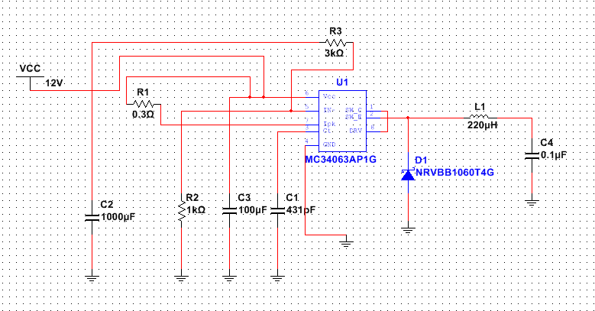

Figure 35: Buck-Boost Converter

For the time where the inductor is not working the discharge of the current can be measured by the following formula. We are planning to use a 7.4V lithium battery and there are some components of our circuit that use 5V and there are other components that use 12V. If we implement a buck-boost converter in our project all of these formulas will be useful to see how much current we are supplying to all the components in our circuit as well as finding out how efficient our power conversion is.

|  |  |  |
| --- | --- | --- |
|  | $$∆I_{L}\left(-\right)=-\frac{V_{O}-V_{d}-I_{L}R_{L}}{L}T_{OFF}$$ | (19) |

#### Dc to Ac Inverter

Performing an inversion of power from direct current to alternate current is a bit more challenging than building a basic step up or step down converter. There are two actions that must take place for this process to be accomplished. The first step that is needed to carry out this inversion is to convert the small DC voltage to a high voltage DC source. After this happens the DC source needs to be converted to an AC waveform. The way that this can be accomplished is through pulse width modulation. There are two different types of DC to AC inverters that they sell in stores and what makes them different is the output being generated.

The difference between the two outputs being generated can be seen in Figure 36, one of the outputs looks more like a DC output being modulated between a constant voltage and 0 and the other output is the sine wave most people are familiar with. The modified sine wave passes the high DC voltage for a period of time to allow the average power and rms voltage to be the same of a sine wave. They tend to be cheaper and therefore do not give good results when giving power to an inductive load. On the contrary, the output of a pure sine wave inverter in most cases is identical to the output coming out of an electrical outlet but in some cases one can get power that is a bit cleaner out of the pure sine wave inverter. The pure sine wave inverters also allow more sensible devices such as digital clocks, laser printers and medical equipment like in the case of a dialysis machine to draw the power needed to operate in optimum condition. Another simple advantage that pure sine wave inverters give is the ability to run inductive loads faster and without much noise compared to a modified sine wave device. One can also see in Figure 39 an oscillator circuit which is used to create a sine wave.

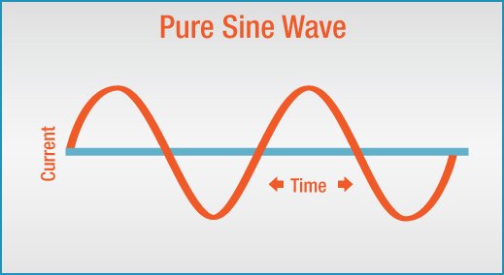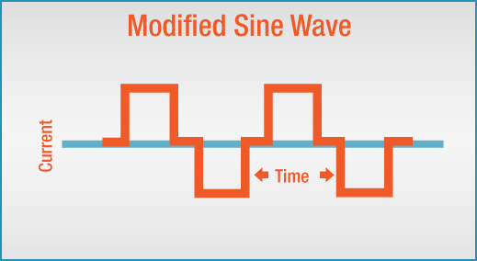

Figure 36: Sine Wave vs Modified Sine Wav

The focus of the Florida Solar Energy Center (FSEC) revolves around renewable energy and energy efficiency. One of the things that our team would like to do if time permits is to have a connection between the remote controlled car and a small house model that FSEC has available in their lab. This connection will be a power inverter which will take the direct current from the lithium battery on the car and will turn this into alternate current so that it could be used throughout the house. The idea behind doing this is so that FSEC will be able to take measurements in a small scale and be able to reproduce similar results once everything is scaled up. Adding this inverter to the project is an extra task to all the other features that our team will be adding to our project. If it is the case that our team is not able to build a power inverter from scratch due to time constraints then our team will buy a power inverter so that FSEC will still be able to run tests from the remote controlled car to the house. If that becomes the case we designed a Matlab simulation of a DC to AC converter in Figure 37. In Figure 38 is the output from the simulation. In the simulation it takes in a 10V input, which is about the amount we will receive from the fuel cell, and we are able to achieve an AC output of 12V.

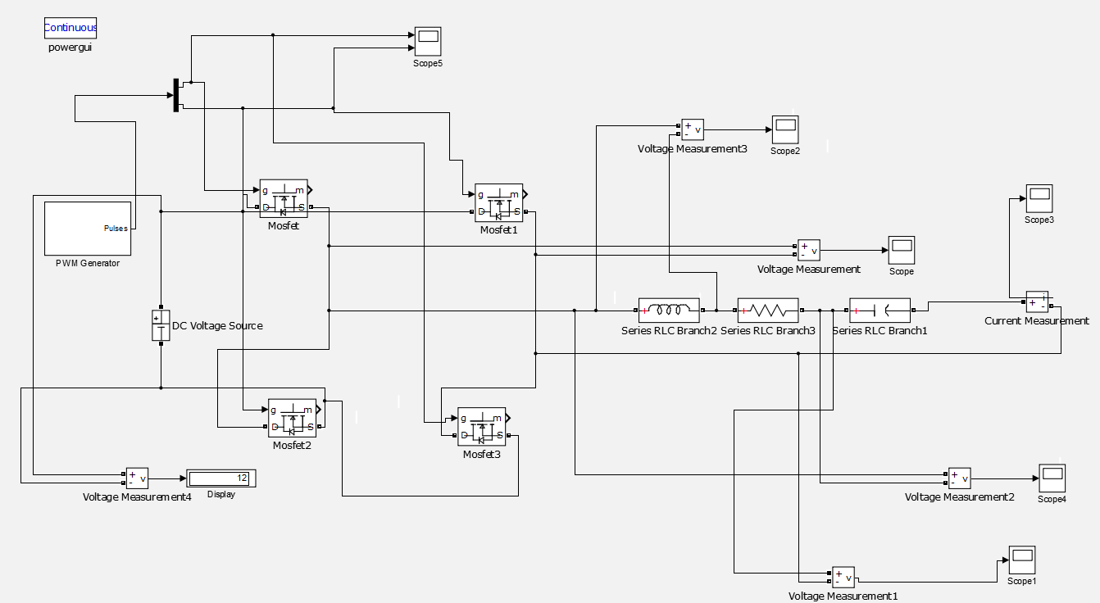

Figure 37: Matlab simulation of 12V DC to 12V AC

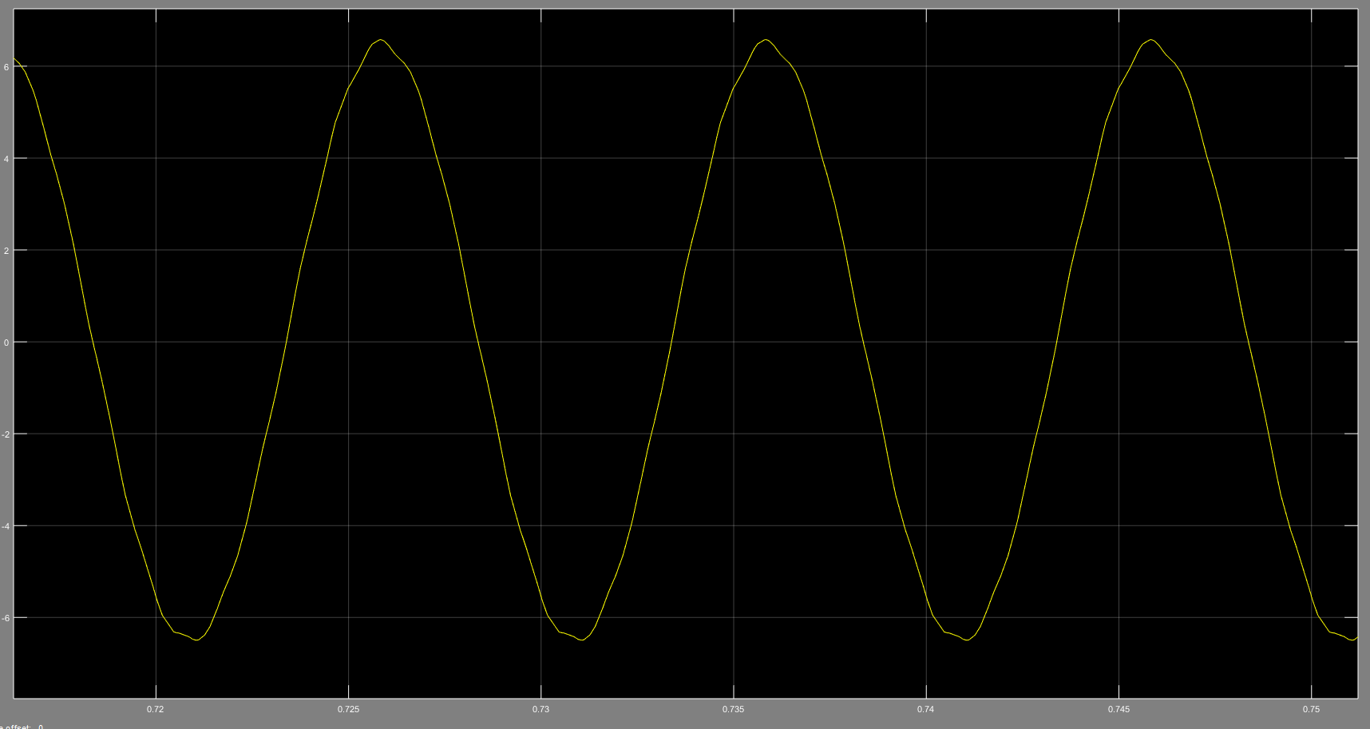

Figure 38: Output of Matlab simulation

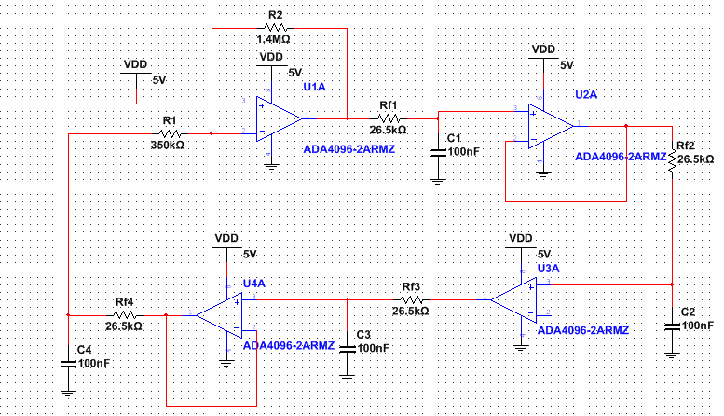

Figure 39: Oscillator Circuit

#### Cuk Converter

The Cuk converter is a converter that does both stepping up and stepping down of voltage. This topology is an extension of the boost-buckle converter. It is made up of the input and output stage. The way this converter works is that the voltage coming from Vin is fed to inductor L1, when the transistor is on the current going through the inductor builds the magnetic field of the inductor in the input phase. The diode that shares a node with CB and L2 is reversed biased causing energy to dissipate from the storage elements to the output phase. When the transistor is off, inductor L1 fights to maintain the current flowing through it by changing polarity and sourcing current as the magnetic field collapses. This in turn produces energy to supply to the output phase of the circuit through the capacitor between L1 and L2 . A Cuk converter has the same application as a buck-boost converter but the major difference that a Cuk converter has over the buck-boost converter is that the input and output inductors result in a filtered current on the left and right side of the converter while buck, boost and buck-boost converters have a pulsating current that happens on at least on one of the sides of the circuit. The pulsating current results in an increase in the ripple of the circuit and because of this the efficiency of the power source will be lowered. The layout of a Cuk converter can be seen in Figure 40 which was implemented using a LM2611A.

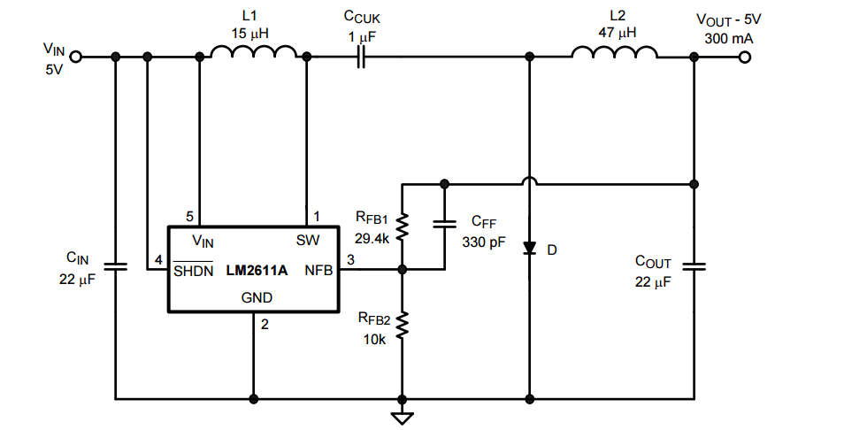

Figure 40: Cuk Converter (permission pending)

In Figure 41 is a Matlab simulation of a cuk converter. The current of input and output have very low ripple content. Also below in Figure 42 is the output voltage of the converter. It displays an output of roughly 19V from a 10V input. I don’t believe we will need such a great output for out=r load but just wanted to demonstrate that if needed we could get one.

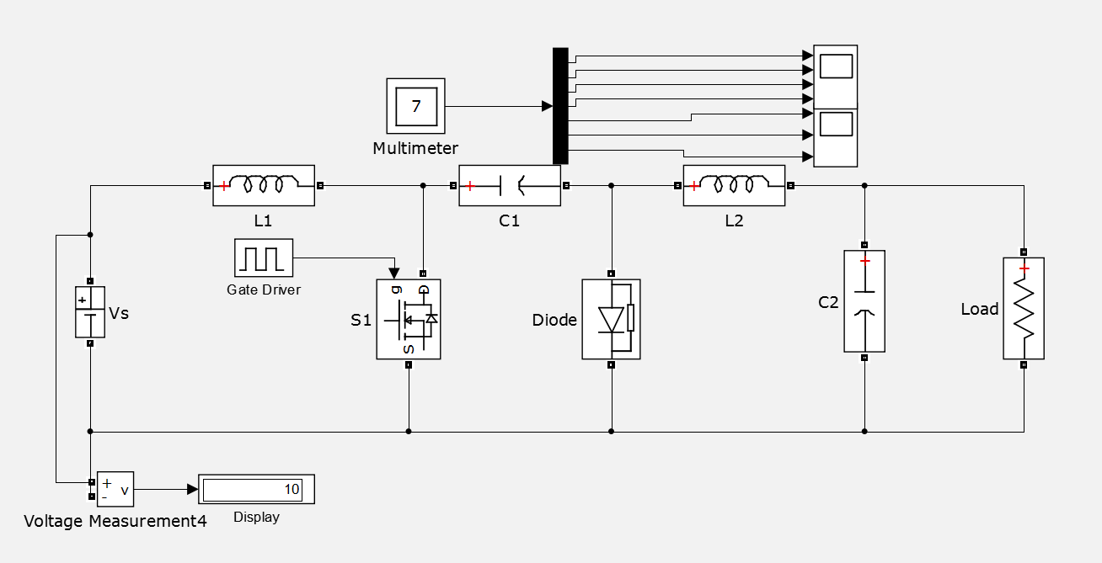

Figure 41: Matlab simulation of Cuk converter

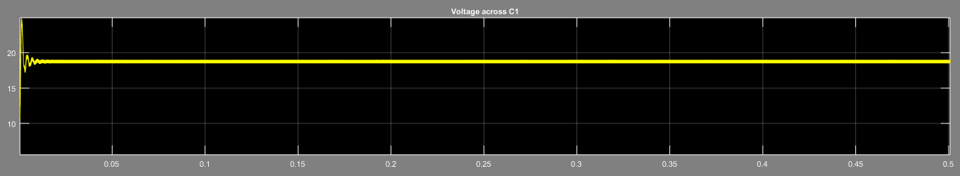

Figure 42: Output from matlab simulation of Cuk converter

Protection Circuit:

For the purpose of protecting our circuit and its components we are planning on building a layer on top of our electronics that protects for both voltage as well as circuit spikes and surges. The easiest way that we found this can be done is by adding a regular diode across an inductive load for cases when there is a small switching frequency voltage and using a Schottky diode when there is a need for higher switching frequency. Below are some of the diodes that we have looked into and could implement into our project.

|  |  |  |  |  |  |
| --- | --- | --- | --- | --- | --- |
| Name | Cost  ($) | Switching Speed (ns) | Breakdown Voltage (V) | Forward Voltage at 10 mA (V) | Total Capacitance |
| 1N4148 | 0.05 + SH | 4 | 75 at 500 mA | 1 at 10 mA | 4 pF at 1MHz |
| MMBD4448HW | 0.02 + SH | 4 | 80 at 250 mA | 0.855 at 10 mA | 3.5 pF at 1MHz |
| BAS16 | 0.19 + SH | 4 | 85 at 500 mA | 0.855 at 10 mA | 2 pF at 1MHz |

Table 20 - Regular Diodes

|  |  |  |  |  |  |
| --- | --- | --- | --- | --- | --- |
| Name | Cost  ($) | Continuous Forward Current (A) | Reverse Current (mA) | TJMax  (°C) | Efficiency  (%) |
| VT5202-M3 | $0.79 | 1.2 at 135˚C | 5 | 175 | High |
| MBR10100G | $1.04 | 10 at 135˚C | 6 | 175 | High |
| C4D05120A | $5.62 | 8 at 135˚C | 0.3 | 135 | High |
| CVFD20065A | $10.36 | 26 at 135˚C | 0.3 | 175 | High |

Table 21 - Schottky Diodes

Another thing that we have looked at as far as protecting the parts of our circuits that contain inductive loads is to build a snubber circuit. A snubber circuit is an auxiliary simple circuit that consists of a resistor and a capacitor. This snubber circuit is used to eliminate or reduce noise when using a switching regulator. One place where we can use this in our project is when we build the boost converter we can add it right in between the voltage coming in after passing through the MOSFET and the inductor.

#### Duty Cycle

Duty cycle is measured in a percentage which describes the amount of time a signal is high compared to the amount of time a signal is low. The period of a signal can vary between a couple of seconds, a minute or maybe even an hour. Since the duty cycle is a ratio of the amount of time a signal is on compared to the amount of time a signal is off one has to make sure that these are being measured the same way and have the same units. When talking about direct current the voltage is considered to be high when it is at a constant value greater than zero and low when the voltage is zero. For example if the voltage is high at 10V for half the time and then it is low at 0V then this is considered to be a 50% duty cycle.

The duty cycle is important because the more a component is used in a circuit the sooner it will deteriorate. This means that if a component has a life expectancy of 300 hours and has a duty cycle of 25 percent then this component will only last 150 hours under a 50 percent duty cycle. As our team chooses what elements will be used in our project we have to keep in mind to choose elements that have lower duty cycles so that elements will last longer which will save us money in the long run.

#### Pulse Width Modulation (PWM)

Linear voltage regulators tend to create a substantial amount of heat since they are mainly used to step down voltage. The stepping down of voltage from the input to the output means that there is a loss of power and that only leaves one place where that extra power could go. The power is absorbed by the linear voltage regulator and this means that the more the voltage drops between the input and output the more heat is absorbed in the regulator. Power can only be lost during the transition which is when a switching device is neither on nor off. The reason behind this is that power is equal to the voltage multiplied by the square of the current. If the voltage or the current are near zero then there is barely enough power. By changing the pulse width we affect the duty cycle which in turn also affects the average voltage seen by the circuit. Pulse width modulation is a way to be able to create an analog signal utilizing a digital source. The other part that makes up PWM it is the frequency. What the frequency is able to determine is how fast a cycle is accomplished which means a change between a high and a low in the duty cycle and is measured in Hertz. By switching a signal on and off at a quick enough rate and with a specific duty cycle the output will seem like a lower constant voltage. An example of using pulse width modulation with a varied duty cycle is to create a 4V signal given a direct current of 10V a duty cycle of 40% would be needed. If the high voltage signal is toggled fast enough between the on and off position the average voltage of the toggle is seen as the output voltage.

#### Pulse Frequency Modulation (PFM)

Pulse Frequency Modulation provides a different technique of regulating the output of a switching converter. This technique is different from pulse width modulation in that instead of varying the duty cycle to regulate the output voltage the wave frequency is the one that changes. This type of modulation provides a better way to deal with noise in the system than other types of modulations. Some of the advantages that pulse frequency modulators include are that they are simple to build and better low-power conversion. As there are advantages to this technique there are also some drawbacks. The first drawback that this topology has is the fact that it is easier to filter a circuit with a fixed-frequency than one with a frequency that operates under multiple frequencies. The next flaw that it has is that it leads to a higher ripple voltage at the output that can cause damage to devices connected. Lastly at very low frequencies the transient response time of the converter may cause slow responses.

The main reason why DC to DC converters are widely used is because they provide efficient regulation over a multitude of input voltages and output current which is not provided by a linear regulator. It is crucial to understand the different losses a switching regulator can experience to be able to choose a regulator that fits our needs. One of the losses is caused by the loss generated from charging and discharging the MOSFET gate capacitance, this happens most when a transistor is working at a large frequency. This loss occurs when the current is flowing through the drain-source of the MOSFET when the differential voltage across these is large. Another loss has to do with the efficiency of voltage converters since voltage converters are pretty efficient at handling bigger loads but inefficient at lower ones. The reason for this is the internal oscillator as well as the drive circuits for a pulse width modulation controller. There are some losses that affect pulse width modulators and others that affect frequency pulse modulators. A solution to this is to get a dual-mode modulator that changes between pulse width modulation and pulse frequency modulation at a specific current so that efficiency can be enhanced for lower loads. This is the route that our team is going to take since there is already a modulator in the remote controlled car that does both pulse width and pulse frequency modulation which indicates that there are times when we can benefit from the pulse width modulator but when the current is low we will be able to switch to pulse frequency modulation.

### Advantages and Disadvantages of Switching Regulators

One of the advantages that a switching regulator has over a linear regulator is the ability to dissipate power more efficiently which in turn reduces the heat in the system and helps batteries have a longer live. As the years go by and technology keeps improving manufacturers have been able to increment the frequency for switching regulators from a few hundred kilohertz to a couple of megahertz. Being able to work at higher frequencies is a good thing since it allows people that build circuits the ability to use smaller components, which in turn decreases the size of the circuit board. A negative aspect of high switching frequency devices is that they do not perform well when compared to lower switching frequency devices and therefore force whoever is using them to make a choice between size and cost or a longer battery life.

Linear regulators are very simple to implement but have some drawbacks. One drawback is that the efficiency of the linear regulator declines greatly as the difference between the output and the input voltage increase. The other drawback is that linear regulators are only able to step down voltage which is a small section of what converters and inverters are capable of doing. These limitations are what have made switching regulators very famous among the world of electronics.

Switching regulators on the other hand are able to step up, step down and invert voltages which covers the need of most electronics projects. They also provide really high efficiency which can range from 80 percent to upper 90’s. One disadvantage that switching regulators have are that they are very complex and require a lot of effort to implement. Another downside of switching regulators is that most of them use pulse width modulation and because of this as frequency increases so do switching losses. This happens because every time a switch happens, regulator MOSFETs incur losses. The more switches there are the more losses the MOSFET incurs. Another problem is that losses tend to be higher the higher the input voltage is. What having all these losses mean is that there is a limit on the switching frequency that a converter is able to have before losses become too great. Our team has experienced firsthand the difficulties that come when dealing with a switching regulator as we have implemented both a boost and a buck converter as part of our testing and have found that the boost converter was a lot harder to implement that the buck converter was. Table 22 which was acquired from Digikey explains more in detail the differences between these two regulators and points out some key factors on how to choose between a linear regulator and a switching regulator.

|  |  |  |
| --- | --- | --- |
|  | Linear | Switching |
| Function | Only steps down (buck) so input voltage must be greater than output voltage | Step up (boost), step down (buck), inverts |
| Efficiency | Low to medium, but actual battery life depends on load current and battery voltage over time. Efficiency is high if difference between input and output voltages is small | High, except at very low load currents (μA), where switch-mode quiescent current (IQ) is usually higher |
| Waste Heat | High, if average load and/or input to output voltage difference are high | Low, as components usually run cool for power levels below 10 W |
| Complexity | Low, usually requiring only the regulator and low-value bypass capacitors | Medium to high, usually requiring inductor, diode, and filter caps in addition to the IC; for high-power circuits, external FETs are needed |
| Size | Small to medium in portable designs, but may be larger if heat sinking is needed | Larger than linear at low power, but smaller at power levels for which linear requires a heat sink |
| Total Cost | Low | Medium to high, largely due to external components |
| Ripple/Noise | Low; no ripple, low noise, better noise rejection | Medium to high, due to ripple at switching rate |

Table 22 - Switching Regulators vs Linear Regulators

There is a solution to all of these losses and it is to use a zero-voltage switching device. These devices are not affected the same way regular switching devices are and are able to work at higher frequencies. This not only improves the performance but it reduces the external components of the circuit even more. Zero voltage switching devices use what is called soft switching, which is a technique to improve a switching regulator’s efficiency. When using soft switching the voltage reaches zero before the MOSFET is turned off or on, this helps eliminate overlaps between voltage and current and losses are minimized. A graphical representation of the voltage reaching zero before the MOSFET is turned on again can be seen in Figure 44.This method can also be used when one wants to switch the MOSFET once the current reaches zero instead of the voltage. An advantage that comes with being able to switch smoothly is that electromagnetic interference is reduced.

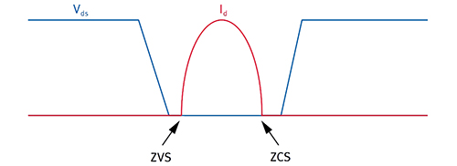

Figure 44 - Zero Voltage Switching (permission pending)

### Microcontroller

Selecting the proper microcontroller for our application was one of the critical decisions which could possibly control the success or failure of our project. There were numerous criteria we considered when choosing a microcontroller. The main goal is to select the least expensive microcontroller that minimizes the overall cost of the system while still fulfilling the system specification. We started off by asking ourselves “What does the microcontroller need to do in our system?” To answer that question we created 25 below to know exactly what we needed from our power system microcontroller.

|  |  |  |
| --- | --- | --- |
| Description | Dir. | Comments |
| Select Battery | Out | Active high |
| Battery Switch Overcurrent | In | Active low |
| Select Fuel Cell | Out | Active high |
| Fuel Cell Switch Overcurrent |  | Active low |
| Enable Charger | Out | Active high |
| Charge Status | In | High for charging, Low for done |
| Enable Boost Converter (for 12V Bus) | Out | Active high |
| Battery Voltage | In | Analog |
| Charge Current | In | Analog |
| Battery Output Current | In | Analog |
| Fuel Cell Output Current | In | Analog |
| Fuel Cell Voltage | In | Analog |
| Battery Voltage | In | Analog |
| Battery Temperature | In | Analog |

Table 23: Power System MCU I/O

The second step was to conduct a search for microcontrollers which meet all of the system requirements. It involved searching the internet, datasheets, and some technical trade journals. We focused our search on a preferred single-chip solution for cost as well as reliability reasons. After reviewing many microcontrollers the next step was to narrow it down to which we were going to use. The last step had several parts, all of which we attempted to reduce the list of acceptable microcontrollers to a single chip choice. These parts included pricing, availability, development tools, manufacturer support, and stability. The entire process was iterated a few times to arrive at an optimum decision.

After all these steps we decided to go with the MSP430. The MSP430 had everything we were looking for in a microprocessor. We are able to do everything we need in a single-chip. It had the required amount of I/O pins/ports we need. We were also looking for a microprocessor with enough memory both RAM and flash as well as an analog to digital converter (ADC), the MSP430 met all our requirements. Its CPU core has the power to handle the system requirements for the implementation language. Another factor in our decision was the fact that everyone in our group were comfortable with using the MSP430 due to the face that we have previously work with them in our Embedded Systems course. Along with there being the launch pad available to program the microcontroller easily with our computers.

The Texas Instruments MSP430 is an ultra-low-power microcontroller that consists of five low-power modes, is optimized to achieve extended battery life in portable measurement applications. The device features a powerful 16-bit RISC CPU, 16-bit registers, and constant generators that contribute to maximum code efficiency. The digitally controlled oscillator (DCO) allows wake-up from low-power modes to active mode in less than 1 µs. They are mixed signal microcontrollers with built-in 16- bit timers, up to 24 I/O capacitive-touch enabled pins, a versatile analog comparator, and built-in communication capability using the universal serial communication interface. Refer to Figure 45 for a functional block diagram. In addition the MSP430 has a 10-bit ADC [12]. T shows a few of its parametric from its datasheet.

|  |  |
| --- | --- |
|  | MSP430G2553 |
| Frequency (MHz) | 16 |
| Non-volatile Memory (KB) | 16 |
| SRAM (kB) | 0.5 |
| GPIO General-purpose input/output (GPIO) | 24 |
| Inter-Integrated Circuit (I2C) | 1 |
| Serial Peripheral Interface (SPI) | 1 |
| universal asynchronous receiver/transmitter (UART) | 1 |
| ADC | ADC10-8ch |
| Comparators | 8 |
| Timers - 16-bit | 2 |
| BSL | UART |
| Min VCC | 1.8 |
| Max VCC | 3.6 |
| Active Power (uA/MHz) | 330 |
| Standby Power (LPM3-uA) | 0.7 |
| Wakeup Time (us) | 1.5 |
| Additional Features | Watchdog  Temp Sensor  Brown Out Reset  IrDA |
| Special I/O | Capacitive Touch I/O |
| Operating Temperature Range (C) | -40 to 85 |

Table 24: MSP430 Parametric

In conclusion, selecting the right microcontroller for our project was not an easy decision, as microcontrollers have been more complex devices since on-chip resources were added. Since the trend is toward more on-chip integration of off-chip resources to reduce system costs, the decision was very complex.

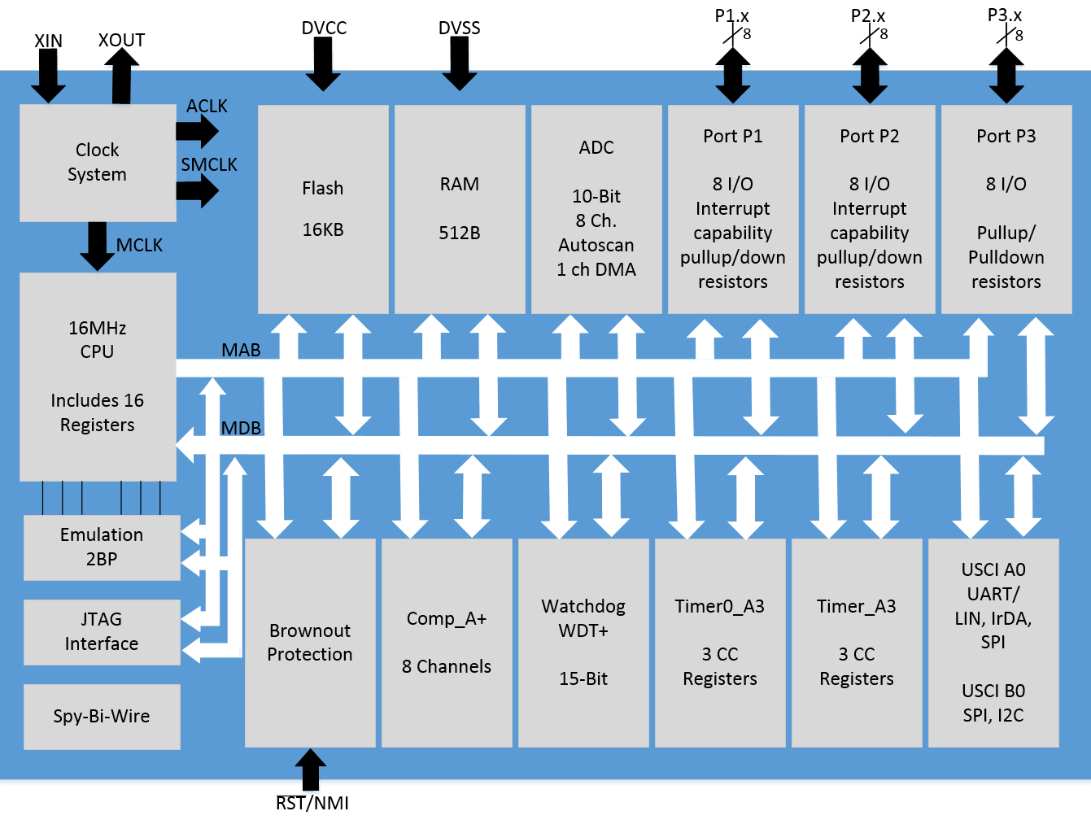

Figure 45: Functional Block Diagram

### Microcontroller Interface

Information is sent and received by the MSP430 through a set of ports. Each port can have up to 8 pins and each port is named with a capital P followed by a number starting with one. Most pins can be configured to be either input or output with some inputs having the ability to raise interrupts if the voltage changes across it. This microcontroller uses memory-mapped technology which allows the CPU to treat ports as registers. These ports which can now be treated as registers are treated the same way a register in RAM would be treated meaning that they can be read, written and modified. The maximum pins a port can have are 8, each pin has its own job and they are as follows.

Not all ports have 8 pins but for the ports that do an explanation of what each port does will follow. The PxIN port returns the logical values on the inputs if they are set for digital input and output. This register can only be used to read and also happens to be volatile which means that it may change at any time. This register is used to be able to react to its surroundings and perform a certain action when something outside of the system happens such as getting input from a keyboard. As far as the PxOUT port goes it takes care of writing to a pin if it happens to be configured as an output. If it is not configured to be an output then the value will be stored in a buffer and will only appear in the pin later and only if it is changed to be an output. The port PxDIR in which DIR stands for direction is a simple to understand port. If this port is given a value of 0 then it will act as input and if given a value of 1 then it will be an output. The PxREN pin is set to 1 to activate a pull-up or pull-down resistor on a pin. The PxSEL pin is used to select between input and output depending if the pin trying to be selected happens to be an input or output. If trying to select a special function then there might be other registers needed depending on how complicated the specific function is. The interrupt enable pin enables the interrupts when the value on an input pin is changed. Interrupts are enabled when the bit is set to 1 in this register and off otherwise, having interrupts off as a default. Every input or output pin has a PxIFG interrupt flag. This flag is turned on when the PxIE and the GIE are set and once is on it must be turned off by the software. Transitions are the only event that turns on the interrupt flag. Since the turning on and off of this flag must happen in the software side it provides the ability to have software initiated interrupts making the FxIFG an extremely useful flag.

There is a mechanism that protects the MSP430 from software failure called watchdog timer. The watchdog timer counts up and resets the MSP430 when it reaches its limit protecting the hardware from a bug in the code such as an infinite loop. Since the MSP430 will be reset after the watchdog timer reaches a certain point it is important for the user to continuously clear the counter before the limit on the timer is reached. The watchdog timer can be controlled by using a bit register called WDTCTL. This register has a security system so that it won’t accidentally be reset and therefore requires a password in the upper byte of the register. If the wrong password is passed to WDTCTL it will automatically reset and it can be done intentionally to wipe out any software that the chip had stored. The lower byte of WDTCTL has the command to be executed and it is important not to forget about it when giving a task to the watchdog.

To be able to understand better what can be done with the MSP430 there needs to be an understanding of some basic instructions. As seen on Figure 46 there are 27 instructions that were made custom for the MSP430 and there are another 24 instructions that are provided to facilitate the job of the programmer. Following is a short list of some of the most important instructions used in the MSP430.

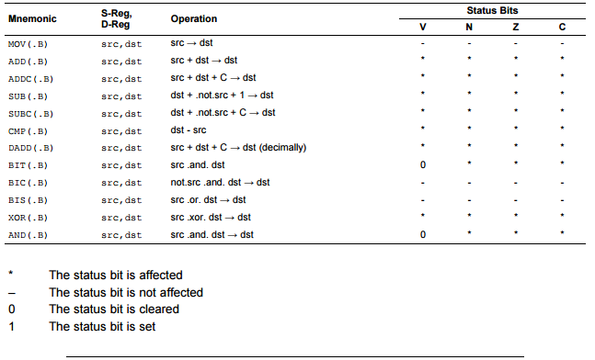

Figure 46 - Instruction Set MSP430 (permission pending)

### Universal Asynchronous Receiver/Transmitter (UART)

UART is a circuit whose job is to carry out serial communication. UART is able to provide communication between parallel and serial interfaces. There are two sides to UART, one of the sides containing data lines and control pins and the other side has two serial wires with the names RX and TX. On the transmit side of the UART is where data packets are created, when these packets are created some bits must be appended to each packet and these are the sync and parity bits. The packets created by the UART are sent with precise timing using whatever baud rate was specified. On the receiving end of the UART the baud rate has to be considered again as it is this rate that dictates how often the UART is going to sample the receiving line. Advance UARTs have a buffer which allows for storage of data until the microcontroller is ready to process this data. The method used to release data from the receiving buffer is FIFO and means that whatever data arrived first will be processed first. When talking between two devices it is really important to make sure that both of them are running on the same baud rate as if they are not there is a great chance for misinterpreted data or even garbage data.

### Serial Peripheral Interface (SPI)

Serial Peripheral Interface is used to send data between the microcontroller and other devices such as registers, secure digital cards, and different types of sensors. Since it can talk to different devices there has to be a way to choose which device it is talking to at that one time. The way that it chooses which device it is talking to at that moment in time is by using separate clocks and data lines along with a select line. SPI is a type of synchronous communication.

There are many protocols for communication but they mainly fall under two categories which are synchronous and asynchronous communication. Asynchronous communication does not guarantee when data is sent and that both sides of the communication will be running at the same rate. Computers are driven by one clock and problems can occur when two different systems with different clocks try to communicate. What asynchronous communication does to solve this problem is that it adds additional start and stop bits to each byte and this is done with the sole purpose of allowing the receiver to sync up data as it arrives. Another thing that needs to take place before communication can be established between two parties is to agree on a transmission speed. Having two different clocks is now not that big of a deal since the receiver is adding those extra bits at the start of each byte. Asynchronous communication works well but it has a lot of overhead since it has to add all those extra bits to the start and the end of every byte. Synchronous communication is a better solution. The way that SPI works is that it uses individual lines for data transfer and one clock that keeps everything in sync which is usually called CLK for clock or SCK for Serial Clock. This clock contains an oscillating signal that tells the receiving party when to acquire data from the data line. The acquisition of data can either happen in the rising or falling edge of the clock signal. In SPI there is only one clock signal and it is generated by the master. The receiving end is called the slave. The way that communication works between the master and the slave is as follows. When the master sends data to the slave this data will be sent through a specific data line called MOSI which stands for Master Out / Slave In. In case that the slave needs to communicate with the master, the master will continue about its job just as before and the data will be put in another data line called MISO which stands for Master In / Slave out. The master needs to know when a slave is trying to communicate and how much data is it trying to communicate as if it samples at the wrong time it will receive garbage data. The last line used by SPI is called Slave Select (SS). The SS line is used for telling the slave when it should be awake to receive or send data as well as to select one slave if there is more than one slave present. Figure 47 shows what would it look like to use SPI to receive data.

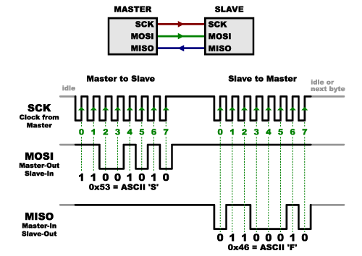

Figure 47 - Serial Peripheral Interface: Receiving Data (permission pending)

This type of communication topology is mainly used when receiving data from sensors. It uses high speed signals and because of this reason it should only be used to send data over short distances. If there is need to send data more than a couple of feet it is recommended to send this data at lower clock speeds and to consider utilizing a special driver chip. The advantages of SPI include that it’s faster than asynchronous serial communication, the hardware used to receive data is simple and the advantage of being able to use more than one slave. Some of the disadvantages of using SPI are that it requires a larger number of pins than other methods of communication, communications have to be defined before they take place, all communications must be initiated by the master and each slave requires a separate line. There are slight variations of this communication topology including one called SPI Full Duplex. This type of SPI has separate send and receive lines which means that one is able to receive and transmit data at the same time.

### Inter-integrated Circuit (I2C)

When using SPI connecting a master to a slave requires four lines for each data line. In top of that for every slave that is added an additional chip select pin is required. This mess of a set up makes SPI undesirable when having to connect many slaves to a master. One thing this communication has an advantage over SPI is that it allows the utilization of more than one master. This communication protocol also allows for multiple slaves to communicate with one or more master chips. I2C is meant for short distance communication just like SPI and only requires two wires to exchange information. The simplicity of design that comes with I2C is one of its most important features. There are only two wires needed to support I2C the same as asynchronous communication but with the advantage of being able to have many more slave devices up to 1008 to be exact. Even though the master devices are not allowed to talk to each other each master is able to take turns communicating with as many slaves as it wants. There is one down side to this protocol and it is the rate at which information is transferred greatly decreases. Data is now sent at a rate of 100 kHz to 400 kHz which is significantly slower than SPI. There is also some overhead with I2C, for every 8 bits of data that is sent there has to be an additional bit of metadata added to the packet being transmitted. As seen on Figure 48, there are two signals that make up I2C, these are the SCL which is the clock signal and the SDA which happens to be the data signal. The clock signal is generated by whichever master is selected at the time. Slave devices are able to have some control over the clock of the master so that they can force it to not send more data out for that cycle. This is known as clock stretching and even though it is mainly used by the slaves any clock signal can be stretched.

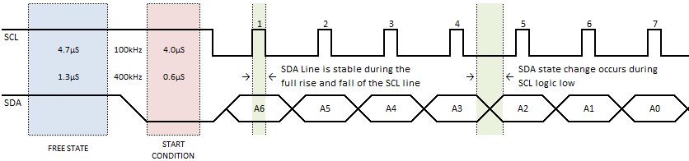

Figure 48 - Inter-integrated Circuit: Receiving Data (permission pending)

One of the things that is different with this topology is that bus drivers are considered open drain which means that drivers can pull a signal low but cannot push it high. This also means that there will never be any conflicts with a bus pushing a data line high while another bus simultaneously tries to pull it low which in turn prevents damages to all the drivers as well as preventing excessive power dissipation. Given that devices cannot drive signals high this topology allows devices with different voltages to be connected with each other. An example of this is a fan that needs 5V to be powered to be connected with a Raspberry Pi that is powered by 3.3V. For cases where the difference in voltage is great between two devices, a shifter board can be used which is a simple solution to overcome this large voltage difference.

Communication with I2C is more complicated than with other topologies such as UART and SPI. One can see in Figure 48that messages are split between two frames which are the address frame and the data frame. The address frame is used to specify which slave a message will be sent to and the data frame is an 8-bit message that is passed along from slave to master or the other way around. The way this protocol specifies the start of set up for the address frame is by having the master pull the data signal low and push the clock signal high. This will indicate to all the slaves that the master is about to begin transmission. If more than one master is used then it works in a similar manner as the first master to pull low the data signal wins ownership of being able to transfer data first.

When I2C was first introduced it had an address space of 7 bits. Later improvements allowed I2C to be faster as well as have an address space of 10bits. When establishing new communication the address space always comes first. The way that the address is set up for 7 bit addresses is as follows, the most significant bit comes first, then comes a read or write bite which shows if the operation requested is a read which is indicated by a 1 or a write which is indicated by a 0. Bit number 9 is used as negative acknowledgement and this is the case for both data frames as well as address frames. The frame is sent to the receiver and once the first 8 bits are transferred it will take control of the data line. If this device does not pull the data line low before the 9th clock pulse then this means that the receiving device did not receive the message or it was not sure on how to process the message. In case of any failures the exchange of information will halt and it would be up to the master to decide how to handle this failure.

Once the address frame is processed, data is able to start flowing. The master is in charge of the clock signal which it makes sure to keep pulsating at a specific interval. The data will be place in the data line either by the master or the slave depending on the read/write bit that was discussed above. The data frames are in no particular order and it is a common practice to have the slave device increment its internal register so that the following operation either a read or write comes from the subsequent register available. With all of this data flowing from master to slave and vice versa there needs to be a stopping condition once all the data is transmitted. The master declares this stopping condition as a transition of low to high on the data line after a low to high on the clock signal with the clock signal staying high. Given this stopping condition, there should never be a case where the value of the data line should change while the clock signal is high during normal operation.

Our team is planning on using the MSP430 to take input from the fuel sensors and be able to relay this information to the management system. The management system we are planning to have will display information about each of the sensors so that it can serve as an educational experience as well as to make sure that the fuel cell remote car is functioning as expected.

The MSP430 has a universal serial interface which allows for basic synchronous serial communication. The most basic form of communication an MSP430 can provide is for the microcontroller to act as an 8 or 16 bit shift register that can be used to output data streams. Adding a bit of software on top of the MSP430 will allow the implementation of serial communication. The built-in hardware also helps with the implementation of communication protocols such as SPI and I2C.

Some of the things that the Universal Serial Interface includes are three-wire SPI mode support, I2C mode support, variable data length and programmable clock generation among many other things. The USI shift register which contains either the data that has been received or the data to be transmitted can be accessed through software. The bit counter counts the number of sampled bits and sets the universal serial interface interrupt flag when the USICNTx port becomes zero. Whenever this port gets set to a value greater than zero will set clear the interrupt flag if this flag is equal to zero and would not do anything otherwise. The counter and shift registers are both driven by the same clock. The bits of the USICNTx port will not underflow which means that once it reaches zero it stops decrementing.

### CPU Registers

The MSP430 has sixteen CPU registers and they are numbered R0-R15. Out of these sixteen registers there are four which have dedicated functions and the others can be used for any purpose. R0 is the first dedicated register, it is used for the program counter and it indicates the next instruction to be executed. The program counter is incremented according to the instruction being executed which always has an even number of bytes. The next dedicated register is called the stack pointer and it is used to store the return addresses of subroutine calls and interrupts. This register can also be used by software with the whole instruction set as well as with all addressing modes. The stack pointer is initialized inside of RAM by the user and aligned to even addresses. The status register can be used either as a source or a destination register. When used in register mode the status register is only able to process word instructions. R2 and R3 are considered to be constant generator registers and hold six common constants. These registers are useful because there is no need for special instructions, no memory access is necessary and no additional code is needed. The constant generator allows the MSP430 to have extra functionality by using emulated instructions on top of the 27 instructions that it comes equipped with. The other registers that are on the MSP430 are the general purpose registers and they can be used in multiple ways such as data registers, index values and pointers. These registers can be accessed through byte or word instructions.

### Addressing Modes

There are seven different addressing modes for the source operand and there are four for the destination operand. Register mode allows for the transfer of information between two registers, if moving from R11 to R12, R11 stays the same. This mode is valid for both source and destination and the data in the register is available through word or byte instructions. The index mode allows to move the contents of the source address to the destination address. Neither the source or destination registers are affected by this operation. The program counter will be incremented automatically so the next instruction can be executed. Under symbolic mode the programmer is able to move the contents of the source address EDE to the destination which is TONI. The words which immediately follow the instruction contain the difference between the program counter and the destination or source address. These are just a few of the address modes explained and there are many different things that can be done with each address mode.

### Regenerative Braking

The electrical characteristics of a combined battery-ultracapacitor system match well with the high ratio of peak-to-average power demands in many driving scenarios, and a combined system can reduce both the total size and cost of a vehicle energy storage unit, as well as increase battery lifetime [13]. Typically, batteries and ultracapacitors are used in a parallel configuration. Power loads are shared by a simple switch/diode selection circuit [14]. In these configurations, the voltage of the ultracapacitor module is often near that of the batteries. While this facilitates power transfer between the two energy storage elements, it also requires a relatively large ultracapacitor module with many cells in series. These systems may use one or two DC/DC converters capable of both boost and buck operation [15].

The common parallel configurations of battery and ultracapacitor banks handles short duration, high-current events, smoothing the demand on the battery. These configurations often require a capacitor bank with a voltage comparable to that of the battery bank. In some cases, the capacitor voltage operates in a range between the battery voltage and some maximum charge voltage, supplying current to the motor or other load when its voltage is higher than that of the battery. The series configuration places a low voltage ultracapacitor module in series with the battery and primary DC/DC converter, as shown in Figure 49. In this configuration, the ultracapacitor still serves to reduce periods of high current demand on the battery. During braking, the DC/DC controller disconnects the battery and only the ultracapacitor is used to recapture energy. Acceleration can be serviced by the batteries alone or the batteries and ultracapacitor together. Power sharing is accomplished by a summation of voltages, rather than a summation of currents as in the parallel configurations. The controller supplies only as much voltage from the batteries as is needed to supplement the ultracapacitor voltage to achieve a desired current through the load. The current demand from the batteries is proportionally reduced by advantage of power conservation in the DC/DC conversion.

The series configuration has several advantages, particularly in the context of our project. It is a simpler circuit to build and to explain; the ultracapacitor voltage adds directly to the voltage output of the primary DC/DC converter. This converter could potentially be an off-the-shelf two-quadrant DC motor controller, and no additional large inductors are needed to smooth the current since all elements are in series, all current passes through the motor inductance. At its input, the DC/DC converter sees the fixed battery voltage instead of a fluctuating higher voltage as in some parallel configurations. The ultracapacitor bank can have both a lower voltage and a lower total energy capacity, since its entire voltage range can be used during the transient braking and acceleration periods. This reduces the cost and size of the ultracapacitor bank. A capacitor module with lower voltage and higher capacitance will have a lower effective series resistance (ESR), so it will dissipate less heat at high currents. The need for precharging is also eliminated.

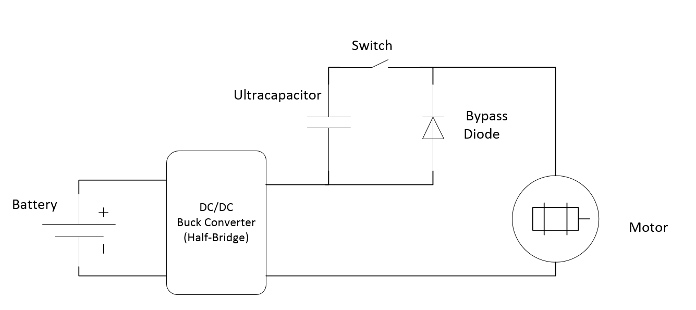

Figure 49: Battery/Ultracapacitor Series Configuration (permission pending)

The benefits of the series configuration certainly outweigh the disadvantages. The key function of the ultracapacitor as a buffer for high current demands, particularly during braking, is preserved, though the ability to completely manage power transfer paths is sacrificed. The simplicity, low cost, and ease of implementation of this configuration make it practical for light vehicles with significant cost constraints, for which regenerative braking may otherwise be out of reach.

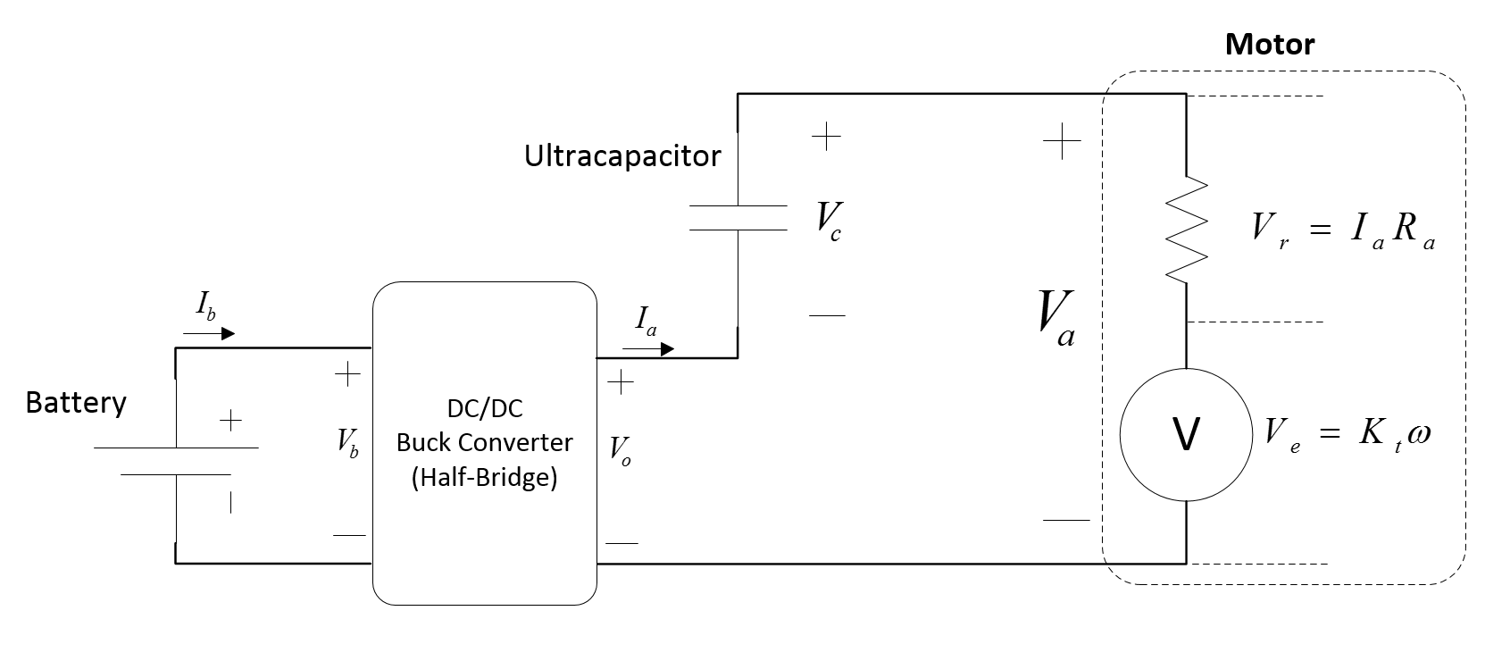

Figure 50: Simple model of Regenerative Braking System (permission pending)

During acceleration, the series-configured system transfers power from both the battery and the ultracapacitor to the motor. The important dynamics of power sharing during acceleration are captured by the model in Figure 50 and the resulting power conservation equations. The system takes as its input a command for armature current, I*a*, and the power sharing is established by the following:

|  |  |  |
| --- | --- | --- |
|  | $$P_{motor}=P_{batt}+P_{cap}-I_{a}^{2}R_{a}=τ_{a}ϖ$$ | (20) |
|  | $$P_{cap}=I_{a}V_{c}$$ | (21) |
|  | $$P_{batt}=τ_{a}ϖ+I_{a}^{2}R_{a}-I_{a}V_{c}$$ | (22) |

where *Pmotor*, *Pbatt*, and *Pcap* are the mechanical, battery, and, capacitor powers, respectively, *Ra* is the armature resistance, *Vc* is the capacitor voltage, *ω* is the motor speed, and *τa* is the acceleration torque. As shown by Eq. 22, energy stored on the ultracapacitor reduces the power demand on the battery. The fraction of the total electrical power that is delivered by the battery is given by:

|  |  |  |
| --- | --- | --- |
|  | $$\frac{P_{batt}}{P_{batt}+P_{cap}}=1-\frac{I_{a}V_{c}}{τ_{a}ϖ+I_{a}^{2}R_{a}}=1-\frac{V_{c}}{V_{a}}$$ | (23) |

where *Va* is the total voltage across the motor terminals. When the capacitor voltage is greater than *Va*, no power is needed from the battery. Otherwise, the ratio depends on both the speed and acceleration of the vehicle. Additionally, the stored voltage extends the maximum speed of the vehicle once the acceleration load is met.

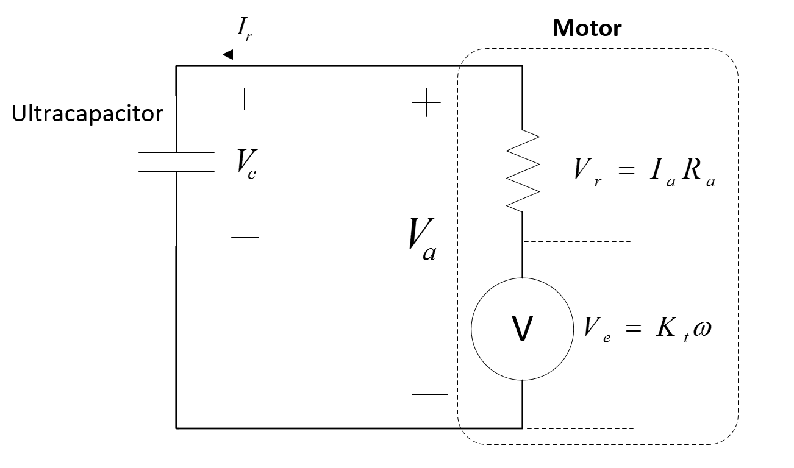

Figure 51: Ultracapacitor only during regenerative braking (permission pending)

During regenerative braking, the DC/DC converter is used to effectively short-circuit its output, connecting the motor directly to the ultracapacitor as shown in Figure 51. The batteries are thus excluded from the circuit during braking and only the ultracapacitor, which has a much higher charge rate, is used to accept large regenerative currents from the motor. The power transfer from kinetic energy into the ultracapacitor is easily predicted by:

|  |  |  |
| --- | --- | --- |
|  | $$P_{cap}=τ_{b}-I_{r}^{2}R_{a}=I_{r}V_{c}$$ | (24) |

*τb* is the braking torque, *ω* is the motor speed, *Ir* is the regenerative braking current, and *Ra* is the motor armature resistance. Braking current is modulated by controlling the field coils of the DC motor, which effectively varies back-EMF through K*t,* the motor torque constant. In this configuration, regenerative braking can only be achieved when the back- EMF generated by the motor is larger than the capacitor voltage, so a saturation point exists when the field current is maximized. Further electrically-controlled braking can be achieved by reversing the field and driving forward current through the armature, but this would not be regenerative.

## Battery System

### Battery Selection

We plan on using a polymer lithium ion battery designed for RC use. These are very common in the RC industry and can provide high currents. Lithium ion batteries are also used in full-size electric vehicles. Most RC batteries are sold as “polymer” although there is some ambiguity as to whether this makes them different from “normal” lithium ion batteries. Regardless, research indicates that we can use polymer lithium ion and lithium ion batteries interchangeably.

We will use a 2S type battery, where the number “2” indicates that the battery consists of two stacked cells. A cell has a typical voltage of about 3.7V (the actual voltage varies). Therefore our battery will have a typical voltage of about 7.4V. We will target a battery capacity of between 2000mAh and 5000mAh. Typically the battery charge rate is set at 1C, meaning the charge current is such that the battery can be charged in one hour (for example a 5000 Ah battery can be charged at 5A).

For RC applications the 2S type is often used because the NiMH batteries that used to be common have a similar voltage range. There are 1S batteries, but these appear targeted for lower power applications. There are also 3S batteries available, which can provide more instantaneous power, but we chose not to use these. A major disadvantage to the 3S batteries for our design is the fact that they run above 11V, which would require a more complicated power supply scheme.

The maximum voltage for a 2S battery may be either 8.2V or 8.4V depending on whether the anode uses coke or graphite. Presently, 8.4V is more common. The voltage difference may appear small, but this voltage determines when charging stops and using the wrong voltage could result in battery damage and safety issues.

### State of Charge Measurement

The battery state of charge can be difficult to determine since there is no direct way means of measurement. However, we can estimate it by monitoring voltage, current, and even temperature.

In theory, measuring the current going into or out of the battery (also known as coulomb counting) should provide an exact determination of charge in the battery. In practice, while this method can provide an estimate of charge, it will have inaccuracies which will accumulate with time since it requires integration of the current. Inaccuracies result from such factors as uncertainties in the exact resistance of the current sense resistor (although this can be calibrated).

Voltage can also provide an estimate of state of charge. The voltage versus charge curve is not linear. At high charge and low charge states, the change in voltage increases, making charge measurement more accurate at these ends. However, in the middle part of the graph, the voltage is mostly flat, making it hard to measure. Also, voltage measurements work best when the battery is not in a state of charge or discharge (and it works especially well when the battery has been allowed to sit unused for hours); these are conditions which are often not possible to attain. Nonetheless, because voltage measurement is simple and provides an instantaneous estimate of charge (without integration), this method is often used.

There are dedicated ICs available which measure the state of charge based on both voltage and current measurement. These ICs can use current measurements when there are high or changing current loads. Voltage measurements are used when the battery charge is not changing rapidly and can be used to correct drift inherent in the current measurements. These ICs may even incorporate models of the battery which take into account temperature, and which adapt the model with time. These ICs also include digital EEPROM registers which allow calibration data to be stored.

One of the key factors we must consider for charging is charge current. While our battery will likely accommodate a charge current of at 2A to 5A, we may not want to charge at this rate for several reasons. Firstly, when we are charging from the fuel cell, we may not want to put a large load on the fuel cell. Secondly, for safety reasons we may want to limit the battery current. Although the battery should be able to accommodate a high current, we may not have a very intelligent charging circuit (as compared to a commercial wall-plugged unit). A lower current should allow for lower risk. Third, a higher charge current will require that the components be able to handle higher currents.

One option we considered is to allow for different charge currents, depending for example on whether the charger is plugged into a wall or running off of the fuel cell. However, all of the charge management solutions we have examined have a fixed charged current determined by the value of a current sense resistor. While we could try to build a circuit to electronically adjust the resistance, we think this will overly complicate our circuit and may cause issues with the charging circuit. If we inadvertently increase the charge current, this could become a safety issue. The only other option would be to build our own charge controller, but this would be beyond the scope of this project. Therefore, we will need to design for a fixed charge current.

Another important factor is the availability IC packages. The vast majority of IC chips are surface mount. A search on Mouser found the following chargers in a DIP package: BQ2000, BQ2054, and BQ2954. However, these ICs did not meet our needs. Of the surface mount chips, many are designed for mass production and come in flat pack or BGA packages. Both of these packages have the contacts on the bottom of the chip, and thus are difficult to solder and to probe. We chose to use pinned surface mount packages only. We also found a few ICs that seemed to meet our needs, but they required large orders (note that we may have been able to find another supplier that sold individual chips, but we did not pursue this). Many ICs are designed for single cell applications, and are not compatible with the 2S configuration that we will use (these single cell ICs often also only support a limited charge current). We need to make sure that we use a chip that provides support for two cells.

A major decision is whether to use a linearly regulated charger or a switch-mode charger. As the name simply, these types determine how the voltage is dropped between the input and the battery. The battery charge circuit must run off a power source of 12V. When accounting for the protection circuitry, let us assume that the input will be 11V (which is a rounded approximation). If we assume in the worst case that the battery will be at 6V, then the voltage drop will be 5.5V. If the charge current is 1A then a linear charger would need to dissipate 5.5W with a linear regulator.

For efficiency reasons, a switch-mode charger would be preferred. There are a couple ICs that we identified: the MAX1873 and the BQ2954. Both of these chips require an external switching transistor. The external switching circuit uses a buck topology. While the required circuits are not overly complex, we are still hesitant to use a switching charger, due to possible issues. Also, we would need to determine the size and weight of the inductor required, to determine if this would cause an issue. For this reason, we will instead plan to use a linear charger. If we use a modular design, we still have the option to design and implement a switching charger at a later time.

There are many linear charging ICs, and it was difficult narrowing down the options. Using TI’s “Battery Charger Management Selection Tool”, we identified the following TI ICs: BQ2057 and BQ2400X (the BQ24005 was identified in a previous Voog Breathalyzer Ignition Interlock System senior design project). We also identified the LM3622. The BQ2057 and LM3622 require external transistors, whereas the BQ2400X uses an internal transistor. Because the BQ2400X does not require the external pass transistor, it could be a good candidate (it can handle 1.2A continuous current). In order to meet its voltage and power dissipation requirements, we would probably need to add diodes in series between the power supply and input. However, in order to dissipate heat properly, the surface mount package includes a large metal pad on the bottom which needs to be soldered to the PCB. This will make prototyping difficult as we will not be able to use a surface-mount-to-DIP adapter. Of ICs with external transistors, both the BQ2057 and the LM3622 would be suitable for our purposes. However, we will choose the BQ2057 because it requires slightly fewer external components, has a pin indicating status, and has more comprehensive documentation. Both chips cost roughly the same amount.

The BQ2057 accepts an input voltage of up to 15V, so this matches our power source. The IC supports both single cell and double cell batteries in different IC versions. It also supports maximum battery voltages of 8.2V or 8.4V (each voltage requires a different part number). Assuming we use a 2S 8.4V maximum voltage battery, we need part number BQ2057WSN (SOIC package) or BQ2057WTS (TSSOP package). We will order the BQ2057WSNTR which comes in a tape and reel (the other option comes in a tube). We do not have a preference and the tape and reel version is slightly cheaper.

### Circuit Design

The charge circuit is shown in Figure 52, and the parts list can be found in *Table 42*. We still need to determine the exact charge current, but are considering 0.5A and 1A. Note that the circuit is not designed to charge and discharge at the same time. Research suggests that while this is possible, charging a battery while it is in use is tricky, since it is hard to determine whether charge current is going to the battery or to the load. Therefore, we chose not to attempt this (especially due to the safety issues). The design centers on a BQ2057 IC which automatically handles all phases of charging: pre-charge, constant current charge, and constant voltage charge, and charge termination.

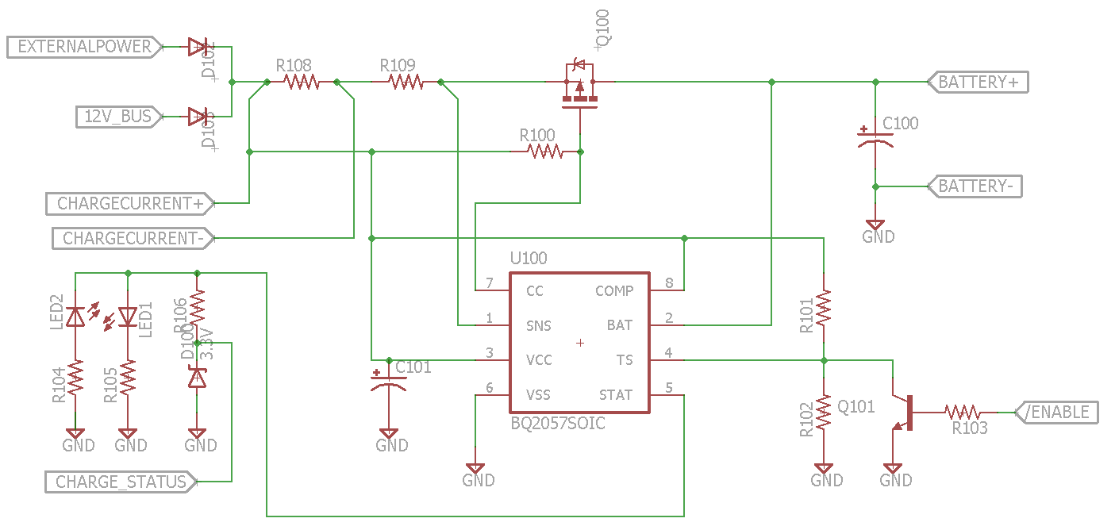

Figure 52: Battery Charge Circuit

Rather than using a switch for selecting the charge source, we will use diodes. The external power source voltage is about the same as the 12V bus, so if both sources are present, it is not clear which would be “selected”. When an external source is connected, the 12V bus can be turned off to allow the external source to provide power. Likewise, when external power is disconnected the 12V bus can be enabled to provide power. We may have to change this design if we need to charge the battery while the 12V bus is enabled. In this case, because the charge current is not that large, we will use the P-MOSFET switch design. Because we have a protection diode, we will only use one P-MOSFET, rather than the back-to-back configuration.

The IC provides a temperature sense feature, which we will not use. However, to disable the temperature sense we need to bias it between 30% and 60% of VCC. We will aim for 45%, and will use 1% tolerant resistors to make sur that we stay well within range. The temperature sense is also used to enable or disable the charger – to disable the sense pin needs to be pulled outside of the 30% to 60% range (when the temperature sensor is included in the design, this would indicate that the temperature is too high). To accomplish this, we will use a transistor to pull the pin close to ground.

The IC also includes a status pin which can be used to communicate with a microcontroller or to drive LEDs. The pin is pulled to VCC when charging, and to ground when charge is complete. It will be High-Z when the charger is disabled (or when there is a temperature fault if a temperature sensor is used). Since we do not need to check for High-Z, we can use a simpler circuit. We will use a Zener diode to level shift from VCC to 3.3V. We will also include LEDs to provide for an extra status during debugging. These can be omitted in the final version.

The input diodes and charge control MOSFET need to pass up to 1A, but to give ourselves a margin, we will select devices that can handle up to 1.5A continuous current. The MOSFET may need to drop up to 9W (this is a conservative estimate), and the protection diode will need to dissipate a little over 1W. The IC requires a current sense resistor for the constant current charge phase with a voltage drop of 125mV. We will use two resistors for the current sense so that we can also measure the charge current with the microcontroller. We need two resistors because we need a smaller voltage drop than the charger IC. Because we only require a small current for measurement, and because all devices on the charge current path are low impedance, piggybacking on the same current measure resistor should not be an issue. We will use the current measurement circuit shown in Figure 52. Current only needs to be measured in one direction so ground can be used as a reference. We will use the INA213 IC which has a gain of 50. To provide a maximum output of 3.3V, we need a maximum voltage drop of 66 mV across R108.

## Electronic Speed Controller (ESC)

### Overview

In order to drive the motor, a speed controller is needed. One type of controller is a mechanical speed controller. This type uses a servo to control the wiper on a rheostat. While these types of controllers are robust, for several reasons they are largely obsolete. Modern controllers are of the electronic type. These generally take a PWM signal as an input and drives the motor using a switched drive signal. We have the option of using the existing ESC which came with the car (if it still works), buying an ESC, or building our own.

We were planning on building our own ESC but did not have enough time to do so, our plan was as follows, we will retain compatibility with commercial off the shelf ESCs as well. This will allow us to compare our custom built ESC to commercial ESCs, and will also provide a backup in case our controller fails. Also, although we want the main controller to provide input for the ESC, we want the option to attach the ESC directly to the radio. In order to accomplish these compatibility goals, the controller and ESC will both need the capability to use standard PWM control signals.

Different types of controllers are needed for driving brushed and brushless motors. A brushless AC motor is more efficient, although the control circuit is also more complex. For our system we plan on using the motor included with the car, which is a brushed motor.

### Commercial ESC Study

### I2C Communications

The board can be controlled and queried using the I2C bus. The power system will reside at I2C address 0x00 (7-bit addressing mode is assumed). The communication scheme described in section 0 will be used. The read registers can be seen in Table 25 and the write registers can be seen in Table 26.

|  |  |  |  |
| --- | --- | --- | --- |
| Reg. # | Description | Data Bytes | Values |
| 0x00 | Alert Status | 1 | 0x00 No alert  0x01 Fuel Cell overcurrent  0x02 Battery overcurrent |
| 0x01 | Motor Speed | 2 | 0A – 1A (10 bit) |
| 0x01 | Motor Voltage Average | 2 | 0A – 1A (10 bit) |
| 0x02 | Motor Current Average | 2 | 0A – 1A (10 bit) |
| 0x03 | Motor Voltage History | 10 | TBD (10 bit) |
| 0x04 | Motor Current History | 10 | 0A – 20A (10 bit) |
| 0x05 | External Power Source Connected | 1 | Binary |
| 0x06 | Fuel Cell Current | 2 | 0A – 10A (10 bit) |

Table 25: Power System I2C Read Registers

|  |  |  |  |
| --- | --- | --- | --- |
| Reg. # | Description | Data Bytes | Values |
| 0x80 | Read Register | 1 | Register # for next read |
| 0x81 | Select Source | 1 | 0x00 None  0x01 Battery  0x02 Fuel Cell |
| 0x82 | Enable 12V Boost | 1 | Binary |
| 0x83 | Enable Charger | 1 | Binary |
| 0x84 | Battery Current Limit | 2 | 0A – 20A (10 bit) |
| 0x85 | Fuel Cell Current Limit | 2 | 0A – 10A (10 bit) |

Table 26: Power System I2C Write Registers

### Motor Control

The electrical characteristics of a motor can be modeled using a voltage source, resistor, and inductor in series. The voltage source is due to the back EMF generated by the motor, the resistance is due to parasitic resistance (mainly in the motor winding), and the inductance is due to the motor winding.

The back EMF generated by a motor is roughly proportional to the speed. For this reason, the voltage applied to the motor will be roughly proportional to the speed. We will plan on using a typical H-bridge control circuit – due to the internal inductance of the motor, the applied PWM signal will result in an averaged voltage/current. A timing of the PWM drive signals as they relate to the drive modes are shown in Figure 53. The four drive signals are shown (see the circuit in Figure 54 to see which transistor the drive signals correspond to), as well as the voltage across the motor. Note that the signals are not drawn to scale, and some details are not shown (for example the ramp up in speed and voltage when the motor is starting). All signals are active high and indicate whether the corresponding transistor is on or off.

To leave the motor off, all signals should be off (or one low side transistor may be left on). In order to drive forward, Low Side 2 should be left on, and High Side 1 should be pulsed. During each pulse cycle, when the High Side 1 is turned off, the motor inductance will reverse the motor voltage in order to maintain current flow. A path is provided by the free-wheeling diode across Low Side 1. Because of his, a voltage spike will be prevented, and the voltage across the motor will be about 0.7V. To allow the motor to coast, High Side 1 can be turned off. Once the current through the motor stops, the motor voltage will be determined by the back EMF. During the coast phase, the speed of the motor will gradually drop due to friction. During this time, the voltage across the motor can be measured and used to determine motor speed. Note that as long as the motor voltage is less than the supply voltage, there is no path for current to flow from the positive terminal of the motor. This also means that although Low Side 2 is on, it should not have any current flow, although it does provide a ground reference for voltage measurements. In order to quickly stop the motor, both low side switches should be turned on at the same time. This essentially short circuits the motor and causes the mechanical energy to be dissipated through the winding resistance of the motor. While this causes heating, the current through the motor should be about the same as the stall current through the motor. As an alternative, Low Side 2 could be turned off allowing current to flow through the free-wheeling diode instead of the transistor. This would allow some of the energy to be dissipated in the diode, although due to the increased voltage drop, the motor would stop slower. Also, we could control the braking by applying a PWM signal to Low Side 1. Once the motor is stopped, Low Side 1 and 2 could be kept on to keep the motor still. The same discussion applies to reverse operation of the motor, except the drive signals will swap sides.



Figure 53: H-Bridge Drive Waveform

It is important that the high and low signals on the same side are not activated at the same time, or a direct path will be provided from the positive voltage supply to ground (this is called shoot-through). If it is desired to stop immediately after driving the motor, a small delay is needed between turning off the high side transistor and turning on the low side transistor on the same side. This gives one transistor time to turn off before turning on the other. The required delay will need to be determined experimentally.

Speed can be measured by directly monitoring rotation of the drive train. One way to do this is to use an optical encoder. An optical encoder device could be attached to the drive train, or one could be built by attaching a slotted wheel and detecting the slots with an optical device. Another similar method is to attach magnets to the drivetrain and detect them using Hall Effect sensors. While these methods can provide a very accurate measure of speed, they do require mechanical mounting, and must be robust enough to handle the vibrations and shock encountered in a moving vehicle. For this reason, we will measure the motor speed using back EMF voltage measurements even though they will be less accurate.

### Circuit Design

The H-bridge can be seen in Figure 54. We will use an MC33883 driver IC. The advantage to using a driver IC instead of a simple discrete circuit is two-fold: it provides for a lower impedance drive signal which will result in faster switching time, and it includes a charge pump so that N-MOSFETs (with their lower drain-source resistance) may be used as the high side transistors. We will use PSMN1R2 N-MOSFET transistors. Free-wheeling diodes are included across the transistors, although these are not necessary, and we may choose to omit them (this will be determined during prototyping). We include two parallel transistors for High Side 1 and Low Side 2, since these are used for forward drive and we expect them to be used most often. Because the transistors are MOSFETs we are not using resistors for current balancing, but will assume that the MOSFETs will self-balance. Inspection of a commercial ESC showed that only one transistor each was used in High Side 2 and Low Side 1, so we will only plan on doing the same. However, we will leave two transistors in the design until we are sure. Space allowing, we may also include extra pads for parallel transistors in the schematic and PCB, and only use them if we need them. We include a small valued capacitor across the motor. This capacitor is used for suppression of voltage transients, and will need to be determined experimentally. We also need to verify that the motor does not have its own capacitor. The remaining resistors, capacitors, and diodes are as specified in the MC33883 datasheet. We will need to evaluate if the 18V Zener diodes need to be reduced (for example to 15V). The MOSFETs can only withstand a 20V gate-source voltage, and the existing Zener diodes will allow the voltage to get close to this limit.

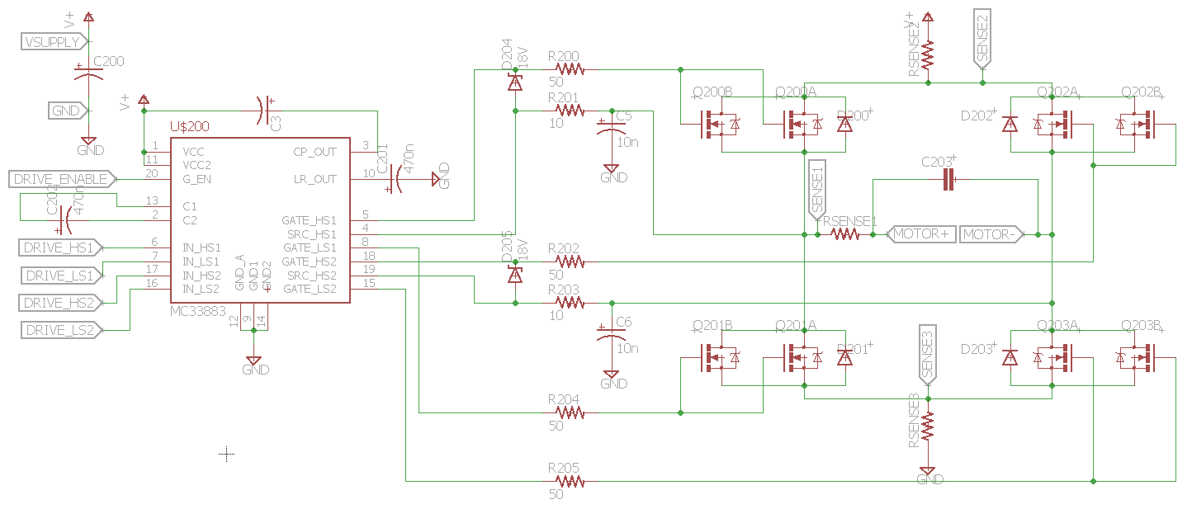

Figure 54: H-Bridge Circuit

We have the option of including current measurement through the motor. A shunt resistor could be placed in series with one of the motor terminals. However, the circuit would ideally need to measure current in both directions (although we could design it just to measure in the forward direction). We could also measure current at the high side input or the low side ground rail (both should give the same result). One of the circuits Figure 53 or Figure 54 would be used to interface with the microcontroller. The motor current may change very quickly, and thus speed of analog-to-digital conversion may be an issue. We will need to evaluate the best method during initial prototyping. We also need to measure the voltage across the motor. To do this, we could use an opamp in a differential configuration. However, the voltage may have either positive or negative polarity, and so the opamp would need to be attached to positive and negative rails (requiring a negative voltage supply). Instead, we will plan on attaching the positive and negative motor terminals to two different ADC channels on the microcontroller. However, we will need to determine if the delay between measurements of the two channels will be an issue.

### Prototyping and Experimentation

In order to gain experience with H-Bridges, we will first build a simple circuit that we can use to quickly experiment with. This circuit is shown in Figure 55. T circuit will use a simple drive circuit consisting of BJTs. The negative terminal of the motor can be hooked to ground if we only want to test the forward direction. Alternatively, we could build a full H-bridge with four MOSFETs.

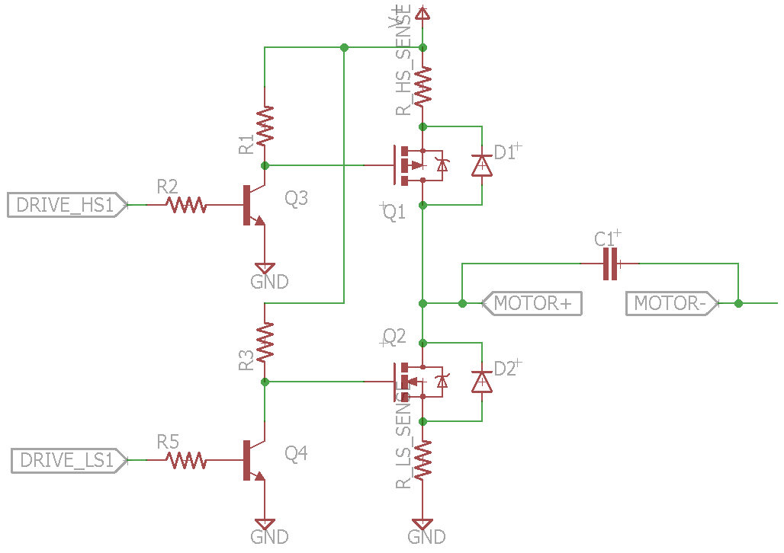

Figure 55: H-Bridge Test Circuit

### Microcontroller

A list of control signals to be used by the microcontroller can be found in Table 27.

|  |  |  |
| --- | --- | --- |
| Description | Dir. | Comments |
| Enable Gate Drive | Out | Active high |
| Drive High Side 1 | Out | Active high |
| Drive High Side 2 | Out | Active high |
| Drive Low Side 1 | Out | Active high |
| Drive Low Side 2 | Out | Active high |
| Motor Voltage + | In | Analog |
| Motor Voltage - | In | Analog |
| Motor Current | In | Analog |

Table 27: ESC MCU I/O

## Testing of RC Components

We tested the battery, radio, ESC, and servo that we purchased to determine the requirements for the commercial off-the-shelf RC components we need to interface with. To do this, we hooked the battery to the ESC, and the ESC to the radio and motor. We then hooked the servo to the radio and the radio to the ESC. Will controlled everything using the handheld controller that came with the radio. Note that because we were using the battery, when making measurements we were able to attach the ground clip to arbitrary points on the circuit, which made some of the differential types of measurements easier.

### ESC

#### External Measurements

The ESC is connected directly to the battery. During our tests, the battery voltage was at approximately 8.35V. We measured the voltage across the motor as well as the current through the motor. To measure current, we attached a 0.01 ohm resistor in series with the motor. We also measured the PWM input signals from the radio to the ESC, as well as the BEC power provided by the ESC to the radio. Our measurements can be seen in Table 28. Note that some measurements are approximate – at this stage we were mostly concerned about getting a general idea of the characteristics. To obtain more accurate current measurements, we would need to take better account of ohmic losses in the resistor terminals. We had read that ESCs sometimes calibrate their idle PWM width with regard to the initial PWM signal present at startup. We tried to determine if our ESC performed this calibration, or if it had a preset idle width. However, our tests were inconclusive.

|  |  |
| --- | --- |
| BEC Voltage to Radio | 5.6V |
| Signal PWM Voltage | 3.3V |
| Signal PWM Period | 16 ms |
| Idle Pulse Width | 1.4 ms |
| Max Forward Pulse Width | 1.95 ms |
| Max Reverse Pulse Width | 1 ms |
| Motor Drive PWM Period | 680 us |

Table 28: ESC Measurements

The waveforms for the motor while driven at a medium speed are shown in Figure 56. The trace with rectangular pulses indicates the voltage and the other triangular trace indicates the current (the scale for the current is 10mV/A). Note that although we ran the motor forward, we must have had the oscilloscope probes connected “backwards”. We can see that the ESC first connects the motor across the battery terminals. The current gradually ramps up until the ESC disconnects the battery (in this case, the current reaches almost 10A). Once the battery is disconnected, the current ramps back down to zero. During this time, we can see the voltage across the motor goes to about 0.7V with opposite polarity. This indicates that the current is flowing through a freewheeling diode. Once the current reaches zero, the voltage across the motor becomes dominated by the back EMF. This voltage is roughly proportional to the speed. An important observation is that the current does not continue to flow when the motor is not connected to the battery. This suggests that the motor inductance is low (which is not surprising considering that this motor has 27 turns). This also means that the motor speed can be measured in between PWM pulses as long as the analog-to-digital conversion can be accomplished quickly enough. When the speed control is set to its maximum value, the ESC simply connects the battery across the motor terminals without switching it on and off. During this time, we observed a current of approximately 2A (although it varied). We also, used a 1kΩ resistor across the motor terminals of the ESC. This gave us a much cleaner PWM waveform. However, it simply confirmed what we already observed. Note that there are is a lot of noise, and some large current spikes during the on to off transition of the ESC (although these current spikes are likely due to measurement error from voltage spikes). As far as we can tell, there are no capacitors across the terminals of the motor.

We were surprised to find that when the ESC is powered on, it plays a series of sounds through the motor. We observed the waveform, which is shown in Figure 57. A square wave is applied to the motor at audio frequencies. Unlike the PWM signal used to drive the motor, the sound waveform has a DC value of zero so that the motor only vibrates. In Figure 57, waveforms with frequencies of approximately 970 Hz and 1.92 kHz can be seen.

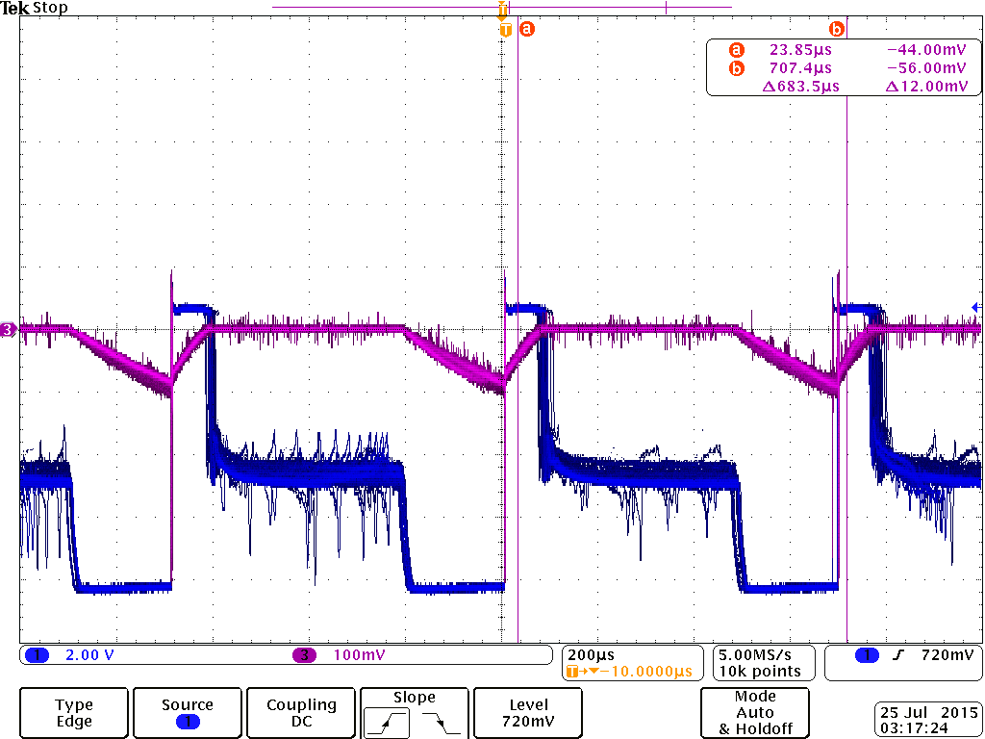

Figure 56: Motor Voltage and Current (10mV/A)

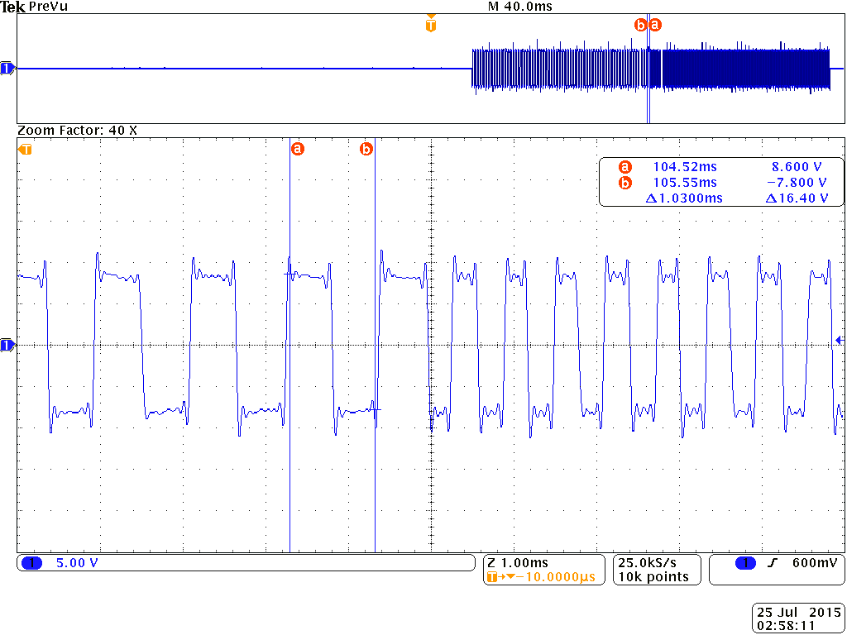

Figure 57: Waveform used to play sound through motor

We also attached the motor directly to the power supply available in the SMART lab, and this helped us get an idea of the voltage and current characteristics of the motor. Using the power supply we were able to apply constant voltages to the motor and observe how the speed and currents reacted (a digital oscilloscope was very useful for this purpose, since we were able to set the trace speed very low and watch the voltage and current waveforms over a multi-second period). These observations were not possible with the ESC since the ESC applied a PWM signal rather than a varying voltage signal. However, we found that the power supply sometimes could not provide the surge current required to start the motor, and sometimes we had to “help” it start by spinning the motor.

#### Teardown Plan

While measuring the outputs and inputs of the ESC gave us a better idea of how our design should work, but there are more details that we will would like to know. The ESC we purchased appears not to be potted, so we will be able to open it up and reverse engineer it. In particular we have the following questions:

* What are the exact signals used to drive the transistor?
* What kind of controller is used?
* What kind of gate drive circuit is used?
* What kind of circuit is used to regulate voltage for the radio?
* What, if any capacitor is placed across the power lines?
* Is there a capacitor placed across the motor terminals?

### Steering Servo

The servo requires three connections: a power line, a ground line, and a signal line. We used a 1 ohm current sense resistor in the power line to measure currents pulled by the servo. Note that we tried using the resistor in the ground line as well, but the servo behaved erratically. The results are summarized in Table 29. When we measured the current while the servo was moving, we received the unexpected results shown in Figure 58. The current is not constant, but pulses at about the same frequency as the PWM signal. By measuring the height and width of the pulse, were able to estimate the average current. If the RC car servo has the same pattern, we will need to anticipate non-constant current draw.

|  |  |
| --- | --- |
| Voltage from Radio | 5.6V |
| Signal PWM Voltage | 3.3V |
| Signal PWM Period | 16ms |
| Idle Pulse Width | 1.6ms |
| Min Pulse Width | 1.2ms |
| Max Pulse Width | 1.95ms |
| Idle Current | 8mA |
| Moving Current | 560mA (peak)  84mA (average) |

Table 29: Servo Measurements

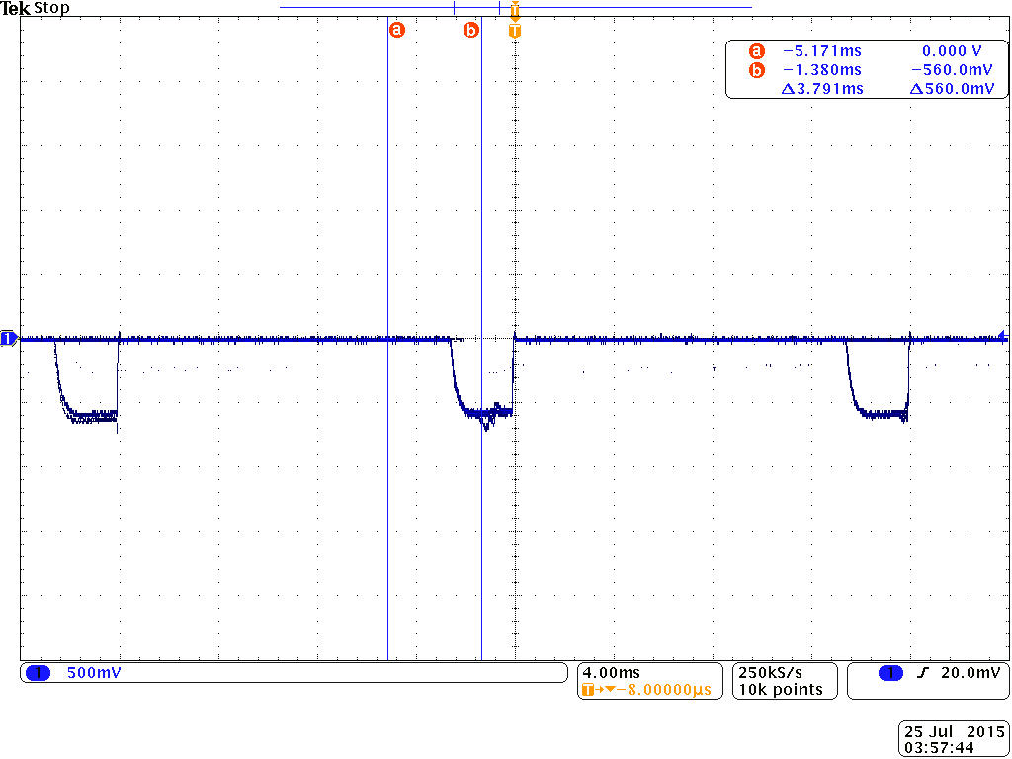

Figure 58: Servo current draw during movement (1mA/mV)

## Hydrogen Storage

### Tank

The tank is BL-60 from SOLID-H, shown in Figure 59. The hydrogen stored in the tank is nominally 60 standard liters. Due to the fact that this is a used tank there may have been some degradation over the years, so we may not have a full 60L in each fill-up now, but it will be close to 60L. Table 30 shows of the tanks specifications.

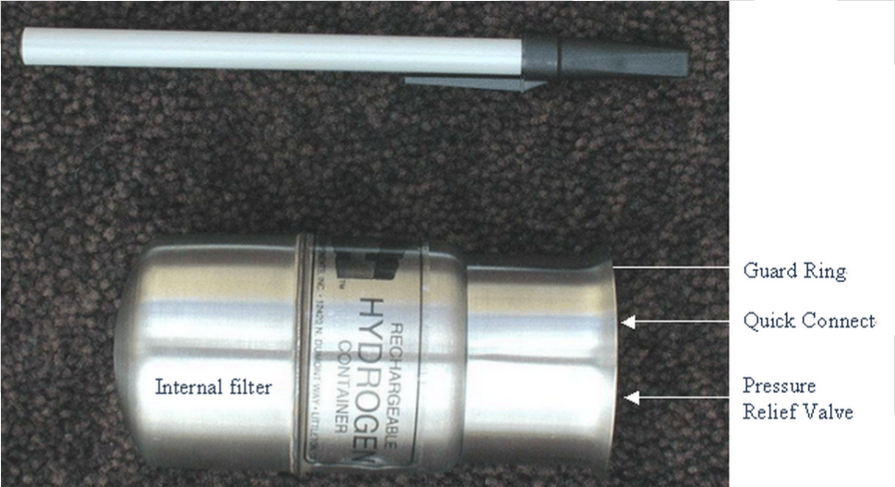

Figure 59: SOLID-H BL-60 Tank (permission pending)

|  |  |
| --- | --- |
| Hydrogen Capacity | 60sL (2.28scf)* |
| Recharge Time | ~ 6 hours (See Note 1) |
| Overall Length | 4.5 inches (144mm) |
| Destructive Proof Test | >2000 psig (136 bar) |
| Materials | Stainless Steel Cylinder with Brass Fittings |
| Cylinder Diameter | 2 inches (51 mm) |
| Mass | 1.4lb (636g) |
| Pressure Relief Valve Set | <550psig (37bar) |

Table 30: SOLID-H BL-60 Tank Specifications

Discharge Rate: The discharge rate depends on many variables. In general, we do not expect to empty the entire hydrogen capacity in a matter of minutes. Hours are required to withdraw 90% or more of the hydrogen capacity from a standard metal hydride container. It is possible to discharge a metal hydride in a matter of seconds. However, this requires extraordinary heat transfer enhancement inside and outside of the container. The largest SOLID-H containers require days to discharge completely.

Note 1: The specified recharge time is for cooling by still air at 20℃ and the charging pressure specified in the SOLID-H manual for Alloys A, L, M or H. A fan will shorten charging time.

* Absolute capacity at diminishing rate for Alloys L, M or H. With Alloy A the absolute capacity is increased to 69 standard liters (2.64scf).

## Fuel Cell

### Voltage-Current Characteristics

The voltage and current provided by the fuel cell can vary greatly based on many factors external to our system and generally beyond control; outdoor humidity, temperature, atmospheric pressure and elevation are just a few factors that influence the voltage-current delivered from the fuel cell. Although it may have unpredictable traits, the unpredictability can be compensated for by actively monitoring the fuel cell’s response and gradually building a profile based on this information to make an informed decision about whether to draw the power from the fuel cell or from the secondary power source.

### Water Management

The membrane inside the fuel cell is the most important part of the system as it is in charge of converting the chemical energy into electrical energy. If this membrane becomes drier its performance will begin to decrease until it stops functioning. This is the biggest reason why water management inside the fuel cell is crucial for optimum performance. To have a good water management system there are many things that need to be considered. Badrinarayanan wrote about the importance of having a good water management system. “Currently considered PEM electrolyte in the fuel cell needs to be hydrated at all times of operation to prevent high ionic resistance that can potentially lead to failure of the membrane (Prater 1994). Maintaining water balance in the cells requires maintaining optimal conditions (pressure, stoichiometry and humidity) in the anode and cathode side. Determining these optimal conditions necessitates understanding the physical processes that occur inside the fuel cell.” The processes inside a fuel cell can be seen in Figure 60.

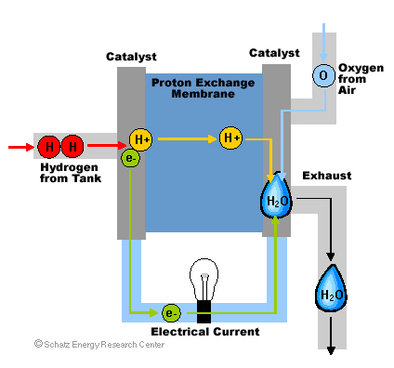

Figure 60 - Fuel Cell Physical Process (permission pending)

Based on the observation of the current fuel cell powered RC car, the H2O produced as byproduct during conversion of H2 into electricity is blown towards the rear chassis of the RC car during operation by the fan unit. If a system that is completely dependent on the fuel cell as its power source generates such a small amount of liquid such that it can simply be disposed of wherever as part of its normal operating procedure, I believe it is safe to make the assumption that our system will produce substantially less amount of liquid and it too can dispose of the H2O wherever as long as we protect sensitive electrical components and circuits.

### Temperature Management

The electrochemical reaction inside a fuel cell takes place on both sides of the membrane almost at the same time. A careful examination of the anode, cathode and overall reactions are as follows.

At the anode:

|  |  |  |
| --- | --- | --- |
|  | H2 🡪 2H+ + 2e- | (25) |

At the cathode:

|  |  |  |
| --- | --- | --- |
|  | ½ O2 +2H+ + 2e- 🡪 H2O | (26) |

Overall:

|  |  |  |
| --- | --- | --- |
|  | H2 + ½ O2 🡪 H2O + heat | (27) |

This overall reaction is the same as a hydrogen combustion reaction. There is energy being released in this reaction as heat which makes it an exothermic reaction. The optimal temperature of a proton exchange membrane fuel cell varies between 75 °C and 80 °C. If one of these fuel cells is operated above this temperature its performance will be diminished. A proton exchange membrane (PEM) does not need to be at a certain temperature to be operational. This type of fuel cell can be operated even at freezing conditions but its performance will suffer. Car companies have researched with these fuel cells all the way to temperatures reaching the -30°C. The maximum temperature at which a fuel cell can be operated at is set by the membrane. The efficiency of the membrane is driven by its humidity therefore after the fuel cell reaches a certain temperature it will not operate efficiently and can even be damaged. This is the reason why PEM fuel cells are typically not operated higher than 90 °C and other types of membranes are used for higher temperatures.

Temperature needs to be monitored continuously for the fuel cell and the power management system components in order to maintain safe operating conditions and protect the equipment during operation in the case of unpredictable failure. In the case that the temperature increases beyond normal operating conditions, a hardware fail-safe should be triggered that will halt all operations as reliably as possible. The hardware fail-safe needs to be completely independent and without any dependencies to any other subcomponents of the system. It should be low-power and have its own power source.

An alternative strategy to guarantee safe operating temperature is to incorporate a “thermal fuse” or “thermal cutoff” into the circuitry which will interrupt the current flow in vital control lines when unsafe temperature are met. These devices incorporate a fusible link which is guaranteed to respond to unsafe temperatures due to the chemical properties of its composition.

When the fuel cell stack’s temperature is below optimal operating temperature, it should keep the inlet valve open to let H2 enter the fuel cell stack while keeping the purge valve closed increasing the pressure within the fuel cell stack. What results is an increase in temperature from the exothermic reaction that due to the internal pressure within the fuel cell increasing as well as the concentration of hydrogen. When the target temperature is met, the purge valve should be opened for a brief second before being closed again.

### Air Flow’s Contribution to Evaporation

Air is supplied to the cell to provide oxygen to the cathode. The presence of the air also provides a vehicle for which excess water can be removed from the system, or in a detrimental case dry the cell out. In order not to remove too much water from the cathode, thus drying the membrane and the anode out, it is necessary to have the correct airflow. The following equation, Eq. 28 is derived from the definition of power, and O2 usage in the cell [16].

|  |  |  |
| --- | --- | --- |
|  | $$Air flow {Rate}_{cathode}=3.57×{10}^{-7}×λ×\frac{P_{e}}{V_{c}}$$ | (28) |

The $λ$ represents the stochimetric ratio, in the case of the PEM $λ$ = 2. The Pe is the power of the cell and the voltage (Vc) represents the voltage of the cell. Since problems arise due to the fact that the drying effect is highly non-liner with respect to the room temperature we must define a few special terms. [16] The humidity ratio ($ϖ$) and the relative humidity ($θ$), allow us to quantitatively describe the necessary water conditions in the cell.

|  |  |  |
| --- | --- | --- |
|  | $$ϖ=\frac{m_{ω}}{m_{a}}$$ | (29) |

Where $m_{ω}$ is the mass of water percent in the sample of the mixture, and $m_{a}$ is the mass of the dry air.

|  |  |  |
| --- | --- | --- |
|  | $$θ=\frac{P_{W}}{P_{sat}}$$ | (30) |

$P_{W}$ is the partial pressure of the water, and $P_{sat}$ is the saturated vapor pressure. These values are typically in the range of 30% to 70%. By using the humidity ratio, relative humidity and the exit air flow rate equation we arrive at the pressure relationship for the PEM. [16] Eq. 31 simply establishes that the vapor pressure at the exit is a function of the air properties and the operating pressure of the cell.

|  |  |  |
| --- | --- | --- |
|  | $$P_{W}=\frac{0.421}{λ+0.188}P_{t}$$ | (31) |

$P_{t}$ is the operating pressure. In order to complete the process we must add the fact that the temperature plays a very important role. The result of adding the temperature into the equation results in a decaying exponential. The region where the cathode will not be too dry or wet, typically 60ºC.

### Fuel Cell Control Algorithm

In Figure 61 we laid out a diagram of how the fuel cell functions. As soon as we flip the switch to turn on the fuel cell the first inlet valve opens up to allow the hydrogen to pass through. Once the stack voltage of the fuel cell becomes greater than 6V then the fuel cell becomes activated and the car becomes functional. As long as the temperature of the fuel cell below 45ºC it will remain active. If not then the fuel cell will shut down. If the last two cells in the stack has a differential voltage greater than 50mV then the second inlet valve begins to pulse to allow the hydrogen to pass through until the voltage of the last lowers. While active the fuel cell will have a shutdown command that will shut off the fan and inlet valves and thus disabling the load.

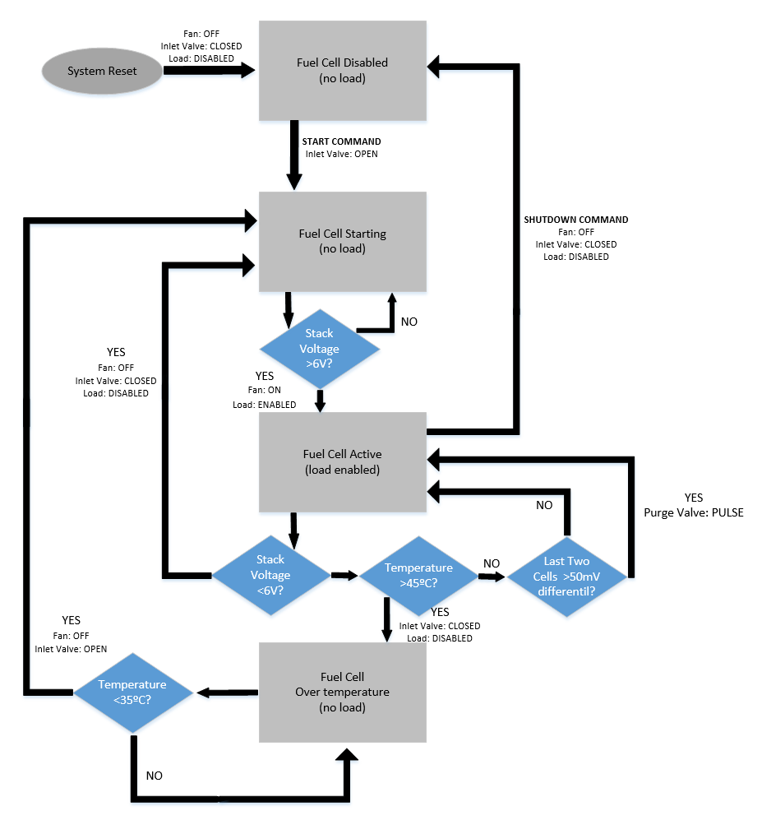

Figure 61: Fuel cell control algorithm

## Wiring

### Power Board Connectors

The power supply board will have multiple connectors leading to other boards and components. Separate connectors will be provided for power and signals. The exact connector types will need to be determined after prototyping, but power connectors will likely be terminal blocks, and signal connectors will likely be Dupont connectors. The connectors going to the main controller are shown in Table 31 and Table 32. The connectors for the battery system are shown in Table 33 and Table 34. Connectors of the same type will also need to be built on the battery system board. Note that the battery system may be built on the same board as the power system, and in this case connectors will not be needed (although the same wires will still need to connect the power system section to the battery system section. The connector for the fuel cell can be seen in Table 35, and the connectors for the ESC can be seen in Table 36 and Table 37. Note that the ESC power connector is split into two parts. The first is compatible with commercial ESCs - while some ESCs use a Deans/T-style connector, the ESC in the RC car uses wires intended to be connected to a terminal block. Therefore, the main power connector will be a terminal block.

|  |  |  |  |
| --- | --- | --- | --- |
| Pin | Description | Dir. | Comments |
|  | Ground | - |  |
|  | Power 3.3V | Out | For microcontroller |
|  | Power 5V | Out | For radio and servo |

Table 31: Main Controller Power Connector

|  |  |  |  |
| --- | --- | --- | --- |
| Pin | Description | Dir. | Comments |
|  | Ground | - |  |
|  | Alarm | Out | Open collector, Active low. |
|  | I2C SDL | - |  |
|  | I2C SCL | - |  |

Table 32: Main Controller Signal Connector

|  |  |  |  |
| --- | --- | --- | --- |
| Pin | Description | Dir. | Comments |
|  | Ground | - |  |
|  | 12V Bus | Out | Main power for charger |
|  | Battery | In | Main power line providing current from battery |

Table 33: Battery System Power Connector

|  |  |  |  |
| --- | --- | --- | --- |
| Pin | Description | Dir. | Comments |
|  | Ground | - |  |
|  | Charge Source Select | Out | Low=12V Bus, High=External |
|  | Charge Current Sense | In | Analog 0 – 3.3V |
|  | External Source Voltage | In | Low=Source Disconnected, High= Source Connected |

Table 34: Battery System Signal Connector

|  |  |  |  |
| --- | --- | --- | --- |
| Pin | Description | Dir. | Comments |
|  | Ground | - |  |
|  | Fuel Cell Output | In | Main power line providing current from fuel cell |

Table 35: Fuel Cell Connector

|  |  |  |  |
| --- | --- | --- | --- |
| Pin | Description | Dir. | Comments |
|  | Ground | - |  |
|  | Main Bus | Out | Main power for driving motor |

Table 36: ESC Main Power Connector

|  |  |  |  |
| --- | --- | --- | --- |
| Pin | Description | Dir. | Comments |
|  | Ground | - |  |
|  | Power 3.3V | Out | For microcontroller |
|  | Power 5V | Out | For Battery Eliminator Circuit (BEC) |

Table 37: ESC Secondary Power Connector

We will want the option to connect the ESC to the radio. However, we also want the option to drive the ESC directly from the control system rather than from the radio. In this case, we can plug the ESC directly into the control board, but will need the control board to connect to the radio. This is necessary not only to receive the radio commands, but also to provide power to the radio. We will provide a connection to the main controller for communicating extra configuration and status signals. However, the ESC should work without this connector so that it can be directly connected to the radio. See Table 38 and Table 39 for connection to the main power supply.

|  |  |  |  |
| --- | --- | --- | --- |
| Pin | Description | Dir. | Comments |
| 1 | Ground | - |  |
| 2 | PWM signal | In | 3.3V High, 0V Low |
| 3 | Power out (BEC) | Out | +5V, 1A maximum  For powering radio |

Table 38: ESC PWM Input Connector

|  |  |  |  |
| --- | --- | --- | --- |
| Pin | Description | Dir. | Comments |
| 1 | Power | In | 5V – 12V |
| 2 | Ground | - |  |
| 3 | Motor + | - |  |
| 4 | Motor - | - |  |

Table 39: Power Terminal Block

### System Wiring Diagram

The fuel cell will be connected to bus by a DC/DC converter. This one-way current converter allows regulating the current given by the fuel cell and also protecting it when braking. The fuel cell must be protected because if the regenerative brake system is implemented in the car, the fuel cell can’t work in a reversible way.

Figure 62 shows an electrical wiring diagram that will be used in our system. The control board as well as the fuel cell control board will be on the same PCB. Which will be powered by the fuel cell or ultracapacitor/battery. It will also output a 12V DC output for any given load. The power PCB will consist of the DC/DC converter as well as the ultracapacitor. The motor controller and the remote control receiver will be components on their own.

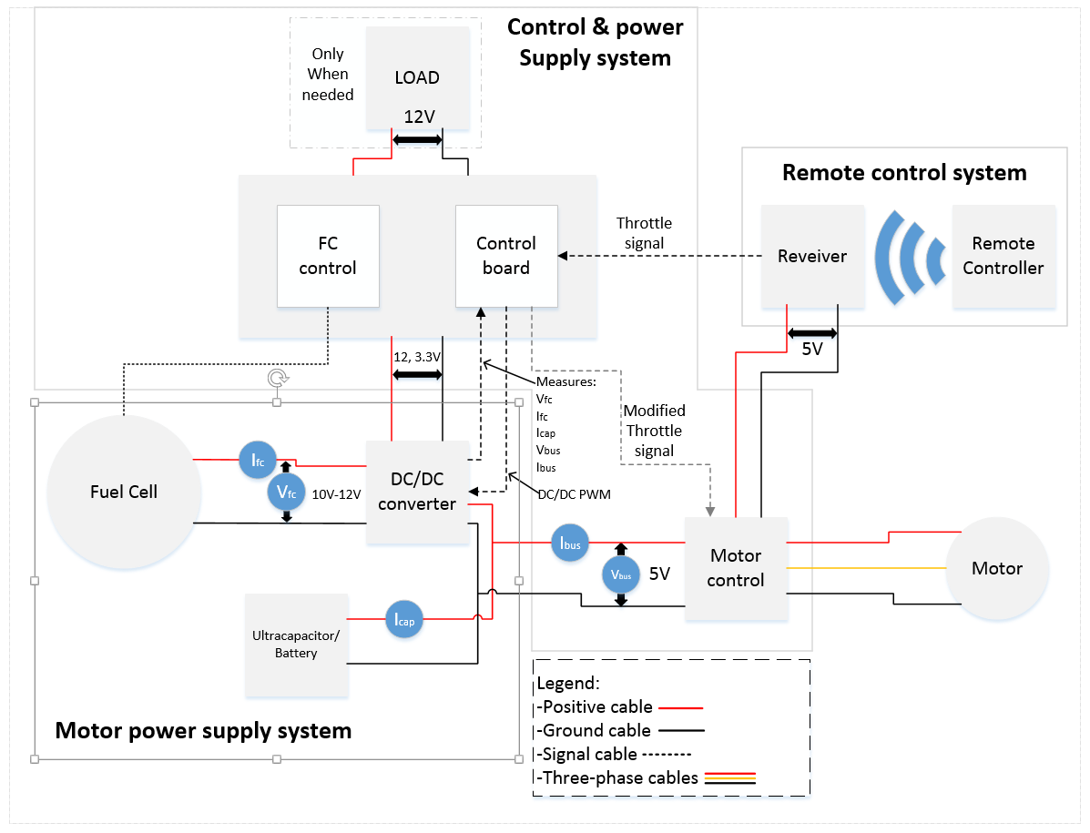

Figure 62: System Wiring Diagram

## Software Architecture

### Runtime Environment

Many runtime platforms were considered in making a decision as to which runtime we will use to run the software we implement for our data processing. We needed a platform that is able to handle I/O in an efficient manner where concurrent operations were emphasized. The features that were a requirement were

* Concurrency emphasis
  + There would need to be support for concurrent operations by either multithreading or using some other means in order to process multitudes of information coming into our system.
* Interoperability with other programming languages.
  + Some source code for libraries are only available in a specific programming language or are already compiled and available only in binary. Our runtime environment should have the ability to interface with anything available to through the command line and the user.
* I/O focused
  + Input and output needs to be fast as possible. Our runtime environment should be able to handle asynchronous I/O operations without blocking other operations from executing.
* Resource efficient
  + The runtime alone should not be costly on the CPU and RAM since it is not known what the maximum amount of computation that would need to be performed at a single instant of time is unknown.
* Many libraries available
  + An open-source community is vital to being able to rapidly develop software in this day and age.
* High developer support
* Actively developed
  + Outdated software is essentially worthless software and only exists for historical reasons. An actively developed runtime environment ensures that the platform we are developing on is capable of handling the hardware it is to run on.

Since C language was taught as part of my course curriculum and introduced in multiple courses throughout, it was the first language considered for use in the software that will drive our system. There are many libraries available for C which can help speed development time up. Also since C is a relatively low-level language with respect to most programming languages available nowadays it is able to work closer to “bare metal” and directly access resources not available to others. However due to the complexities in using third party libraries and the time and effort involved with learning how to implement the build system, as well as, correctly using the build toolchain, it was dropped for consideration although it will be used to implement small libraries only available as a C library.

Python was one of the languages considered since it is known to be popular within data science community and robot vision community. It provides an interpreter for command-line usage as well as a package manager containing library contributions from many open source projects. It is able to interface with libraries implemented in lower-level languages such as C through extensions and able to use just-in-time compilation to increase performance. Also the fact that it can be used as a scripting language with access to all libraries available in the language was one factor that was most appealing to me.

One drawback to Python, however, is that implementing concurrent operations, especially involving I/O bound processes, are non-trivial and implementing non-blocking programs involves dealing with the complexities that come with process synchronization and proper care is required to avoid race conditions in data resource that may compromise application integrity and complicate testing for quality assurance in the long run.

In the end, the decision was made to use *Node.js* as the environment to use that will drive the I/O data processing of our system. Research has shown that the system we are developing can be classified as an “event-driven” system architecture in which the system reacts only in response to events triggered from an external entity. An event driven system can be seen in modern web pages, where the web page, once loaded, does nothing and computes nothing (only listening) until a user interacts with the web page by clicking on an element in the page triggering an event that triggers the “event listener” which responds by producing some kind of computation. To keep CPU resources to a minimum and the web page responsive to user interaction, the web browser cannot keep polling the page by checking if a particular event occurred on an element over and over again every single second. JavaScript, the language used in Node.js, uses a programming paradigm that inherently accommodates for asynchronous event handling very efficiently. Node.js was initially built to be a server-side application and therefore designed with the capability to process I/O very efficiently as a web server should be able to do. Despite the fact it was originally intended to be a web server software, its use has spread beyond the scope of web development thanks to its package manager and open-source community.

### Characteristics

A web server does nothing and computes nothing (only listening) until a request is sent from a user’s web browser to the server. More specifically, the server software creates a socket on a port (usually port 80) and then its thread blocks (doesn’t process anything) during the time it is waiting for new requests. Then the operating system’s kernel puts the process into what is known as an *interruptible sleep state* and moves on to computing other tasks that are not related to the server process. When a user sends a request to the server by opening a web browser and typing in the URL to our site, the request travels over the internet and is routed to our computer’s location, sent through the modem, then through the router, and finally through the Ethernet cable connected to the server and into the server’s network card that issues an hardware interrupt to the operating system. The kernel sees the interrupt and resolves it by reading the request data from the network card, processing the data, and then associating the processed data to the socket before marking the server software process as *runnable* allowing the server software to resume processing by taking the data on the socket and generating a response that is sent back to the user’s web browser. This process must occur for potentially thousands of requests that are made to a single web server and the web server must be able to tend to all of them within a reasonable amount of time for an acceptable user experience. HTTP requests to a server are essentially analogous to any other I/O operations that occur on hardware. A server’s ability to process large amount of requests is often referred to as *scalability*, but it is essentially a measure how well an application is capable of multitasking. It is usually plotted on a graph with “requests served” as a function of “concurrent connections”. Writing scalable applications that run on multi-core processors usually involves having a firm grasp of implementing multi-threaded software architectures where concurrent operations can handle many tasks within a single application thereby reducing latency and using the processor to its full potential. Perhaps this is not the ideal solution to handling I/O operations as efficiently as possible. Is there a better solution to utilizing the CPU?

A comparison of the two major web server platforms (shown in Figure 63), Apache and Nginx, shows some very interesting information regarding software architecture and its efficiency. An Apache web server sees an exponential decrease in the amount of requests served as the number of concurrent connections increases while Nginx decreases linearly. What makes this possible? How is Nginx different from Apache such that it is more scalable that Apache?

Apache vs NGINX
 

Figure 63: Apache vs Nginx (permission pending)

Nginx’s implementation uses *event loops* for handling I/O requests while Apache allocates a thread for every request. In the end, however, they are both using blocking I/O handling and end up spending most of their time waiting on I/O data than actually processing the data.

Node.js offers a solution that incorporates the benefits offered by Nginx without the overhead involved with waiting on I/O data, as well as a whole lot of other innovative ideas that make it much more suitable for data event-driven programming than others. Node.js incorporates a single-threaded event loop which is used to process the program logic the developer incorporates, while the multi-threaded I/O handling is abstracted away from the developer as shown in Figure 64. All events that occur during runtime is placed in an event queue that gets processed by the single-threaded event loop. If the event begins an I/O operation, the job is placed in the thread pool while it is waiting, and the event loop continues by processing the next item on the event queue. When the I/O operation completes, the job is placed back into the event queue until the event loop retrieves it and continues processing it by calling its *callback function*.

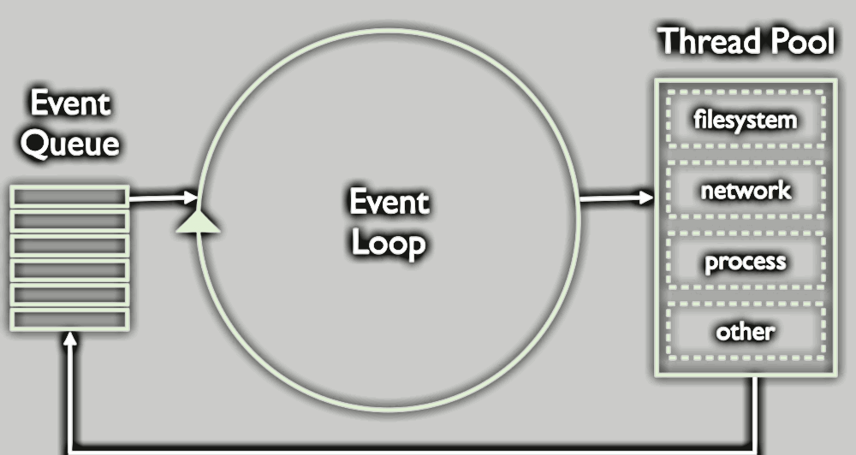

Figure 64: Single-Threaded Event Loop (permission pending)

A *callback function* is how the developer specifies how to process the I/O data when it is received and is a fundamental construct of how JavaScript incorporates asynchronous operations. It is analogous to a function pointer in C that is passed as an argument to another function as shown in Figure 65. Callback functions is a methodology of Node.js and is the default way of handling of asynchronous operation.

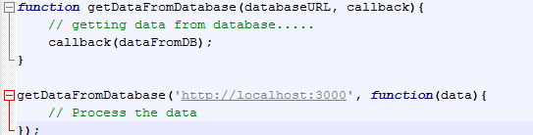

Figure 65: A Callback Function and Invocation

The callback argument is called by the function whenever the function completes its I/O operation which may or may not take long. Sequential function calls are non-blocking which let longer-running processes to be called without having to be waited on by the operations on the following lines.

Node.js is built on Google V8 engine which is Google Chrome’s JavaScript engine. V8 is completely written in C++ and interestingly compiles JavaScript to machine-code before executing; a feature completely different from other JavaScript engines which compiles JavaScript to a form of byte-code for execution instead. This feature is what allows the V8 engine’s performance to exceed others by several folds. Node.js is mostly implemented in JavaScript, along with bindings to V8 using C++. Therefore, Node.js provides utilities which allow it to use libraries written in C++. The runtime also has access to the file system which allows it to execute binaries written in any programming language and manipulate files.

### Implementation

#### Initialization

Upon startup, the SoC first starts Node.js instance via command-line that executes the program code written in JavaScript. The program first reads a configuration file that contains key-value pairs of all the sensors and outputs attached to the input bus and a string specifying the location on the file system where the module code file is located, similar to Figure 66. For each sensor, the program registers an event listener that will emit a signal to subscribers whenever the sensor puts data on the bus. Then the initializer sets up the subscriptions to each event and specifies the function specified in the module code as the callback. The callback function will be called every time the subscribed signal is emitted. The program code also sets up configurations on how each device connected to its output bus will be controlled by creating a global object.

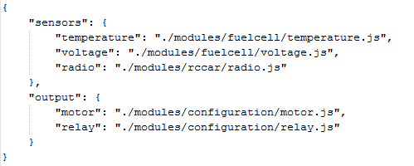

Figure 66: Example Configuration File

Then the program gets ready to initialize the fuel cell for the very first time. The temperature sensor data and the voltage sensor data are actively read into the procedure until the temperature is above 45 degrees Celsius and the voltage drop indicates 6V across the fuel cell. When these conditions are met, the program sends a signal on its output bus to a controller which opens up the purge valve and immediately closes it rendering the fuel cell ready to use.

Finally, the program sets up a server which listens on localhost that will listen to HTTP requests and responds back with HTML that shows statistical data and an interface for changing the configuration of the fuel cell and battery. If there was no server running, we would otherwise need to include an infinite while loop that does nothing the entire time it is running. This would be a waste of resource and we might as well display the information our program sees on a user interface and provide the ability to optimize it as well.

#### Runtime

When the callback to the RC car’s radio receiver is fired by the user pulling the throttle on the remote control, the ‘throttle’ event is emitted which triggers the callback that handles the request by referring to logged data regarding the power supply and then choosing the power supply to select if not already selected. Then the motor controller is sent data specifying the amount of throttle to apply to its output. The program is also actively monitoring data from the fuel cell and the battery and settings values on global variables that are available to all program code. In the event of a critical error, the system will shut down all active sensors and outputs to ensure that none of them are damaged.

# Project Prototype Construction and Coding

## Heliocentris R/C Car Kit

The Heliocentris R/C car is fueled by pure hydrogen, this car is powered by an on-board 12 cell (60 W) fuel cell stack. Water is the only by-product. Comes with a removable 60 sL metal hydride tank for hydrogen storage. Enough for up to 4 hours of driving. The integrated power box provides an additional electrical power outlet delivering 12 V DC (25 W). Perfect for powering cameras, laptops, and cell phones. Drives at speeds up to 8 mph and has a control range of 150 m.

## PCB Manufacturing

Where our Printed Circuit Board (PCB) will be mad all depends on a few factors. Of course we would like to pay as little as possible due to the fact that this project will be funded by all of us. So it will come down to when we will have our PCB design ready. The important factors that are going to be considered in the overall price of our PCB will be the dimensions, depending on how big our board will be plays a big impact on the pricing. The number of layers we will have, we most likely will only need 2 layers. The lead time of how long it will take to receive our board.

From doing some extensive research we narrowed it down to two manufactures. Again depending on the quote we receive from the manufacturer our choice may change. The two we found to be relatively cheap and have a good lead time was OSH Park and Advanced Circuits.

Advanced Circuits is the 3rd Largest PCB Manufacturer in the United States. Based on lots of reviews they seem to be a very reliable manufacturer. They are not a broker or “middle man” that has your design outsourced in China or something of that sort. Advance Circuits has their own 62,000 sq. ft. state-of-the-art manufacturing facility. All orders they receive go through an engineering file review before going to fabrication to prevent us from receiving an unusable board. They also have a great track record for getting your PCB on time. If not then it’s free. We will be able to receive instant quotes with them and there are no minimum lot requirements. And probably the best and most appealing feature of all is they have a student program that give students a discounted rate for PCBs. The student deal is $33 for each 2 layer board.

OSH Park seems to be another good manufacturer for PCBs. They produce high quality, lead free boards that are manufactured here in the United States. They provide free shipping to anywhere in the world. But in our case we just need it delivered to Orlando. According to reviews they provide great service and will have your PCB delivered to you on time. 2 layer boards are $5 per square inch (with 3 copies of our board included in that price) and ship in under 12 calendar days from ordering. 4 layer boards are $10 per square inch (also including 3 copies of our board). As stated we would receive three copies of our board for a pretty low price. For rush orders they have an option where you can get your 2 layer boards faster with our Super Swift Service. The turn time drops to 5 business days for a cost of $89 per design you accelerate. All 2 layer boards are FR4 170Tg/290Td which are suitable for lead-free processes and temperature. They have ENIG (gold) finish for superior solderability and environmental resistance. The boards are 1.6mm thick (0.063 inches) with 1 ounce copper on both sides. For four layer boards, the internal copper is 0.5 ounce. Also internal cutouts are allowed and supported.

When the time comes to have our PCB design manufactured we will consider all the factures previously discussed. Our first two options will be either OSH Park or Advanced Circuits. If the pricing seems to be more than expected we will consider other Manufacturers. But for now those are our two top choices and more likely than not we will choose one of them.

## Parts Acquisition and BOM

Throughout the semester we purchased a few things to attempt to get a bit of a head start on our project as well as get a better understanding of the things we were researching. Below is our Bill of Material (BOM) everything from the material we purchased to prototype to materials we are going to use on the final project will be listed in the tables below. Table 40 is a list of the materials we purchased for prototyping purposes. Table 41 is a list of parts for the power system board, Table 42 is a list of parts for the battery system board, and Table 43 is a list of parts for the ESC. Note that the reference designator number start at 1 for the power system, 100 for the battery system, and 200 for the ESC.

| Subsystem | Description | Part # | Total Cost ($) |
| --- | --- | --- | --- |
| R/C Hand Held Controller | 2.4GHz 3-Channel Transmitter | FS-GT2B | 30.98 |
| Power Board | DC-DC Adjustable Step-up Power Converter Module | LM2577 | 5.49 |
| Motor | Brushed Motor | Z-E0067 540 | 12.91 |
| Steering Servo | Universal Servo | 31311S HS-311 | 9.98 |
| Motor Controller | RC Car Brushed Speed Controller, Max 320A with Reverse Brake | B009YSHYTE | 12.28 |
| Battery Charger | B6 OEM Battery Balance Charger For 1-6 cell Lipo | F2-9TSQ-U8R1 | 21.70 |
| Battery Charger | 60W 12V 5A Adapter Charger | GK135560 | 7.96 |

Table 40: Bill of Material of Prototyping Parts

|  |  |  |  |
| --- | --- | --- | --- |
| Description | Ref Des | Part | Total Cost ($) |
| High Side Gate Driver |  | LTC1154CS8 | 7.64 |
| N MOSFET |  | PSMN1R2-30YLD | 5.16 |
| Zener Diode 15V |  | MMSZ5245 | 0.20 |
| Current Limit Resistor |  | 0.01Ω (10A) or 0.005Ω (20A) | TBD |
| Current Measure IC |  | INA213 | 2.15 |
| Current Sense Resistor |  | 0.0066Ω (10A) or 0.033Ω (20A) | TBD |
| Reverse Current Protection Diode |  | STTH1003SBY-TR | 2.94 |

Table 41: Bill of Materials of Power System

|  |  |  |  |
| --- | --- | --- | --- |
| Description | Ref Des | Part | Total Cost ($) |
| Battery |  | 7.4V 5200mAh High Power 2S 30C Lipo | 31.99 |
| Charger IC | U101 | BQ2057WSN | 2.12 |
| Current Measure IC |  | INA213 | 2.15 |
| P-MOSFET | Q100 | STD26P3LLH6 | 0.82 |
| NPN BJT | Q101 | 2n2222 | TBD |
| Input Diodes | D102, 103 | DB2W60400L | 1.10 |
| Current Sense Resistor | R108 | 0.15Ω (0.5A) or 0.075Ω (1A) | 0.75 |
| Current Sense Resistor | R109 | 0.1Ω (0.5A) or 0.05Ω (1A) | 0.75 |
| Bypass Capacitors | C100, 101 | 0.1 µF | TBD |
| MOSFET Bias Resistor | R100 | 1kΩ | TBD |
| Status LEDs | LED1, 2 | Red, Green | TBD |
| Status LED Resistors | R104, 105 | 1kΩ | TBD |
| Status uC Resistor | R106 | 10kΩ | TBD |
| Status Zener Diode | D100 | 3.3V | TBD |
| Temp Sense Resistor | R101 | 5.1kΩ 1% | TBD |
| Temp Sense Resistor | R102 | 4.7kΩ 1% | TBD |
| BJT Base Resistor | R103 | 1kΩ | TBD |

Table 42: Bill of Materials of Battery System

|  |  |  |  |
| --- | --- | --- | --- |
| Description | Ref Des | Part | Total Cost ($) |
| H-Bridge Gate Driver | U200 | MC33883HEG | 7.44 |
| H-Bridge N-MOSFETs |  | PSMN1R2-30YLD | 7.74 |
| Supply Bypass | C200 | 2200µF | TBD |
| Flywheel Diodes | D200, 201, 202, 203 |  | TBD |
| Zener Diodes | D204, 205 | 18V | TBD |
| Capacitors | C200, 201 | 470nF | TBD |
| Capacitors | C202, 203 | 10nF | TBD |
| Gate Resistors | R200, 202, 204, 205 | 50Ω | TBD |
| Source Resistors | R201, 203 | 10Ω | TBD |

Table 43: Bill of Materials of ESC

# Project Prototype Testing

System-On-Chip with touchscreen and GPIO output and optional sensor input can be quickly programmed to provide stub data input into digital pins of units dependent on a controlling unit. It is important to never test a device using a device that hasn’t been tested.

## Hardware Specific Testing

Taking into consideration cost and risk associated with using the actual fuel cell unit in testing environments, functionality of each independent unit in our system will be verified in isolation if possible before consideration for integration testing with other units combined will be made.

However, there exists units in the system which have dependencies to other units in which a decision must be made regarding which units test in what order in order to test the unit; either test the unit together with a tested dependency or create a device that will mock the behavior of its dependency. Having an integration plan will help prioritize and manage development efforts.

Units such as motor controllers can be tested in complete isolation using an external power supply, oscilloscope, and a microcontroller that can be easily programmed to send the control signals controller would be expecting. The measured output values of the motor controller can be compared against theoretical computations and expected behavior.

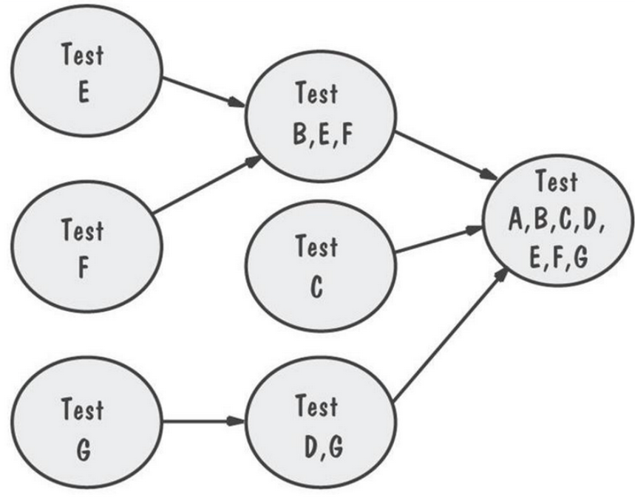

Figure 67: A variation of a possible Integration Plan

Regardless of which integration pattern used, the ability to turn on the fuel cell by emulating the behavior of the current system already in place will be of the first priority for the first phase of implementation.

The logic processor that is incorporated in the current system initially opens the inlet valves on power-on by triggering a relay switch to open letting hydrogen to flow into the fuel cell stack. It then it reads data from various sensor to determine if conditions have been met to open and immediately close the purge valve to equalize the concentration of hydrogen across the fuel cell stack that outputs a steady voltage drop.

The sensor data read by the processing unit includes the voltage drop that occurs across the entire fuel cell stack, the two voltage drops that occur across the last three fuel cell stacks, and the temperature at around the region of the last few fuel cells. Verifying the assumption that the logic board on the current system does not perform any complex computations using its sensor data and only waits until preset conditions are met to fully power on the fuel cell, emulating the same observed behavior will allow us to proceed with development operations without the fuel cell unit on-premises until a later time. There is no further changes to the fuel cell block that will be made and efforts will focus on designing and prototyping power control units.

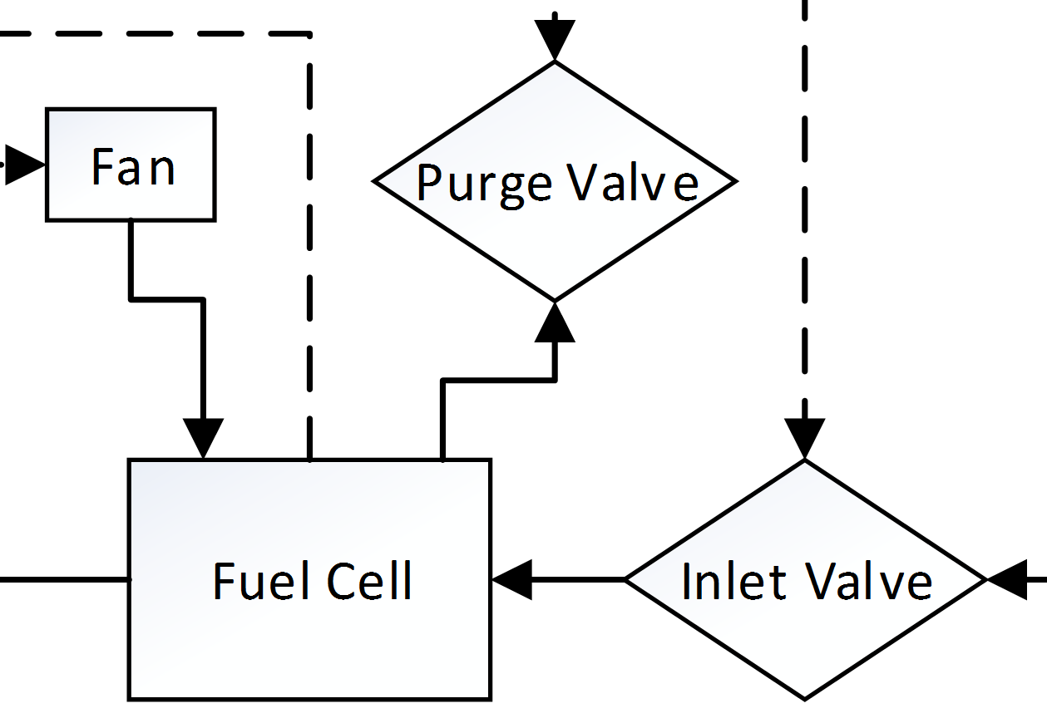

Figure 68: Fuel Cell Module

### Fuel Cell Simulation

#### Overview

There are factors and situations which are unpredictable and varying in actual usage situations and which must be taken into account when designing the logic involved in the system.

* The energy being demanded by the power supply is chaotic and dependent on the user or how/where/what of our energy source is being used on.
* Our processing logic needs to optimize requests for power in order prolong energy usage time; therefore it needs to dynamically compute an optimized signal.
  + An energy demand signal that has been observed by the CPU to be sharply spiking up and down randomly over a time span should take this past behavior in account and optimize the real energy being requested from the power controller and send to the motor.
* To simulate the user in a usage scenario for testing purposes, dummy data can be fed in to the processor which would act as data coming from radio receiver into processor.

The optimized signal data sent out on the control bus should use less energy over a time span taking into account data from its sensor bus and past energy-demand behavior. Components that have dependencies towards the fuel cell should output to alternative devices where the output can be measured and have mock inputs that simulate the behavior of the fuel cell as close as possible. Figure 69 illustrates how the processing unit can be tested in isolation without an actual fuel cell in place. A power supply provides the voltage sensors with voltage drop data that would otherwise be read from the fuel cell stack, and a cup of warm water provides the temperature sensor with heat that would come from the fuel cell stack. The output control signals that would be connected to the two solenoids that open the input valve and purge valves are connected to a Multimeter instead of the solenoids. This eliminates the possibility of a defect influencing the test result outcome.

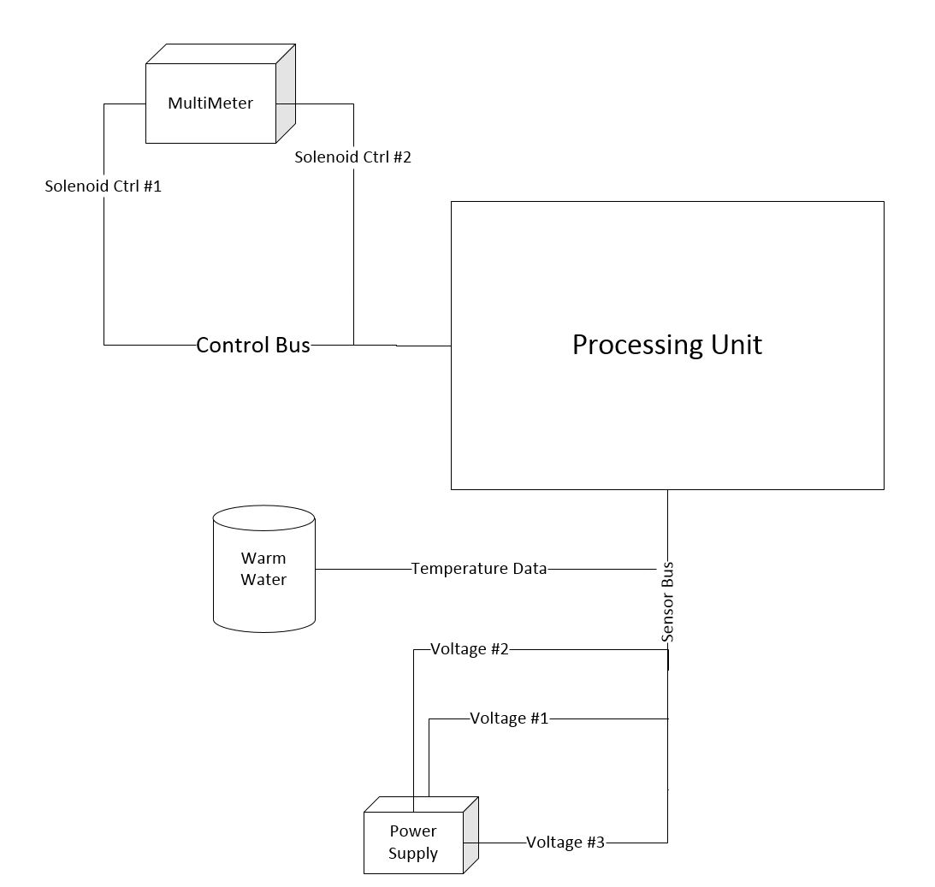

Figure 69: Testing Processor with Readable Output + Mock Input

#### Circuit Design

We need a power source that we can use to simulate the fuel cell. This same circuit could also be used for simulating the battery (although we have a physical battery available, a simulator would allow us to quickly vary the test voltage). In the senior design lab, we have several different models of power supply available. Of these, the Tektronix PWS4305 has the maximum output voltage of 5A. However, we would like to be able to simulate currents of up to 10A. One option we have is to just do our tests with a limit of 5A. Another option would be to gang together two of the PWS4305 power supplies (we would need to physically locate them next to each other). In order to do this we will need a balancing circuit as shown in Figure 70. The diodes are used as reverse current protection, and the resistors are small-valued power resistors used to account for small voltage differences in the outputs of the supplies. Because the diodes are present, if the supplies are set at different voltages, the supply with the highest voltage will supply all current (but no damage will be done).

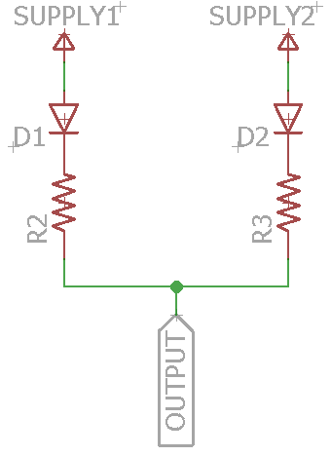

Figure 70: Power Supply Balance Circuit

Another option would be to use a fixed output voltage source such as a PC power supply. This would provide enough current, but with the obvious disadvantage that the voltage cannot be varied. Note that in this case we could also use the battery as a power source. In order to provide voltage varying capability, we could use a fixed output supply with a linear regulator. We could build a discrete regulator using an opamp and transistors, or we could gang together LM317 regulators. An advantage of this circuit is that we can include both voltage and current control, and can control the regulator using a microcontroller (the lab power supplies are programmable, but only to a limited degree).

### Load Testing

In various units in the system it is absolutely critical to verify it meets performance requirements under load before development continues further.

* With *n* amount of signals on the signal bus of the CPU and *m* amount of control signals being controlled, how hard is the CPU working and what is its latency
* With full power being demanded from the fuel cell, at what rate is the head of the fuel cell increasing?
* With full power being demanded from the fuel cell, what is the rate at which the hydrogen is being consumed?
* How will the system behave if the load demanded spikes to full capacity every 30s interval?
  + Based on the observed behavior how does it compare against an ideal response where the energy demand for the entire timespan was known ahead of time? How much more energy was lost as a result?

### Power System

#### Fuel Cell

The fuel cell can be tested in complete isolation from the other subsystems and has itself has three subsystems within; the voltage sensor, the temperature sensor, and the solenoid controls. The voltage sensor implementation can be tested by comparing its readings with readings from a Multimeter and calculating an average of the difference between the two readings to determine if it falls within an acceptable range. The temperature sensor can be tested in a similar fashion where the implementation readings will be compared against readings from a higher end temperature read. Testing the operation of the solenoid control is trivial and can be determined by observation alone. Integration testing of the three components will involve connecting them to the processing unit and providing heat from warm water and voltage drop from a power supply and then verifying that the solenoids are triggered appropriately. Then the next step would be to connect the system to the leads of the current sensors on the fuel cell stack and verifying that our solenoids are triggered at about the same time as the current system; multiple trials will be conducted where our system must replicate the current system functionality within a 1-second threshold above 75% of the time in order for the test to pass.

The voltage output of the fuel cell will need to be connected to a DC-DC converter to stabilize the voltage when switching between battery and fuel cell power source in the integrated unit. The components connected to the power source are expecting a steady DC voltage supply and is unaware of the power source implemented in our system.

### Battery System

The battery system can be tested in isolation by connecting a Function Generator in place of the fuel cell stack that is set to generate a square wave input into the DC-to-DC converter with the battery connected in place and then probing the DC to DC Converter using an oscilloscope as shown in Figure 71. If the DC-to-DC converter is functioning correctly, the output voltage should remain relatively constant when viewed through the oscilloscope. This test will demonstrate that when voltage oscillation occurs within the circuit, the voltage is drawn from the battery instead of the function generator. This simulates the situation in which voltage demand increases abruptly when the throttle is pushed all the way down and the RC car is made to accelerate. The fuel cell will not be able to deliver power as quickly as the battery and therefore it is not efficient and performance friendly to draw power from the fuel cell in such situations.

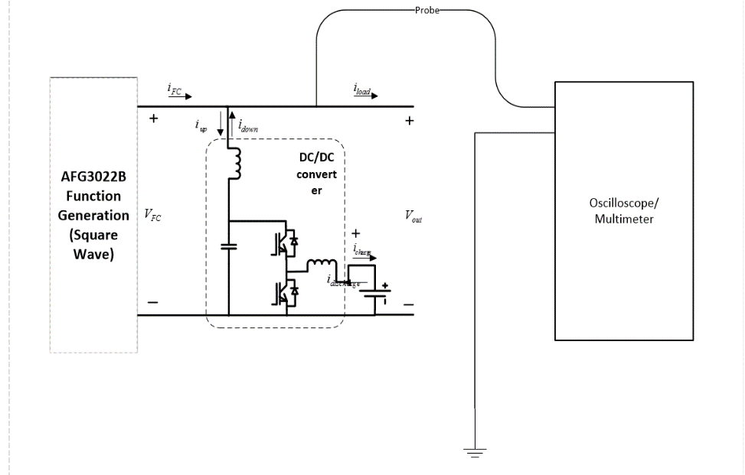

Figure 71: Battery System Testing with Square Wave Secondary Voltage Applied (permission pending)

### Integration: Fuel Cell, Battery, Power System

The entire power system can be tested by connecting the battery, the fuel cell and the power controller together, and putting a signal on the control lines while monitoring the power output through an oscilloscope. This test is only viable once each of these units were tested in isolation. Otherwise, even a passing integration test is a worthless test since it is essentially unreliable and the true faults of the system cannot be seen or observed. Upon sending a signal telling the power controller to switch power sources, there should be an observed reading on power being drawn from the other power supply different from the one selected before. The power being outputted should see no interruption whatsoever during this process

### ESC

Electronic speed controllers are basically a PWM controllers made to work specifically for electric motors. They are usually implemented with a microcontroller and various firmware are vastly available. Although we choose not to reinvent the wheel and re-implement an RC car component, in the case that we do implement an ESC, for whatever reason, testing it would be quite a simple process. Generally for a brushed motor, an ESC receives a 50 Hz PWM input signal and depending on the length of time a pulse is held for, produces a strict set of outputs. A 1ms signal turns off the connected motor while a 1.5ms signal drives the motor at half-speed, and a 2.0ms drives the motor at full speed. In order to test the ESC all we would need to do is connect it to a function generator that is set to output the functionality we are testing for and a power supply. Then we would monitor the output signals to verify that it is producing the appropriate response. An ESC for a brushless motor is different however, where the output produced is not a single constant signal but a sequence of signals that drives the brushless motor. Therefore, the type of motor we will be using would need to be known ahead of time to know the type of signal that the ESC should output. Testing this unit would be similar to testing a ESC made for a brushless motor but the function generator timing and the oscilloscope would need to be calibrated so produce a single static image since the output is sequential.

### Motor Stand

During prototyping, we will want to see how the motor, ESC, power system, and controller respond to a load. Therefore it would be convenient to mount the motor in a test stand and to provide a dynamic load. There are numerous motor mount brackets with predrilled mounting holes available for hobbyists. We can build a stand by mounting the bracket onto a wooden or metal plate base. We also can buy a metal plate, drill holes in it ourselves, and mount it to the base using L brackets. We can also mount a second bracket facing the first one. The drive motor will be mounted to one bracket, and a test motor will be mounted to the second bracket to act as a dummy load. The two motor shafts can be joined using wheel hubs which are also available from hobby stores. The hubs have screws used for mounting wheels, but in our stand, two hubs will be screwed together back-to-back.

In order to vary the loading, the windings of the load motor can be either shorted (for maximum load), or can be put across a resistor for load variation (the torque will vary with current). When the windings are open circuits, there will be no load (except for friction). We will need to use power resistors (we could probably also build a transistor-based variable load, although this will probably be beyond the scope of this project). We will need to experimentally determine the necessary resistor power rating. We could build a simple switch setup to switch the power resistor in and out. We may need a surge protection device for when the load motor is open circuited while it is running.

There are adapters specifically designed to join shafts, but we will use the hubs because they allow us to mount discs between the hubs. For example, we have the option of measuring motor speed. We can do this by inserting a cardboard wheel with light and dark sections which would be detected using a light sensor. We could also use a setup with Hall Effect sensors. In addition to measuring speed, we also have the option of mounting a fly wheel between the motors (or even to the drive motor only with no load motor). Unlike the load motor, a flywheel would provide a greater rotational inertia which would be a good simulation of the inertia of the car. However, fly wheel could get heavy and may require special mounting considerations.

## Software Specific Testing

As software engineering is a discipline in itself, it is important to follow common convention and methodologies as closely as possible in order to develop software that is free of programmer errors. In order to develop meaningful tests that aren’t redundant and considering the fact that the primary focus of our software is to control hardware, it would be important to first identify what should be tested and what shouldn’t be tested. In other words, it would be wise to differentiate *programmer errors* from *operational errors* and use this information to determine what to test. Operational errors are errors that are beyond the control to the software and cannot be corrected whatsoever in the context of the software. These errors are caused by manifestation of hardware errors that must be corrected at the hardware level and not the software. Programmer errors are caused by the logic or syntax of the literal program code. These types of errors can always be corrected by changing the program code and should be the focus of our tests.

### Test Framework

There are many testing frameworks available for Javascript that can be used for unit testing. All of them are equally feature-rich and there was no benefit of choosing one over another. The only deciding factor was how well I felt each of their documentation were written. Therefore, I decided to use the *Mocha* testing framework since their documentation is quite extensive and their Github account happens to be the most active project out of all framework repositories.

### Version Control

It seemed too cliché to use Github for version control since it’s what everybody seems to be doing these days. Therefore, I chose to use Bitbucket instead. It also helps that Bitbucket allows for infinite number of private repositories unlike Github which charges for private repositories after an account creates five. We do not plan on making our repository public whatsoever as this creative work belongs to us and us only. There is no need to disclose how I implemented the software unless necessary, and the only time that I think it would be useful for anyone else is if they are attempting to do a senior design project identical to ours; which in my mind is absolutely unacceptable and is grounds for plagiarism.

I will be incorporating the *Git-flow* pattern for branch management and create a branch for every feature currently being developed. The branch will be merged into the master branch upon passing all tests and working to specification. We will also use a continuous integration service to automatically execute unit tests whenever a commit is made to our repository. This way, any updates to our code repository will be guaranteed to pass all unit tests and, as a result, ensure that our project is working to specification. I will be using Travis-CI which automatically set up hooks to our code repository to automatically run the unit tests whenever anything is checked into our repository.

# Administrative Content

Current research progress, barriers, conflicts and issues must be let known to all other group members. Architecture changes, requirement changes should be agreed upon by everybody in the group.

## Milestone Discussion

Our schedule for Senior Design 1 can be seen in Figure 72 and Figure 73. Because we are taking Senior Design in the shorter summer semester, accomplishing all milestones has been challenging. After narrowing down our project scope, we started a consultant search and we tried to acquire relevant documentation from past projects. Eventually, we obtained a report for a Fall 2014 Mechanical and Aerospace Engineering project “Flow Field Optimization of a Proton Exchange Membrane Fuel Cell”. From this report we obtained the contact information for Dr. Paul Brooker at the Florida Solar Energy Center. Once we contacted him, he was very helpful, and offered for us to use the hardware that is now the focus of our project. While this was a major step forward, we were not left with a lot of time for research and design.

While we have been able to gather a lot of information via emailed pictures, we will need to take measurements of the RC Car. We will also need to make some observations to understand the existing design. Eventually we will need to make modifications to the car. For these reasons, we will need to anticipate occasional travel to Cocoa.

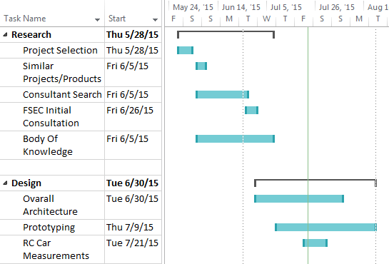

Figure 72: Senior Design 1 Timeline (Research and Design)



Figure 73: Senior Design 1 Timeline (Documentation)

Our schedule for Senior Design 2 can be seen in Figure 74, Figure 75 and Figure 76. Note that we are unsure of some of the deadlines, so some of the dates are estimates. Before we can make any modifications to the existing RC car, we will need to have our new custom hardware ready to replace the existing hardware. Therefore, we will plan on building an initial prototype which we can demonstrate with the use of a dummy fuel cell. If this new hardware works well, then we may be able to try it out with the RC car and fuel cell in order to verify that our design works before starting the final build.

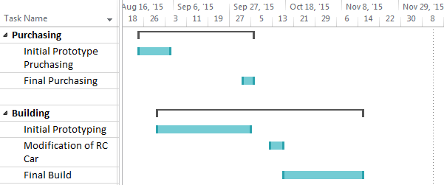

Figure 74: Senior Design 2 Timeline (Purchasing and Building)

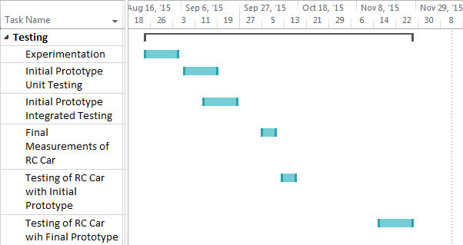

Figure 75: Senior Design 2 Timeline (Testing)



Figure 76: Senior Design 2 Timeline (Presentations)

## Budget and Finance Discussion

When using a fuel cell and hydrogen tank on any system, the budget is one of the most important things to consider. In order to properly estimate the budget, a large amount of research was completed. The first thing to research was previous projects and things currently on the market with similar features. Believe it or not many fuel cell powered RC cars are manufactured by companies and the ones that are, are on an extreme scale. The next step was to research similar projects that implemented many of the same features, as this would give the best estimation of cost. However, since no other project implemented everything the exact same way, this would only be a rough estimate. Some things that made the estimation difficult were scrap parts. With a project such as this one, certain parts were bound to break due to a limited knowledge of how these parts will function under such testing conditions. Parts such as the capacitors, microcontroller, and voltage sensor can be somewhat sensitive and the max voltage limitations given in the description manuals are only a close estimation to how they will actually function.

An important part of the research that was done was pricing of these parts. Many factors that were needed to be looked at were different prices, the quality of the part, and shipping requirements. When looking at parts for the overall project, many different companies sold the same part, so the first thing that was looked at for each of these parts was their actual price. In theory, the cheaper part should be chosen on a limited budget, but the quality of these parts comes into question. The way to overcome this limitation without trusting an unknown company was to look at reviews of the individual part and the company as a whole. The last thing to look at when choosing a part was the shipping requirements of these parts. With small and out-of-garage companies based off of websites such as eBay, an important thing to understand is when these parts would be expected to arrive. If these parts were limited to only ship once a month, this would mean that the group would not receive these parts for a month or more at a time. This would certainly prove to be a problem. This would completely change the timeline of the milestones, as parts could not be tested on time. This would ultimately push the entire project back. The best way the group found to avoid this issue was to order from bigger, well known, companies. These companies usually guaranteed a reasonable shipment date that could be worked around, while still keeping the cost to a minimum. Due to the fact that most of the necessary parts needed were provided by the Florida Solar Energy Center all we had to go by when it came to a budget was the components needed to prototype and based off of the components needed for our PCB designs. After all factors were taken into account, the budget could be drawn up and determined. This budget is shown in the Parts Acquisition and BOM section above.

# Appendix

## Appendix A: References

|  |  |
| --- | --- |
| [1] | US Department of Energy, "Fuel Cell Technologies Market Report," *Energy Efficiency & Renweable Energy,* 2012. |
| [2] | G. Harper, Fuel Cell Projects for the Evil Genius, McGraw-Hill Education, 2008. |
| [3] | F. Barbir, PEM Fuel Cells: Theory and Practice, Amsterdam ; Boston: Elsevier Academic Press, 2005. |
| [4] | A. K. J. L. D. a. M. A. M. H. H. Tao, "Family of multiport bidirectional dc-dc converters," *IEE Proceedings in Electric Power Applications,* vol. 153, no. 15, 2006. |
| [5] | F. T. a. I. B. H. Al-Atrash, "Tri-modal half-bridge converter topology for three-port interface," *IEEE Trans. Power Electron,* vol. 22, no. 1, 2007. |
| [6] | H. P. a. P. K. Jain, "Series-parallel resonant ups with capacitive output dc bus filter for powering hfc networks," *IEEE Trans. Power Electron,* vol. 17, no. 6, 2002. |
| [7] | V. V. a. S. Cuk, "Small-signal analysis of resonant converters," *IEEE Power Electronics Specialists' Conf. Rec,* 1983. |
| [8] | R. Beardmore, "Roymech," 20 January 2013. [Online]. Available: http://www.roymech.co.uk/Useful_Tables/Drive/Gear_Efficiency.html. [Accessed 31 July 2015]. |
| [9] | R. Shelquist, "Wahiduddin," Shelquist Engineering, 1 March 2015. [Online]. Available: http://wahiduddin.net/calc/density_altitude.htm. [Accessed 31 July 2015]. |
| [10] | R. Beardmore, "Roymach," 17 January 2013. [Online]. Available: http://www.roymech.co.uk/Useful_Tables/Tribology/co_of_frict.htm#Rolling. [Accessed 31 July 2015]. |
| [11] | Texas Instruments, "Zerø-Drift, Bi-Directional Current/Power Monitor with I2C Interface," [Online]. Available: http://www.ti.com/lit/ds/symlink/ina219.pdf. [Accessed 5 August 2015]. |
| [12] | Texas Instruments, "MIXED SIGNAL MICROCONTROLLER," April 2011. [Online]. Available: http://www.ti.com/lit/ds/symlink/msp430g2553.pdf. [Accessed 21 July 2015]. |
| [13] | R. Sclupbach, "Design methodology of a combined battery-ultracapacitor energy storage unit for vehicle power management," *Power Electronics Specialist Conference, IEEE,* 2003. |
| [14] | A. Stienecker, "Improved Battery Charging in an Ultracapacitor-Lead Acid Battery Hybrid Energy Storage System for Mild Hybrid Electric Vehicles," *SAE World Congress,* 2006. |
| [15] | J. D. a. M. Ortuzar, "Ultracapacitors + DC-DC converters in regenerative braking system,," *IEEE Aerospace and Electronic Systems Magazine, Vol. 17, No. 8,* 2002. |
| [16] | A. Dicks and J. Larminie, Fuel Cell Systems Explained, 2003. |

[17] Tong, Xingcun Colin. Advanced Materials and Design for Electromagnetic Interference Shielding. Boca Raton: CRC, 2009. Print.

[18] Badrinarayanan, Paravastu. PEM Fuel Cell Water and Thermal Management: A Methodology to Understand Water and Thermal Management in an Automotive Fuel Cell System. Thesis. 2001. N.p.: n.p., n.d. Print.

[19] Ang, Simon S., and Alejandro Oliva. Power-switching Converters. Boca Raton, FL: Taylor & Francis, 2005. Print.

[20] "LM3671 (ACTIVE)." LM3671. N.p., n.d. Web. 18 July. 2015.

[21] "Basic Concepts and Simple Switching Transients." Transients in Power Systems (2001): 1-13. Web.

[22] "What Is a Pulse Width Modulation (PWM) Signal and What Is It Used For?" - National Instruments. N.p., n.d. Web. 18 July. 2015.

[23] N E C A M S I D. DC/AC Pure Sine Wave Inverter (n.d.): n. pag. Web.

[24] "I2C." I2C. N.p., n.d. Web. 23 July. 2015.

[25] "Serial Peripheral Interface (SPI)." Serial Peripheral Interface (SPI). N.p., n.d. Web. 15 July. 2015.

[26] Keeping, Steven. "Understanding the Advantages and Disadvantages of Linear Regulators." Understanding the Advantages and Disadvantages of Linear Regulators. Electronic Products, 8 May 2012. Web. 25 July 2015.