CDA6530: Performance Models of Computers and Networks (Fall 2015)
Project 2: Using Matlab Simulink to derive numerical solution for differential equations
(Due: Oct. 11th midnight via webCourse)

You have learned matlab simulink from the example of the simple worm propagation modeling in class. Now you are asked to derive the numerical solutions for more complicated differential equations.

If you cannot access Matlab Simulink, you can use an equivalent free software 'Xcos' (similar to Simulink), which comes with the free software package 'Scilab' (similar to Matlab). The website is:
http://www.scilab.org/products/scilab
Submission: please submit this project assignment via webcourse. You should attach a zip file containing:
1). A report file (such as word file) containing experiment figures and simulink model figures, and
2). Simulink model files (.mdl), and matlab script file (.m file in which you call the simulink model and plot the results), so that I can test by myself.

If you use ‘Xcos’, please explicitly show how the teacher can test your simulation model.

1. 2nd-order damped, forced oscillator system.

You are requested to solve the Ordinary Differential Equation:
With initial conditions:
^{and}

Run the simulation for 10 unit time. You need to plot the x(t) curve to show its dynamics.

2. Two coupled spring with Damping

Consider the following two coupled spring with damping system:
Where x₁(t), x₂(t) represent the positions of the two block m₁ and m₂. k₁ and k₂ denote the Hooke’s constants (you can think them as the strength metric of springs). Suppose the two springs have frictions, with the damping coefficient of δ₁ and δ₂, respectively. The differential equations governing the system’s dynamics are:
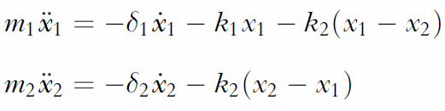

Now we assume the two blocks have weight m₁ = m₂ =1. The four constants have values of: k₁ = 0.4, k₂ = 1.808, damping coefficient δ₁ = 0.1 and δ₂ =0.2.
The initial condition is:

Plot the dynamics of position variables x₁(t) and x₂(t) on two graphs from t=0 to t=50, respectively.

